How to create kit or Assortment Item

Kit Item and Assortment Item
Kit item is made up by multiple component items. In business process, it will purchase by component item and inventory also saved by component item. But it sells based on kit item.
Assortment Item is made up by multiple component items. In business process, it will purchase by assortment item, and the inventory also saved by assortment item. It sells based on assortment item too.
The different of kit item and assortment item is mainly on the inventory issue. The same of kit item and assortment is that they both need to maintain BOM in item master page.

How to create kit or assortment item
The kit item and assortment item creation process is same as standard item besides below differences:
- In item master page, there are the filed named “Pack code” and “Mfg/Purchased” field.
- If the item is kit item, the pack code=kit and Mfg/Purchased=Mfg or Both.
- If the item is assortment, the pack code= Assortment and Mfg/Purchased=Mfg or Both
- Kit item and assortment item both need to set up BOM in item master page.

How to set up BOM for kit or assortment item
- Go to Item master pages and set item pack code=Kit or Assortment.
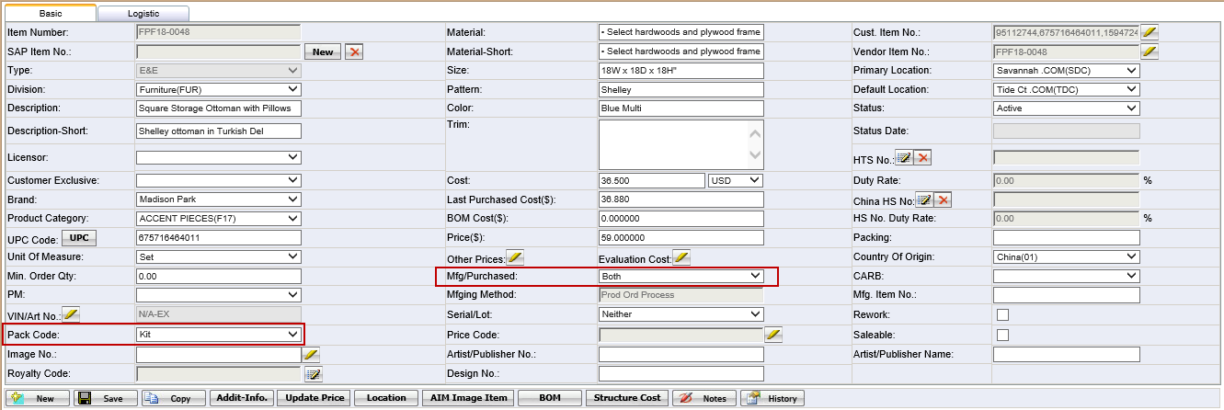
- After saving the item basic information and click<BOM> button to set up bom for kit or assortment item.
- Click BOM button to open the BOM creation page:
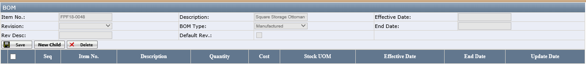
Notes:
- <Save>: to save the BOM header.
- <New Child>: to add a new child for items or children items’ child.
- <Delete> : to delete the children items.
- Click the button “New child” on Bom page to add a new child:
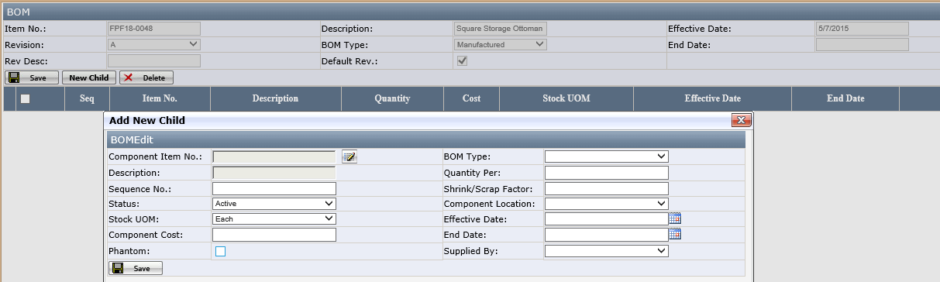
Fields:
- Component Item No: select the component item .
- BOM Type: This field is used when the component item has different BOM type. if the child item has no BOM Type, the BOM type is default as blank; if the child item has BOM type, the default BOM is Manufactured and is allowed to update it. It is no useful at present.
- Quantity Per: enter how many component item for this kit or assortment item.
- Phantom: If Phantom is checked, it means this item is virtual item and the Phantom item is not showing on purchase order BOM, this phanton item’s component will be shown in BOM. This field is not useful at present.
- Fill the required field and save it.
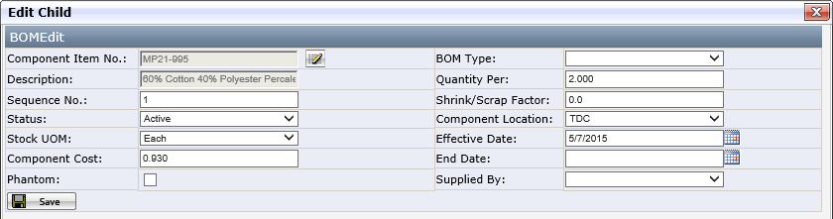
After save, the information will be in the grid. One component item set up successfully.
If there are multiple component item, just repeat the process to add another component item.
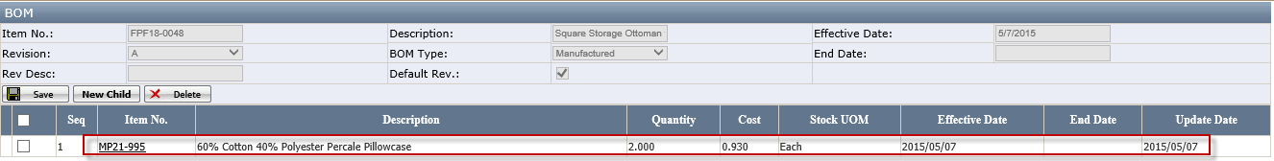

Notes:
- When it sold on website, It needs to set up retail item list page.
For kit item, it only need to set up retail item for kit item. It needn’t to set up component item in retail item.

