WMS Manual-Olliix

Background
The Olliix orders will go through different processes based on different shipping method.
- If the Olliix orders’ shipping method is LTL or Will Call, such orders business type is Dealer wholesale and it will go WMS process;
- If the Olliix orders’ shipping method is others, such orders business type is Dealer Small Package and it will go drop ship process.
This manual is how to process olliix order by WMS process. In order to operate the dealer wholesale orders, the user should be below access:
1. It should have dealer wholesale business type and relation location.
2. It should have “Batch Admin” job function to create batch for olliix orders.

How to process Olliix Dealer wholesale orders

Service auto read olliix orders
- Olliix orders are read from olliix website to EEC by EEC service “GetOlliixOrder”. After operating the service, User can view order on Olliix Order List webpage.
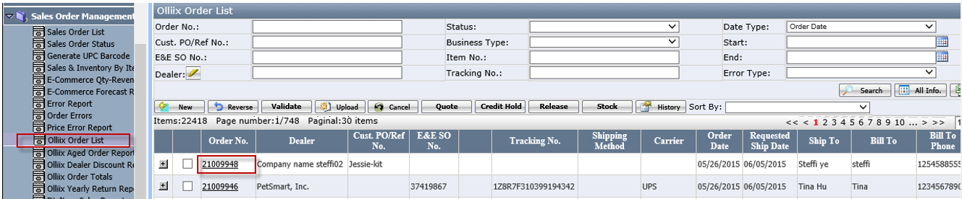
Button
- Validate: it is used to validate the sales order based on the business rules.
- Upload: it is used to upload to macola system.
- Cancel: it is used to cancel sales order.
- Quote: it is used to review freight quotation of olliix order.
Click quote to open below review page
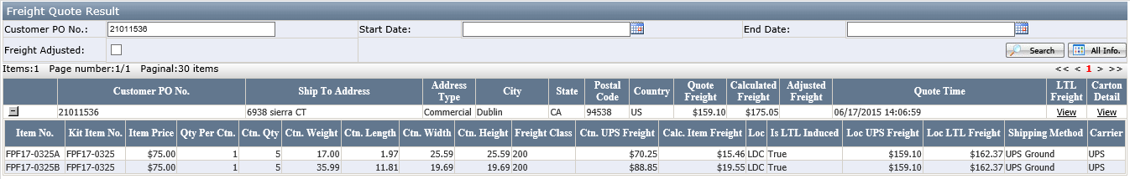
- Credit Hold: it is used to hold this order and only accounting team have the access to use it.
- Release: It is used to release the credit hold orders.
- Stock: it is used to review the item inventory.
a.) click stock to open the stock review page, in this page, user can know the inventory situation.
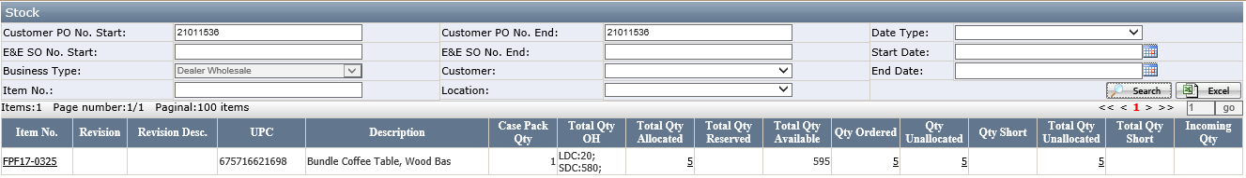
b.) If the item is kit item, the item no will be links
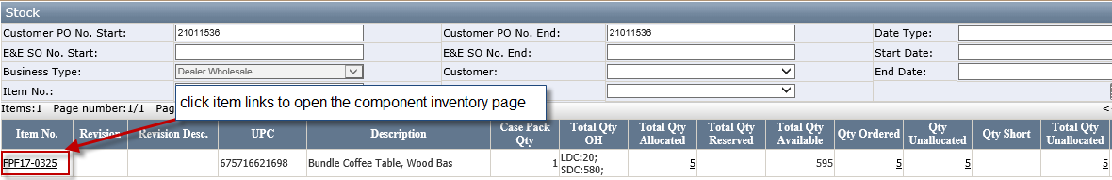
c.) Click this link to open component stock page
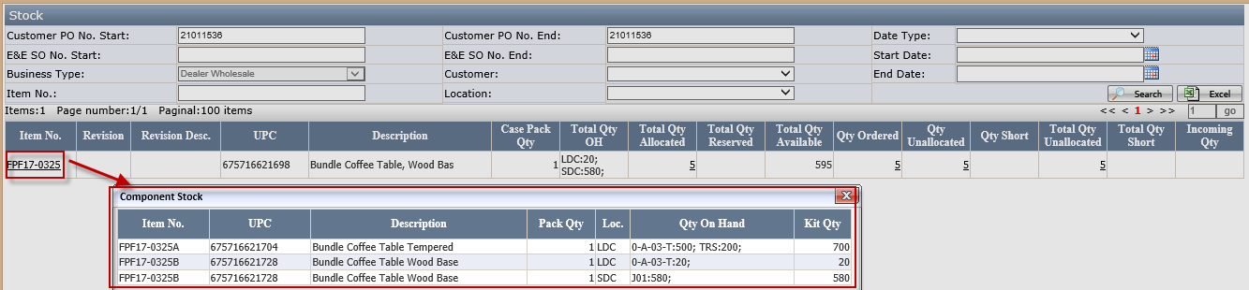
Here, the user can know how many available inventory of kit’s component.
Kit item inventory=min (component on hand qty/pack qty)
History: It is used to review the order update history.

Decide the order’s business type
The order’s business type is decided by shipping method. If the shipping method is LTL or Will Call, the order business type is “Dealer Wholesale” and it will go by WMS process. See below sales order detail page:
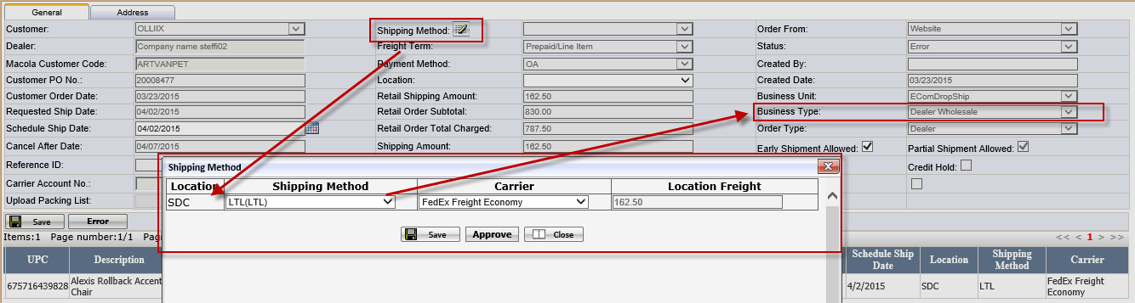
Notes:
It is allowed to update the shipping method before the sales order upload to Macola system.
If shipping method is LTL or will call, it will go by Dealer wholesale process.
If sipping method is not LTL or will call and it will go by drop ship process

Service auto validate and upload orders
EEC service would validate wholesale order. After passing validation, EEC service would upload it to Macola.

Handle order errors
In olliix sales order list page, if the order has the error when validate or upload order process. User needs to solve these errors. See below:
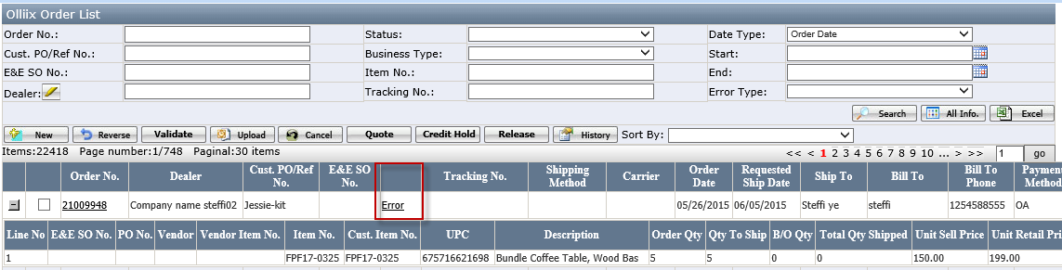
- Error: invalid item
Solution: to create this item in EEC and upload it to Macola.
- Error: Item missing the dimension or weight
Solution: to add the item dimension or weight in item master list page.
- Error: order Item xxx is out of stock.
The message is:” Resolve inventory issues by increasing the onhand or canceling the Sales Order line item”.
- If the item is standard item (pack code is not kit), replenish the inventory for order item.
- If the item is kit item (pack code=kit) out of stock, it will replenish the component item of this kit item. The replenish quantity= kit item lack qty* per qty
For example: kit item “Kit1” with component BOM11 and BOM12
BOM11, Per qty 1;
BOM12, per qty 2;
If the kit item less quantity is 3 pieces, the replenish quantity should be 3+6=9 pieces：
BOM11=3*1=3 pieces
BOM12=3*2=6 pieces

Create Batch
- After clearing all errors of orders, go to Wholesale Batch Mgt webpage to create a batch.
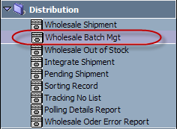
- Click <New> button.
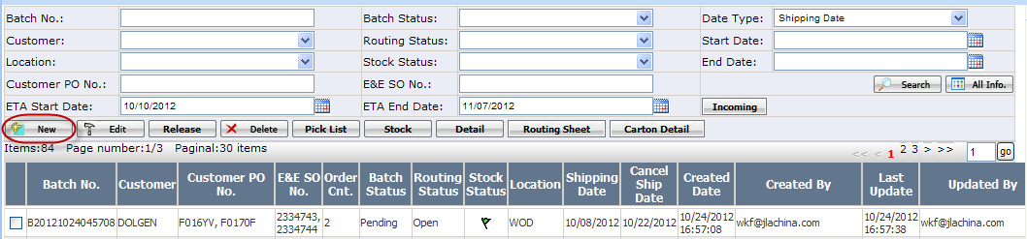
- On below pop up webpage, select customer, business type, location, and choose Release Status as Release Required, then click <Search> button.
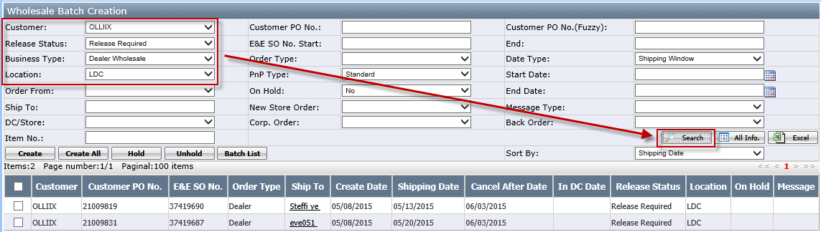
Notes: The business type should be changed to dealer wholesales when creating batch for olliix orders.
- Select macola orders that you want to create batch, click <Create> button.
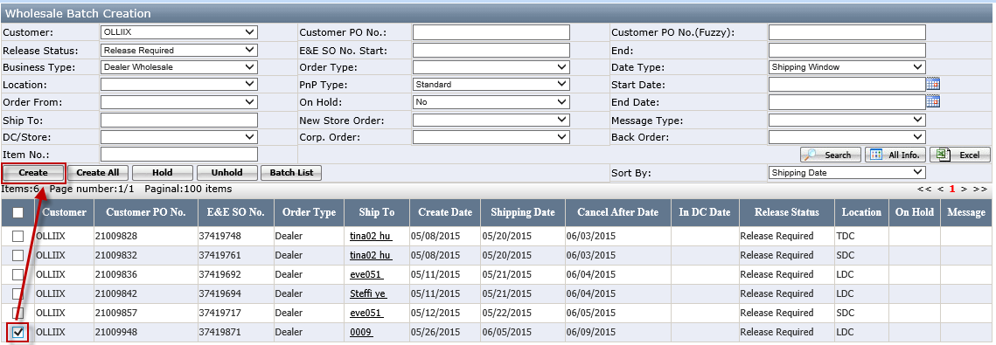
Once batch is created successfully, the new batch’s status is Pending.
*********************************************************************
Note: When create batch, the selected macola orders must have overlapped shipping window. And for in DC customer, all in DC date must be in the same week.
*********************************************************************

Release Batch
- Select the Pending batch, click <Release> button to release it.
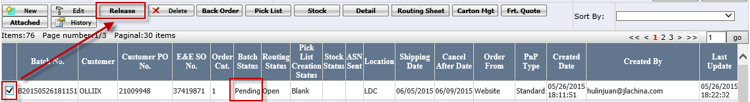
- Stock: it is to review stock information
- Detail: It is used to review the batch pick list detail.
- Carton Mgt: it is to review the carton information. Detail see <Carton Mgt> page.
- Once it is released successfully, the batch status will be changed to Released.
Notes: if the order inventory is not enough, the stock status will mark with red flag.

Generate Pick List
- Go to Wholesale Batch Mgt and select the Released batch, click <Pick List> button.
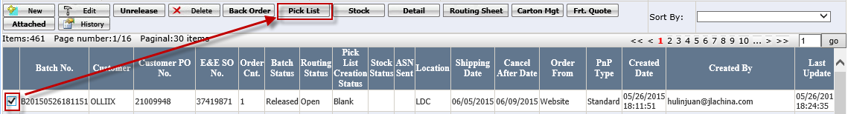
- You will see below pop up window:
- Sort by: item no or bin loc.
- Limited Bin/Carton: If you want to limit the number of bins in each printed pick list, select Limited bins, and enter the number of bins. Otherwise, just leave it as blank.
- Click <OK> button to generate pick list.
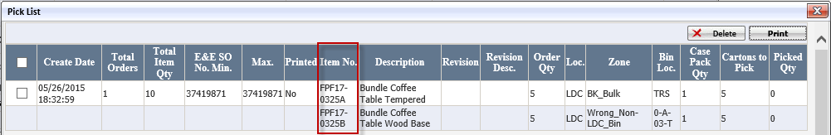
Notes:
- If the item is not kit item, in the pick list, the item no= order item no
- If the item is kit item, in the pick list, the item no=kit’s components item no.
The kit’s component item is maintained in item master list page.
For order 210099481 as example, in the sales order, the order item is FPF17-0325, since the FPF17-0325, is kit item, so, in pick list, it shows component item FPF17-0325A and FPF17-0325B.
Please refer to <How to set up Kit or Assortment Item> to know more about kit item.
- Click <Print> button to print out pick list.
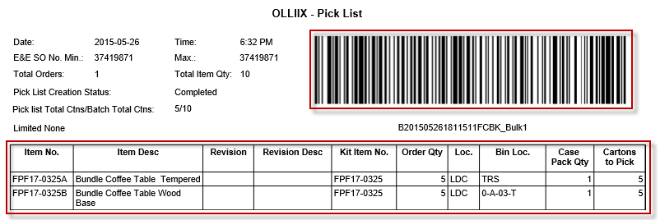
Notes: In pick list paper, for kit item, the cartons to pick is component qty, the qty=kit item qty* per qty. what’s more, the kit item will show in kit item no. column in pick list paper.
- After pick list is generated, the batch status will be changed to PL Created.

Generate Routing Sheet
- Go to Wholesale Batch Mgt and select the batch, click <Routing Sheet> button.
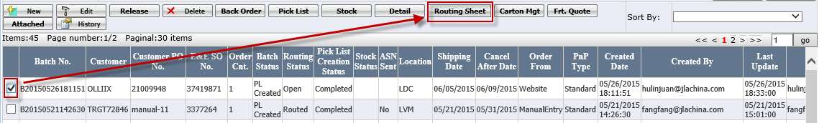
Notes: For the detail function of <routing sheet>, please refer to <how to generate routing sheet>
- Once routing sheet is successfully generated, you will see below routing sheet list webpage.
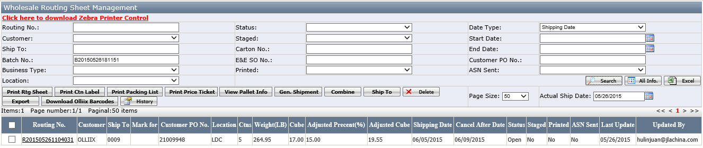
Button:
- Print routing sheet: it is used to print out the routing sheet. After print out the routing sheet, the printed status will be “yes"
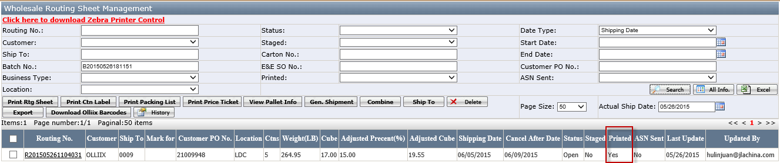
- Print carton label: it is used to print out the carton label.
On routing sheet list webpage, select the routing sheet, click <Print Ctn Label> button.
You will see below pop up print ctn label window.
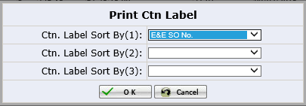
The ctn label will be print out sort by 1 and 2 and 3. The sort by default is from customer profile setting and user can update it. After that, click <ok> to print out carton label. Please notes:
- If it is kit item, it will print out the kit’s component item carton label.
- If it is not kit item, it will print out the order item’s carton label.

- Print Packing list: it is used to print out the packing list.
For olliix order, if customer upload the packing list on olliix website, it will print out the upload packing list. If the customer haven’t upload packing list, it will print out the standard packing list as below:
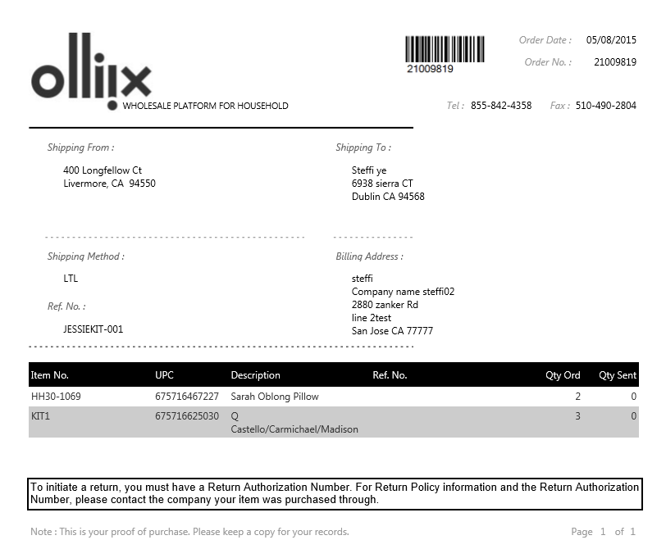
- Print Price Ticket
Notes：Olliix order needn’t print price ticket.
- View Pallet Info *notes: Kit item doesn’t support Pallet function*
- Gen.Shipment: It is used to create the shipment.
In wholesale routing sheet management page, select one or multiple routing sheet, click <Gen.Shipment> button to generate shipment.(***Note: For olliix order, It had better to use this button to generate shipment since the carrier and ship method etc. information will get from orders automatically.***)
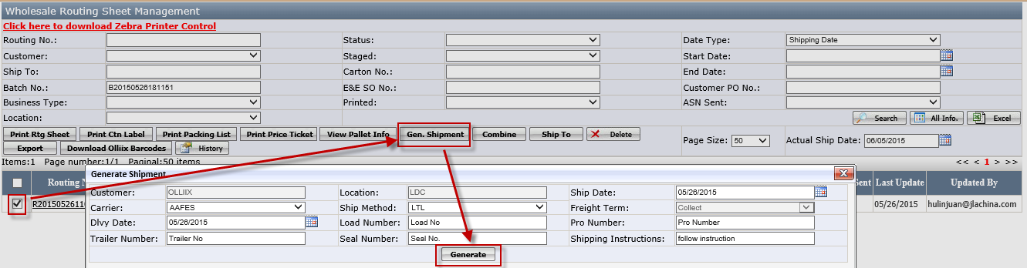
After generate it successfully, the status will be shipped.
- Download Olliix Barcode: It is used to download olliix order’s carton barcode.
Notes: For olliix order, every time, the user should click this button to check whether the dealer carton barcode file had uploaded or not.
If it has, click this button will download the file and print it out;
If it has not, will pop up message:” there is no order contains the barcode file.”.

Create Shipment
There are two places to create shipment. One place is in wholesale shipment page.
Another is in Wholesale Routing Sheet Management page. (See <Gen.Shipment> button function)
- Go to Wholesale Shipment webpage.
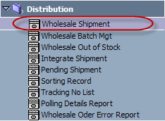
- Click <New> button.
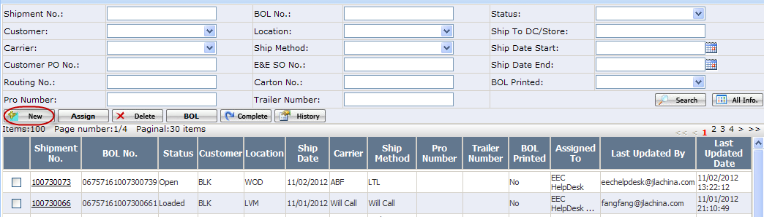
- On below pop up webpage, enter shipment header information and then click <Save> button.
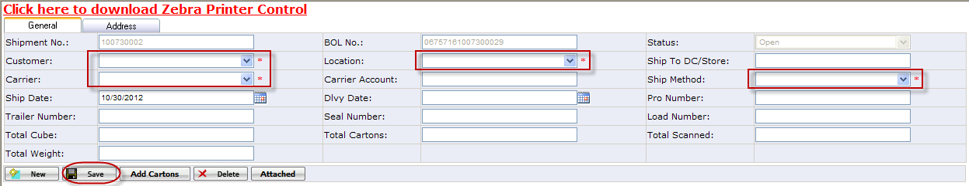
Note: Customer, Carrier, Location and Ship Method are required fields for creating a shipment header.
- Add cartons to shipment
After shipment header information is saved, click <Add Cartons> button.
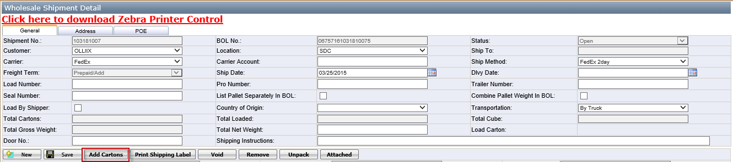
On the pop up window, select a Routing No. that you need to add to the shipment. When a routing number is selected, you will see all cartons that belong to the routing sheet.
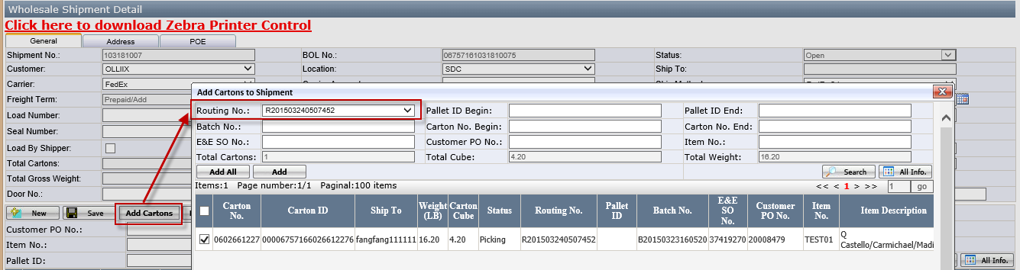
Select cartons you need to add to the shipment, click <Add> button.
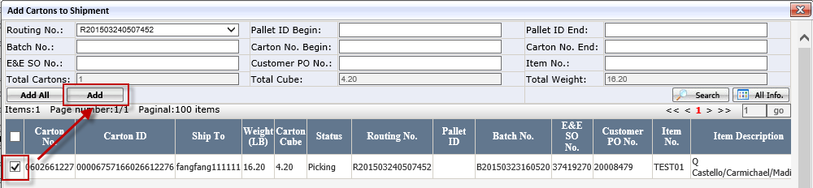
After cartons are added to shipment, EEC will switch back to below shipment detail webpage, and now, the shipment status will be changed to Routed.
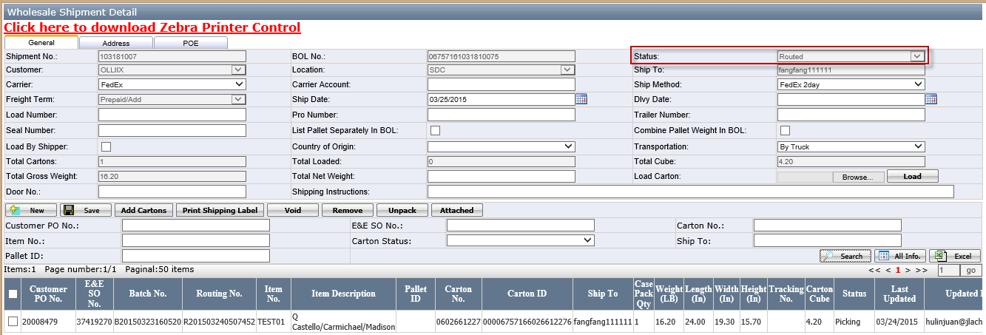
- Print Shipping Label
Print shipping label is only available when the ship method is small package such as UPS or FedEx. If the ship method is LTL, this button is disable. User use this button to print out the shipping label and generate the tracking no.
Select item you need to print shipping label, click < Print Shipping Label > button.
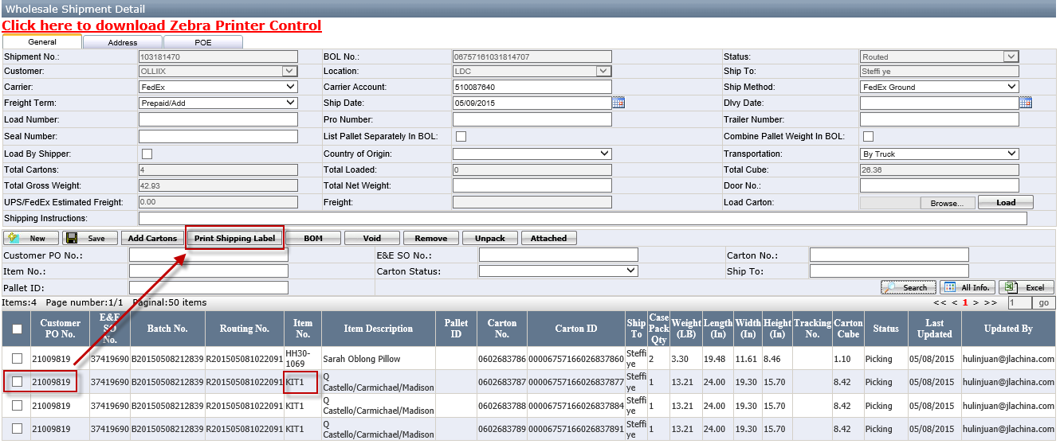
Notes: If the select item is kit item, it will print out shipping label based on kit’s component item.
After printing the shipping label, the tracking no will be shown in the grid
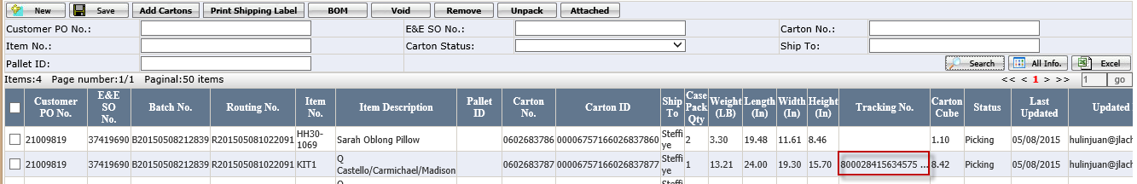
- Void: it is used to delete the shipping label.
- Remove: it is used to remove the item from this shipment.
- Upack: it is used to delete the shipping label too. The difference with void button is this button only delete shipping label in our system, but not delete it from carrier system.
Notes: The address’s state, zip, country must be correct, otherwise the tracking no can’t be print out.

Assign Shipment to Truck Loader
- Go to Wholesale Shipment Mgt and select the shipment (Status: Routed), click <Assign> button.
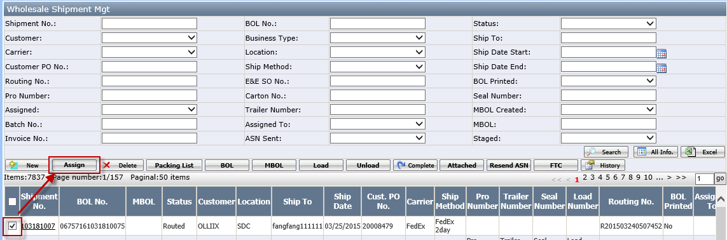
- On below pop up window, select one or multiple truck loaders, click <Assign> button.
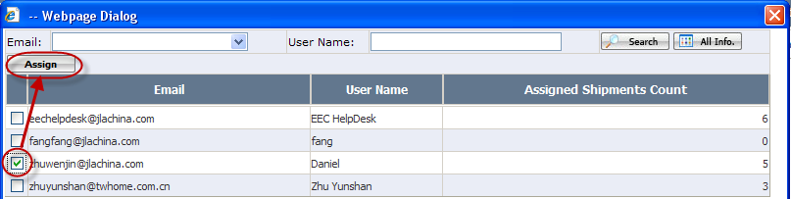

Load Cartons/Pallets to Truck
There are two ways to load carton. One is by wireless application. Another is to click load button to load it.
- User can use wireless application “TruckLoading” to load the cartons. The detail see <how to do Truckloading> manual.
Notes:
If the item is kit item, when using wireless application, it shows kit’s component item. After all components loaded, the kit item will be loaded too.
- Also, user can click<Load> button to load cartons:
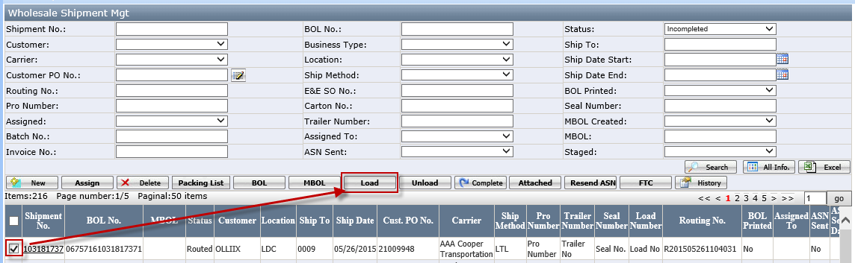
After loading it, the shipment status is loaded.
Please note that the user with role “Shipment Admin” has the access to operate the load button.

Print BOL
- Select the shipment that you need to print BOL, click <BOL> button.
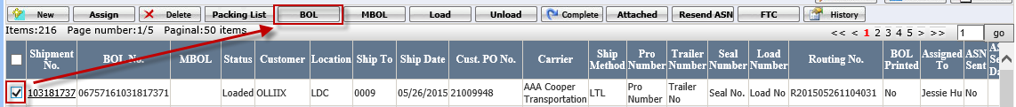
- Then you will see BOL document as below:
Note:
If shipment status is Open or Routed, the BOL cannot be printed.
If shipment status is Loading, the BOL would only show cartons that have been loaded to truck.
If a shipment carrier is LTL or TL, besides above shipment detail, the Bill Of Lading would also be printed out.

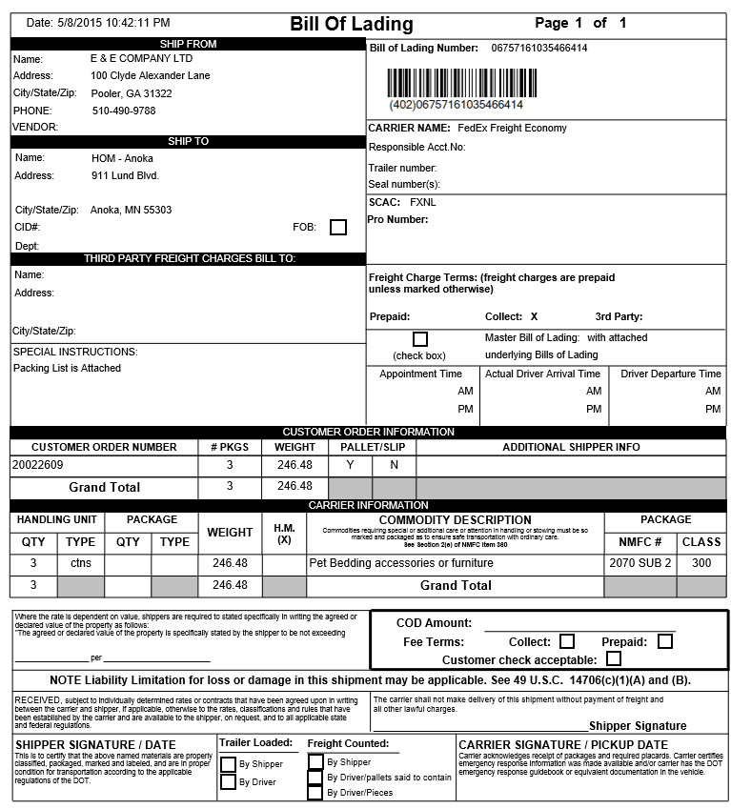

Print Packing list
Select the shipment, click <Packing List> button to print packing list.
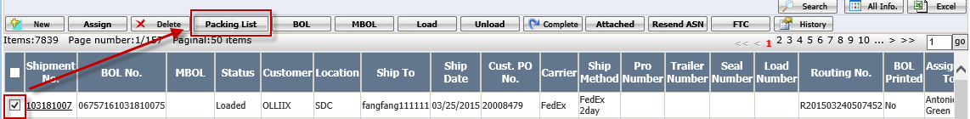
Notes: It is same function in routing sheet page Print Packing list

Complete a Shipment
Select the shipment that you need to complete, click <Complete> button.
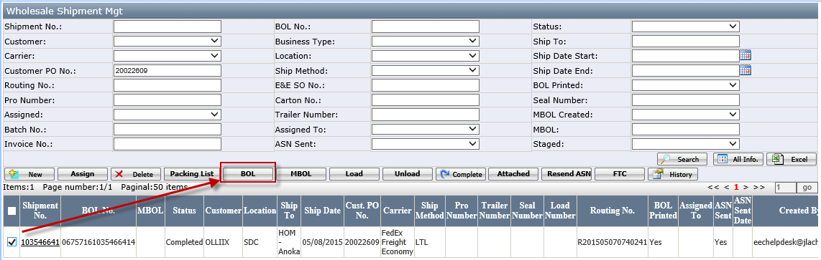
Once the shipment is successfully completed, its status would be changed to Completed.
Note:
If a shipment status is not Loaded, it cannot be completed.
Only ‘Shipment Admin’ is able to complete a loaded shipment.

Carton Mgt
In wholesale Batch Mgt page, click <Carton Mgt> button to open carton management page:
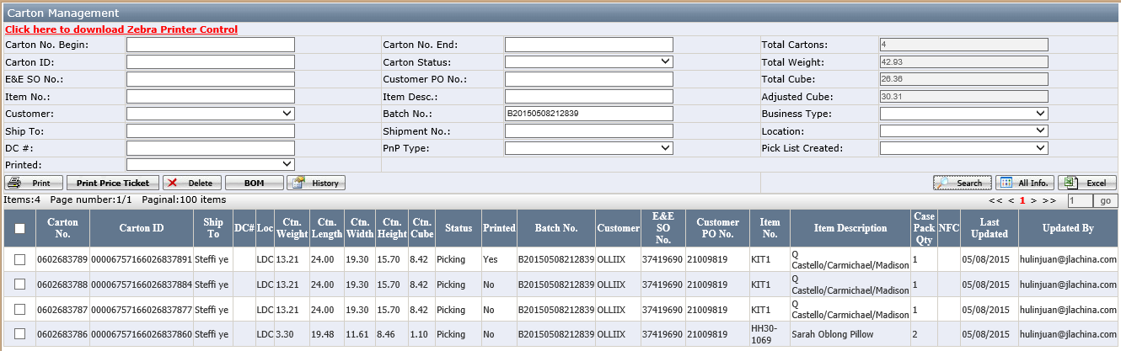
- Print
It is used to print out the carton label.
- Print Price Ticket
This button is same function in routing sheet’s print price ticket button.
It is used to print out the price ticket. It is not required for all customer. Only in the customer profile page, the “Price Ticket Required” field is checked, the price ticket can be printed out by this button. Otherwise, it will pop up message:” Price Ticket is not required by customer.”
- Delete
It is used to delete the carton from this batch,
- BOM
BOM button is only available for kit item and is used to review kit item component information.Select one item and click BOM button, if the item is kit item, click BOM to open below page:
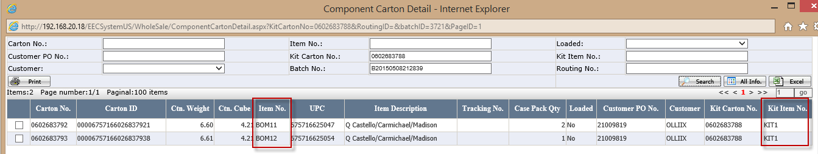
If the select item is not kit item, click BOM pop up message:” Select carton does not contain components.”

View pallet Info
- Go to routing sheet detail page and click<View pallet info>button to open the Pallet Management page. 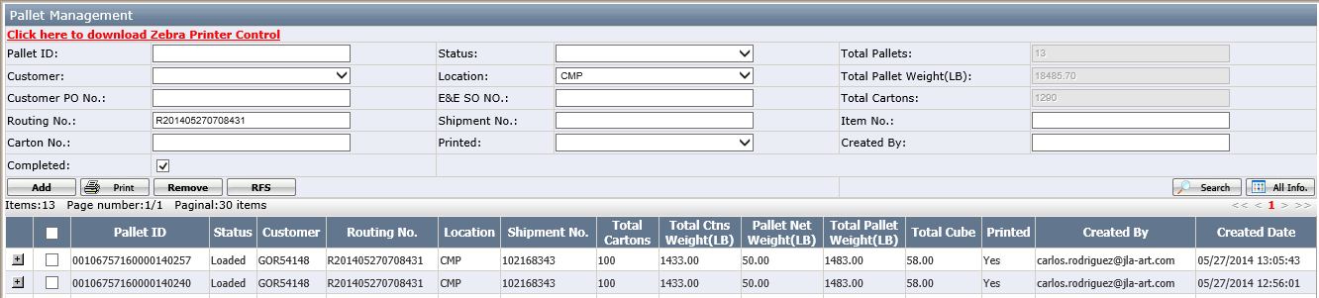
Button:
- <Add>: it is used to add carton to pallet.
- <Print> button: It is used to print out pallet.
- <Remove> button: it is used to remove the pallet or the carton had added into pallet.
- <RFS> button. This is used to remove pallet from shipment without delete the pallet information. Also, if the pallet status=loaded and click <RFS> button, the pallet status will be changed from loaded to open. When the pallet is open, the user can remove this pallet.
Notes: The pallet is created by wireless application (see <how to create pallet>)
- Click the add button to open “Add carton to pallet” page. In “Add Cartons to pallet” page, select the carton no and click <add> button. This carton will be added into the selected Pallet
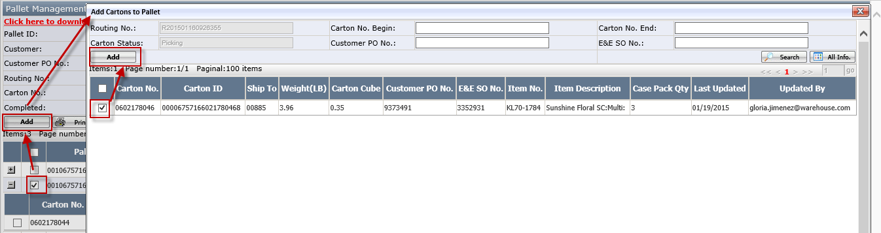
After adding cartons
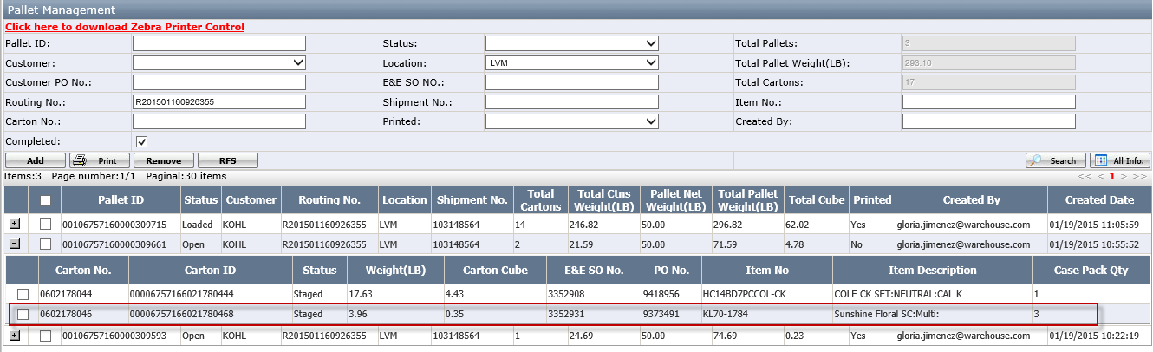

Status Description

Batch Status
Status | Description
Pending | When batch is created.
Released | Batch is released by distribution team, has generated carton information.
PL Created | When batch has generated at least one pick list.
Picking | When picker start to pick items with wireless application.
Transferred | When picker has picked all items in the batch, and transferred inventory to 000.
Completed | When all orders in the batch have finished Macola Post.

Routing Status
Status | Description
Open | No carton in the batch has been added to a routing sheet.
Routing | Parts of cartons in the batch have been added to a routing sheet.
Routed | All cartons in the batch have been added to a routing sheet.

Routing Sheet Status
Status | Description
Open | When routing sheet is automatically generated.
Routing | When part of the routing sheet has been added to shipment.
Routed | When the whole routing sheet has been added to shipment.

Pallet Status
Status | Description
Open | When pallet is built.
Loaded | When pallet has been loaded to truck.

Carton Status
Status | Description
Open | When carton is automatically generated.
Picking | When carton has been added to a routing sheet.
Staged | When carton has been added to a pallet (Not all cartons have this status).
Loaded | When carton has been loaded to truck.

Shipment Status
Status | Description
Open | When shipment header is created.
Routed | When a routing sheet has been added to shipment.
Loading | When part of cartons in the shipment have been loaded to truck.
Loaded | When all cartons in the shipment have been loaded to truck.
Completed | When load is completed and BOL has been printed.

Release Status
Status | Description (With Cancel Date) | Description (With In DC Date)
Future Orders | Shipping Date-Current Date>14 | In DC date-current date>=22
Release Required | Shipping Date-14 <= Current Date &  Current Date < Cancel Date | 1<=In DC date-current date<=21
Update Required | Current Date >=Cancel Date &  Total Quantity to ship >0 | Current date>=In DC date &  Total Quantity to ship >0
Cancel Required | Current Date >=Cancel Date &  Total Quantity to ship =0 | Current date>=In DC date &  Total Quantity to ship =0

