How to pick item by wireless application

Wireless picking process contains two main steps: 1. Load pick list to the scanner by scanning pick list barcode 2. Go to the bin loc. to transfer items by scanning bin loc. barcode.

Login WMS Picking
- Find wireless application named WMS Picking in wireless machine.
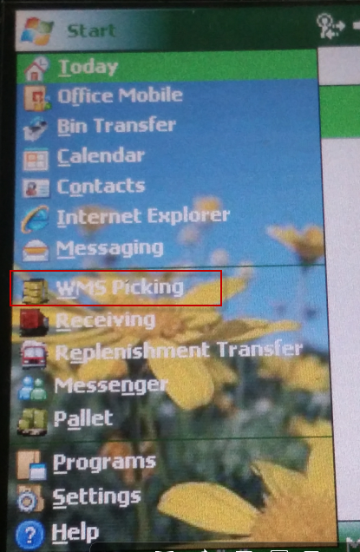
- Go to the log in page of this wireless picking application on scanner, see Fig. 3.1
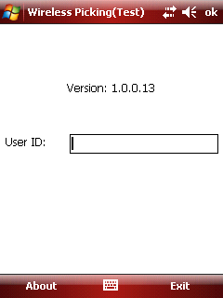
Fig. 3.1
Page Description:
- This page is used for picker log in.
Field:
- "User ID": Scan the user id barcode or enter User ID manually. The barcode could display in the field and system will verify the user authenticity.
Other:
- After the picker logs in, reload all the open items related to the picker if he does not finish all the transfer tasks last time.
Role:
- Warehouse staff with roles Warehouse Admin and Warehouse User could work on scanner.
After picker scan the user id barcode or enter user ID manually to logs in, pick list can be loaded into the scanner, see Fig. 3.2
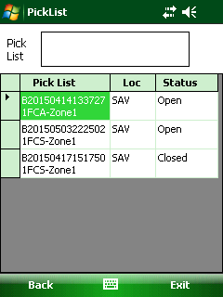
Fig. 3.2

Scan Pick List
Scan the pick list barcode in pick list paper, see below screenshot.
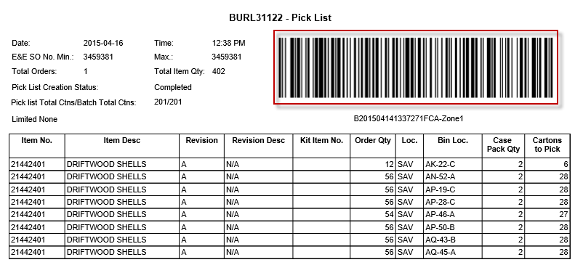
After that, the pick list will be scanned into wireless application and show in the grid as below:
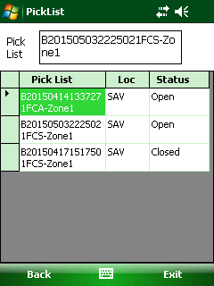
Fig. 3.3
Page Description:
- This page is used for scanning the pick list barcode and listing all the pick lists scanned.
Function Button:
- <Back>: Click to log out.
- <Exit>: Click to exit system.
Grid:
- "Pick List": This text field is used for storing the scanned pick list barcode, use two lines to display the stored pick list barcode in order to display completely. Barcode is encoded two parts: batch no. and its related zone to make it unique.
- "Status": If all the items in the pick list are transferred, the status will be "Closed" and it will be removed from the scanner the next day. Otherwise, it is "open".
Others:
- If the zone barcode the user is scanning that has been scanned by another picker before, pop up the warning message as "This pick list has been assigned to another user: XXX. Do you want to continue?", If the user clicks "Yes" to take over this pick list or click "No" to not to take over. XXX is the user name.
- After pick list is scanned, batch status will be changed to “Picking”.

View Item List
Double click the pick list (see fig 3.3) to open item list of this pick list, see Fig. 3.4
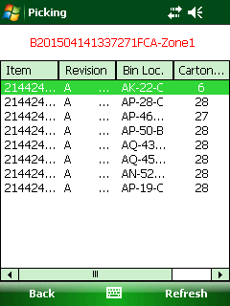
Fig. 3.4
Page Description:
- This page is used for listing all the items in the pick list that need picking
Function Button:
- <Back>: Return back to Fig. 3.3.
- <Refresh>: Refresh data manually.
Grid:
- Revision: if the item has revision, when scan the item, picker should be checked the revision information.
- Cartons to Pick: It is the qty that need transferring.
- Status: If the line item finishes transferring, the status will be "Closed". Otherwise, it will be "Open" or "Skipped" if it is skipped in transferring. Items in "Open" or "Skipped" status could both be transferred.
- Sort: Default sort by "Bin Loc.", and then by "Item".

Scan Item and enter Picked Qty
Select the item and enter picked Qty item picking page (see fig. 3.5)
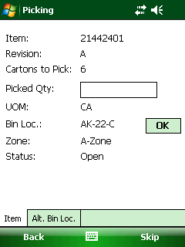
Fig. 3.5
Page Description:
- This page is used for displaying the item info that is going to be picked.
Function Button:
- <Back>: Return back to Fig. 3.4.
- <Skip>: if "Skip" is clicked, the status for the item will be "Skipped" on Fig. 3.4. If current item is skipped, display the next un-transferred "Open" item. If there is no "Open" item, display the next un-transferred "Skipped" item. This skip process is cyclic. If the picker wants to transfer item in other pick list, then "Back" to Fig. 3.3.
Header Field:
- "Qty to Pick" or "Cartons to Pick": It is the qty left that has not been transferred.
- "Picked Qty": It is the qty that is going to pick in this scanning.
- “Status”: show status of the item "Open/skipped".
TAB:
- <Item>: This tab displays the current item that is being transferring.
- <Alt. Bin Loc.>: Change to another bin location to transfer the item. If it is clicked, switch to Alt.Bin Loc (see Fig. 3.12)
Other
- "Picked Qty" could not be larger than "Qty to Pick". To prevent from unchecking the quantity, the number must be entered manually. "Picked Qty" should not be larger than "Qty to Pick", and could not be 0. If "Picked Qty" is larger than "Qty to Pick", pop up the message:” Qty to Transfer must be less than or equal to Qty to pick.” see Fig. 3.7
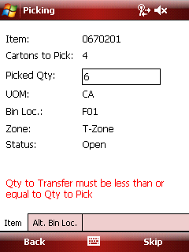
Fig. 3.7
- If a picker wants to partially scan for an item, it is allowed but the line item will be separated into multiple lines based the scan times. see Fig. 3.9 and Fig. 3.10

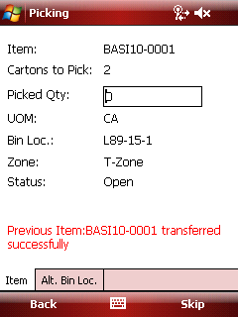
Fig. 3.9
Qty of 2 is transferred successfully and there is still 2 left. After this left two have been transferred successfully, we can see the line item has been separated into two lines, see Fig. 3.10
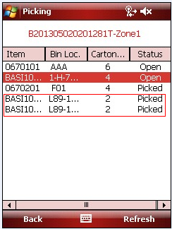
Fig. 3.10

Scan the Bin Loc.
After enter the picked Qty, the picker should scan the Bin Loc. Barcode. After that, the item is picked. See below.
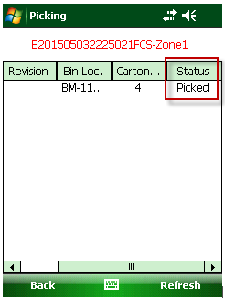
Please notes:
- If the bin loc. scanned is not the bin loc. on the screen, it will pop up message ”Incorrect Bin Loc.” see Fig. 3.6
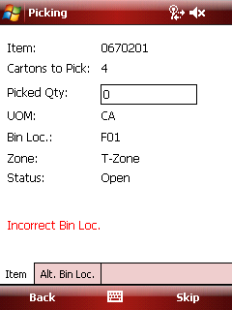
Fig. 3.6
- If the Bin Loc barcode is damaged, the picker can click <OK> button to pass the scanning bin Loc.
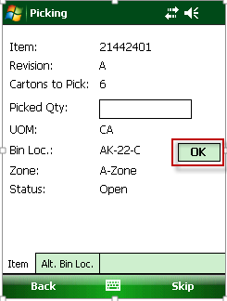

Alt. Bin Loc.
When the picker can’t find item in assigned Bin Loc., the picker can use Alt.Bin Loc. to replace the old bin loc.. Just click <Alt Bin Loc> tab
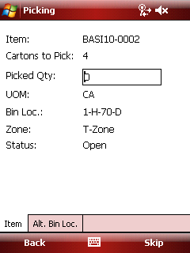
Fig. 3.11
Open the alter bin location for current item, see Fig. 3.12
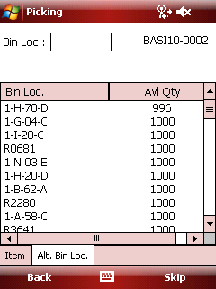
Fig. 3.12
Page Description:
- This page is used for altering bin loc. for the item to be transferred.
Field:
- "Bin Loc.": The picker could scan the bin loc. barcode on the rack directly instead of selecting bin loc. in the grid. If the scanned bin loc. does not exist in the grid, show a warning message "Wrong bin loc.". Otherwise, turn to "Item" tab and update the info. just like select bin loc. in the grid (to refer No. 5).
Grid:
- "Avl Qty": The available qty of the item in this bin loc. "Avail Qty" = "Qty On Hand" - "Qty in other transferring". "Qty in other transferring" means the qty of the item in the bin loc. in other previous transferring process and not completed yet.
- "Bin Loc.": If certain line is selected, turn back to "Item" tab and update the “Bin Loc.” and " Qty to Pick".
Select bin location “1-A-04-D” and turn to item tab automatically, see Fig. 3.13

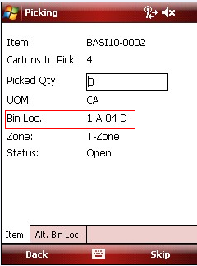
Fig. 3.13

Skip Item
Click <skip> button to skip item.
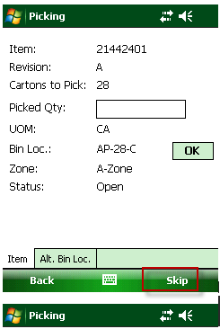
Fig. 3.14
"Skip" is clicked, display the next un-transferred item (Firstly "Open" items, and then "Skipped" items). “Skipped” items will be transferred later than “Open” items by system automatically. Check the item status on item list page, see Fig. 3.15
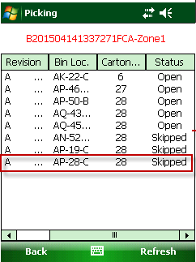
Fig. 3.15

Transfer Complete
When all items are picked, the pick list status will change from open to closed after the background service” Macola Inventory transfer” has operated.
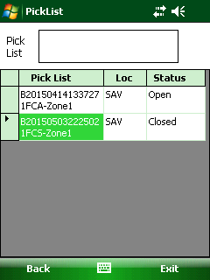

At the same time, the batch status will be “Transferred” in EEC system.
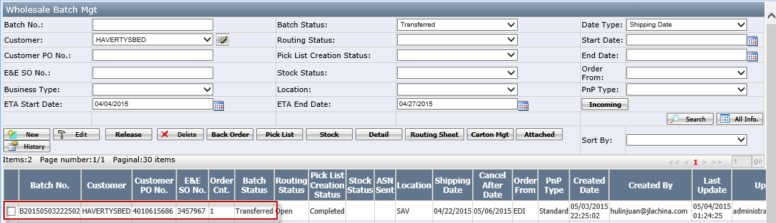

Other Issue

Take Over Pick List
The new user just scans the pick list which has been scanned by the other user.
It will pop up the warning message as "This pick list is assigned to another user: XXX. Do you want to continue?"
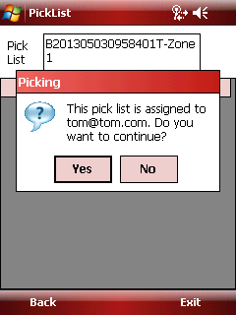
Fig. 3.16
If the new user clicks "Yes", the pick list will be reassigned to this new user. Fig. 3.17 shows the original picker has only one pick list left. Click no to cancel it.
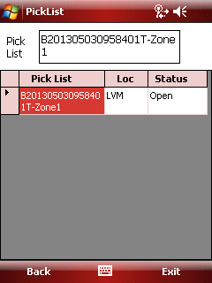
Fig. 3.17

