How to pick item by WMS Picking
- Find wireless application named WMS Picking in wireless machine, click it to log in wireless picking application, see Fig. 3.1
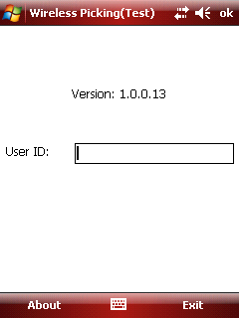
Fig. 3.1
- User ID: Scan the user id barcode or enter User ID manually. The barcode could display in the field and system will verify the user authority.
- Role: Warehouse Admin and Warehouse User could work on scanner.
- After picker scan the user id barcode or enter user ID manually to logs in, pick list which assigned this picker will be list in the grid. see Fig. 3.2
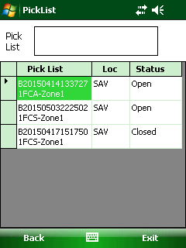
Fig. 3.2
- Scan the pick list barcode in pick list paper, see below screenshot.
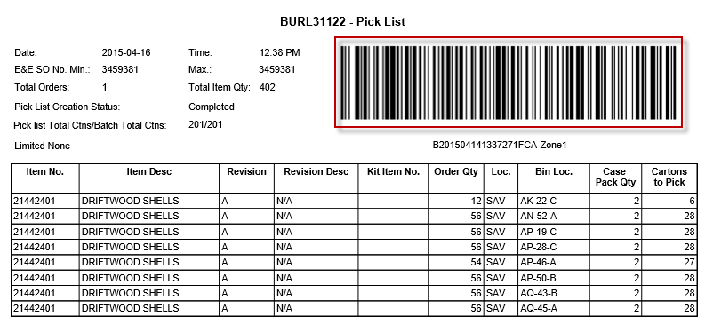
- After that, the pick list will be scanned into wireless application and show in the grid as below. This page is used for scanning the pick list barcode and listing all the pick lists scanned.
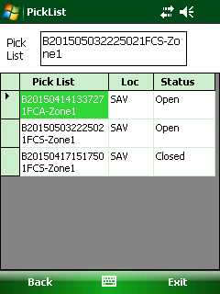
Fig. 3.3
Button:
- Back: Click to go to previous page.
- Exit: Click to exit system.
Grid:
- Pick List: This text field is used for storing the scanned pick list barcode. Barcode is encoded two parts: batch no. and its related zone to make it unique.
- Status: If all the items in the pick list are transferred, the status will be "Closed" and it will be removed from the scanner the next day. Otherwise, it is "open".
Notes:
If the pick list barcode which user is scanning that has been scanned by another picker before, pop up the warning message: "This pick list has been assigned to another user: XXX. Do you want to continue?", If the user clicks "Yes" to take over this pick list or click "No" to not to take over. XXX is the user name.

- Double click the pick list (see fig 3.3) to open item list of this pick list, see Fig. 3.4
This page is used for listing all the items in the pick list that need picking
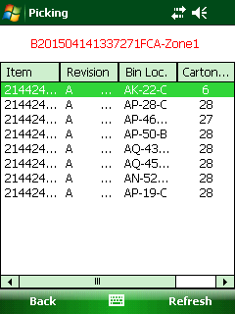
Fig. 3.4
Button:
- <Back>: Return back to Fig. 3.3.
- <Refresh>: Refresh data manually.
Grid: In the grid, the item default sort by bin loc., then sort by item no.
- Revision: if the item has revision, when scan the item, picker should be checked the revision information.
- Bin Loc: it is used to show bin no.
- Cartons to Pick: It is the qty that need transferring.
- Status: three options of status: open, skipped and closed.
Open: it means item need to picking.
Skipped: the item skipped it.
Closed: the item has been picked.
Notes: Items in "Open" or "Skipped" status both need to pick.

- Scan Item and enter Picked Qty.
Select the item and enter picked Qty item picking page (see fig. 3.5).
This page is used for displaying the item info that is going to be picked.
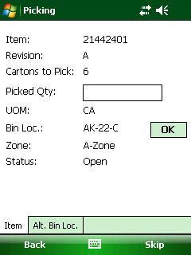
Fig. 3.5
Button:
- Skip: If "Skip" is clicked, the item status will be "Skipped". The detail see <skip item>
- Ok: if the bin barcode is damaged, use this button to replace scan bin no.
Field:
- Cartons to Pick: It is the qty left that has not been picked.
- Picked Qty: It is the qty that is going to pick. Picked Qty can’t be larger than "Qty to Pick" and also can’t be 0. If Picked Qty is larger than "Qty to Pick", it pop ups the message:” Qty to Transfer must be less than or equal to Qty to pick.”
TAB:
- Item: This tab displays the current item that is being transferring.
- Alt. Bin Loc.: Change to another bin location to transfer the item. If it is clicked, switch to Alt.Bin Loc (see Fig. 3.12)
Other
- If a picker wants to partially scan for an item, it is allowed but the line item will be separated into multiple lines based the scan times. see Fig. 3.9 and Fig. 3.10

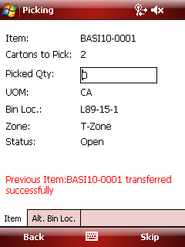
Fig. 3.9
Qty of 2 is transferred successfully and there is still 2 left. After this left two have been transferred successfully, we can see the line item has been separated into two lines, see Fig. 3.10
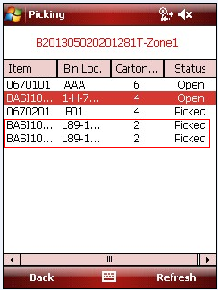
Fig. 3.10

- Scan the Bin Loc.
After enter the picked Qty, the picker should scan the Bin Loc. Barcode. After that, the item is picked successfully. Then repeat the process to pick all items.
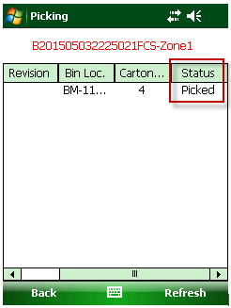
Notes:
- If the bin loc. scanned is not the bin loc. on the screen, It will pop up message: ”Incorrect Bin Loc.”
- If the picker can’t find item in assigned Bin Loc., the picker can use Alt.Bin Loc. to replace the old bin loc., the detail see <Alt.Bin loc.>tab.
- If the Bin Loc barcode is damaged, the picker can click <OK> button to pass the scanning bin Loc.
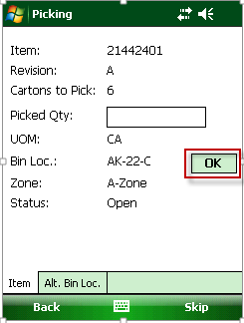

- When all items are picked, the pick list status will change from open to closed after the background service” Macola Inventory transfer” has operated.
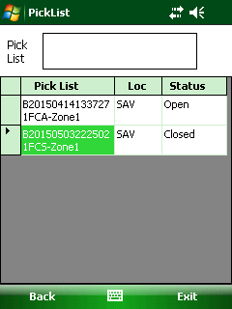

At the same time, the batch status will be “Transferred” in EEC system.
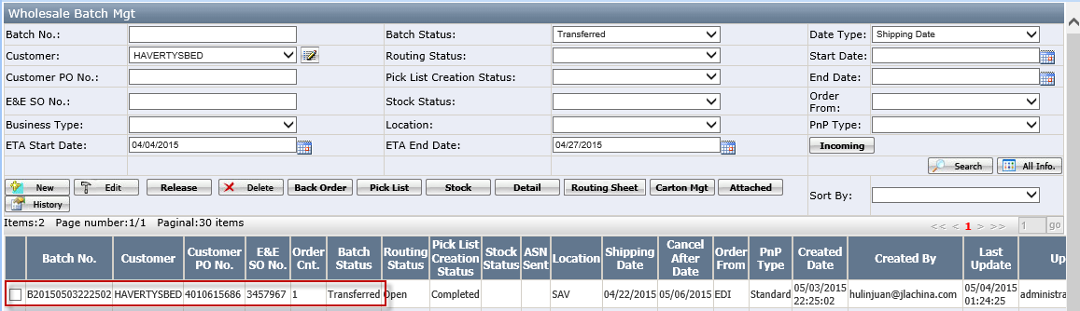

Skip Item
- In picking page, there is the <skip> button to skip item.
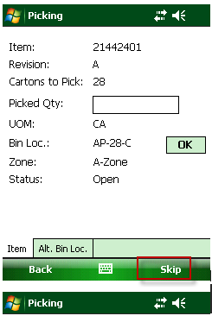
Fig. 3.14
- Skipped items will be transferred later than “Open” items by system automatically. Check the item status on item list page, see Fig. 3.15. All the skipped item will put the last lines. If current item is skipped, display the next un-transferred "Open" item. If there is no "Open" item, display the next un-transferred "Skipped" item. This skip process is cyclic
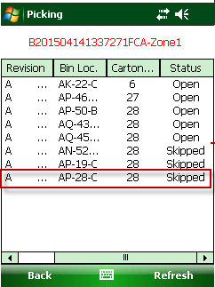
Fig. 3.15

Alt. Bin Loc.
When the picker can’t find item in assigned Bin Loc., the picker can use Alt.Bin Loc. to replace the old bin loc.
- Click <Alt Bin Loc> tab
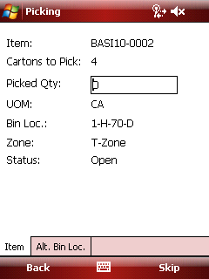
Fig. 3.11

- Open the alter bin location for current item, see Fig. 3.12
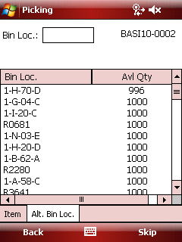
Fig. 3.12
Field:
- Bin Loc.: The picker could scan the bin loc. barcode directly instead of selecting bin loc. in the grid. If the scanned bin loc. does not exist in the grid, show a warning message "Wrong bin loc.". Otherwise, turn to "Item" tab and update the info.
Grid:
- Avl Qty: The available qty of the item in this bin loc.
- Bin Loc.: It is showing the bin no which this item.
- Select bin Loc.such as “1-A-04-D” and turn to item tab automatically, see Fig. 3.13.
Then follow the same step to pick this item.
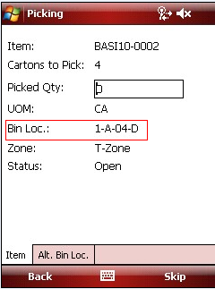
Fig. 3.13

Take Over Pick List
The new user just scans the pick list which has been scanned by the other user.
It will pop up the warning message as "This pick list is assigned to another user: XXX. Do you want to continue?"
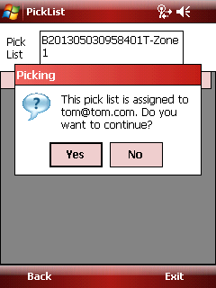
Fig. 3.16
If the new user clicks "Yes", the pick list will be reassigned to this new user. Fig. 3.17 shows the original picker has only one pick list left. Click no to cancel it.
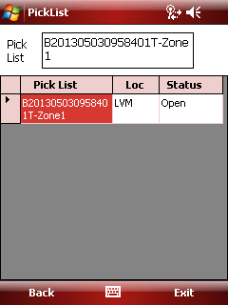
Fig. 3.17

