How to generate pick List

Generate Pick list rules
There are four different ways to generate the pick list
- Generate pick list by batch
It is standard way to generate the pick list. The pick list is based on batch. The detail operation is to see <how to generate pick list-Standard>
- Generate pick list by Items
In this way, in customer profile page, the “Partial Order Pick List Allowed” should be checked. It means that system allow to generate pick list for items have enough inventory first in one order. For example order xxx with four items. If item1 has enough inventory, the other three items has not enough inventory, it is allowed to generate pick list for item1.
The other operation refers to <how to generate pick list-Standard>
- Generate pick list by Routing.
In this way, in customer profile page, the “Partial Order Pick List Allowed” should be checked and also, the batch’s routing sheet should be generated.
When generate the pick list, it has to select the routing sheet first as below:
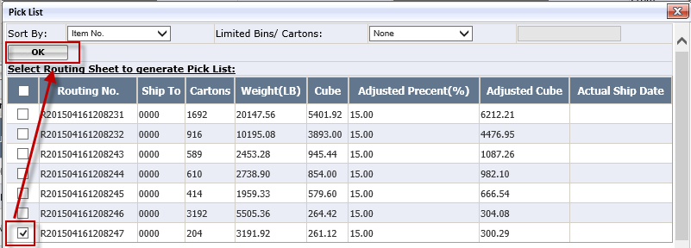
The other issues are same to generate standard pick list
- Generate pick list by Customer po.
In this way, in customer profile page, the “Pick by customer order” should be checked. It means to generate pick list based on customer order, one customer order will be one pick list. It is used by Walmart customer only at present.

Notes: If “Partial Order Pick List Allowed” and “Pick by customer order” both checked in customer profile, it means to generate pick list based on customer order and also it allows to generate pick list for item with enough inventories.

How to generate pick list-Standard
- Select the batch and click <pick list> to generate pick list
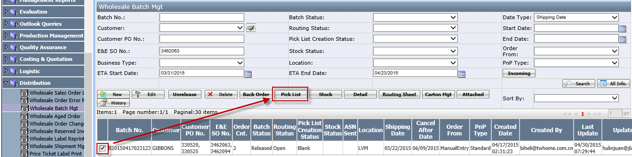
Notes: before generating pick list, the batch status=released and pick list creation stations=blank.
- Then, open below pick list page
- Sort by: it is used to determine the pick list sorting. Two options: item no and Bin Loc.
Sort by=item no, it means each pick list sort by item no;
Sort by=Bin Loc. It means each pick list sort by bin no.
- Limited Bins/Cartons: it is used to determine how many pick list will be generated.
For example: Limited bins/Cartons=Bins and 5, it means each pick list shows 5 bins.
Limited bins/Carton=Cartons and 50, it means each pick list show 50 cartons. But if one item carton exceed 50 ctns, It wouldn’t split and will stay in one pick list.
See below samples:
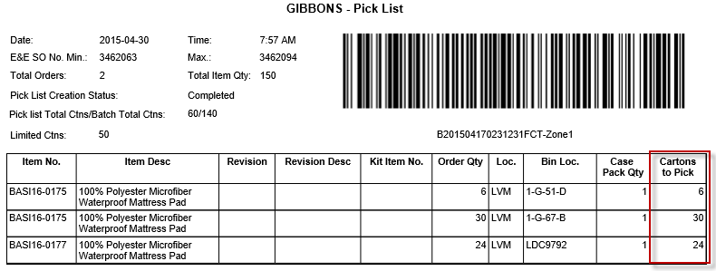
6+30+24>50 but the last 24 items belongs to one item, so it will Not split.
- Click <Ok> to generate pick list successfully. After that, Go to wholesale Batch Mgt page, the batch status will be PL Created and pick list creation stations=completed.

How to delete generate pick list

Delete pick list which item has picked
1. Select the pick list and click <Delete> button.
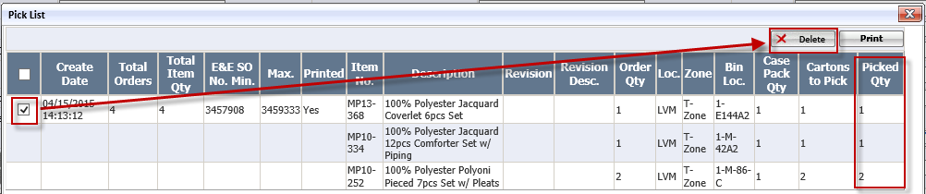
If the pick list has picked, It will pop up below message:
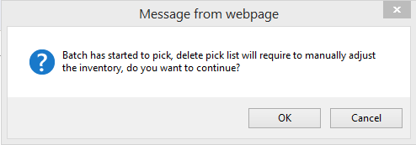
Click<ok> to delete the pick list. In this case, after delete the pick list, the user have to return back to inventories manually.
Notes: delete pick list is to delete whole pick list. It is not allowed to delete parts of picked item from pick list.

Delete pick list without picked
- If the pick list is not picked, just click <Delete> to delete it:
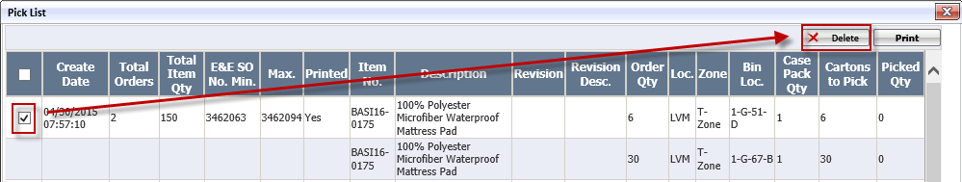
- After the pick list is deleted, the column will be change to blank

