How to build pallet
- Find the “ pallet” application in wireless machine and click it into log in page
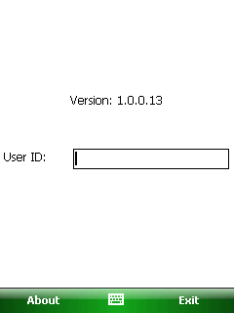
- Scan user id barcode or enter User ID manually to log in:
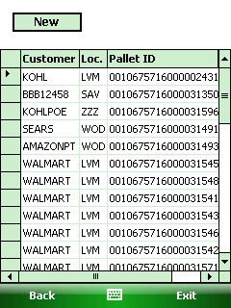
[Pict-2]
- New : It is used to create a new pallet
- Back: go back to previously page.
- Exit: It is to exit the pallet application

- Click <New> button in pic-2 and enter pallet detail page
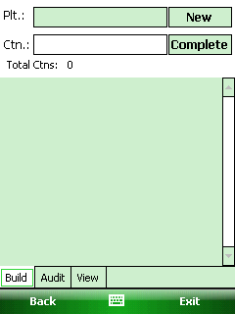
[Pict-3]
Button:
- New: click it is used to generate pallet Id
- Complete: it is used to complete the pallet.
Tabs:
- Build tab: this page is used to build pallet. see Pict-3
- Audit tab: this page is used to check to pallet information. Detail see<Audit tab>
- View tab: this page is used to review the pallet information. Detail see<View tab>
- Scan the carton barcode on carton label
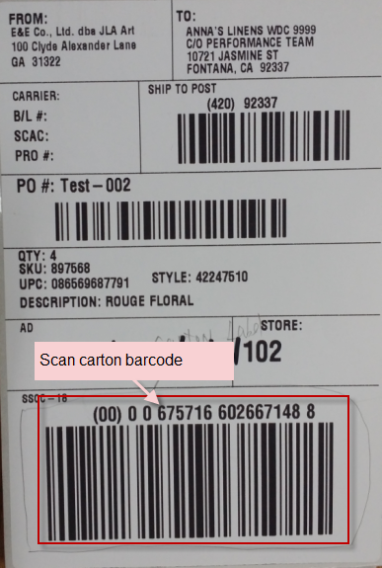
Then one carton will add into this pallet.
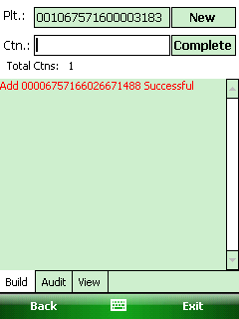
- Repeat to scan the carton label until all carton added into this pallet.
After all carton added into this pallet, click<complete> button to print out the pallet label. Then the pallet built successfully.

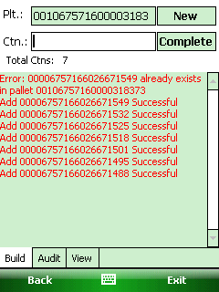
Notes: If the scanned carton existed in this pallet already, it will pop up message:” xxx already existed in pallet.

Audit tab
Audit tab is used to check to pallet information.
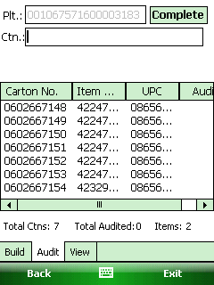
Complete: this button is the same function in build tab.

View tab
View tab is used to review the pallet. Scan the pallet barcode to review it.
