Customer Profile –Logistics Manual

Customer Profile Logistics Tab
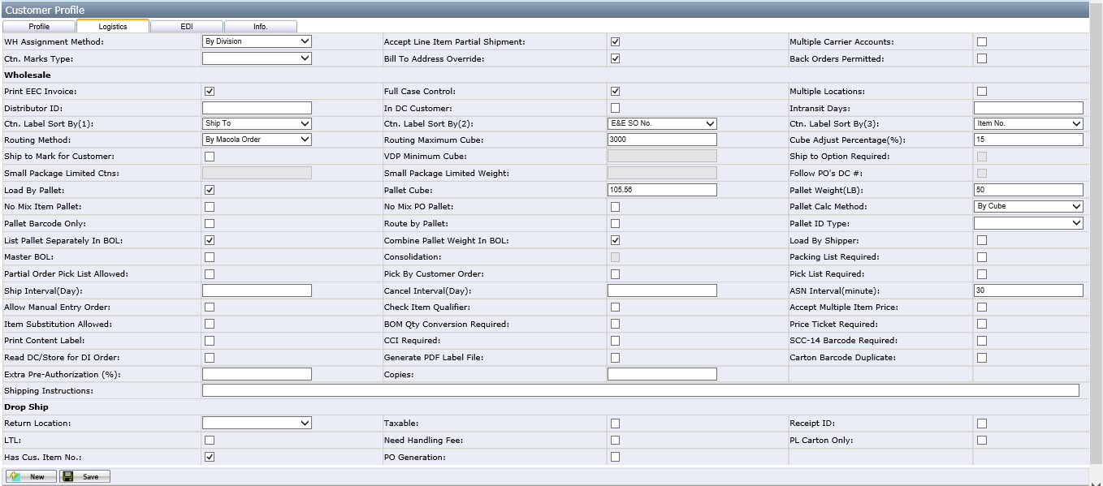
- WH Assignment Method: Decide how to get line item ship from location during validation step.
- By Item: Get location from Item master page customer item location.
- By Store: Get location from customer store address location.
- By Customer: Get location from this customer Loc. on the customer profile page.(The Loc. button will be appear after you checked “By Customer”).
- By division: Get division from Item master page, then get the location according to Division Location page.
- By Ship to State: Get the location from state’s location on State webpage.
- Accept Line Item Partial Shipment: This allows a line item to be shipped with less than quantity ordered. Default is Yes (checked).
- Ctn. Marks Type: Selects whether or not a customer requires a UCC-128 style label on all cartons. Default is blank (No)
- Bill To Address Override: If this button is checked, when orders upload to Macola, the Macola order’s bill to will be read the customer profile’s bill to instead of customer order’s bill to. Default is blank (No).
- Multiple Carrier Accounts: If this is checked, the customer could use multiple carrier accounts for different ship methods from one same location. Default is unchecked(No).
- Back Orders Permitted: Used to decide customer support back order or not. Default is unchecked (No).

Wholesale:
- Payment Condition: This field is used to set payment term for customer, this payment term will be used in EDI 810 file. Default is blank.
- Full Case Control: If it's checked, customer's order must be full case, otherwise order cannot pass the validation step. Default is checked.
- Multiple Locations: If it's unchecked, customer order must have the same location for one DC/Store, otherwise order cannot pass the validation step and pop up error. If it is checked, it allows different location for one DC/Store, but when passing the validation step, it still pops up the message to tell user. Default is unchecked.
- Distributor ID: It is used to generate UCC-128 carton barcode, default is blank.
The blank means the carton barcode is our company. If the barcode is from customer, the barcode data should be entered to this textbox.
- In DC Customer: If it's checked, system will use in DC date to calculate Macola order shipping date, order release status and batch shipping date.
- Intransit Days: This will be used to calculate shipping date, only allow to input integer, default is 8.
- Ctn. Label Sort By (1, 2, 3): This will used to decide the print sequence when print carton labels. Default sort by carton no.
- Routing Method: Decide the way to generate routing sheet.
- By Macola Order: This is the default option, when generating routing sheet, cannot split Macola order, one Macola order must in one routing sheet.
- By Item no: When generating routing sheet, cannot split line item, one order line item must in one routing sheet.
- By Ship To: When generating routing sheet, can split order, line item to different routing sheet based on ship to DC/Store No..
- One PO One Routing Sheet: When generating routing sheet, each Macola Order will generate a separate routing sheet.
- Routing Maximum Cube: It's the maximum cube for each routing sheet, used in routing sheet generation logic. Default is 3000.
- Cube Adjust Percentage: This will be used to calculate adjusted carton cube when generate routing sheet. Default is 15%.
- Load by Pallet: If it's checked, system allow to load pallet to truck. Default is checked (Yes).
- Pallet ID Type: This field is used to decide the way to generate pallet ID. There are two options: UCC-128 and Blank. The default is blank.
This button is only enable when Load by Pallet is checked.
- Pallet Cube: This is used to calculate routing sheet estimated pallet count in advance. Only enable when Load by Pallet is checked. Default pallet size is 40*48*95 inch, cube feet is 105.56.
- Pallet Weight (LB): Default is set at 50.00#
- No Mix Pallet: If it's checked, pallet can't have cartons with different item number. Only enable when Load by Pallet is checked. Default is unchecked (No).
- No Mix PO Pallet: If it’s checked, pallet can’t have cartons from different customer PO. Only enable when Load by Pallet is checked. Default is unchecked (No).
- List Pallet Separately in BOL: If this is checked, system will display pallet information separately in BOL. Default is checked (Yes).
- Combine Pallet Weight in BOL: if this is checked, system will add pallet’s weight to total weight in BOL. Default is unchecked (No).
- Pick List Required: If it's checked, user only allows to print out carton label that has generated pick list. Default is unchecked (No).
- Master BOL: If this is checked, customer allows to create master BOL and wireless application will print out Master BOL when the last BOL is printed. Default is unchecked (No).
- Consolidation: If it unchecked, all BOL must have the same ship to when create MBOL, else user needs to select ship to for MBOL, only available when Master BOL is checked, Default is unchecked (No).
- Packing List Required: If this is checked, when print BOL will print BOL and packing list, otherwise will print BOL and shipment detail. Default is unchecked (No).
- Partial Order Pick List Allowed: if it’s checked, system allow to generate pick list for items have enough inventory first in one order. Default is unchecked (No).
- Pick By customer order: generate pick list based on customer order, one customer order will be one pick list. It is used by Walmart customer only at present.
- Allow Manual Entry Order: For non-manual entry customer,If it's checked, it means this customer is allowed to manually entry order too. The default is unchecked (No).
Notes: if the customer’s order from=ManualEntry, even doesn’t check this button, it also is allowed to manually entry order.
- Generate PDF Label File: If it's checked, when print carton label, system will generate PDF file with default carton label format. Default is unchecked (No).
- Ship to Mark for Customer: This is used when a customer has their orders shipped to a distribution center and marked for the store. Default is unchecked (No). at present, BBBCA12460 is checked.
- VDP Minimum Cube: Only enable when Ship to Mark for Customer is checked, When generate routing sheet, if the rest of cartons’ cube >= LTL Minimum Cube, Routing sheet will ship to DC, otherwise will ship to store. Default is blank (No).
Notes: VDP=vendor distribution Pool
- Ship to Option Required: This is only enable for ship to mark for customer. If this is checked, when generate routing sheet, system will popup ship to option page (see below screenshot) to let user select the ship to for routing sheet.
Otherwise system do not need to popup the ship to option page, default is unchecked (No).
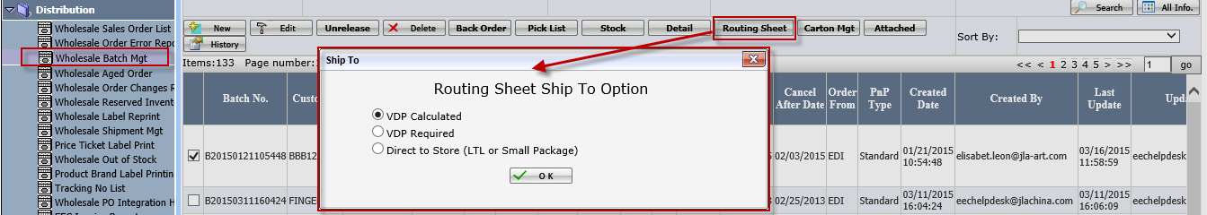
- VDP Calculated: this option means the calculation is based on VDP Minimum Cube setting value.
- VDP Required: It means whatever the cube will go to VDP.
- Direct to store: It means some orders will go to store, but the calculation is based on “Small package limited cnts/weight” configuration.
- Small package limited Cnts/Weight: This is only enable for ship to mark for customer. It is used to decide whether use LTL or small package ship method.
Notes：only the routing sheet ship to option= Direct to store, this field value will be used to decide whether use LTL or small package ship method.
- Follow Po’s DC#: This is only enable for ship to mark for customer.
When system generate the routing sheet, if this checkbox is checked, the ship to DC will be from Po’s DC#, if not checked, the ship to DC will be from customer profile’s DC address.
- Copies: This field is used to decide how many copies to print when print BOL and packing list. Only allow to input integer, default is 1.
- Check Item Qualifier: If this is checked, during item validation, system need to match customer item with the same item qualifier in EDI 850. Default is unchecked (No).
- Accept Multiple Item Price: If this is checked, the same customer item will have different price, and during validation step, system will check item price according to PO's freight term. Default is unchecked (No).
- Item Substitution Allowed: if it is checked, the item is allowed to substitute.
- Print Content Label: if it is checked, besides printed out the carton label, it also will print out content label.
- Read DC/Store for DI Order: If it is checked, customer’s address must maintain the DC/Store, otherwise, it will pop up error when validate the sale orders. If it is not checked, customer’s address must maintain “0000” store in customer profile.
- Extra Pre-Authorization(%): It is used for manual orders which paid by Credit card. Such orders will charge more money from customer. the percentage is based on this field.
- Carton barcode duplicated: UCC14 or SCC12, The carton barcode is allowed to duplicated. If it is checked, Built pallet wireless application will ask user to select Pos which you want to scan.
- Ship Interval(Day): It’s used to calculate batch release status. If the textbox is blank , then the Default Ship Interval(Day) = 14 days, for In DC Customer, default Ship Interval(Day) = 21 days. Default is blank.
- Cancel Interval(Day): It’s used to calculate batch release status. If the textbox is blank , then the default Cancel Interval(Day) = 0,for In DC Customer, default Cancel Interval(Day) = 0. Default is blank.
- ASN Interval(Minute): Amount of time after BOL is completed that the system transmits an ASN. Default is blank.
- Load by Shipper: If Load By Shipper is checked, when print BOL, automatically check the two checkbox "By Shipper" at the bottom of BOL (In Trailer load and Freight counted columns, the by shipper option will be checked). Default is unchecked (No).
- SCC-14 Barcode Required: If this is checked, when release batch, need to get UK from order line item to carton, if order line item does not have it, system need to generate scc-14 barcode for carton. Default is unchecked (No).
- Pallet Barcode Only: If this is checked, when print pallet label print pallet label only has barcode. Default is unchecked (No).
- Route by Pallet: this function is not done.
- Price ticket required: If this is checked, user will see print price ticket button on routing management page and carton management page to print price ticket. and validation service will need to get retail price from EDI 850 or customer item maintenance page. Default is unchecked (No).
- CCI Required: If this is checked, when print BOL, system will also print CANADA CUSTOMS INVOICE. Default is unchecked (No).
- BOM Qty Conversion Required: If this is checked, when read EDI 850, system need to convert BOM qty and price to master item's qty and price. Default is unchecked (No).
- Shipping instructions: Any special notes that need to be on every order. This is the static text display on customer BOL and MBOL special instructions field. Default is blank.

Drop Ship:
- Return Location: Select the location for the drop ship returns from consumers. Default is blank.
- Taxable: Is customer charged sales tax. Default is unchecked (No).
- Receipt ID: If this is checked, for this customer, you must scan the barcode in the Packing List after did the pack in Packing Station. So it’s force- print the Packing list operation. Default is unchecked (No).
- LTL: If this is checked, it indicate that the customer is support the LTL transportation. Default is unchecked (No).
- Need Handling Fee: If it is checked, system would check whether the order handling fee>0, if not, the order cannot pass validation. If it is unchecked, system would not add handling fee to order even the retail item has handing fee. Default is unchecked (No).
- PL Carton Only: If it is checked, only print the contents in related cartons when print Packing List in Packing Station or FC Docs. Default is unchecked (No).
- Have Cus. Item No.: If this is checked, it indicate the customer has its own item number. If this is unchecked, during the purchase order validation step, it’ll treat the item number as customer item number. Default is unchecked (No).
- PO Generation: whether the customer need to generate purchase order or not. Default is unchecked (No).

3rd Party Freight charge processing.
- If a customer wants the freight bill to go to another company please provide Name, Address and enter on the Info. Tab under customer Profile.

