E&E JLA Home
WMS Manual
Version: 1.0
11/15/2012

Contents
• How to process normal wholesale EDI orders? 4
1. Service auto read EDI orders 4
2. Service auto validate and upload orders 4
3. Create Batch 4
4. Release Batch 5
5. Generate Pick List 6
6. Generate Routing Sheet 7
7. Create Shipment 9
8. Assign Shipment to Truck Loader 11
9. Load Cartons/Pallets to Truck 12
10. Print BOL 12
11. Complete a Shipment 13
• How to deal with release failed issue? 14
• How to delete a batch? 16
• How to delete a routing Sheet? 17
• How to delete a pallet? 18
• How to delete a shipment? 20
• How to delete a carton from batch? 21
• How to delete a carton from routing Sheet? 22
• How to delete a carton from Pallet? 24
• How to delete a carton from Shipment? 26
• How to void shipping label? 27
• How to cancel order line item? 28
• How to cancel an order? 29
• How to change order line item quantity? 30
• How to unrelease a batch? 31
• How to view incoming items? 32
• How to hold a macola order? 33
• How to unhold a macola order? 34
• How to add carton to a loaded pallet? 35
• How to add carton to a routing sheet? 37
• How to combine multiple batches to the routing sheet? 39
• How to combine multiple routing sheets together? 40
• How to change Ship To for Ship to Mark For customer? 43
• How to create Master BOL? 47
• Status Description 49
❖ Batch Status 49
❖ Routing Status 49
❖ Routing Sheet Status 49
❖ Pallet Status 49
❖ Carton Status 49
❖ Shipment Status 50
❖ Release Status 50
• Page Introduction 51
❖ Wholesale Order Error Report 51
❖ Interchanges Outlook 53
❖ Interchanges Detail 54

WMS Manual
- How to process normal wholesale EDI orders?
- Service auto read EDI orders
Wholesale EDI orders would be read into EEC at regular intervals by EEC service. You could view them on Sales Order List webpage.
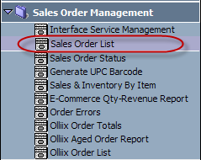
- Service auto validate and upload orders
EEC service would validate wholesale order, once it passes validation, EEC service would upload it to Macola.
- Create Batch
- Go to Wholesale Batch Mgt webpage.
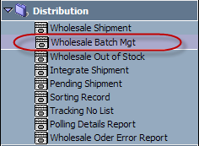
- Click <New> button.
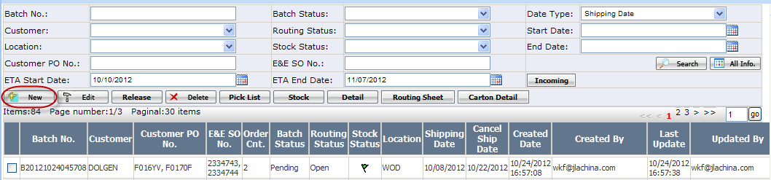
- On below pop up webpage, select a customer, a location, and choose Release Status as Release Required, then click <Search> button.
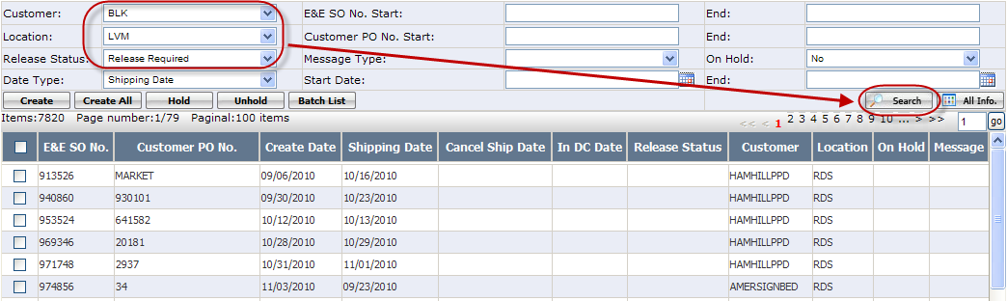
- Select macola orders that you want to create batch, click <Create> button.
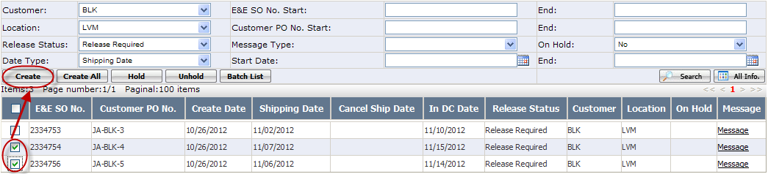
Once batch is created successfully, the new batch’s status is Pending.
****************************************************************************************************
Note: When create batch, the selected macola orders must have overlapped shipping window. And for in DC customer, all in DC date must be in the same week.
****************************************************************************************************
- Release Batch
Select the Pending batch, click <Release> button to release it.
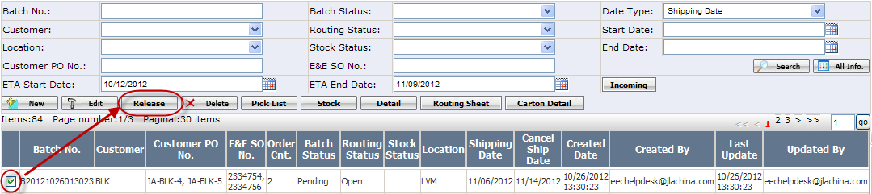
Once it is released successfully, the batch status will be changed to Released.
- Generate Pick List
- Select the Released batch, click <Pick List> button.
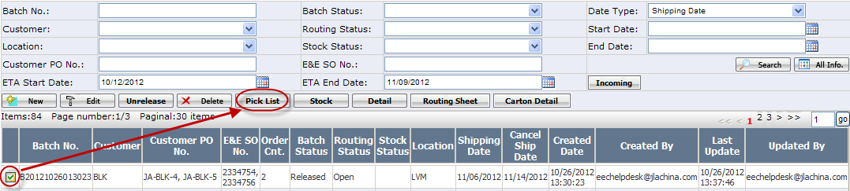
- You will see below pop up window, on which there are 2 options: Unlimited bins & Limited bins.
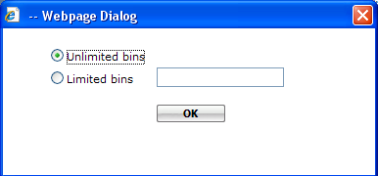

If you want to limit the number of bins in each printed pick list, select Limited bins, and enter the number of bins. Otherwise, just leave it as Unlimited bins.
Click <OK> button.
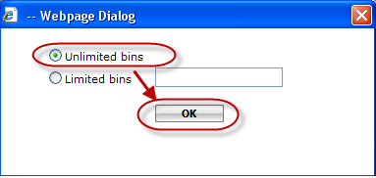
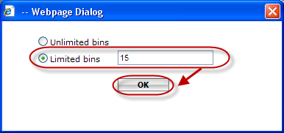

Or

- Print Pick List
Once pick list is successfully generated, you will see below pick list webpage. Select the pick list, click <Print> button to print out pick list.
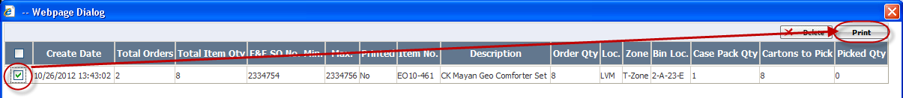
After pick list is generated, the batch status will be changed to PL Created.

- Generate Routing Sheet
- Select the batch, click <Routing Sheet> button.
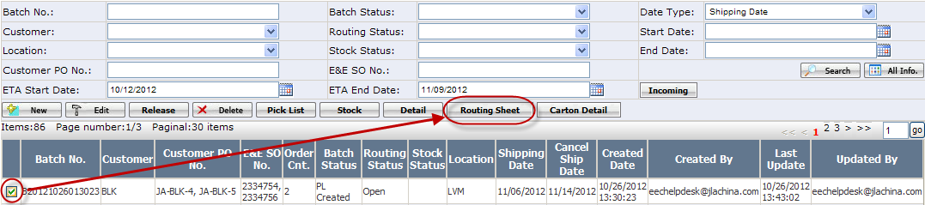
Once routing sheet is successfully generated, you will see below routing sheet list webpage.
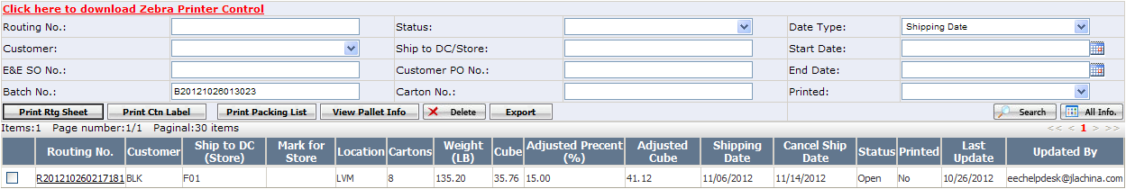
And the batch’s routing status will be changed to Routed.
- Print routing sheet
On routing sheet list webpage, select the routing sheet, click <Print Rtg Sheet> button.
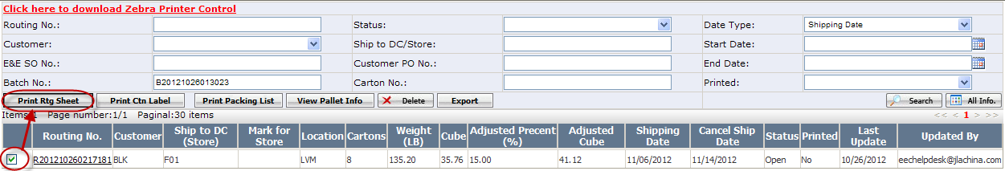
You will see below routing sheet which can be directly printed out.
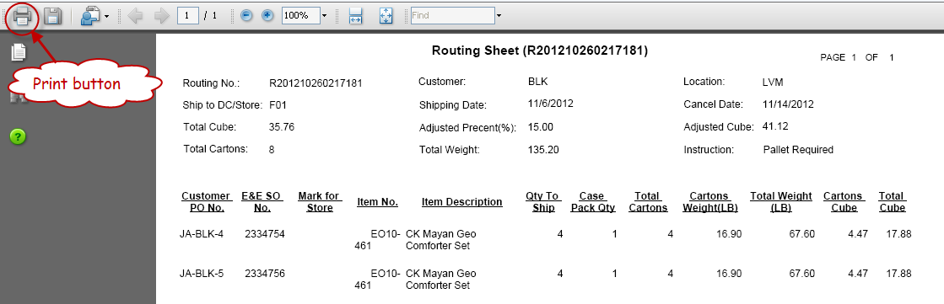
- Print carton label
On routing sheet list webpage, select the routing sheet, click <Print Ctn Label> button.
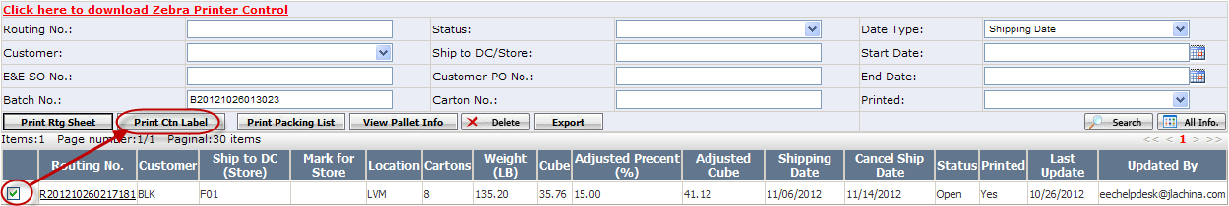
You will see below carton labels which can be directly printed out.
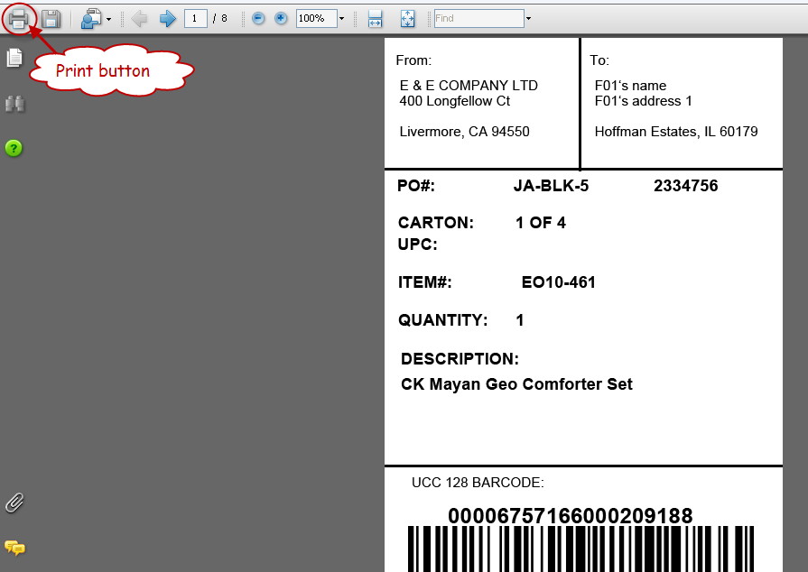
- Export routing sheet
On routing sheet list webpage, select the routing sheet, click <Export> button.
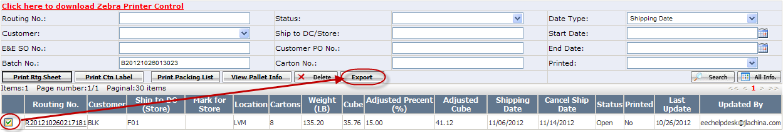
You will get below exported routing sheet.
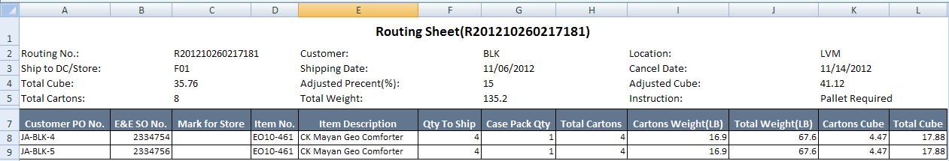

***************************************************************************************************Note: For different customers, the format of exported routing sheet might be different.
****************************************************************************************************
- Create Shipment
- Go to Wholesale Shipment webpage.
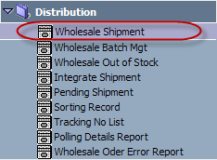
- Click <New> button.
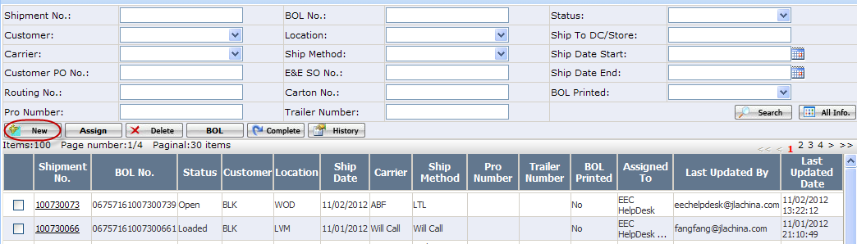
- On below pop up webpage, enter shipment header information and then click <Save> button.
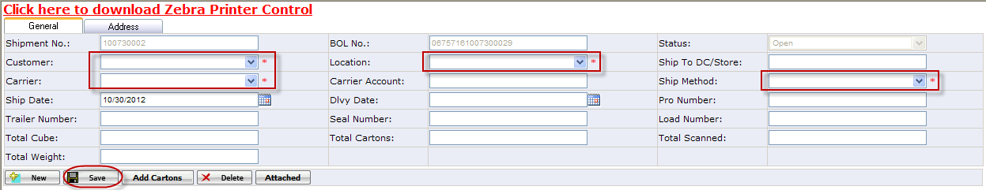
***************************************************************************************************
Note: Customer, Carrier, Location and Ship Method are required fields for creating a shipment header.
***************************************************************************************************
- Add cartons to shipment
After shipment header information is saved, click <Add Cartons> button.
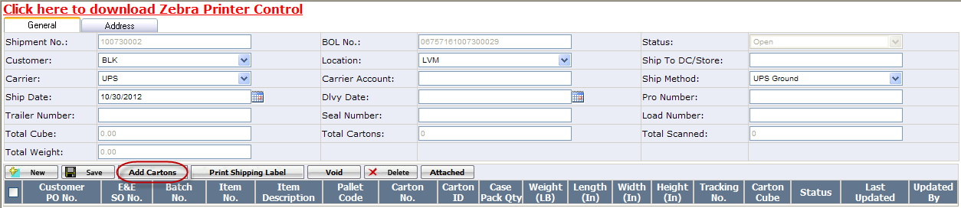
On the pop up window, select a Routing No. that you need to add to the shipment. When a routing number is selected, you will see all cartons that belong to the routing sheet.
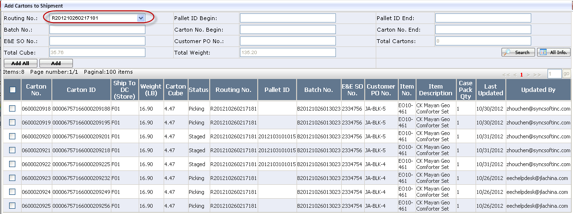
Select cartons you need to add to the shipment, click <Add> button.
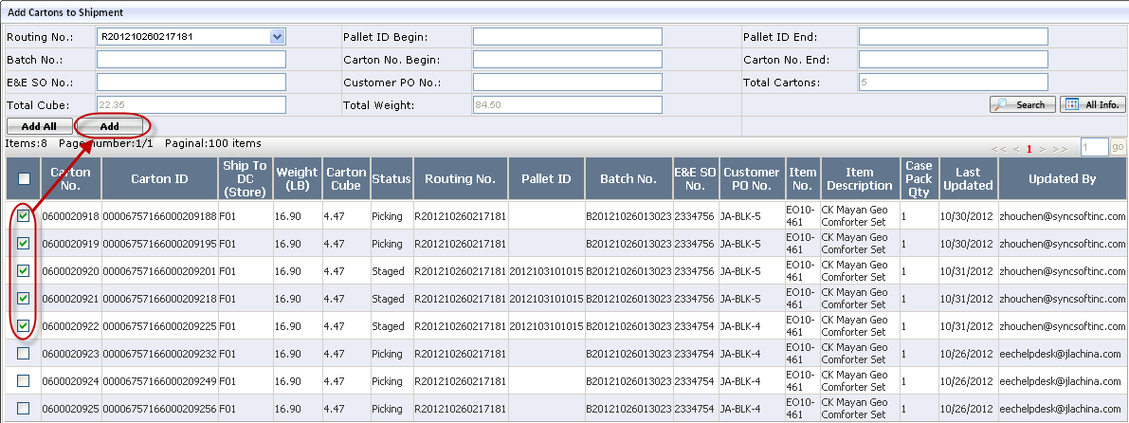

After cartons are added to shipment, EEC will switch back to below shipment detail webpage, and now, the shipment status will be changed to Routed.
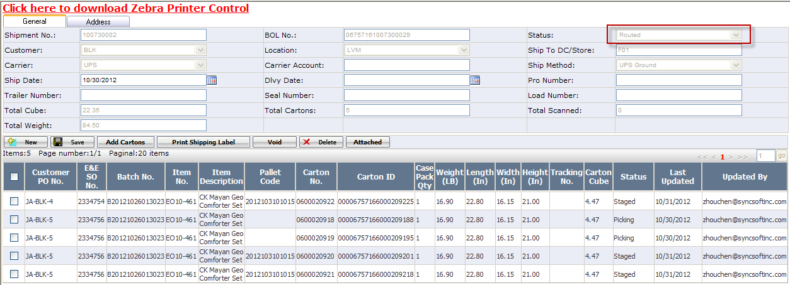
- Print Shipping Label
If the shipment carrier is UPS or FedEx, you shall print shipping label.
Select cartons you need to print shipping label, click < Print Shipping Label > button.
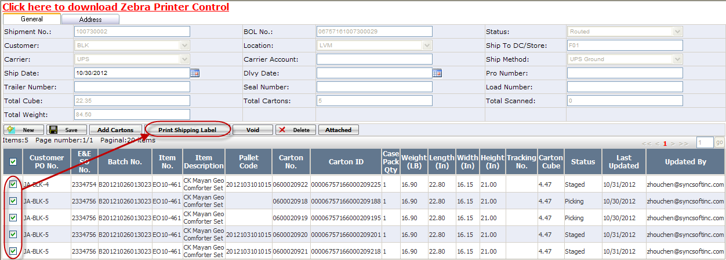
- Assign Shipment to Truck Loader
- Select the shipment (Status: Routed), click <Assign> button.
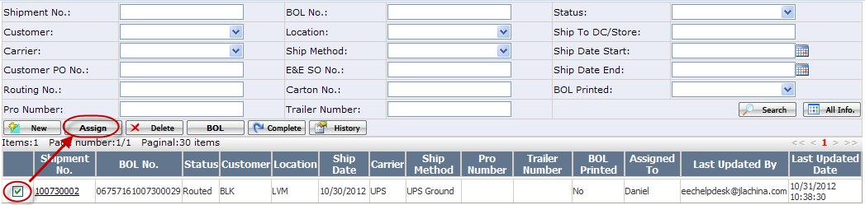
- On below pop up window, select one or multiple truck loaders, click <Assign> button.
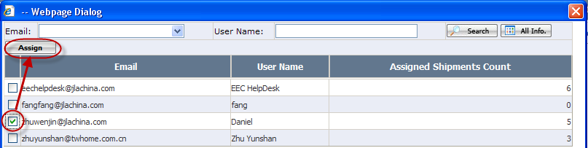
- Load Cartons/Pallets to Truck
- Print BOL
Select the shipment that you need to print BOL, click <BOL> button.
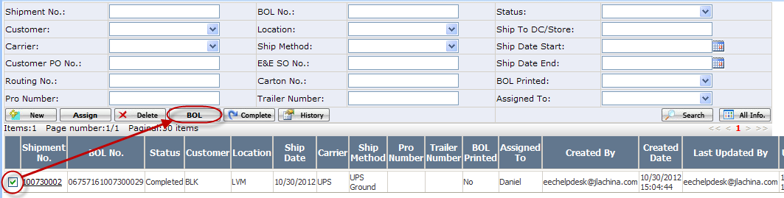
Then you will see shipment detail on below pop up webpage.
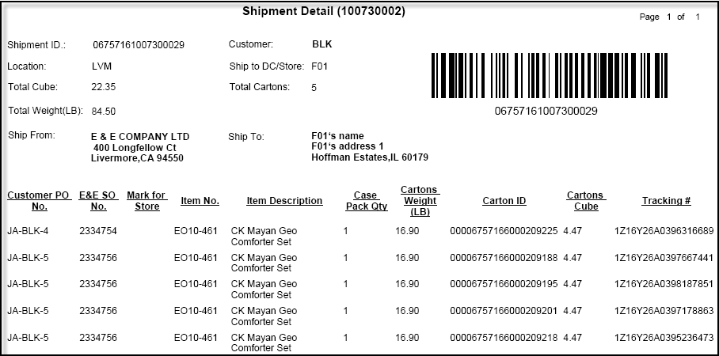
***********************************************************************************************
Note:
- If shipment status is Open or Routed, the BOL cannot be printed.
- If shipment status is Loading, the BOL would only show cartons that have been loaded to truck.
- If a shipment carrier is LTL or TL, besides above shipment detail, the Bill Of Lading would also be printed out.
***********************************************************************************************
- Complete a Shipment
Select the shipment that you need to complete, click <Complete> button.
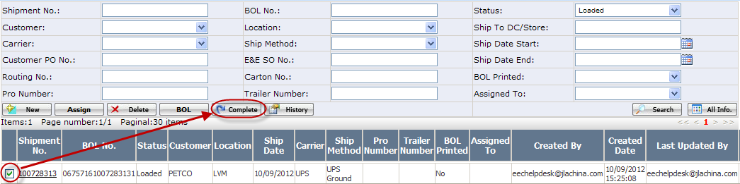
Once the shipment is successfully completed, its status would be changed to Completed.
************************************************************************************************
Note:
- If a shipment status is not Loaded, it cannot be completed.
- Only ‘Shipment Admin’ is able to complete a loaded shipment.
************************************************************************************************

- How to deal with release failed issue?
Sometimes, batch might fail to be released because inventory is insufficient. You will see below message:
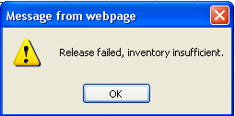
In this case, a flag would show for this batch to indicate it is out of stock.
Then, Distribution Team has to check the inventory, and edit the batch depending on different situations.
- Select the out of stock batch, click <Stock> button.
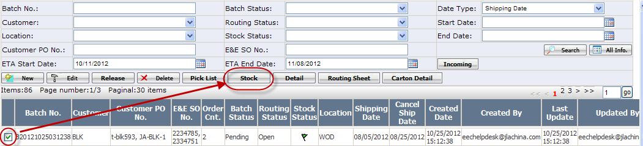
A inventory report will show, on which you can check the Qty Short of each item in this batch.
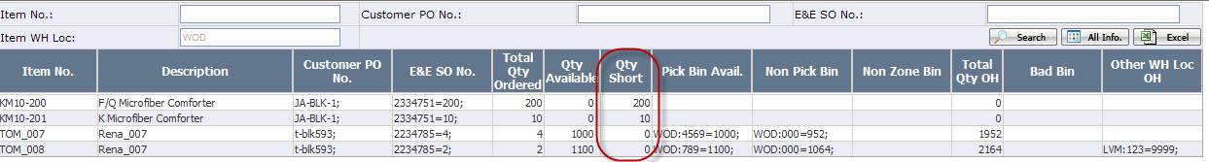
- Go back to batch list. Select the out of stock batch, click <Edit> button.
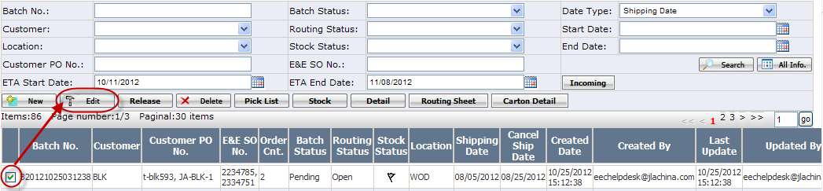
On the pop up webpage, you can see which macola order(s) is out of stock.
If you want to remove the out of stock macola order from the batch, just select it and click <Delete> button.
If you want to zero out out of stock items, click <Detail> button.
On below pop up webpage, you can see a dropdown list called Out Of Stock，select option Yes, and click <Search> button. Then all out of stock items in this batch will be searched out.
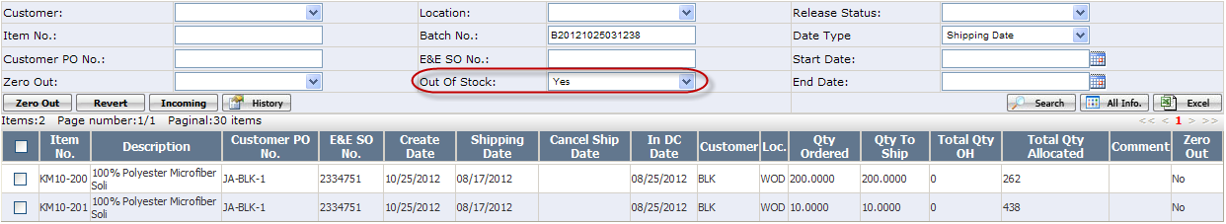
Select the item that needs to be zeroed out, click <Zero Out> button.
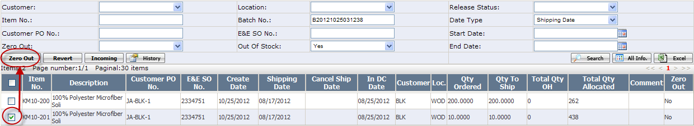

- How to delete a batch?
- Go to Wholesale Batch Mgt webpage.
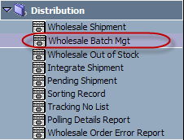
- Search out the batch which you need to delete, select it, and then click <Delete> button.
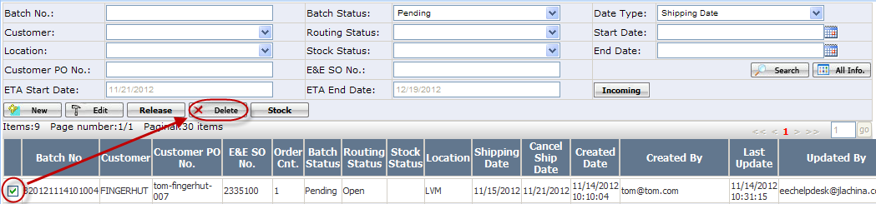
Once the batch is successfully deleted, it would be removed from the batch list.
************************************************************************************************
Note:
- If a batch status is not Pending, it cannot be deleted.
- ‘Distr-DM’ or ‘Distr-VP’ is able to delete all Pending batches, other distribution team users are only able to delete Pending batches that created by him/her-self.
************************************************************************************************

- How to delete a routing Sheet?
- Go to Wholesale Batch Mgt webpage.
- Search out the batch that you would delete routing sheet from, select it, and then click <Routing Sheet> button.
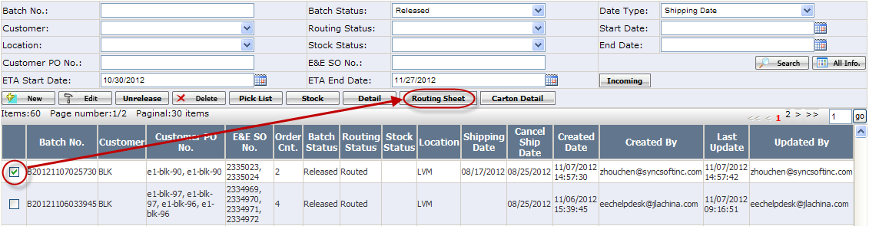
- On below pop up routing sheet list webpage, select the routing sheet that you want to delete, click <Delete> button.
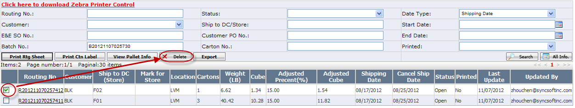
Once it is successfully deleted, it would be removed from the routing sheet list webpage.
************************************************************************************************
Note:
- If a routing sheet has been built pallet, it cannot be deleted.
- If a routing sheet status is Shipping or Shipped, namely the routing sheet has been built shipment, it cannot be deleted.
- ‘Routing Sheet Admin’ is able to delete all Open routing sheets, other warehouse users are only able to delete Open routing sheet that created by him/her-self.

- How to delete a pallet?
- Go to Wholesale Batch Mgt webpage.
- Search out the batch that the pallet belongs to.
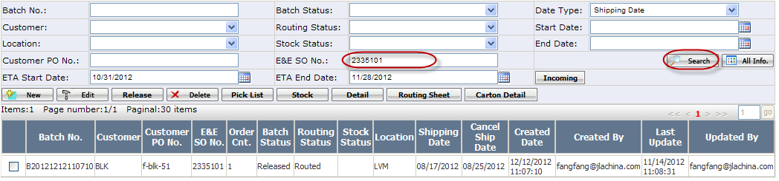
- Select the batch, click <Routing Sheet> button.
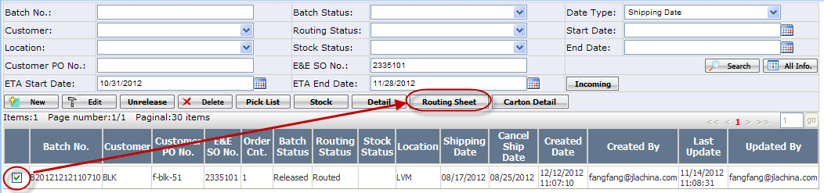
- On the pop up routing sheet list webpage, select the routing sheet that the pallet belongs to, click <View Pallet Info> button.
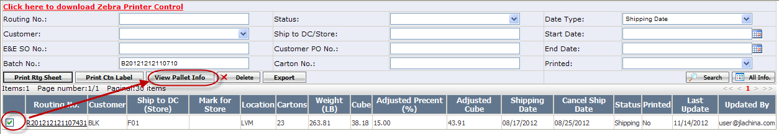
- On the pop up pallet list webpage, select the pallet you need to delete, click <Delete> button. 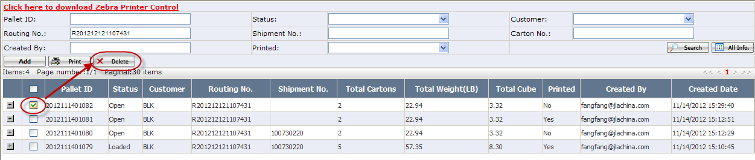
Once it is successfully deleted, it would be removed from the pallet list webpage.
************************************************************************************************
Note:
- If a pallet status is not Open, it cannot be deleted.
- If any carton in the pallet has been added to shipment, it cannot be deleted.
************************************************************************************************
- How to delete a shipment?
- Go to Wholesale Shipment webpage.
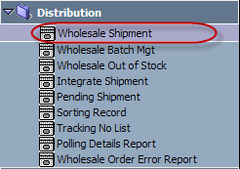
- Search out the shipment that you need to delete, select it, click <Delete> button.
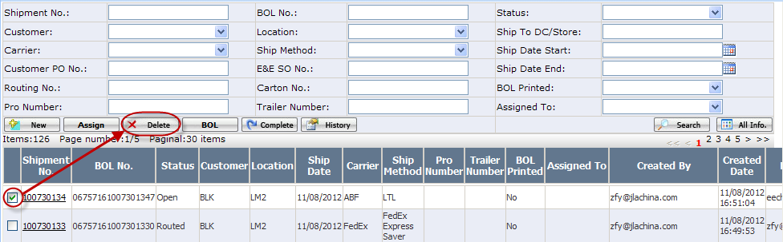
Once the shipment is successfully deleted, it would be removed from the shipment list.
*********************************************************************************************
Note:
- If a shipment status is Loading, or Loaded, or Completed, it cannot be deleted.
- If a shipment has been printed shipping label, it cannot be deleted.
- ‘Shipment Admin’ is able to delete all shipments that allowed to be deleted, other warehouse users are only able to delete shipments that allowed to be deleted and created by him/her-self.
*********************************************************************************************

- How to delete a carton from batch?
- Go to Wholesale Batch Mgt webpage.
- Search out the batch that you would delete carton from, select it, click <Carton Detail> button.
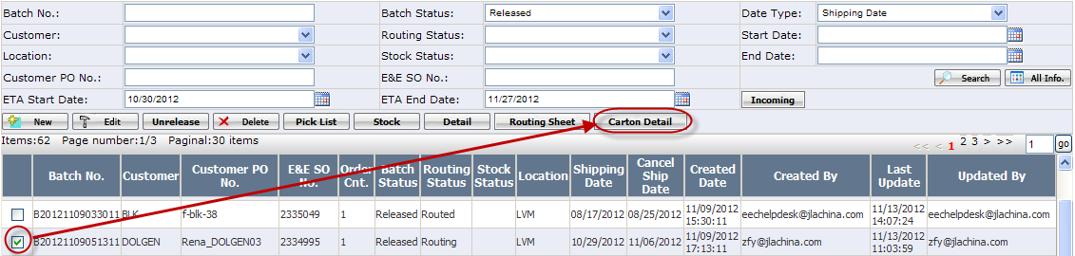
- On below pop up carton list webpage, select the carton that you want to delete, click <Delete> button.
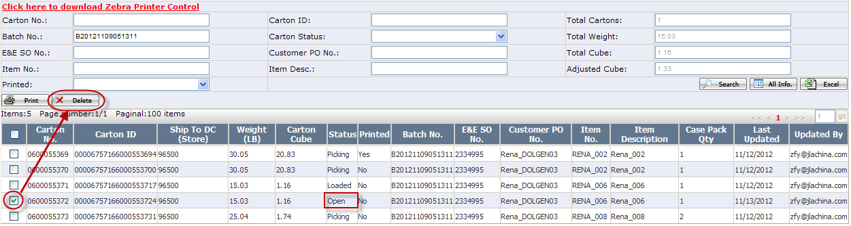
Once it is successfully deleted, it would be removed from the batch.
***************************************************************************************************
Note: If a carton status is Picking, or Staged, or Loaded, it cannot be deleted from batch.
**************************************************************************************************

- How to delete a carton from routing Sheet?
- Go to Wholesale Batch Mgt webpage.
- Search out the batch that you would delete carton from, select it, click <Routing Sheet> button.
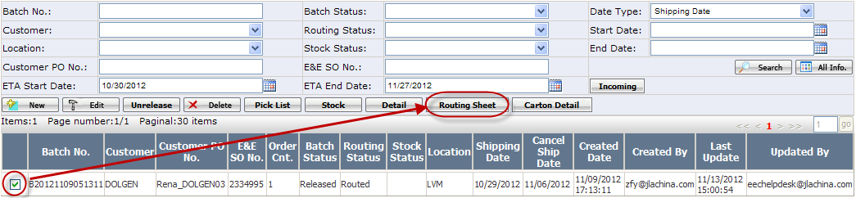
- On below pop up routing sheet list webpage, search out the routing sheet by carton number, click Routing No. hyperlink.
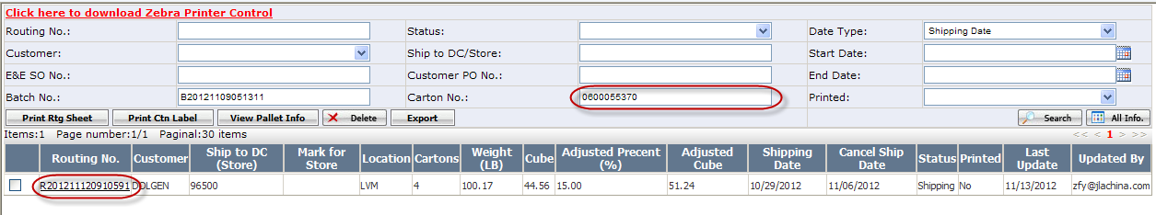
- On below pop up carton list webpage, you will see all cartons that have been added to the routing sheet.
Select the carton that you need to delete from the routing sheet, click <Delete> button.
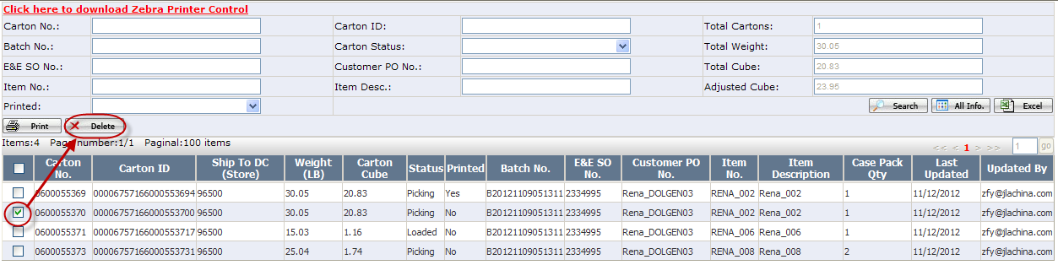
Once it is successfully deleted, the carton would be removed from the routing sheet.
***************************************************************************************************
Note:
- If a carton status is not Picking, it cannot be deleted from routing sheet.
- If a carton has been added to shipment, it cannot be deleted from routing sheet.
**************************************************************************************************

- How to delete a carton from Pallet?
- Go to Wholesale Batch Mgt webpage.
- Click <Routing Sheet> button.
If you know the batch number the carton belongs to, you can select the batch first, and then click <Routing Sheet> button.
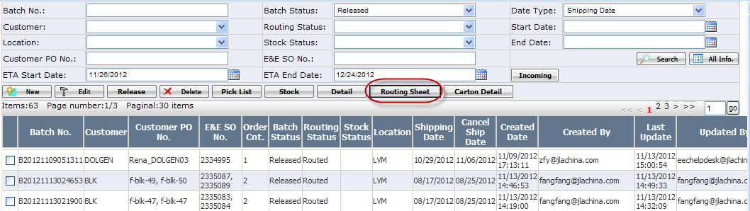
- On below pop up routing sheet list webpage, search out the routing sheet by carton number.
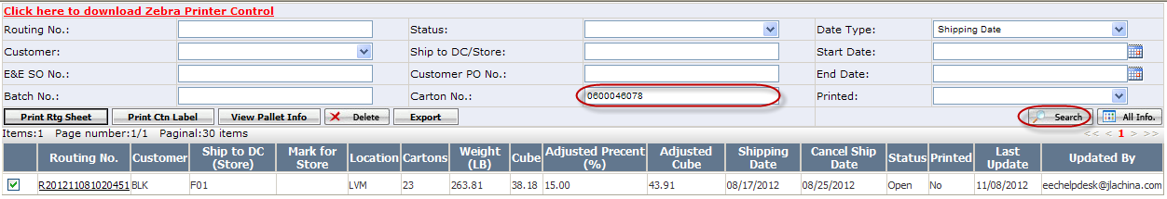
- Select the routing sheet, click <View Pallet Info> button.
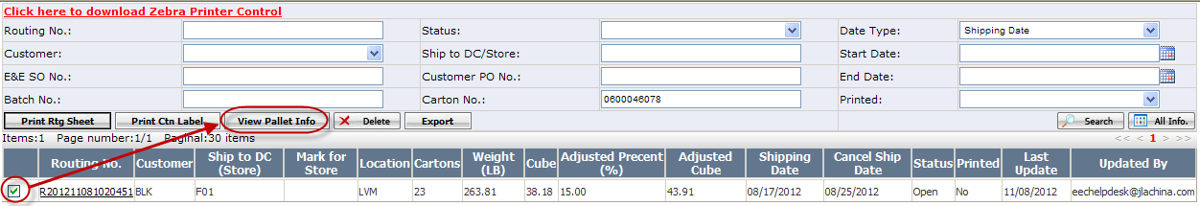
- On below pop up pallet list webpage, search out the pallet by carton number.
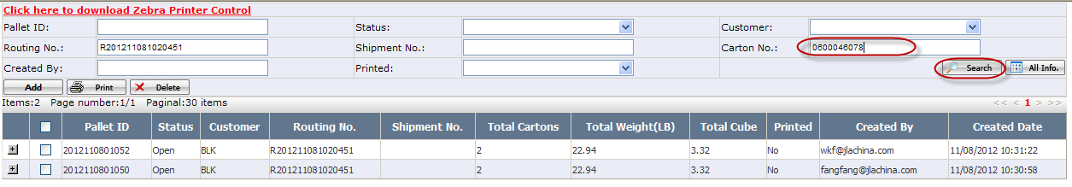
- Click icon to see all cartons that have been added to the pallet.
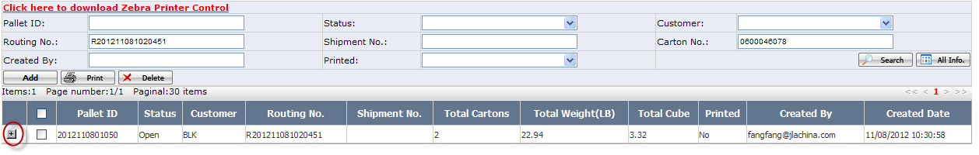
- Select the carton that you need to delete from the pallet, click <Delete> button.
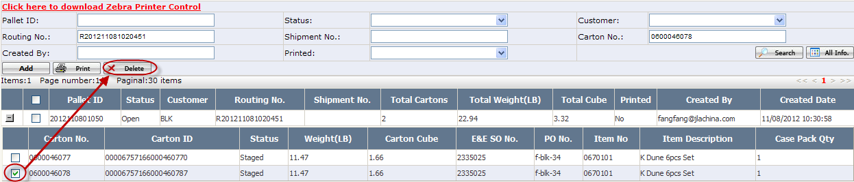
Once it is successfully deleted, the carton would be removed from the pallet.
**************************************************************************************************
Note:
- If a carton status is not Staged, it cannot be deleted from pallet.
- If a carton has been added to shipment, it cannot be deleted from pallet.
**************************************************************************************************

- How to delete a carton from Shipment?
- Go to Wholesale Shipment webpage.
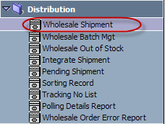
- Search out the shipment by carton number, click Shipment No. hyperlink.
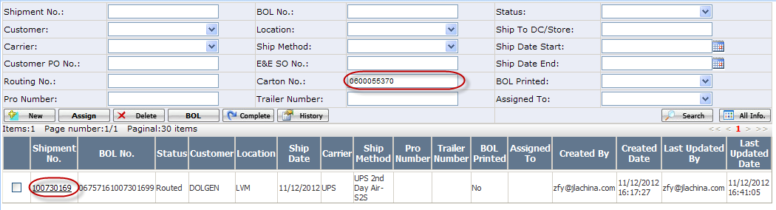
- On below pop up shipment detail webpage, you will see all cartons that have been added to the shipment.
Select the carton that you need to delete from the shipment, click <Delete> button.
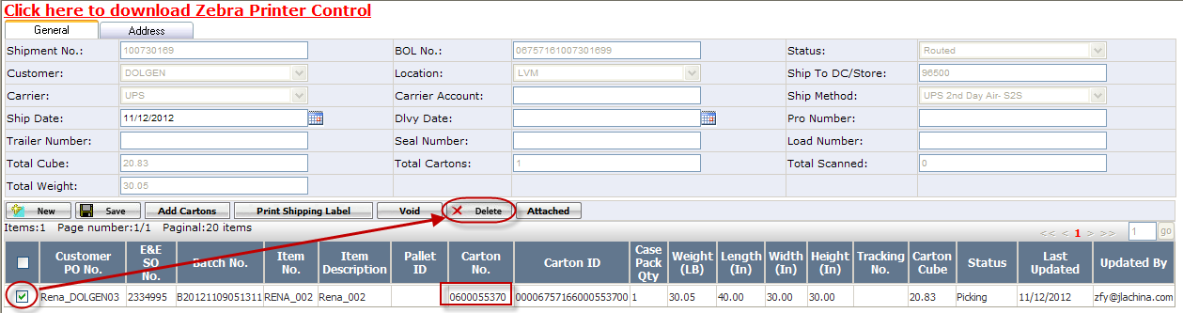
Once it is successfully deleted, the carton would be removed from the shipment.
**************************************************************************************************
Note:
- If a carton status is Loaded, it cannot be deleted from shipment.
- If a carton has been printed shipping label, it cannot be deleted from shipment.
**************************************************************************************************
- How to delete the carton the status=loaded or staged.
Problem: Need to delete carton after the carton has been loaded.
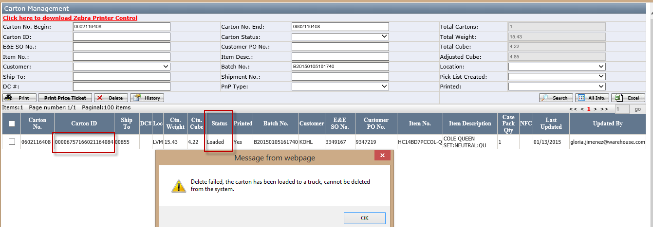
Detail process as below

Remove cartons from Shipment
- Go to wholesale shipment Mgt. page，enter carton no to search out the shipment. If the shipment is at “loaded” status, please follow (2) to unload it.
If the shipment is at “routed” status, don’t need to do (2) process, and click the shipment no to go to wholesale shipment detail page directly.
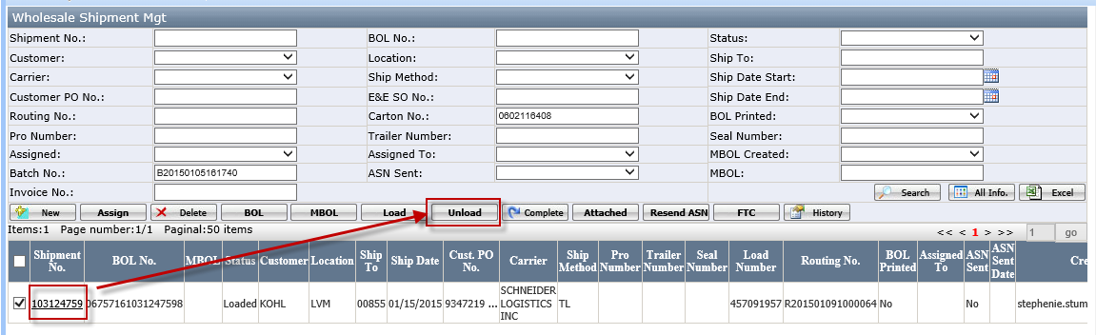
- Select the searched out shipment and click the <unload> button and the shipment status will be changed to “Routed” status.
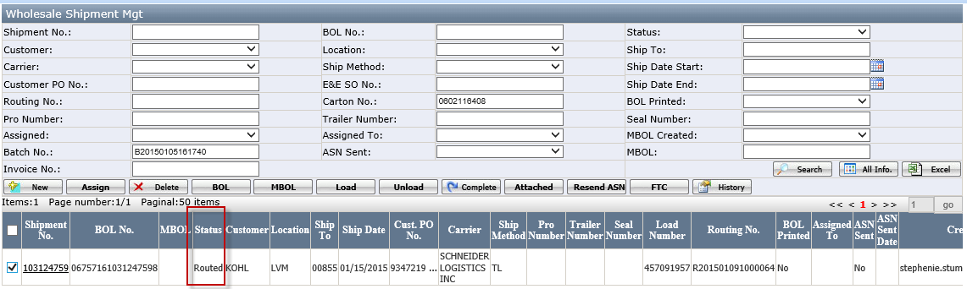
Notes: If delete single carton, needn’t to unload the shipment, user with job function shipment admin and DC manager can deleted loaded carton

- Click this shipment no to open the wholesale shipment detail page and enter the carton no which need to be removed from this shipment, then search out the carton no as below:
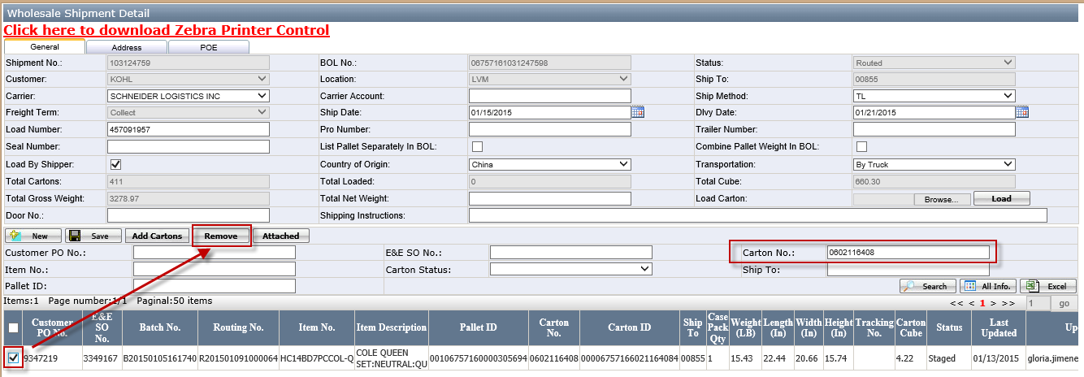
Notes: when the shipment is routed status.
Select the carton no (status=staged/Picking) and click the <Remove> button as above screenshot.

Remove carton IDs from Routing Sheet
- Go to wholesale batch Mgt page and use batch no to search out this batch. Then select it and click<routing sheet> button to open wholesale Routing Sheet Management page
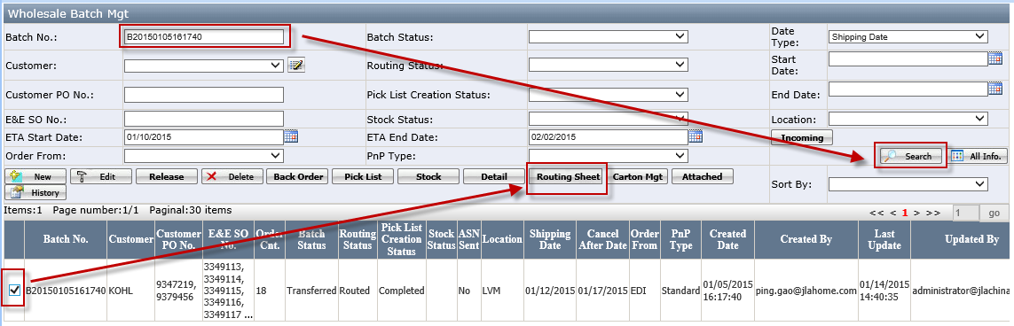
- In wholesale Routing Sheet Management page, search by carton no to find out the routing no as below.
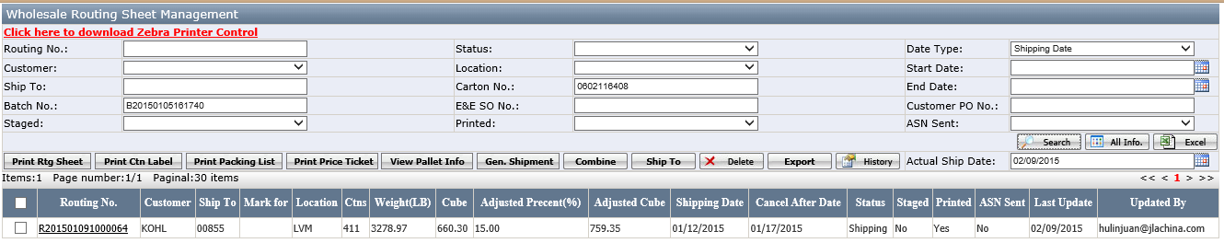
- Click <Routing no> and go to wholesale routing sheet detail page. Select the carton number and click <remove> button.
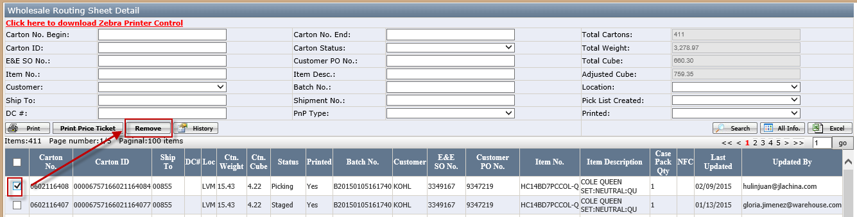
Then pop up below message.
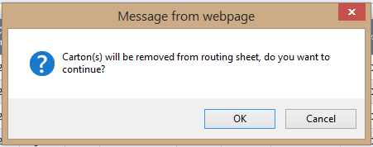
Important Note: After the cartons are removed from the Routing Sheet do not re-open the Routing Sheet webpage until the cartons are deleted. The reason for this is that when the Routing Sheet webpage is opened it will automatically create a routing sheet for any carton IDs that are not already in a routing sheet.

Go to Carton Management webpage find the carton IDs and delete them
- Go back to wholesale Batch Mgt. page and click <Carton Mgt> button.
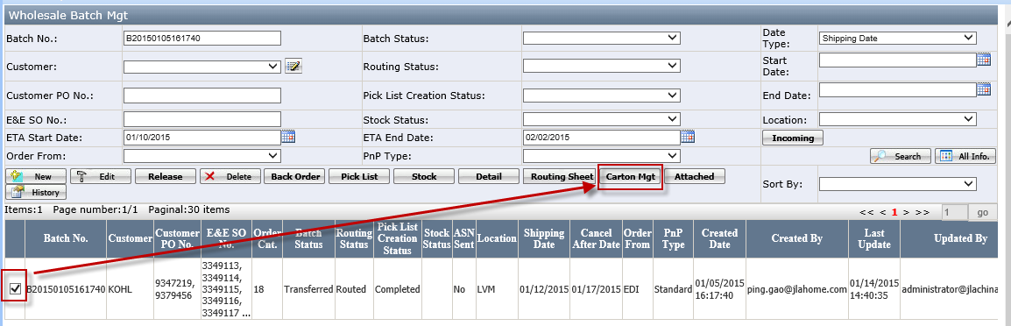
- In Carton Management page, enter the carton no begin and carton no end field, then click <search> button to search out the cartons which need to delete.
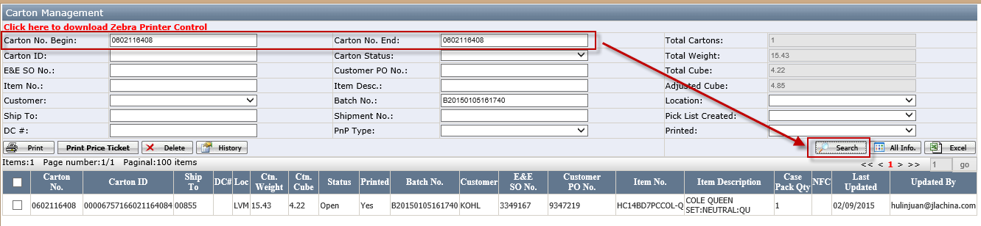
- Select the cartons and click <Delete> button (the carton status=open at this moment)
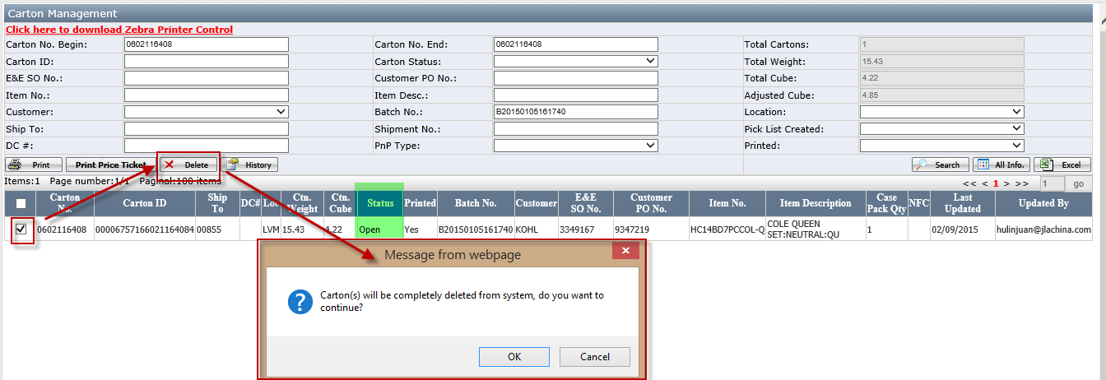
Click <ok> to delete this carton.
After that, go to wholesale sales order list page and search out the sales order, you can see this item has been canceled in sales order.
- How to void shipping label?
- Go to Wholesale Shipment webpage.
- Search out the shipment in which you want to void carton’s shipping label, click Shipment No. hyperlink.
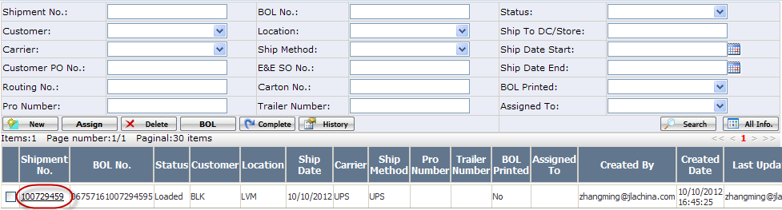
- On the pop up shipment detail webpage, select the carton that you need to void shipping label, click <Void> button.
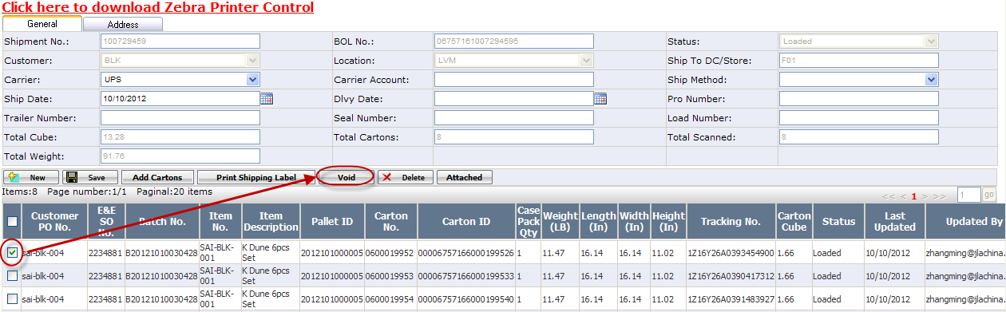
Once it is successfully voided, the carton’s tracking number would be cleared.
**************************************************************************************************
Note:
- If a carton status is Loaded, the shipping label cannot be voided.
- Only ‘Warehouse Admin’ is able to void shipping label.
**************************************************************************************************
- How to cancel order line item?
- Go to Sales Order List webpage.
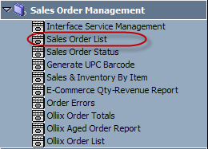
- Search out the order that you need to cancel line item, click the Customer PO No.
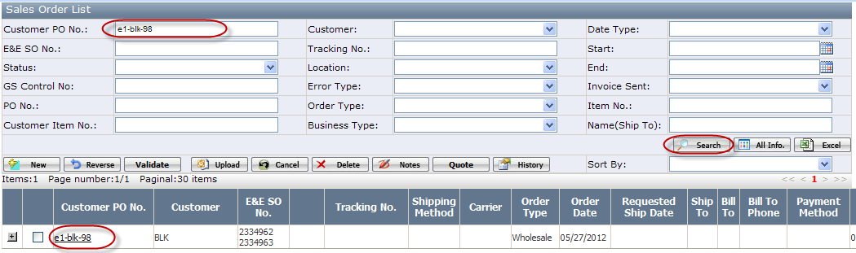
- On below pop up order detail webpage, find out the line item which you need to cancel, click <Select>.
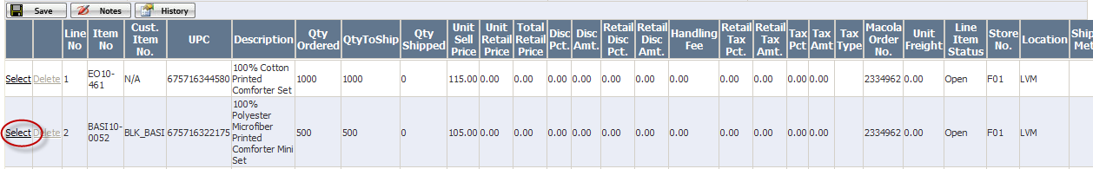
- On below pop up window, click <Cancel> button.
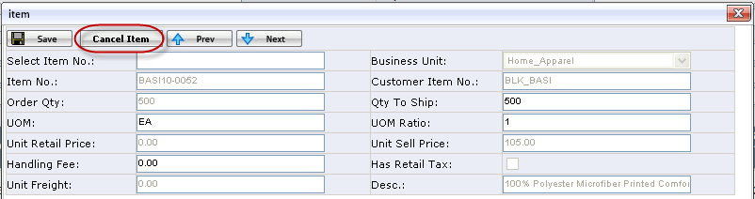
************************************************************************************************
Note: If the line item has been added to batch, only ‘Distr-DM’ is able to cancel it.
************************************************************************************************
- How to cancel an order?
- Go to Sales Order List webpage.
- Search out the order that you need to cancel.
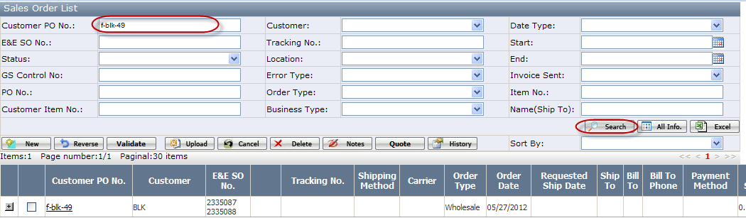
- Select the order, click <Cancel> button.
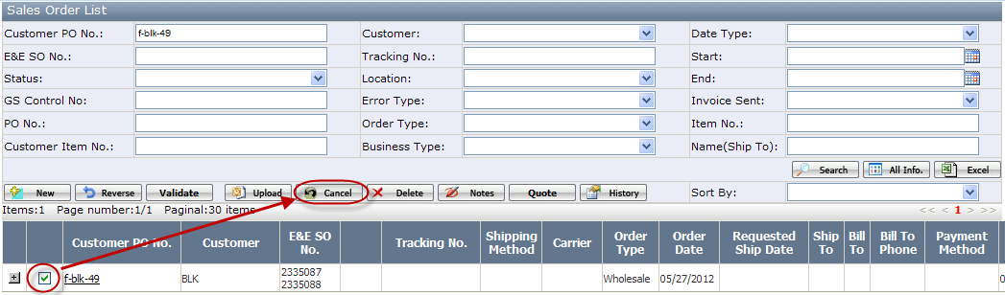
************************************************************************************************
Note: If any line item has been added to batch, only ‘Distr-DM’ is able to cancel the order.
************************************************************************************************

- How to change order line item quantity?
- Go to Sales Order List webpage.
- Search out the order that you need to change line item quantity, click the Customer PO No.
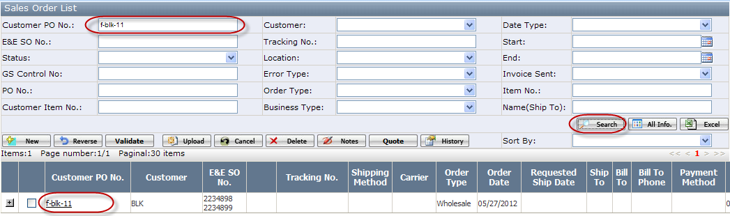
- On below pop up order detail webpage, find out the line item that you need to change the quantity, click <Select>.
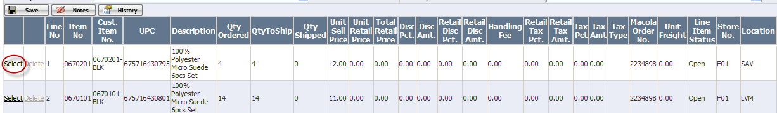
- On below pop up window, change Qty to Ship, and then click <Save> button.
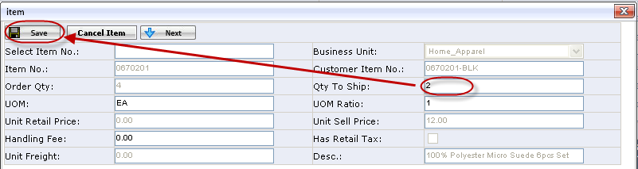
**********************************************************************************************
Note: If the line item’s related batch has been released, Qty to Ship cannot be changed.
**********************************************************************************************
- How to unrelease a batch?
- Go to Wholesale Batch Mgt webpage.
- Set Batch Status as Released, set Routing Status as Open, and then click <Search> button to search out batches that could be released.
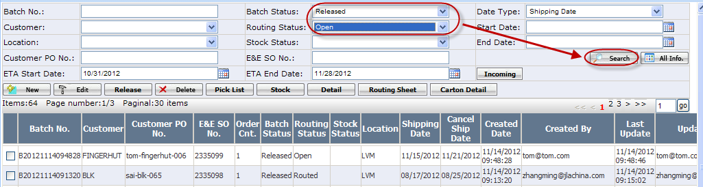
- Select the batch that you need to unrelease, click <Unrelease> button.
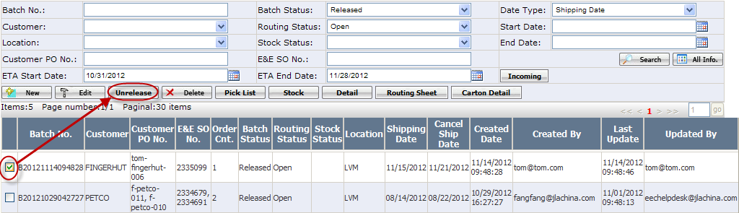
Once it is successfully unreleased, the batch status would be changed to Pending.
**********************************************************************************************
Note: Only ‘Distr-DM’ or ‘Distr-VP’ is able to unrelease a batch.
**********************************************************************************************

- How to view incoming items?
- Go to Wholesale Batch Mgt webpage.
- Click <Incoming> button.
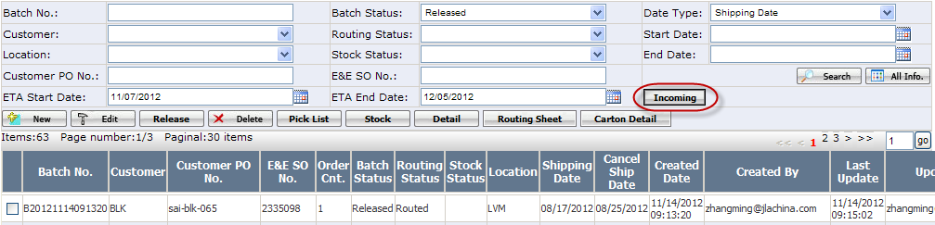
- On the pop up webpage, you would see the detail information of incoming items.
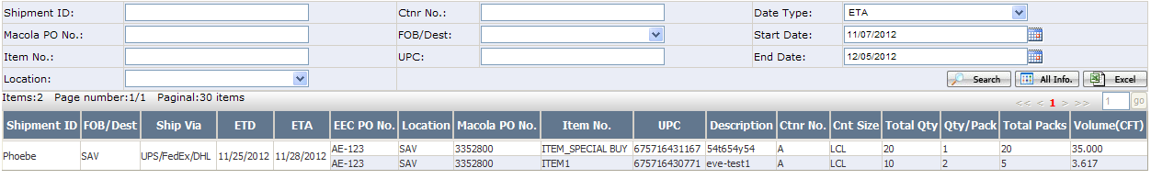
**********************************************************************************************
Note: Only ‘Distr-DM’ or ‘Distr-VP’ is able to change the ETA Start Date and ETA End Date on wholesale batch list webpage.
**********************************************************************************************

- How to hold a macola order?
- Go to Wholesale Batch Mgt webpage.
- Click <New> button.
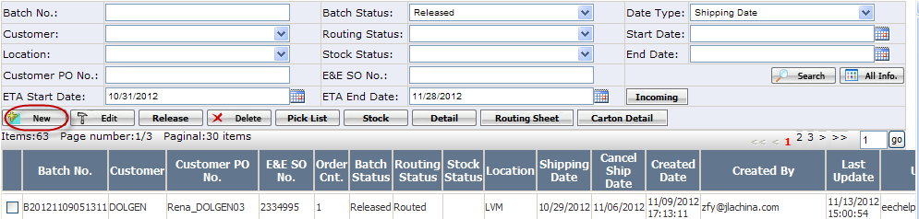
- On below pop up webpage, select the macola order that you need to hold, click <Hold> button.
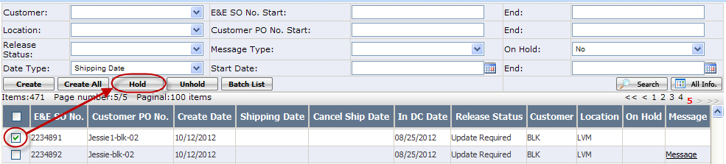
Once it is successfully held, the macola order cannot be created batch.
**********************************************************************************************
Note: If a macola order was not uploaded from EEC, it cannot be held.
**********************************************************************************************

- How to unhold a macola order?
- Go to Wholesale Batch Mgt webpage
- Click <New> button.
- On below pop up webpage, set On Hold as Yes, click <Search> button to search out macola orders that have been held.
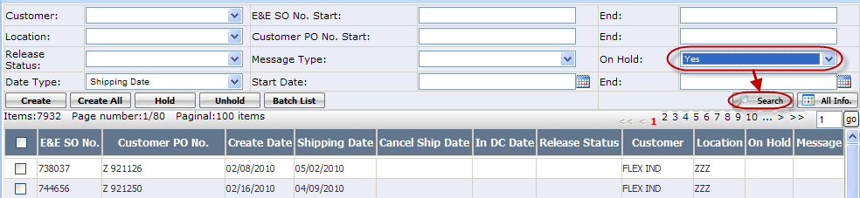
- Select the macola order that you need to unhold, click <Unhold> button.
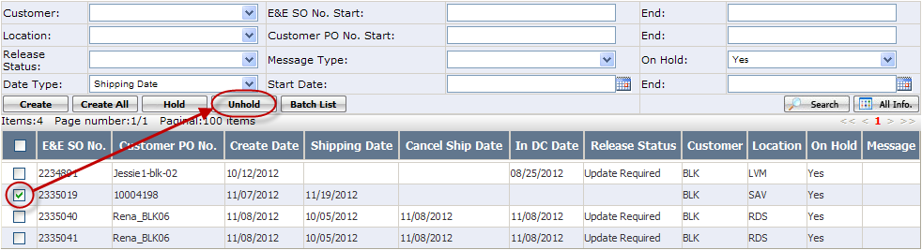
- How to add carton to a loaded pallet?
- Go to Wholesale Batch Mgt webpage.
- Search out the batch that the pallet belongs to.
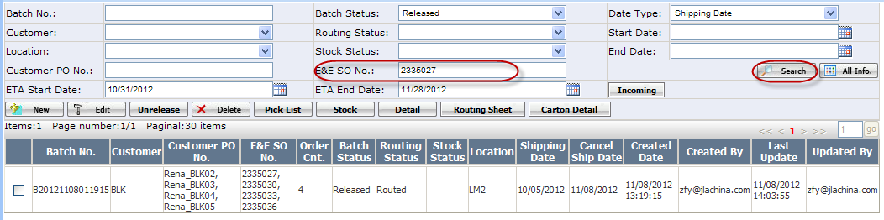
- Select the batch, click <Routing Sheet> button.
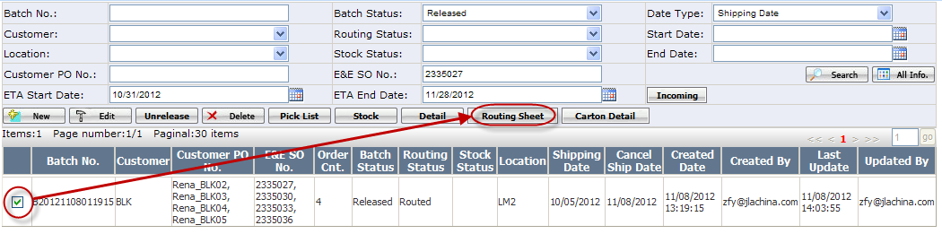
- On below pop up routing sheet list webpage, select the routing sheet that the pallet belongs to, click <View Pallet Info> button.
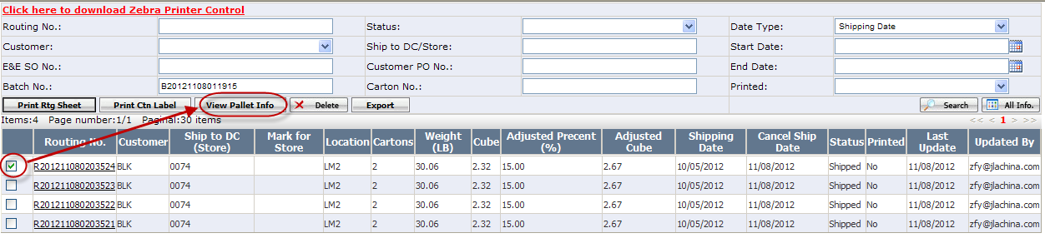

- On below pop up webpage, select the pallet (Status: Loaded) that you need to add carton, click <Add> button.
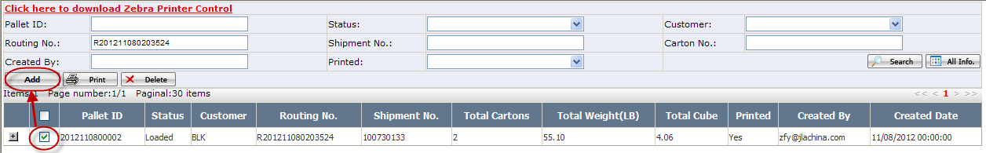
- On below pop up window, select cartons that you need to add to the pallet, click <Add> button.
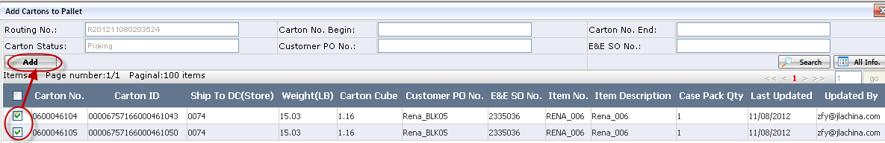

- How to add carton to a routing sheet?
- Go to Wholesale Batch Mgt webpage.
- Click <Routing Sheet> button.
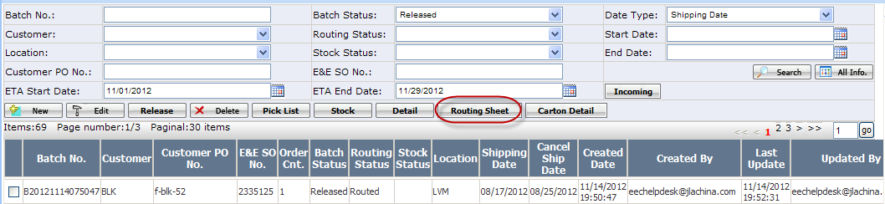
- On the pop up routing sheet list webpage, search out the routing sheet that you need to add carton to, click the Routing No.
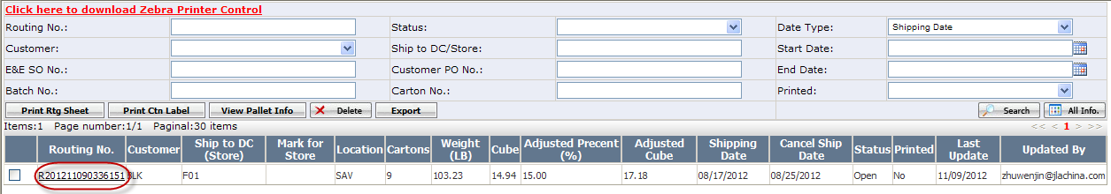
- On below pop up webpage, click <Add> button.
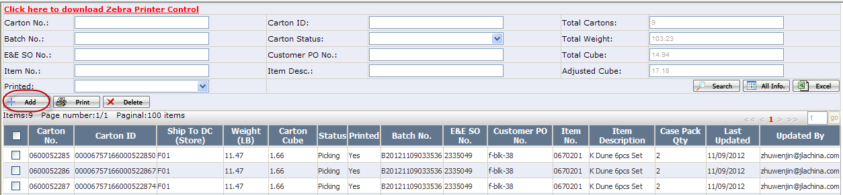
- On below pop up window, you will see cartons that can be added to this routing sheet. Select cartons you want to add, click <Add> button.

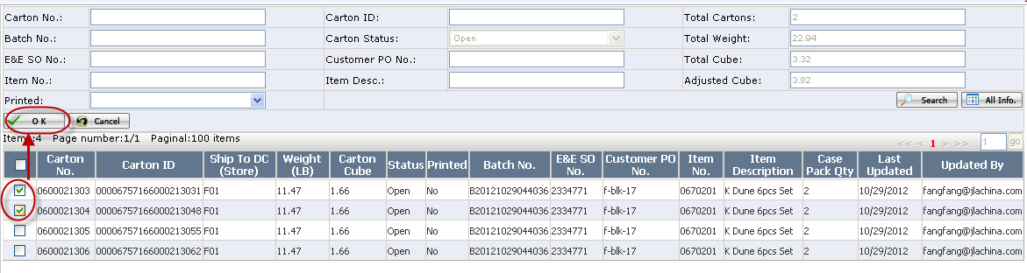
**********************************************************************************************
Note: If routing sheet status is not Open, it cannot be added cartons.
**********************************************************************************************

- How to combine multiple batches to the routing sheet?
- Go to Wholesale Batch Mgt webpage.
- Select batches that you need to add to the one routing sheet, then click the <Routing sheet> button.
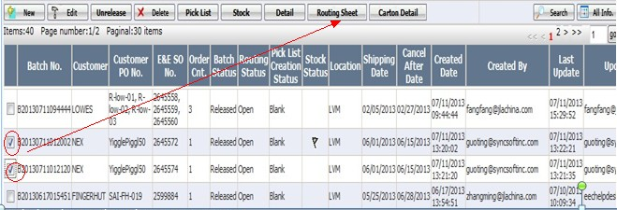

************************************************************************************************
Note: If the batch’s customer, location is not the same with the batch you want to combine or their shipping dates have no intersection, then they cannot be combined together.
************************************************************************************************
- Done.
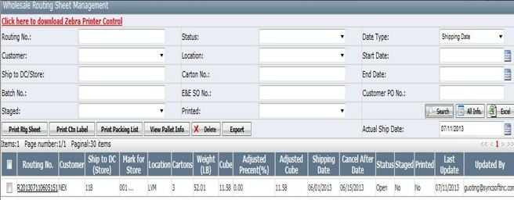
- How to combine multiple routing sheets together?
- Go to wholesale Batch Mgt page and click <Routing sheet> to open wholesale Routing Sheet Management page
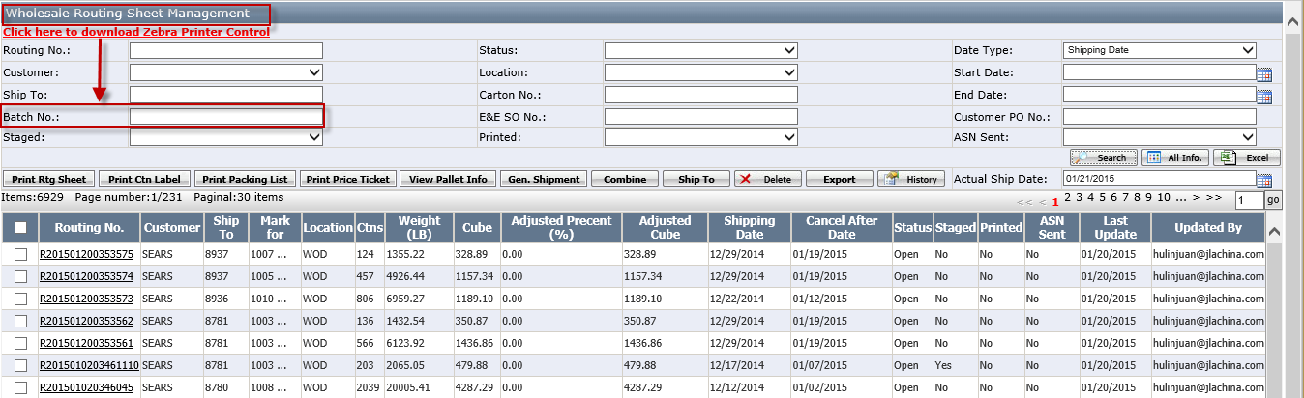
Notes: In wholesale batch mgt page, If you select one batch and click <routing sheet>, In wholesale routing sheet management page, the default is showing all routing under this batch and the selected batch no will be default in batch no search criteria field.
If you don’t select any batch and click <routing sheet> directly, the default are showing all routing sheets and the batch no search criteria field will be blank (see screenshot)
- In wholesale routing sheet management page, select the multiple routing sheets which must have the same customer, ship to, location and the routing status=open. Then click <Combine> button to combine the selected routing sheets as one routing sheet.
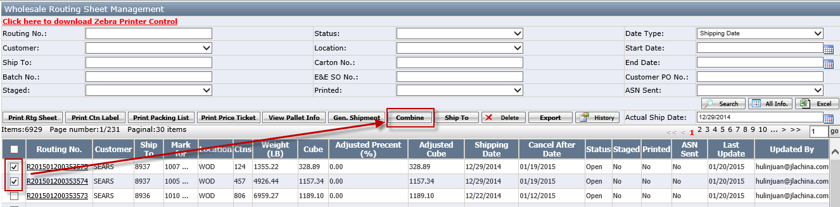
[Before combine]
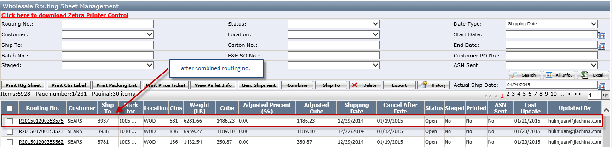
[After combine]
Notes:
- Allow to combine routing sheet from different batch.
- If routing sheet has been built pallet, system will automatically assign the pallet to new routing
sheet.

- How to change Ship To for Ship to Mark For customer?
- Set customer to “Ship to Mark For” on customer profile page.
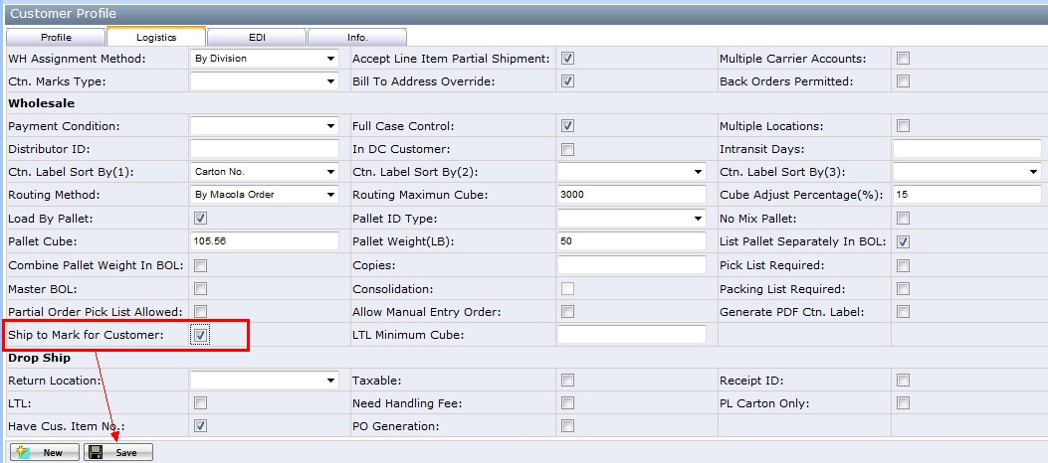
- Check checkbox “Ship to Mark for Customer” to support “Ship to Mark For”.

- Go to Wholesale Batch Mgt webpage.

- Select the Batch No. which is Ship to Mark For. Click<Routing sheet> button.

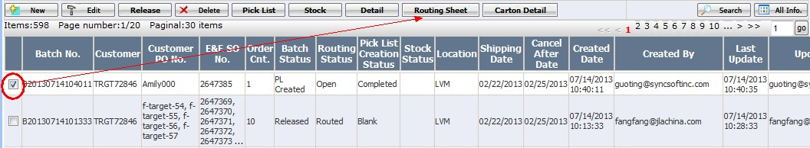

- Webpage would jump out the prompt dialog box as follows. Select one of the options, for example ‘Ship To Mark For’, then click <OK>.

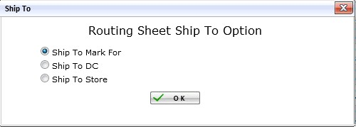
- Ship to Mark for: Decide ship to DC or store based on the cube setup on customer profile.
- Ship to DC: All ship to DC no matter what cube it is.
- Ship to Store: All ship to store no matter what cube it is.

- You will see the routing sheet webpage as follows.

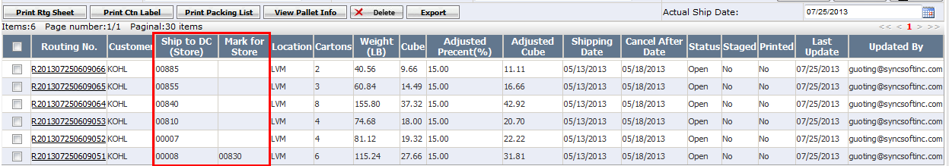

- If you need to change the routing sheet’s Ship To to ‘ship to store’ (or the others, you can change it in the same way). Select the Routing Sheet you want to change. Click <delete> button.

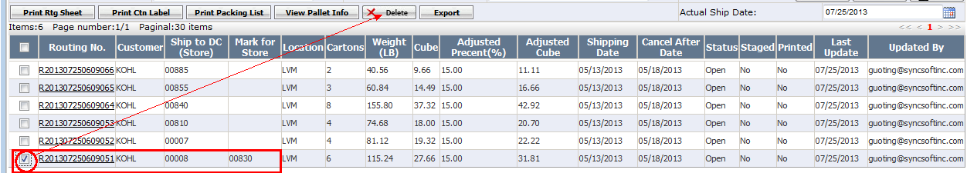

- Back to Wholesale Batch Mgt webpage. Please Re Search the batch you just do the routing sheet operation. You will find its routing status has changed to routing. Select it and click <Routing Sheet>.
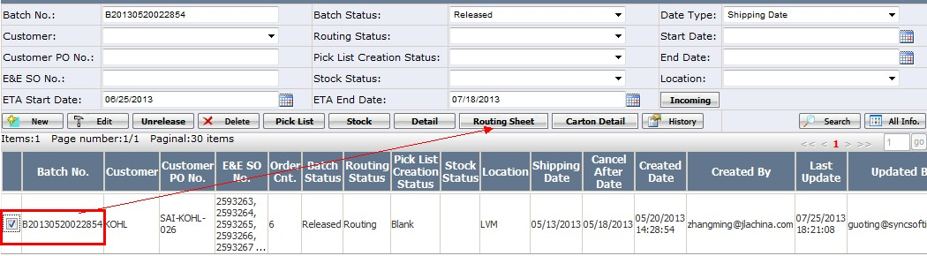

- System will still jump out of the prompt dialog box, now you can reselect one option to suit your needs.
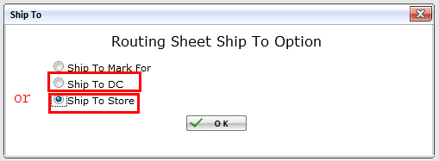

- Now that you have successfully changed the Ship To.

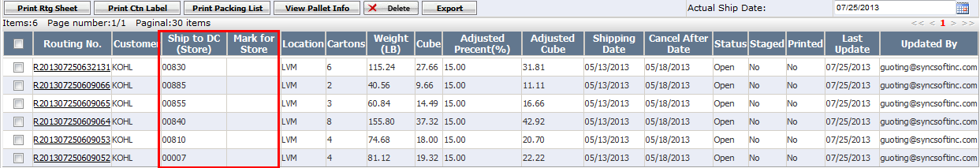

- How to create Master BOL?
- Configuration customer to support Master BOL on customer profile page.
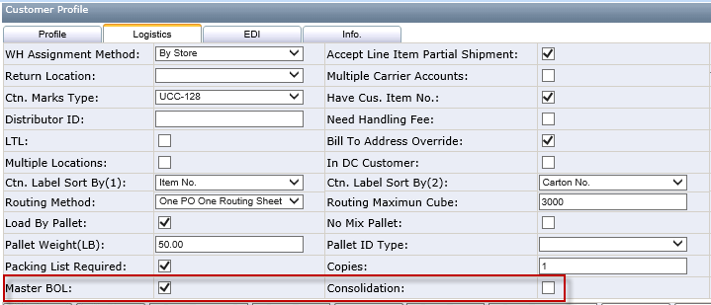
- Check checkbox “Master BOL” to support Master BOL.
- If ”Consolidation” is checked, system will not check ship to and user need to select ship to for the MBOL when generate MBOL.

- Create Master BOL on wholesale shipment management page.
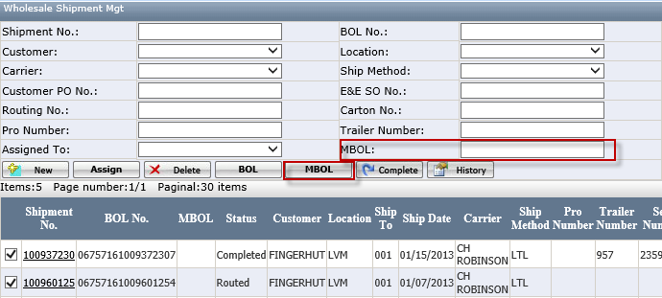
- Select shipment with the same customer, ship from location, carrier and ship to location (Consolidation MBOL do not need ship to).
- Click MBOL button to generate MBOL.
- Direct click MBOL button to see all the MBOL. Or select one shipment and click MBOL button to see the selected shipment’s MBOL after it has been generated.

- Master BOL ship to selection page
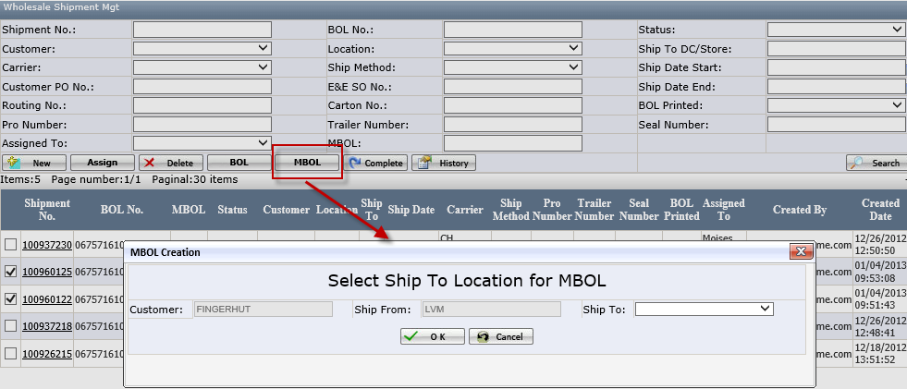
- For Consolidation customer, user needs to select ship to location for MBOL.
- Customer not check Consolidation will not see this page.
- Master BOL Mgt. Page
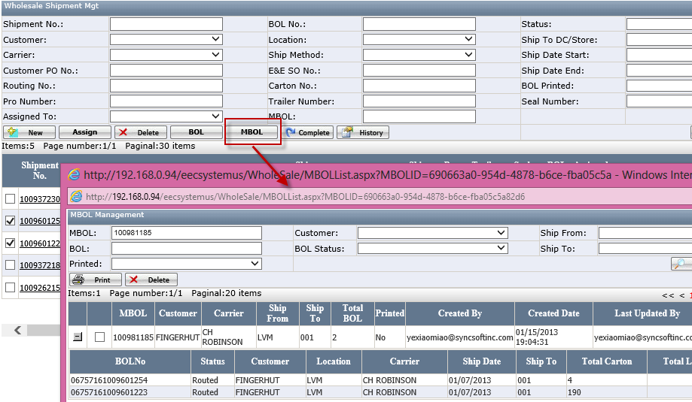
- Normally, wireless application Load Truck will print MBOL automatically when the last BOL is printed, administrator can go to this mgt. page to reprint or delete MBOL for exceptions.
- How to create the FTC document.
FTC button is used to generate FTC document.
- In wholesale shipment management page, Select shipments with the same customer, ship from location, carrier and load number, then click the <FTC> button to generate the FTC document. 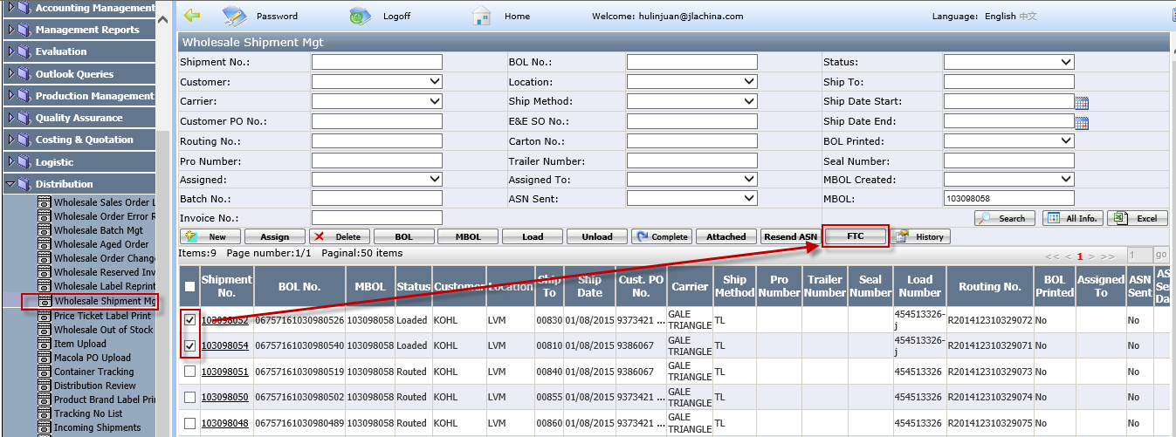
Notes: the selected shipments must be loaded or completed.
- Status Description
- Batch Status
Status | Description
Pending | When batch is created.
Released | Batch is released by distribution team, has generated carton information.
PL Created | When batch has generated at least one pick list.
Picking | When picker start to pick items with wireless application.
Transferred | When picker has picked all items in the batch, and transferred inventory to 000.
Completed | When all orders in the batch have finished Macola Post.
- Routing Status
Status | Description
Open | No carton in the batch has been added to a routing sheet.
Routing | Parts of cartons in the batch have been added to a routing sheet.
Routed | All cartons in the batch have been added to a routing sheet.
- Routing Sheet Status
Status | Description
Open | When routing sheet is automatically generated.
Routing | When part of the routing sheet has been added to shipment.
Routed | When the whole routing sheet has been added to shipment.
- Pallet Status
Status | Description
Open | When pallet is built.
Loaded | When pallet has been loaded to truck.
- Carton Status
Status | Description
Open | When carton is automatically generated.
Picking | When carton has been added to a routing sheet.
Staged | When carton has been added to a pallet (Not all cartons have this status).
Loaded | When carton has been loaded to truck.
- Shipment Status
Status | Description
Open | When shipment header is created.
Routed | When a routing sheet has been added to shipment.
Loading | When part of cartons in the shipment have been loaded to truck.
Loaded | When all cartons in the shipment have been loaded to truck.
Completed | When load is completed and BOL has been printed.
- Release Status
Status | Description (With Cancel Date) | Description (With In DC Date)
Future Orders | Shipping Date-Current Date>14 | In DC date-current date>=22
Release Required | Shipping Date-14 <= Current Date &  Current Date < Cancel Date | 1<=In DC date-current date<=21
Update Required | Current Date >=Cancel Date &  Total Quantity to ship >0 | Current date>=In DC date &  Total Quantity to ship >0
Cancel Required | Current Date >=Cancel Date &  Total Quantity to ship =0 | Current date>=In DC date &  Total Quantity to ship =0

- Page Introduction
- Wholesale Order Error Report
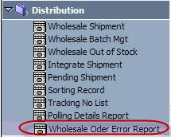
Wholesale Order Error Report shows all wholesale error orders. If an order failed to be validated or uploaded to Macola, it would show on this report. You are able to see each order’s error description and resolution from it, which will help you to fix the order issue. Only Distribution Team has access to this report.

Set Customers
Before you run the report, you should set customers first. You cannot see any error order if you don’t set any customer.
- Click edit icon which is on the right side of Customer dropdown list.
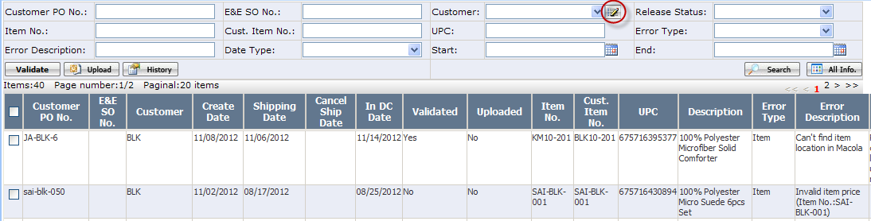
- On below pop up window, select customers from Available list box, then click assign button.
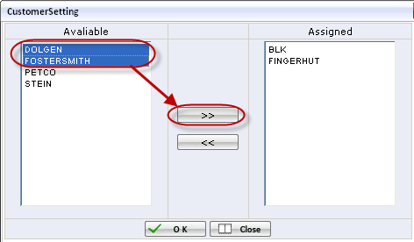
- After customers are assigned, click <OK> button.
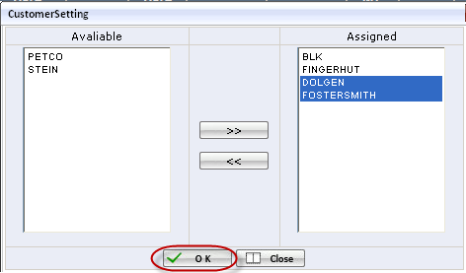
Then in the Customer dropdown list, you will see assigned customers.
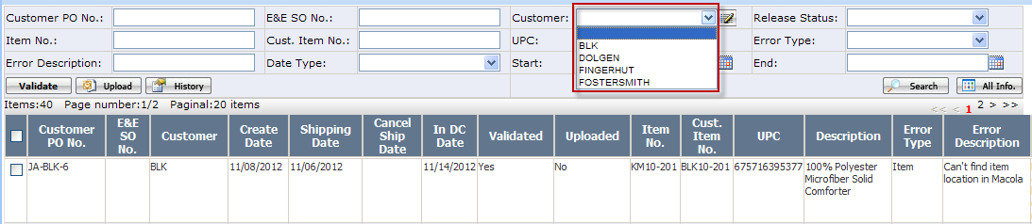

Validate Order
For orders which didn’t pass validation, after you fix the issues, you can validate them again to see whether the error has been resolved or not.
Select order that you think the validation error has been resolved, click <Validate> button. If it passes validation, it will be removed from the report.
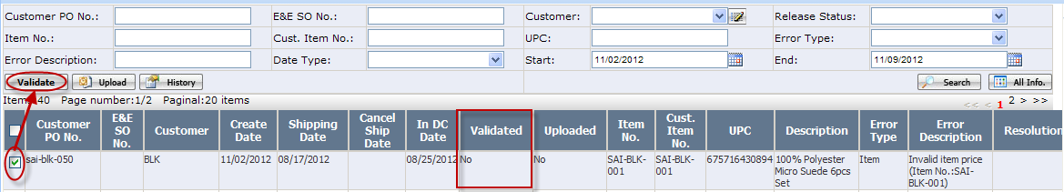

Upload Order
For orders which failed to be uploaded to Macola, after you fix the issues, you can upload them again to see whether the error has been resolved or not.
Select order which you think the error has been resolved, click <Upload> button. If it is successfully uploaded to Macola, it will be removed from the report.
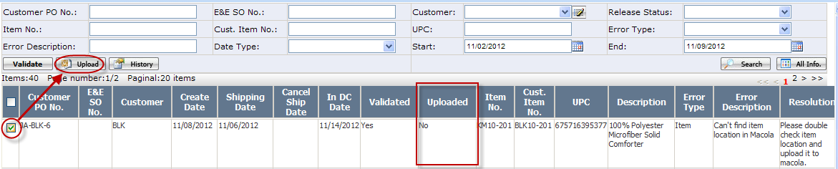
- Interchanges Outlook
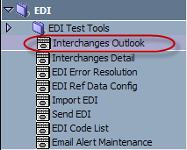
Interchanges Outlook is an EDI source files report. Only EDI Team has access to it.
On this report, EDI Team can see how many EDI source files are there for each Customer, EDI Type, EDI Status and Transmission Type.

View Detail Information
- Select one record, click <Detail> button.
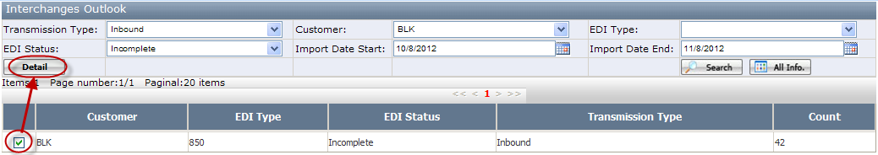
- On below pop up webpage, EDI Team can view EDI source files detail information. This page is the same as Interchanges Detail webpage.
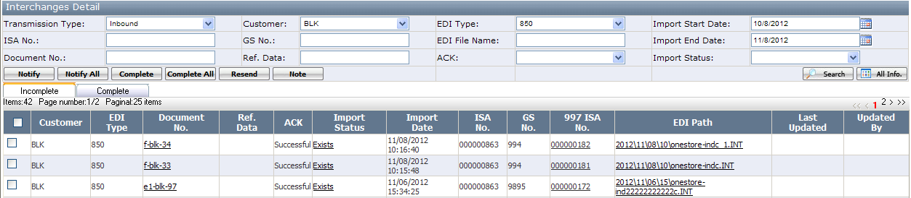

- Interchanges Detail
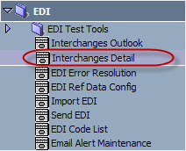
Interchanges Detail webpage is used to manage EDI source files, including both drop ship EDI source files and wholesale EDI source files.
EDI and Distribution team have access to this page. The content on this page would vary with different user roles.

For EDI Team
There are 2 tabs on Interchanges Detail webpage.
- Incomplete Tab: Shows incomplete EDI files that need EDI team to deal with.
- Complete Tab: Shows complete EDI files and those EDI files that EDI team has notified distribution team to handle.

Notify distribution team of incomplete EDI files
- Select EDI files, click <Notify> button.
If you want to notify all searched out EDI files, directly click <Notify All> button.
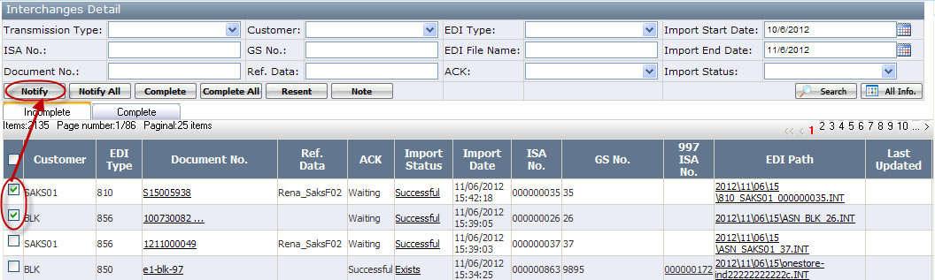
- On the pop up window, select one or multiple distribution users that need to be notified, click <Notify> button. Then those EDI files would be moved into Complete tab.
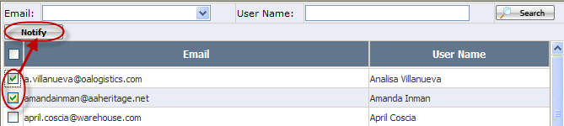

Resend outbound EDI files
Select outbound EDI files, click <Resend> button.
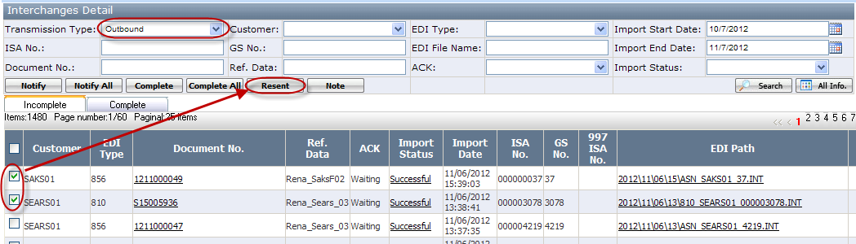

Complete EDI files
Select EDI files you’ve handled, click <Complete> button.
If you want to complete all searched out EDI files, directly click <Complete All> button.
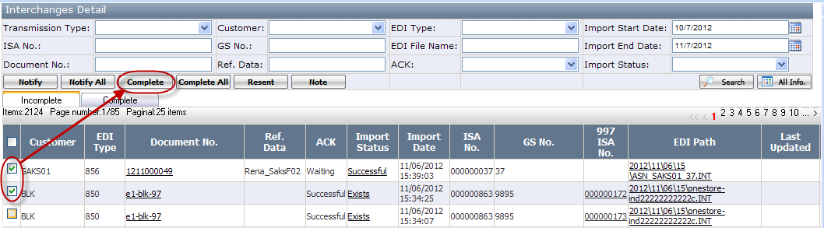

For Distribution Team

There are also 2 tabs on Interchanges Detail webpage.
- Incomplete Tab: Shows EDI files that EDI team has notified you to handle.
- Complete Tab: Shows EDI files that you’ve already handled.

Complete EDI files
Select EDI files you’ve handled, click <Complete> button.
If you want to complete all searched out EDI files, directly click <Complete All> button.
