Sales Transactions Manual
Sales transactions webpage is used to create credit memo or debit mero. After an sales transaction is created, you can upload it to Macola. Please see below for the instruction of how to operate sales transactions.

How to create an sales transaction
Step 1. Go to Accounting Management->Corporate Accounting->SalesTransactions page.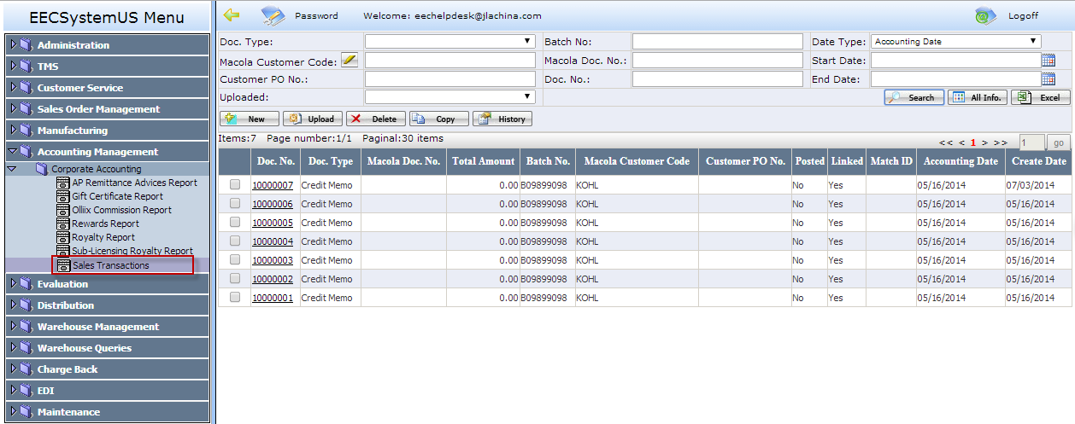
Step 2. Click <New> button to open a new entry page, in which you can enter a credit memo or debit memo. Fields with red frame need to be filled out (see below screenshot).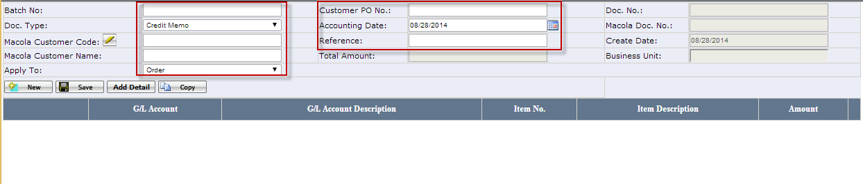
Note: If a sales transaction will affect olliix commission, please set Apply To=Order, and enter the correct customer po number, otherwise, the olliix commission report would be incorrect.
Step3. After saving the sales transaction, click <Add Detail> button.
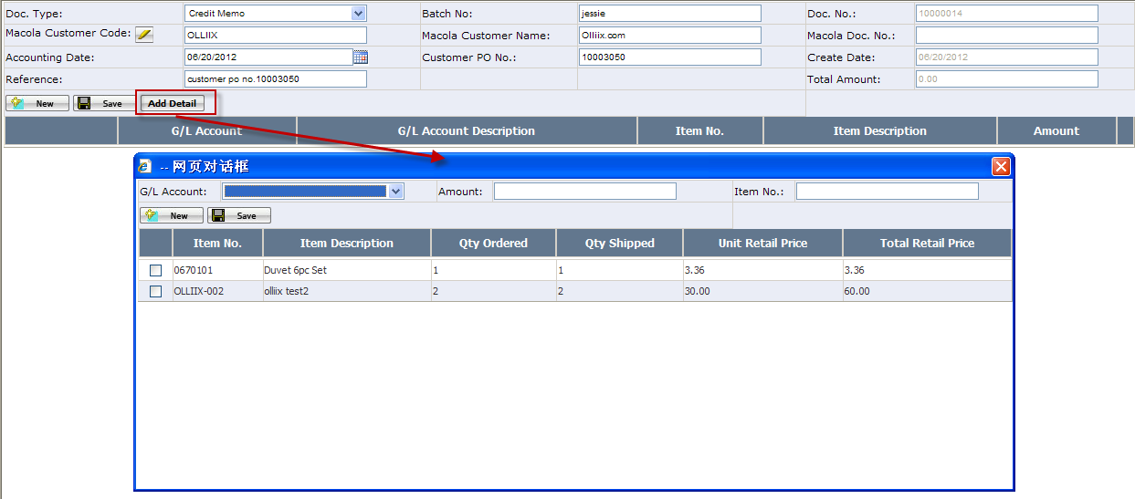
In the pop up windown, select a “G/L Account” and input the Amount. Item number is required when selected G/L Account is a revenue account ( such as 40000 Sales). You can add multiple detail records to one sales transaction.
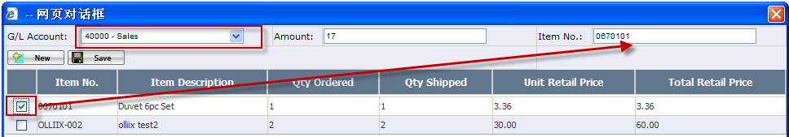

How to upload an sales transaction
Select the sales transaction that you need to upload, then click <upload> button.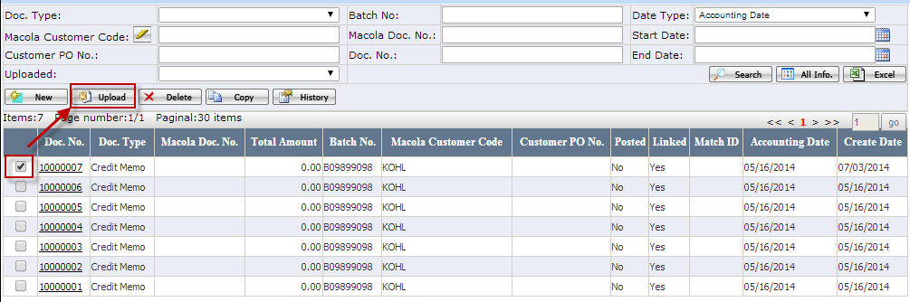
Once the sales transaction is uploaded to Macola successfully, the Macola Document No. will be auto-generated.
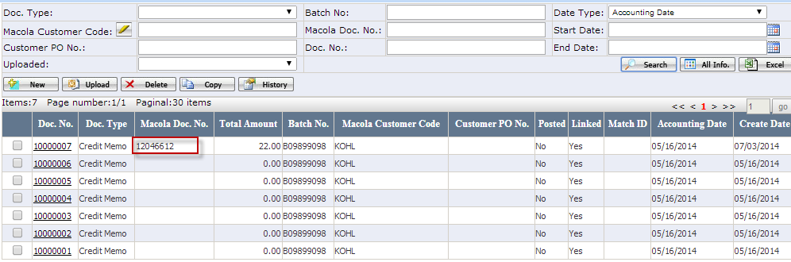
Note:
- When upload a sales transction to Macola, system will check whether journal 910 to 915 and journal 939 to 947 are closed on the accounting date, if all of them are closed, it can not be uploaded to Macola.
- After sales transaction is uploaded, you need to post it in Macola, just like what you did in Macola now.
-------------------------------------------------------------------End-----------------------------------------------------------------------

Related page and other notes
- <Journal> Page : It is under Maintenance module. This page is used to add a new journal which doesn’t exist in EEC but exists in Macola.
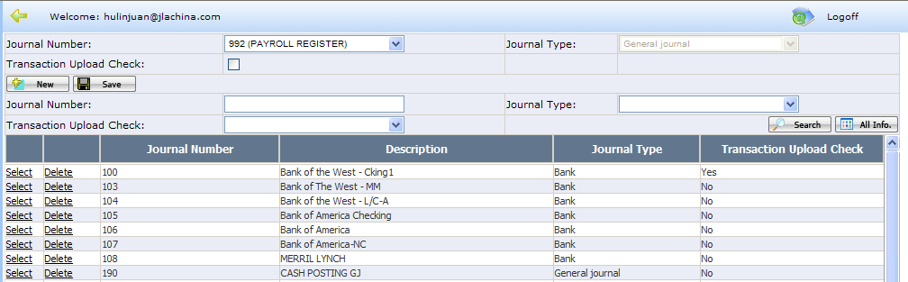
Note: if you want system to check whether the jounal is closed on the accounting date when upload a sales transaction to Macola, please check Transaction Upload Check checkbox.
- Upload to mapping Rule
Please see below screenshot for the details.
