DL Return order Manual

DL Return order steps
Step | Process Step | Operation Dept. | Related System | Detail Description
1 | Initiated | Customer Service  or Customer | DL website | 1.RA is created  2. Transferred to EEC and warehouse client.
2 | Partial Received | US Warehouse | Warehouse | Warehouse receive the return order in US Warehouse application
3 | Return Processed | Customer Service | EEC system | 1. Click <Received> button to return processed.  2. Upload RA to macola and DL by service.  3.Refund RA in DL website
4 | Refund Issued | Customer Service | DL website

**Only shipped order can be returned.

How to make the Return order

Place return order
- Login in DL websiteMy Account My Orders page, open below [Pict-1]
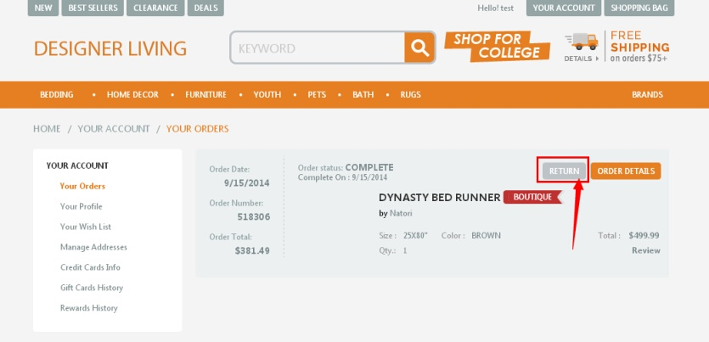
[Pict-1]
- Click “Return” to generate return order that the customer want to return.
- input the return quantity and reason, then click<Submit Return>button (see Pict-2):
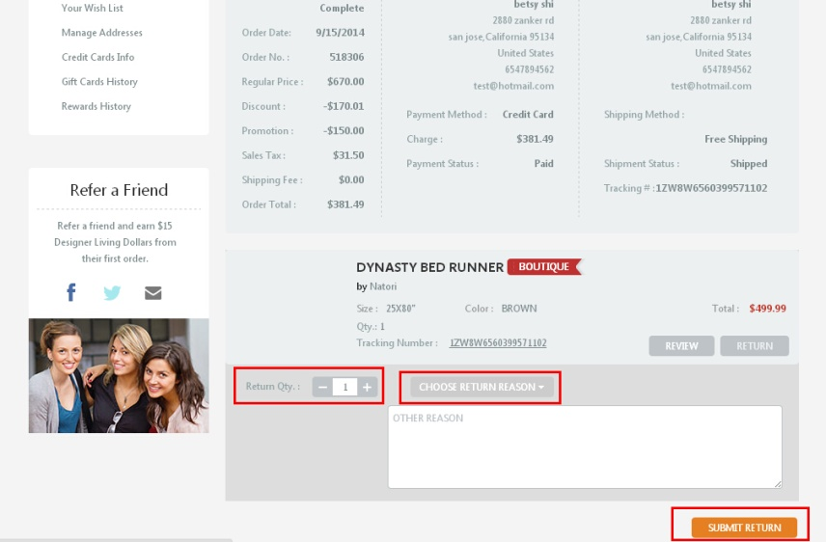
[Pict-2]
- Return order generate successfully as below [Pict-4] and Return Status is “Initiated”.
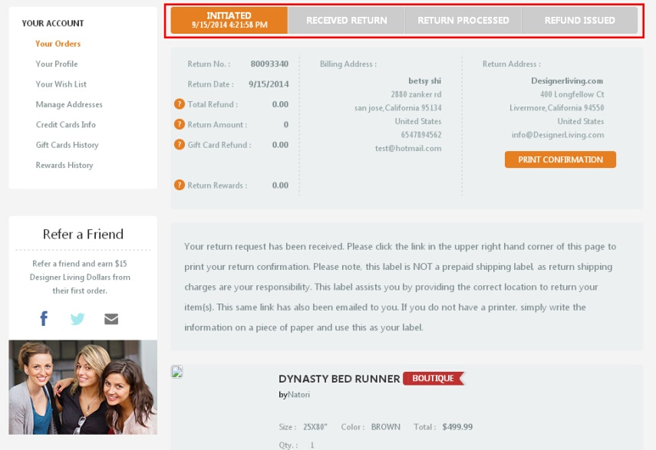
[Pict-4]
Notes:RA is generated. Return Authorization Number: 80093340. Return Status: Initiated.
- Operate EECUS Service “GetRetailSalesOrder/ProcessRA” will transfer RA to EECUS.Then open EECReturn order List page, you will see the RA, See below [Pict-5]
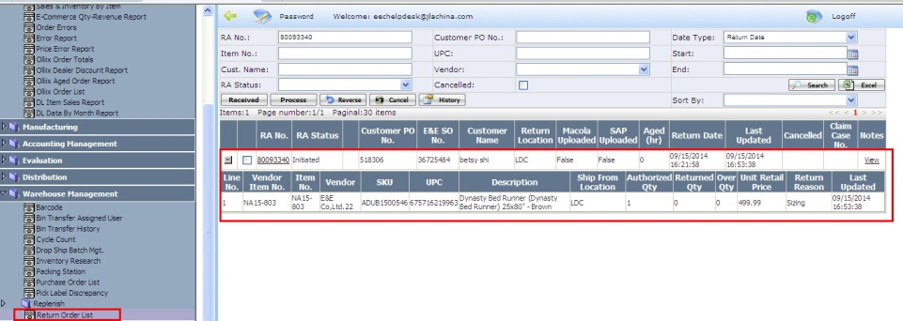
[Pict-5]

Receive return order
- When warehouse user receives the returns, they will input the returned qty usable/unusable and notes.
See below Step ([Pict-6,7]).
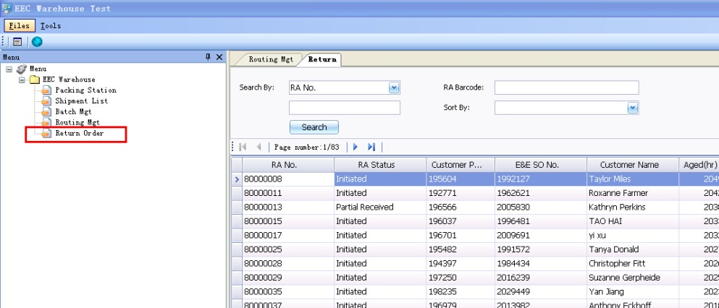
[Pict-6]
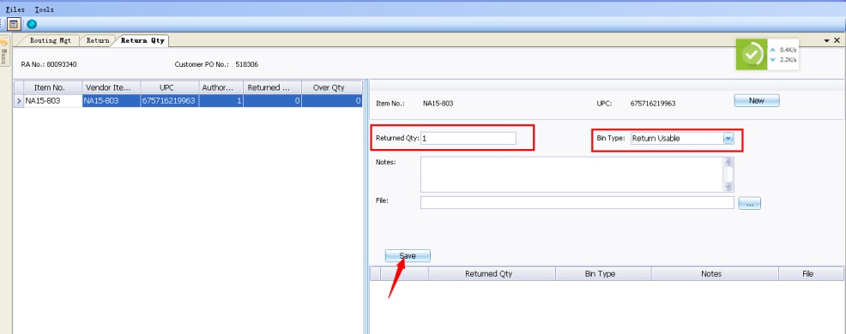
[Pict-7]

- when it finished, Status “Partial Received” will be automatically updated to DL by service “GetRetailSalesOrder/ProcessRA”。See [Pict-8]
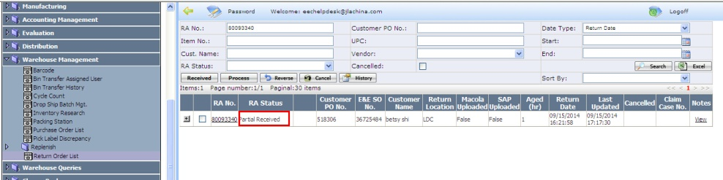
[Pict-8]

Complete return order
- After checking with warehouse and customer and all the returned items have been received completely. Customer service will go to “EECUS-->Sales order management-->return order List” page, click “Received” button.
The RA status will be from “Partial Received” to “Return Processed”.[Pict-9]
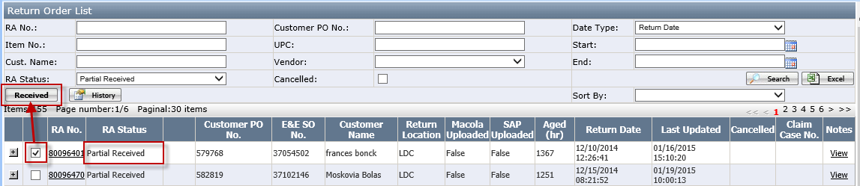
[Pict-9] before clicking received button
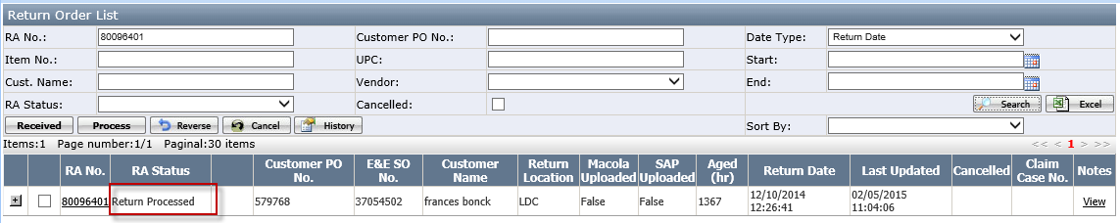
[Pict-10] after clicking received button
- Then, system will operate EECUS Service “Return Order Service” and “GetRetailSalesOrder/ProcessRA”. It will upload RA information to Macola system and to DL website. Meanwhile,The item inventory will be added into Macola table ‘iminvbin_sql’, the location is the default return type location. the Bin is default as the return usable bin or the return unusable bin. If item is usable, it is default to return usable bin; If item is unusable, it is default to return unusable bin . the bin type is set as Bin Location page.
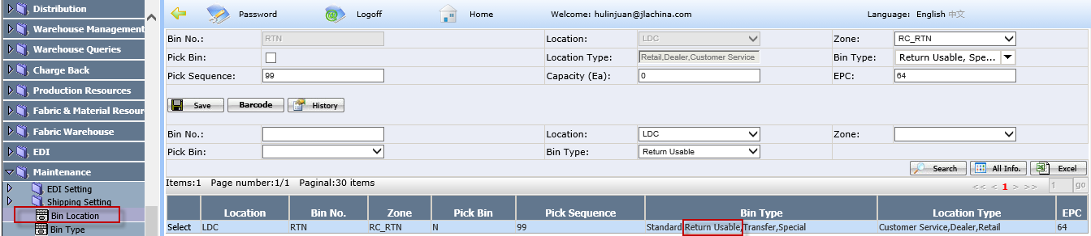

Refund Return Order
- Go back to DL website, now the RA Status will be Return Processed in DL. Customer Service will click on <Refresh> button to have the values of some fields auto-populated except “Shipping” and “Adjustments”, CS can manually enter them after negotiation with customer. See below [Pict-11]
(Notes: Positive number means it should be return to customer. Negative number means it should be subtracted from Return Total.)
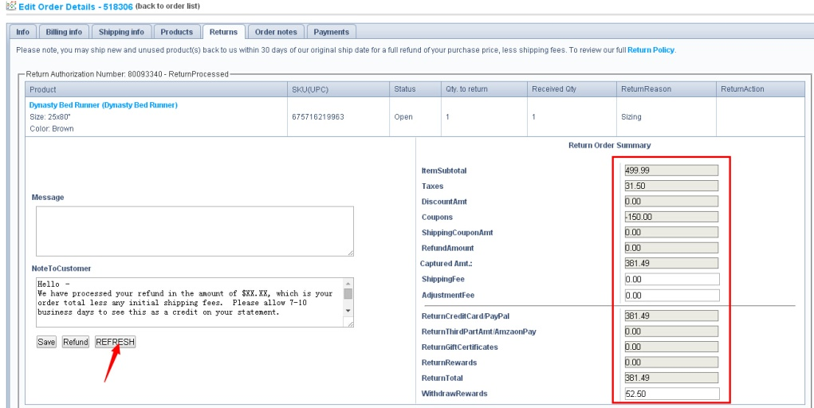
[Pict-11]
- Customer Service will update the refund total and NoteToCustomer field. After saving it, then click<Refund>button, then RA status is from “Return Processed” to “Refund Issued”. See below[Pict-12]
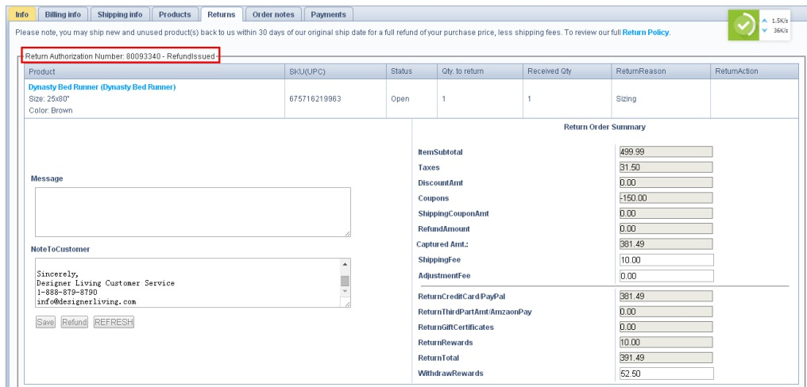
[Pict-12]
- Upload the RA status from DL to EECUS by system service “GetRetailSalesOrder/ProcessRA” and “FeedInfoToCustomerSAP”See below[Pict-13]
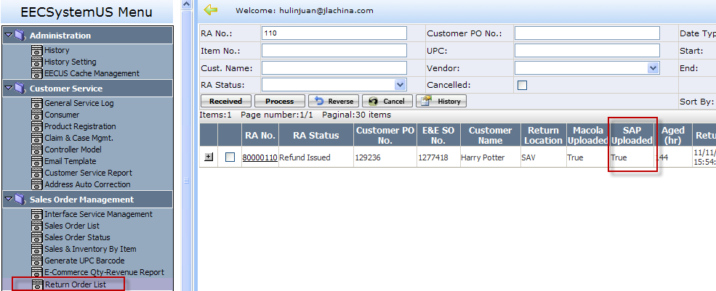
[Pict-13]

How to set up return Bin
1. GO TO Maintenance/Location page and set up a location with “Return Type” checked.
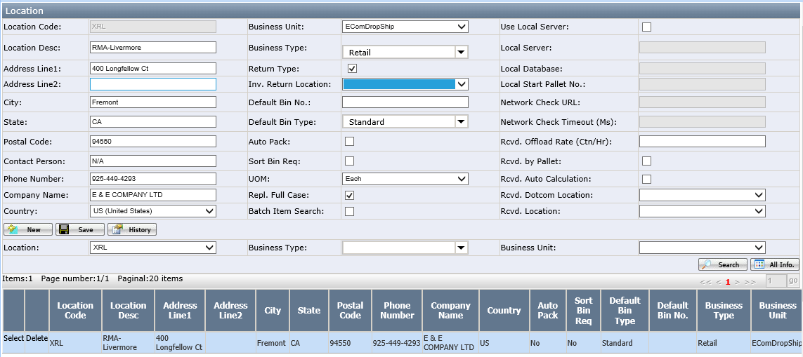
2. GO TO Maintenance/Location page and select another location to link with this return location
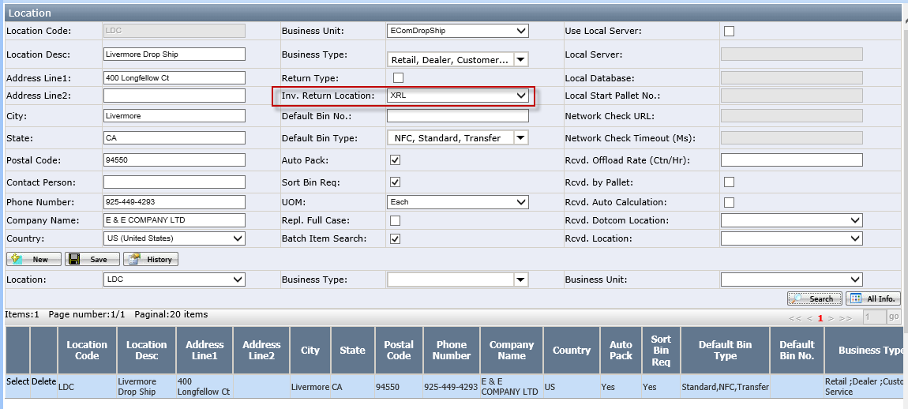
3. Go to Maintenance/Bin location page and create a new bin no, set this bin type is return usable.
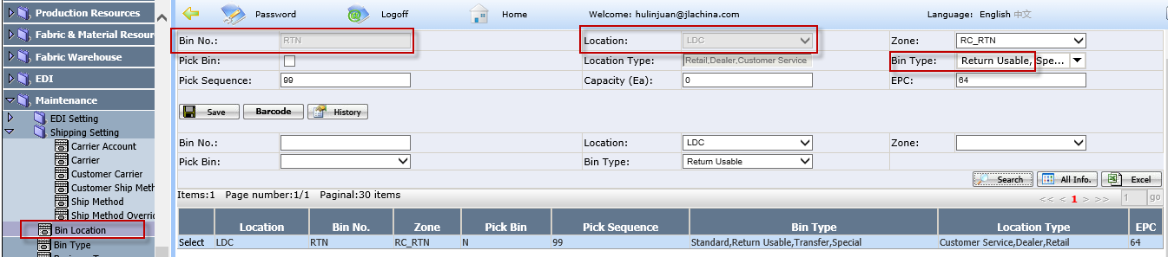
After that. When the bulk return to location “LDC”, the return order’s inventory will be auto added into location “XRL” and the Bin no will be “RTN”.

