Contents
Charge Back Manual 2
Overview 2
Operation 3
❖ Create a Charge Back Case 3
❖ Review a Charge Back Case 6
❖ Accept or Deny a Charge Back Case 7
❖ How to Process Accounting Review Case 10
❖ How to Process Pending Reclaim Case 12
Additional Remarks 13
❖ How to create a case alert 13
❖ How to link a case alert to charge back case 14
❖ How to add note to a charge back case. 15
❖ How to create a credit memo. 16
❖ How to create a Claim 17
❖ How to cancel Claims linked with a charge back case 21
Responsible Party 22
How to create a responsible Party 22
How to change responsible party name 22
How to assign investigation dept. to responsible party 24
How to inactivate a responsible party 25

Charge Back Manual

Overview
The purpose of the Charge Back Module is to systematically manage and follow thru the charge back case, so the accounting team would be able to quantify and manage the charge back cases.
There are 6 process steps for each charge back case. These 6 process steps are followed & processed by 2 groups of people: accounting team and investigation team. Please see below for the process steps and who is responsible to complete each step.
Step | Process Step | Operator
1 | CBC Creation | Accounting Team
2 | CBC Review | Investigation Tem
3 | CBC Deny/CBC Accept | Investigation Tem
4 | CBC Accounting Review | Accounting Team
5 | CBC Pending Reclaim | Accounting Team
6 | CBC Closed | Accounting Team

Operation

Create a Charge Back Case
New case is created by accounting team. Accounting team creates a charge back case and assigns it to related investigation department or push it to “CBC Accounting Review” step directly.
- Go to menu Charge Back->Accounting Process,
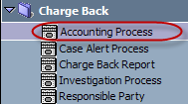
To open Accounting Process webpage which is operated by accounting team.
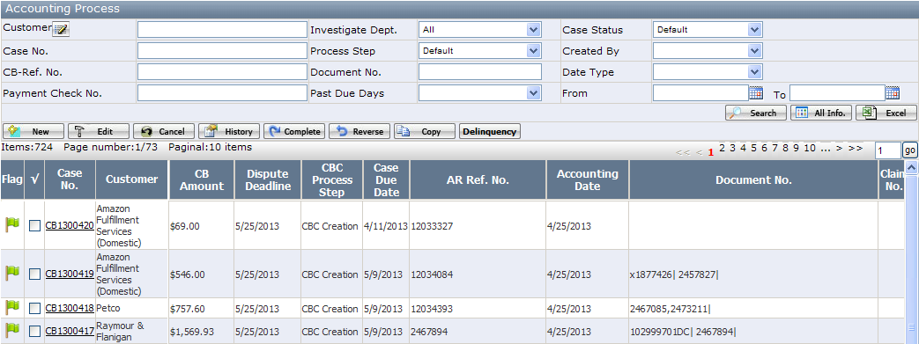
On Accounting Process webpage, you will see a case list. By default, it shows “CBC Creation”, “CBC Accounting Preview” and “CBC Pending Reclaim” cases. You can search all cases by entering various search conditions.
Function button description:

- <New>: Create a new charge back case.
- <Edit>: Edit a charge back case.
- <Cancel>: Cancel a charge back case. Only “CBC Creation” process step case is allowed to be cancelled.
- <History>: View all history records of a charge back case.
- <Complete>: Complete a charge back case to next process step.
- <Reverse>: Reverse a charge back case to previous process step.
- <Copy>: Copy an existing charge back case to create a new case.
- <Delinquency>: Show those charge back cases which Past Due Days is >=-7 and process step is at “CBC Creation”, “CBC Review”, “CBC Accept” or “CBC Deny” .
(Past Due Days=System Date-Investigation Due Date).

- Click <New> button to open a new charge back case page.
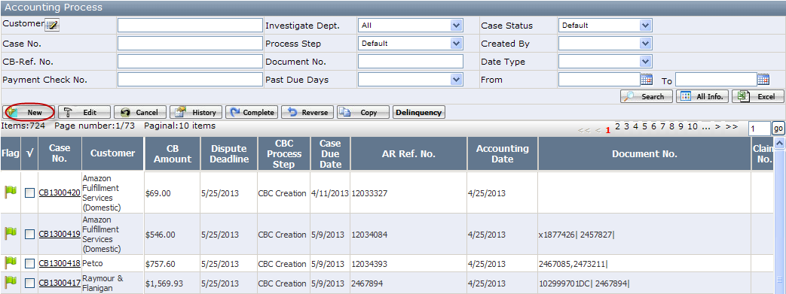
Enter case information (see below fields that marked with red frame) on the opened page, then click <Save> button. Once it is saved successfully, the case is at “CBC Creation” process step.
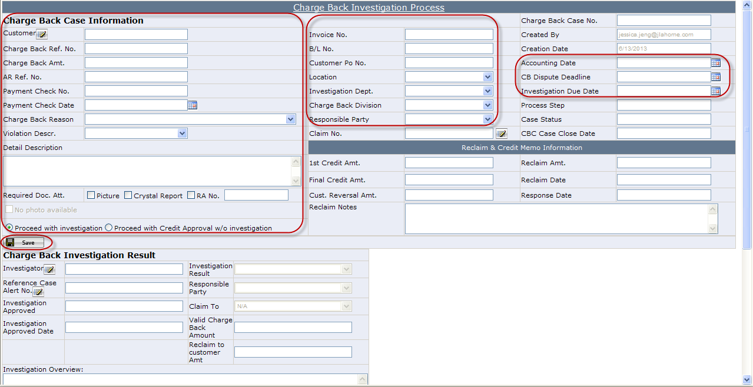
P.S.: By default, Radio button “Proceed with investigation” is selected. If the charge back case doesn’t need investigation, please select “Proceed with Credit Approval w/o investigation.”
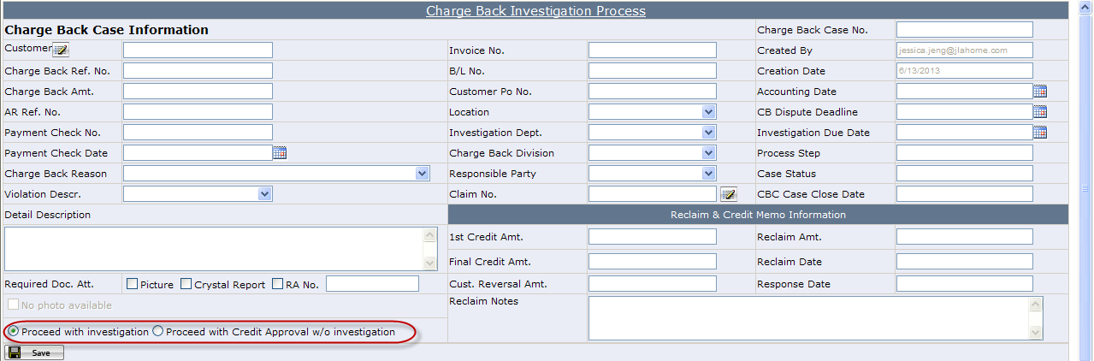
- After the case is correctly created, click <Complete> button to push the case to next process step.
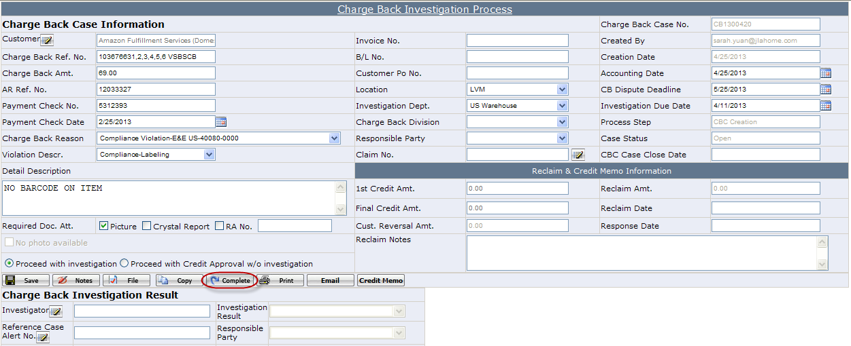
- If
the case will be pushed to investigation department and the process step will be changed to “CBC Review”.
- If
the case will be pushed to “CBC Accounting Review” process step. In this case, the 1st Credit Amt. will default to Charge Back Amt, which means the amount will be accepted. If accounting team doesn’t accept the whole charge back amount, please enter the reclaim amount that the accounting team wants to claim back to customer.
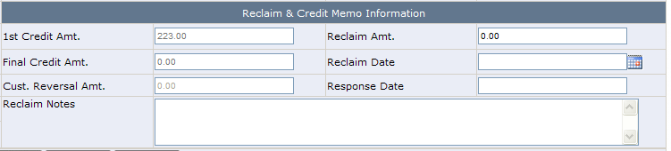

Review a Charge Back Case
Once a charge back case is pushed to “CBC Review” process step, the related Investigation department manager will be able to review the case and assign it to investigators of his/her team.
- Go to menu Charge Back->Investigation Process,
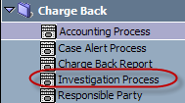
to open the Investigation Process webpage which is operated by investigation team.
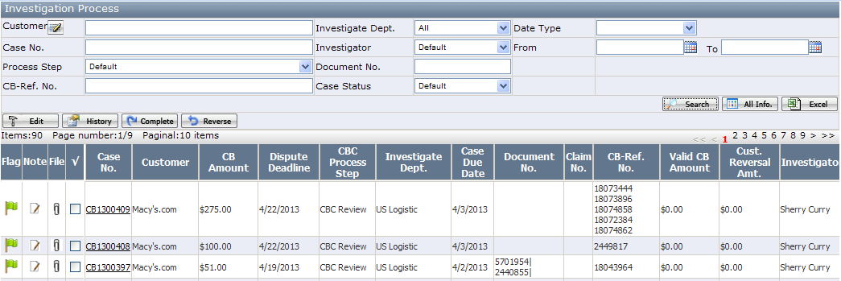
On Investigation Process webpage, user will see a case list. By default, the investigation manager will see charge back cases that assigned to his/her department and case process step is “CBC Review”, “CBC Accept” or “CBC Deny”.
- Investigation manager opens a “CBC Review” case, click icon besides Investigator label to assign the case to investigators.
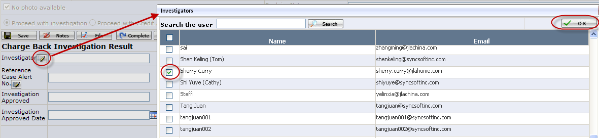

Accept or Deny a Charge Back Case
Once a case is assigned to investigators, investigators are able to see the cases when he/she opens Investigation Process webpage. Investigators must investigate the case and give the investigation result: Charge Back Denied or Charge Back Validated.
- The investigator opens a charge back case which has been assigned to him/her. Based on the investigation, he/she will give the investigation result.
- If investigator accepts the whole charge back amount, he/she must set Valid Charge Back Amount equal to Charge Back Amt., and select “Charge Back Validated” as Investigation result.
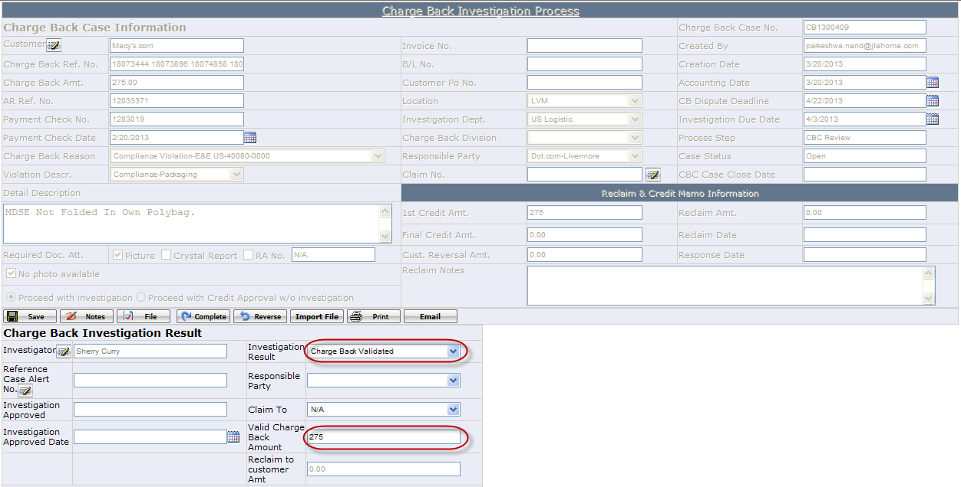
- If investigators don’t accept the whole charge back amount, he/she must enter how much we accept in Valid Charge Back Amount field, and select “Charge Back Denied” as Investigation result. In this case, the Valid Charge Back Amount could be zero. Reclaim to Customer Amt= Charge Back Amt- Valid Charge Back Amount, which is calculated automatically by system.
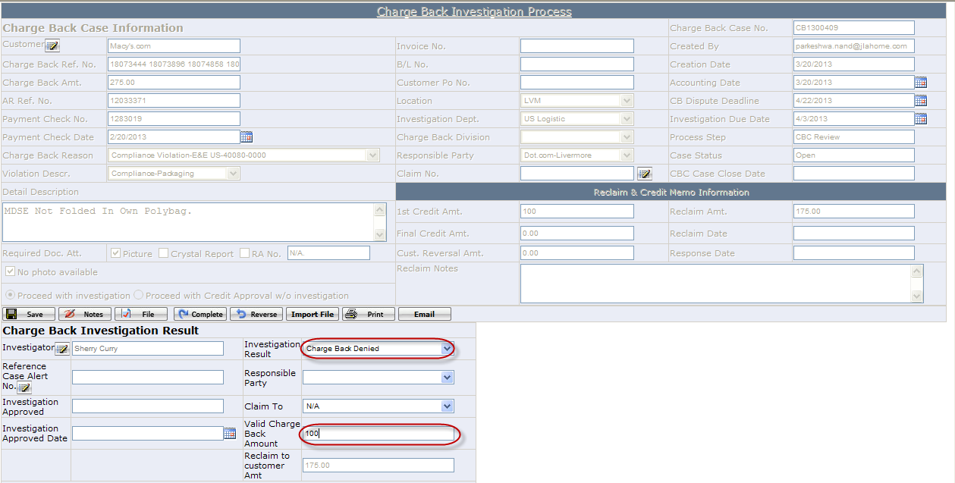
- After Investigator selects investigation result, click <Complete> button to push the case to next step. Based on the investigation result, step 3 will be either <CBC Accept> or <CBC Deny>.
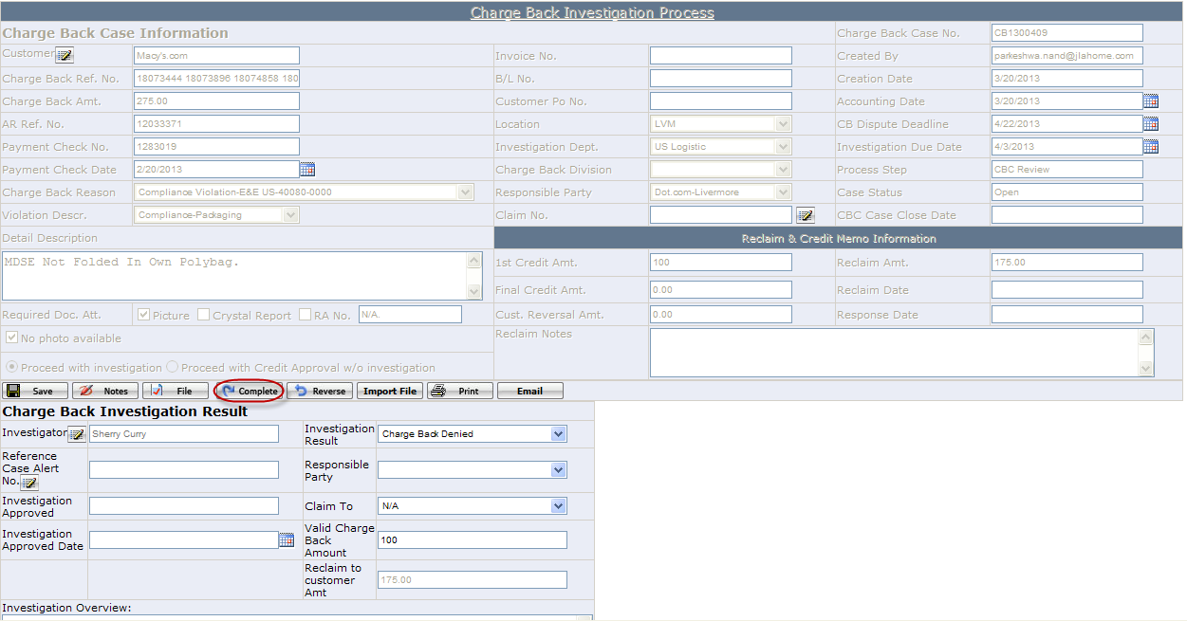
- Investigation manager has to further review the investigation result.
- If investigation manager approves the investigation result, the manager clicks <Approve> button to push the case to “CBC Accounting Review” process step.
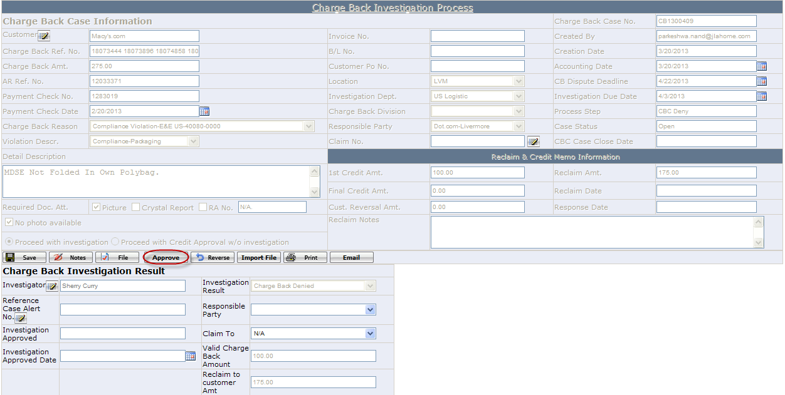
- If investigation manager doesn’t approve the investigation result, the manager should click <Reverse> button to reverse the case back to “CBC Review” step to ask the investigator to re-investigate the case.

How to Process Accounting Review Case
Once the case is completed to “CBC Accounting Review”, 1st Credit Amt=Valid Charge Back Amount, Reclaim Amt. =Reclaim to Customer Amt.
- Click <Credit Memo> button to issue credit memo.
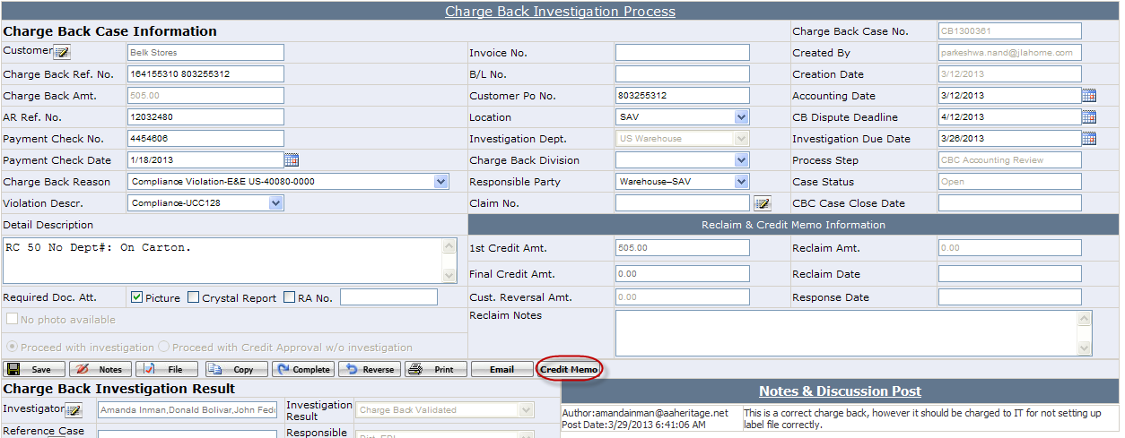
- If Reclaim Amt=0, click <Complete> button to push the case to “CBC Closed” process step.
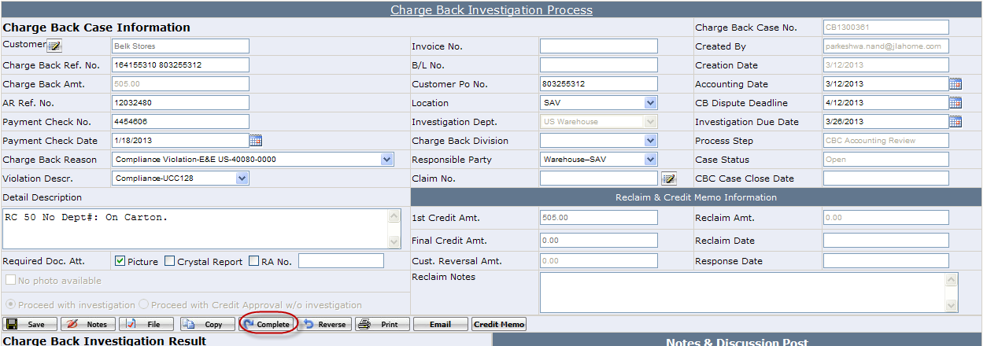
If Reclaim Amt>0,
- Enter reclaim date.
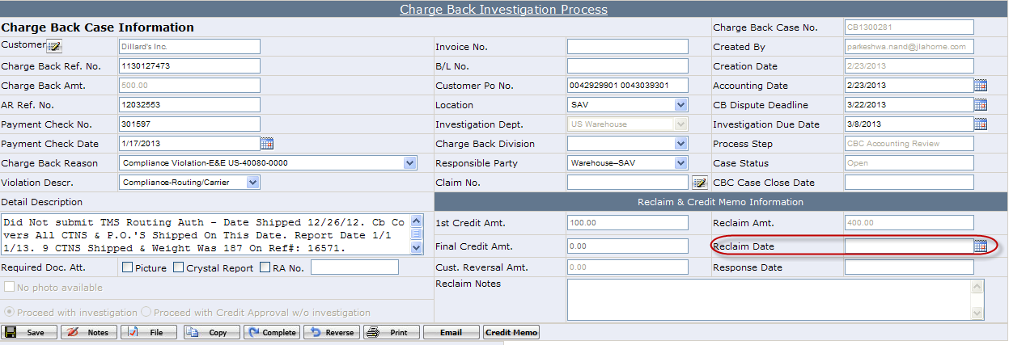
- Click <Complete> button to push case to next process step.
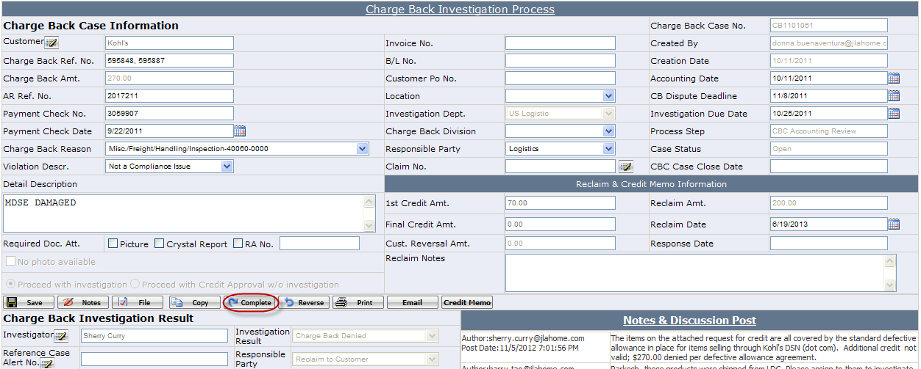
You will see below pop up warning message, if credit memo has been printed out, click <Close> to bypass it and move the case to “CBC Pending Reclaim” process step. Otherwise, click <OK> to go back to case page to do credit memo.
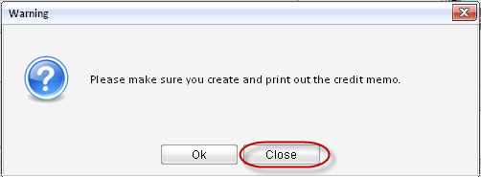

How to Process Pending Reclaim Case
Once accounting team gets response from customer, accounting team should
- Enter Cust. Reversal Amt. and Response Date.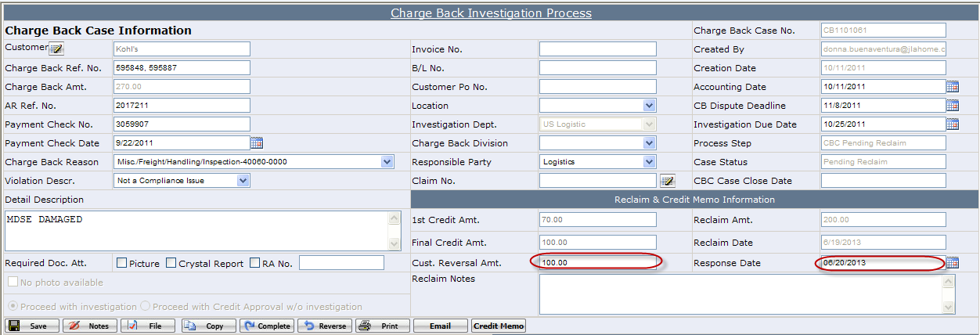 Once Cust. Reversal Amt. is entered, system would auto-calculate Final Credit Amt. Final Credit Amt=Reclaim Amt-Cust. Reversal Amt.
- Issue the final credit memo.
- Click <Complete> button to push the case to “CBC Closed” process step.

Additional Remarks

How to create a case alert
If you can predict a charge back, you can create a case alert in advance. In this case, if the charge back does happen, you can link the case alert to the charge back case.
- Go to menu Charge Back->Case Alert Process.
- Click <New> button to open a new case alert webpage.
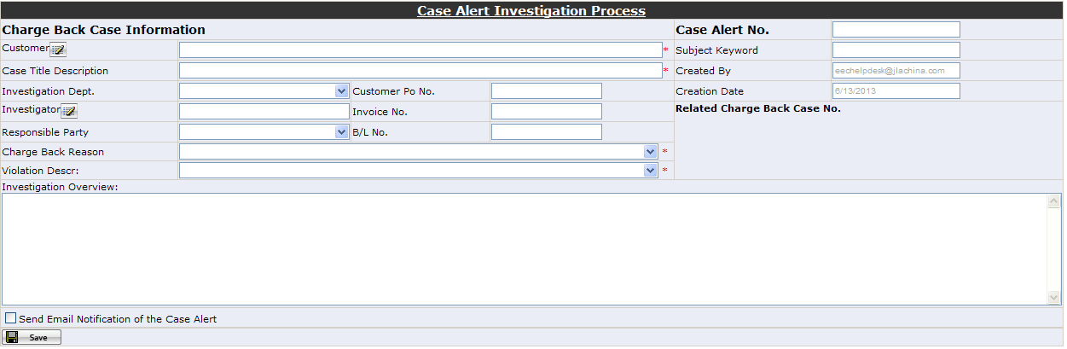
- Enter case alert information, then click <Save>.

How to link a case alert to charge back case
- Click icon besides Reference Case Alert No.
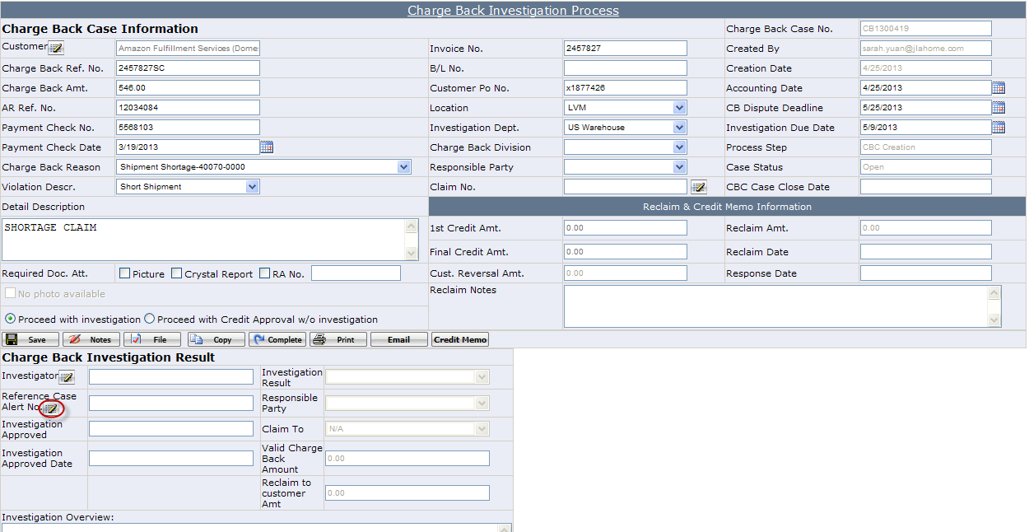
- On pop up window, select the case alert you need and click <OK> button, then the case alert number will show on the charge back case.
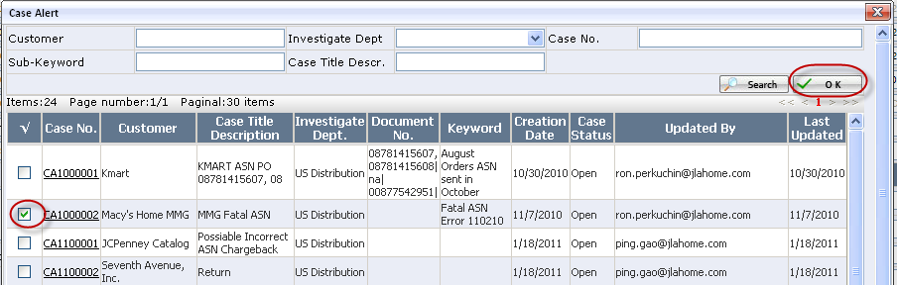

How to add note to a charge back case.
There are two ways to add note.
- There is a <Note> button in case detail page. When you click it, a note entry window will pop up. You can enter your notes here. If you don’t want others except accounting team to see the note, check “Accounting Only”, which means only accounting team can see that note.
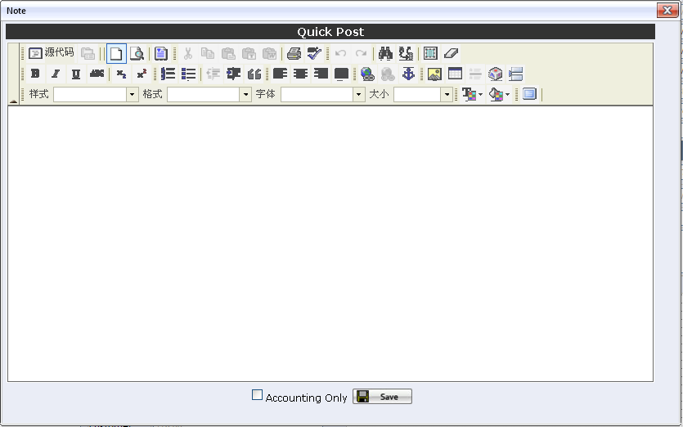
P.S.: “Accounting Only” check box is only visible to Accounting team.
- In the case list grid, there is a “Note” column, you can click the icon to view and add notes.

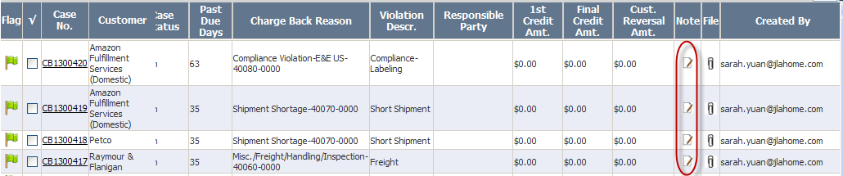

How to create a credit memo.
In case detail page, there is a <Credit Memo> button, which is only used by accounting team. When you click <Credit Memo>, you will see below page.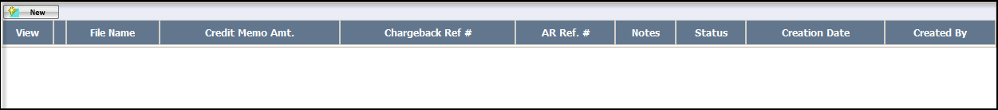
Click <New> to add a credit memo. On below pop up window, enter the credit memo amount and notes.
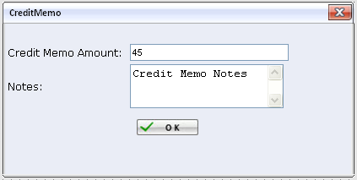
Once it is created, there will be a credit memo record; you can click view to open the credit memo form and print it.
You can cancel the credit memo if necessary, once it is cancelled, the credit memo form cannot be viewed.

How to create a Claim
In case detail page, there is a <Claim> button, which button to set up a claim for this charge back is to claim to factory.
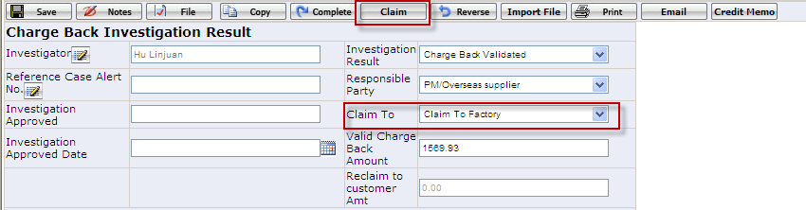
Click <Claim> to pop up claim window as below:
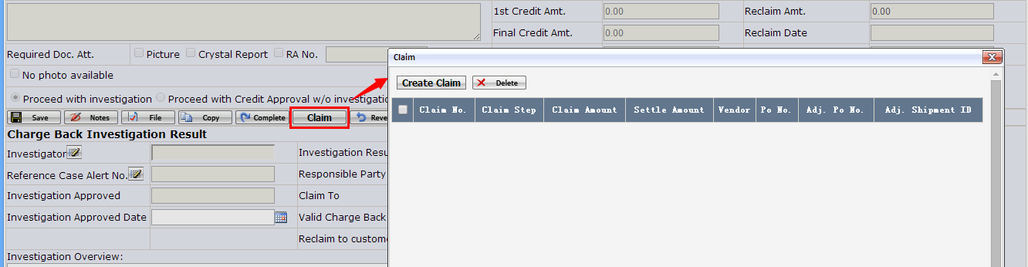
Click <Create Claim > to pop up claim creation page. Search out the po by customer po no or po no. which you are going to claim. See below screenshot.
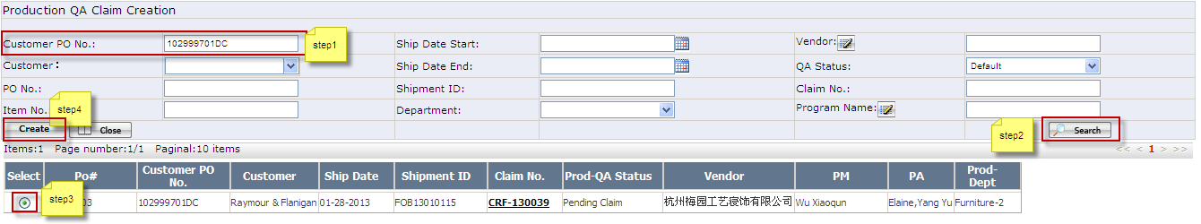
Click the <Create> button to create claim to this charge back case.
There are 3 cases to set up a claims.

Case1: select a po which QA status is “Open” status:
Click the <Create> button to pop up Production Quality Assurance Status Page as below. Select “Production Pending Claim” option and click “Save” button.
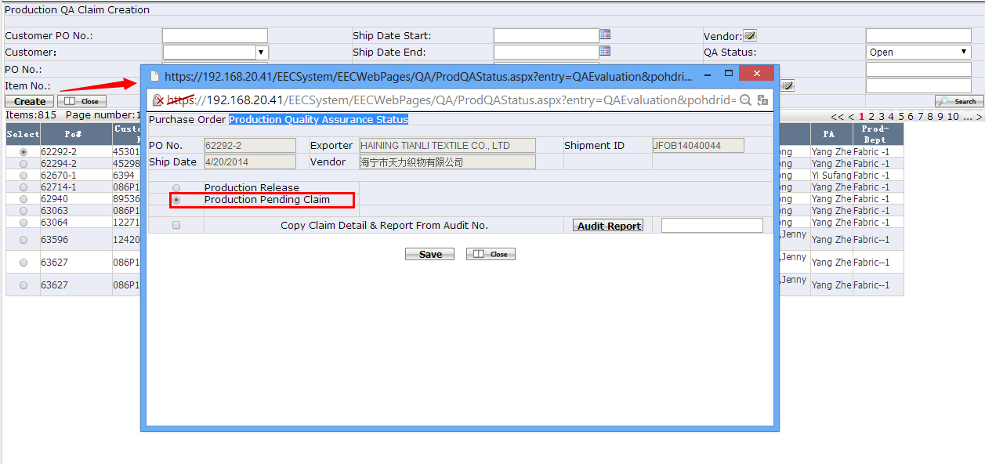
Then pop up claim detail page as below. Specify this claim: Claim Subject, Detail Claim Description, Open Inspection Report and Production Team Claim Settlement Proposal then save them.
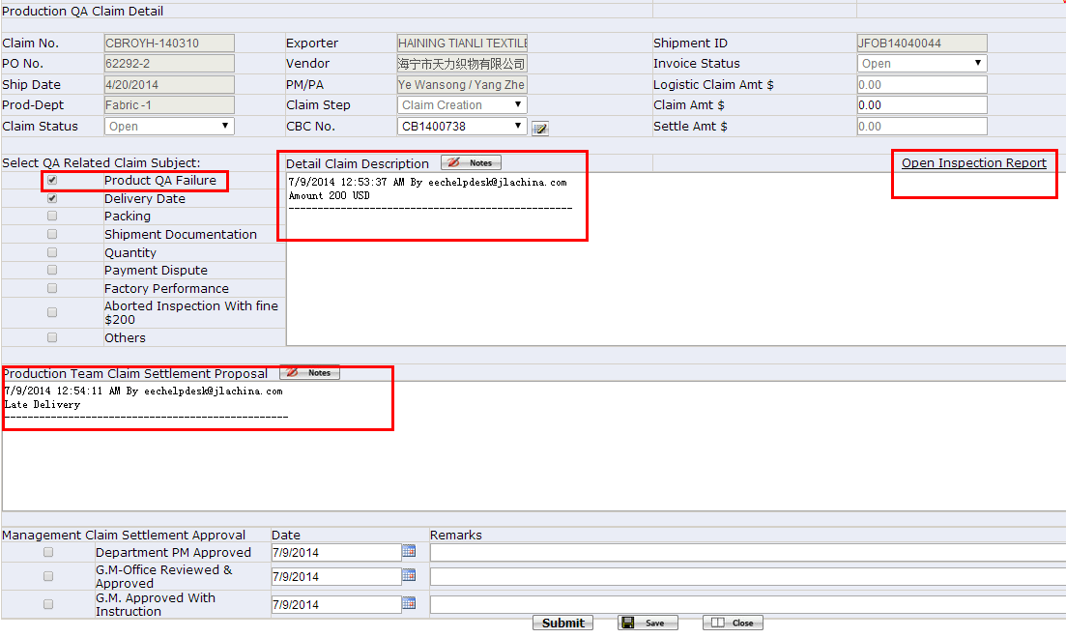
Then, Go back to charge back detail page and click the <Save> button, you will see the claim no has been linked with change back page:
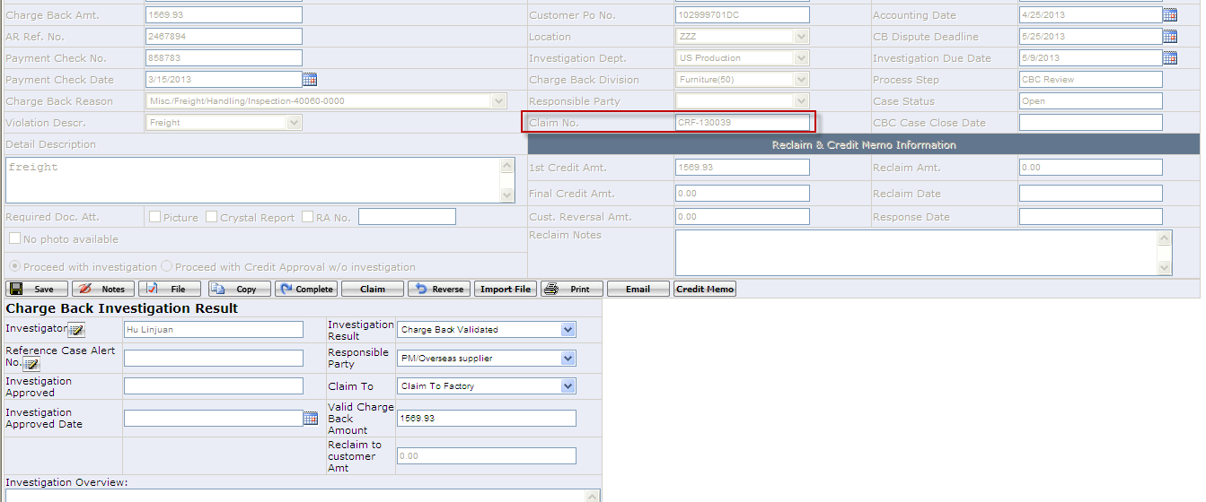

Case2: select a po which QA status is “Pending Claim” or “Claim Resolved” status:
Click the <Create> button to pop up claim detail page as below. There is an area “Production Team Claim Settlement Proposal” and type into PM suggestion, then save it.
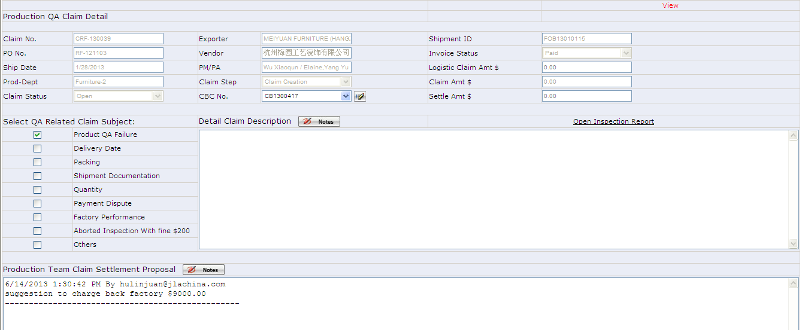
Then, Go back to charge back detail page and click the <Save> button, you will see the claim no has been linked with change back page:

Case3: select a po which QA status is “Prod-Release” status:
Click the <Create> button to pop up claim detail page as below. Specify this claim: Claim Subject, Detail Claim Description, Open Inspection Report and Production Team Claim Settlement Proposal then save them.
Then, Go back to charge back detail page and click the <Save> button, you will see the claim no has been linked with change back page:
After this charge back completed and charge back status is at <Accounting Review>, the accounting team also can click to review the claim detail information as bellows:
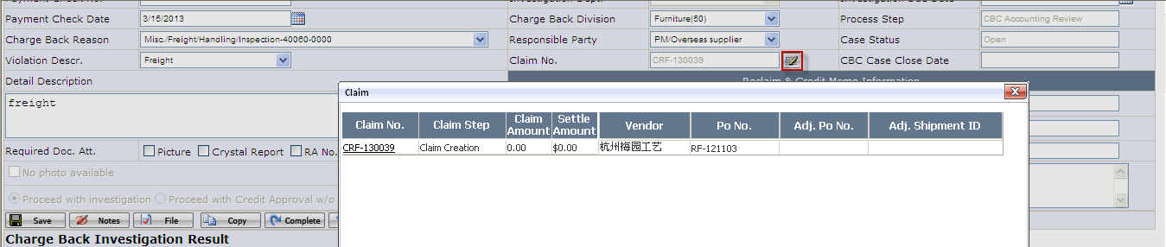

How to cancel Claims linked with a charge back case
In case detail page, there is a <Claim> button, which button to set up a claim for this charge back is to claim to factory and also to cancel claims linked to this charge back case.
Click <Claim> to pop up claim window as below:
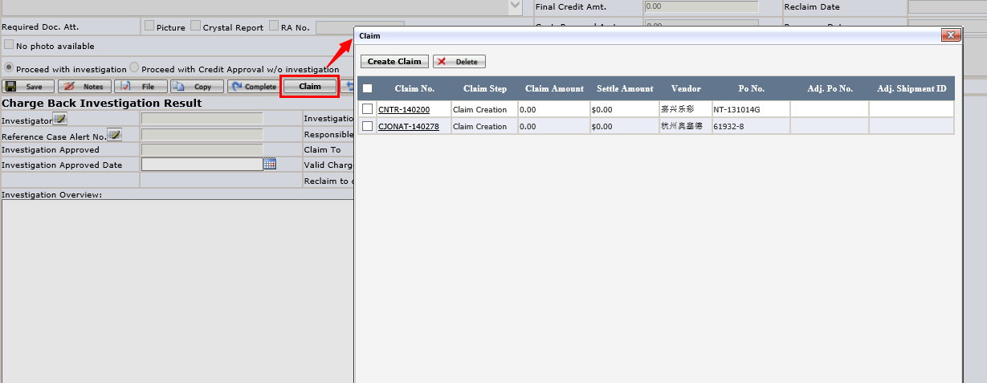
On pop up window, select the claim(s) which need to cancel link with this charge back case and click <Delete> button, then the selected claim(s) will be cancelled and CBC No. will be set blank.

Responsible Party

How to create a responsible Party
- Path of Responsible Party maintenance page: Charge Back->Responsible Party.
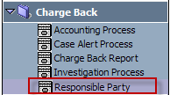
- Enter into the “Responsible Party” and select the Investigation Dept. then save it and the responsible party has been added successfully. see below:
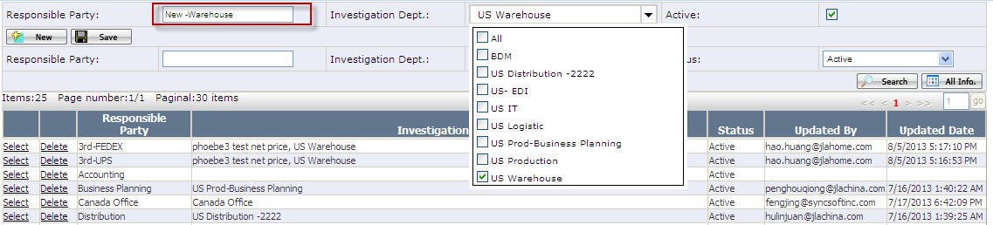

How to change responsible party name
- Find out the responsible party that you need to change name, click ‘Select’.
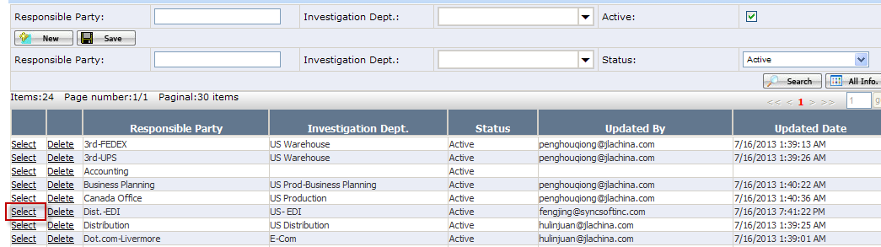
- In edit part, enter its new name in Responsible Party text box.
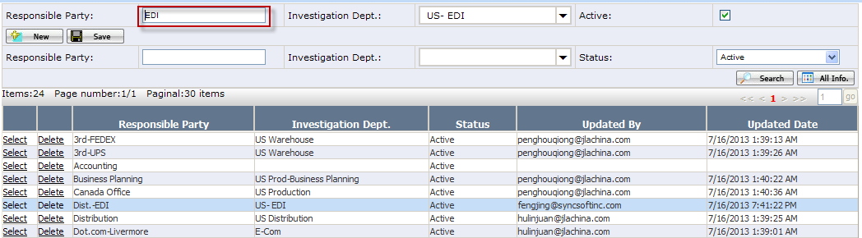
- Click ‘Save’ button.
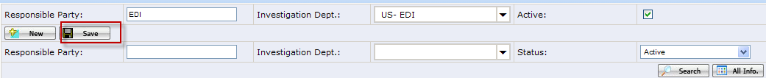

How to assign investigation dept. to responsible party
- Find out the responsible party that you need to assign investigation dept., click ‘Select’.
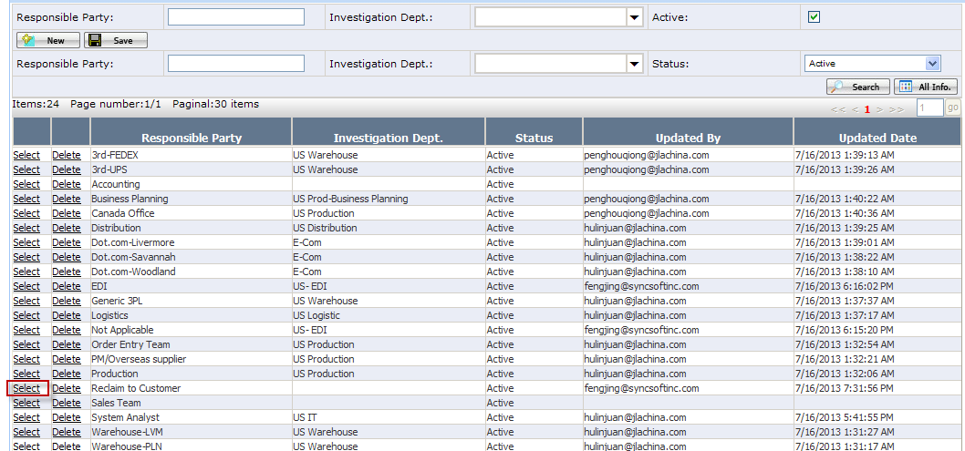
- In edit part, click Investigation Dept. dropdown list, and check which departments you need to assign to the responsible party.
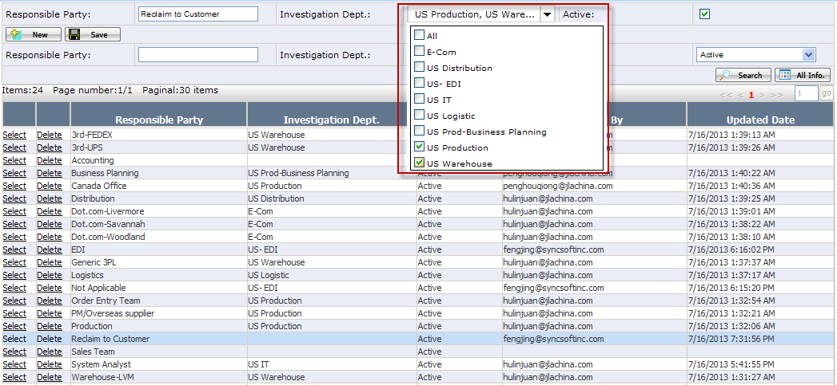
- Click ‘Save’ button.
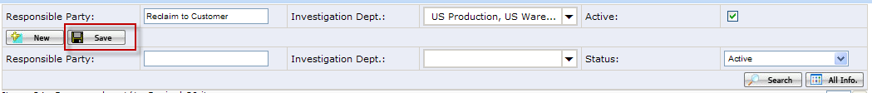
Note: Accounting is able to select all active responsible parties in charge back case.

How to inactivate a responsible party
- Find out the responsible party that you need to inactivate, click ‘Select’.
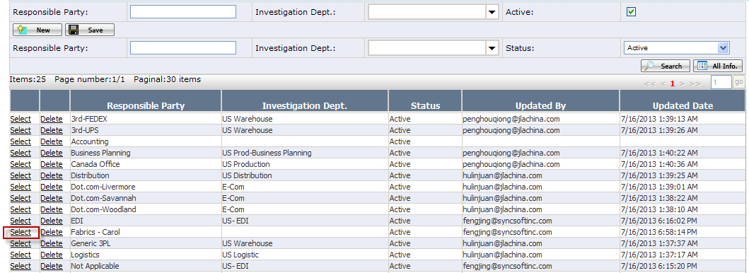
- In edit part, uncheck its ‘Active’ checkbox.
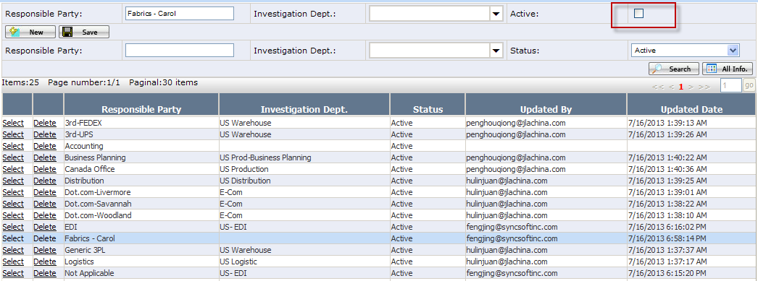
- Click ‘Save’ button, then the responsible party is inactivated.
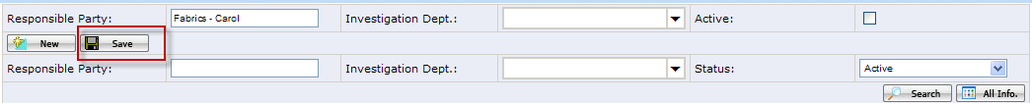
Note: If a responsible party is being used by any non-closed charge back cases, it cannot be inactivated.

