Order date: Wed, Oct 11, 2023
Order number: 2000112-88321570

Your package arrived, CC!
Great news! Items from your order were delivered.

View order

Sold and shipped by Walmart
  Beautyrest Heated Microlight to Berber Solid Blanket, Queen, Chocolate
  $105.20/EA
  Qty: 1
  $105.20

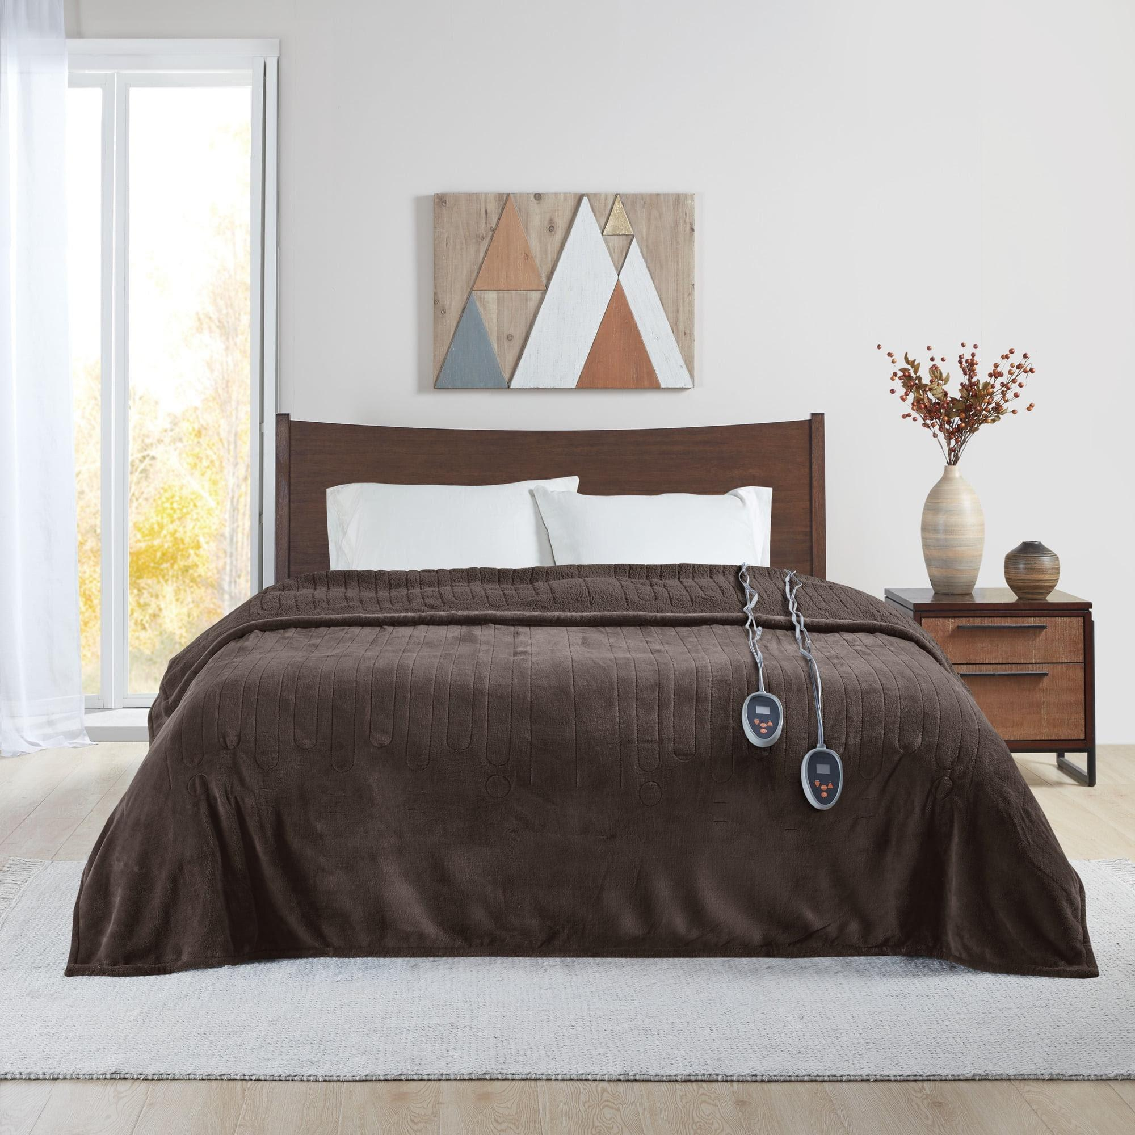

Payment method

VISA ending in 3094

