The finials installed at the foot of the bed on each post need to be removed so that the part needing to be installed (P8, Top Rail) can be installed.

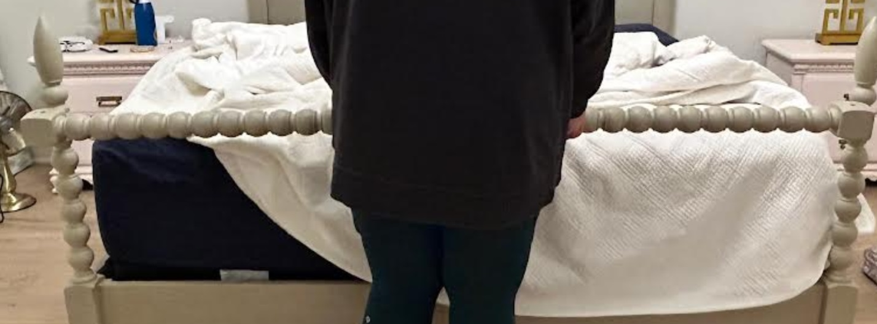

See below, please uninstall part P9, position part P8 on top of each post, then install the finial (part P9) on top of P8 which will also connect down into the post on each side.

