Order Details
Order Date: April 21, 2023
Order Number: 2023111412239872
$160.00 (1 items)
Ship to Home
Joycelyn Thielemier, 5950 Highway 62 W, Pocahontas, AR 72455-927
Status: Shipped
Shipment 1 of 1
Tracking Number
1Z8R7F310399905145
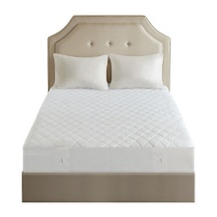
Beautyrest™ Cotton Blend Heated Electric Mattress Pad-5 Heat Settings 10hr Auto off
Product: KING
Color: White
Qty: 1
$148.49
Date Shipped: 04/21/2023
Order Summary
Subtotal:$207.99
Rewards:$10.00
Coupons/Discounts:$49.50
Shipping and Handling:FREE
Tax:$11.51
Total:$160.00
Billing Information

JCP CARD **6785
$160.00
Total may not reflect returns, cancelled items, or other charge backs to your credit card.
2023111412239872
For faster service on exchanges or returns, present this barcode to customer service at any JCPenney store location.
Need help with your order
Customer Care (800) 322-1189
Start a Return
Shipping Information
Joycelyn Thielemier
5950 Highway 62 W
Pocahontas, AR 72455-927
(870) 892-4066
Contact Information
Joycelyn Thielemier
chickjet@yahoo.com
(870) 892-4066

