- Order Number: 6330102379
- Order Date: Sunday, February 26, 2023 at 08:53 AM (CST)
- Items shipped (11 items)
SHIPPING TO
Renee Marchand
39 Beaver St,
Salem , MA 01970
978-621-6803
- SHIPPING METHOD
Standard
PRODUCT DESCRIPTION | SKU | QUANTITY | PRICE | TOTAL
Shipped
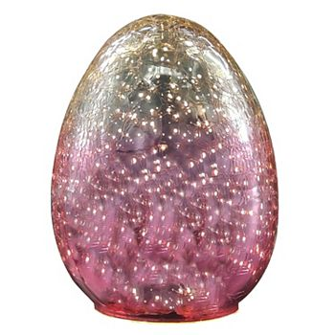  Celebrate Together™ Easter LED Large Yellow & Pink Ombre Glass Egg Table Decor  - ColorMulti  - SizeNO SIZE | 44144560 | 1 | $23.99 | $23.99
Estimated Arrival Thu, Mar 02 2023 to Mon, Mar 06 2023
Tracking#: 9261290274732600672393
Packing Slip/Receipt
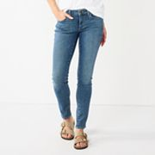  Women's Sonoma Goods For Life® Supersoft Stretch Midrise Skinny Jeans  - ColorMedium Tint  - Size4 | 37857268 | 1 | $19.99 | $19.99
Estimated Arrival Thu, Mar 02 2023 to Mon, Mar 06 2023
Tracking#: 1Z3YA110YW10231211
Packing Slip/Receipt
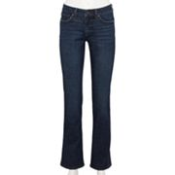  Women's Sonoma Goods For Life® Midrise Bootcut Jeans  - ColorRinse Wash  - Size4 SHORT | 61156630 | 1 | $19.99 | $19.99
Estimated Arrival Thu, Mar 02 2023 to Mon, Mar 06 2023
Tracking#: 9261290274732600672393
Packing Slip/Receipt
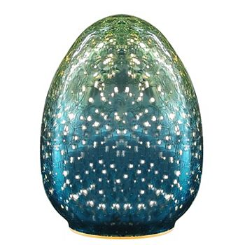  Celebrate Together™ Easter LED Large Blue & Green Ombre Glass Egg Table Decor  - ColorMulti  - SizeNO SIZE | 20863451 | 1 | $23.99 | $23.99
Estimated Arrival Thu, Mar 02 2023 to Mon, Mar 06 2023
Tracking#: 1Z8706650338862503
Packing Slip/Receipt
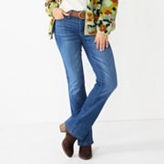  Women's Sonoma Goods For Life® Midrise Bootcut Jeans  - ColorYork  - Size4 SHORT | 58149764 | 1 | $19.99 | $19.99
Estimated Arrival Thu, Mar 02 2023 to Mon, Mar 06 2023
Tracking#: 9261290274732600672393
Packing Slip/Receipt
Women's Sonoma Goods For Life® Midrise Bootcut Jeans  - ColorRinse Wash  - Size4 AVG/REG | 46974528 | 1 | $19.99 | $19.99
Estimated Arrival Thu, Mar 02 2023 to Mon, Mar 06 2023
Tracking#: 9261290274732600672393
Packing Slip/Receipt
Women's Sonoma Goods For Life® Midrise Bootcut Jeans  - ColorYork  - Size4 AVG/REG | 37324640 | 1 | $19.99 | $19.99
Estimated Arrival Thu, Mar 02 2023 to Mon, Mar 06 2023
Tracking#: 9261290274732600672393
Packing Slip/Receipt
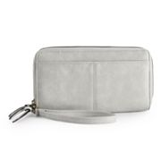  Sonoma Goods For Life® Elowen RFID-Blocking Double Zip Wristlet  - ColorHarbor Mist  - SizeONE SIZE | 75306803 | 1 | $29.25 | $29.25
Estimated Arrival Thu, Mar 02 2023 to Mon, Mar 06 2023
Tracking#: 1Z4E2R09YW29492115
Packing Slip/Receipt
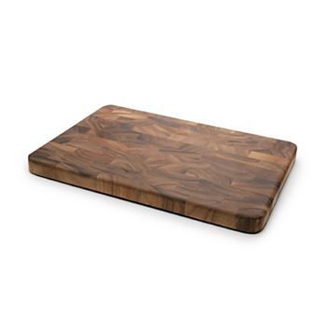  Ironwood Gourmet Large Prepping Station  - ColorBrown  - SizeNO SIZE | 98805839 | 1 | $99.99 | $99.99
Estimated Arrival Thu, Mar 02 2023 to Mon, Mar 06 2023
Tracking#: 1Z1760960304079510
Packing Slip/Receipt
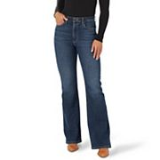  Women's Wrangler Stretch Flare Jeans and Corduroy  - ColorBrockton  - Size4X30 | 37638357 | 1 | $41.99 | $41.99
Estimated Arrival Thu, Mar 02 2023 to Mon, Mar 06 2023
Tracking#: 1Z4E2R09YW29492115
Packing Slip/Receipt
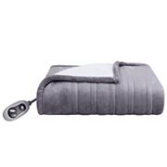  Cuddl Duds® Heated Plush Sherpa Throw  - ColorGray  - SizeTHROW | 72629212 | 1 | $39.19 | $39.19
Estimated Arrival Thu, Mar 02 2023 to Mon, Mar 06 2023
Tracking#: 1Z8706650338862503
Packing Slip/Receipt
  - BILLED TO
Renee Marchand
39 Beaver St,
Salem, MA 01970
978-621-6803
  - PAYMENT METHOD
  - Kohl's Charge x9099
Total: -$175.72
Kohl's Cash
  - -$2.82
  - Paid with Kohls Card x5993
Kohl's Cash
  - -$26.42
  - Paid with Kohls Card x6612
Kohl's Cash
  - -$33.02
  - Paid with Kohls Card x5766
Kohl's Cash
  - -$126.76
  - Paid with Kohls Card x2597
- Subtotal:
- $358.35
- Kohl's Cash & Promos:
- $189.02
- Kohl's Cash x5993
- -$2.82
- Kohl's Cash x6612
- -$26.42
- Kohl's Cash x5766
- -$33.02
- Kohl's Cash x2597
- -$126.76
- Shipping:
- FREE
- Standard To 01970
- FREE
- Fees & Tax
- $6.39
- Sales Tax
- $6.39
- Total
- $175.72
- YOUR EARNINGS
- Kohl's Rewards: $12.70
added to balance

