Hi, Ellen!
Rewards ID: 9100 9700 211
- My Info
- Orders

FAQS
- Can I cancel or change my order?
- I can't find my order
- Order Tracking Definitions

QUESTIONS?
Contact us and we'll be happy to assist you with any questions about your order.
< Back to Order History
Order Details
- Order Number: 6298994897

- Order Date: Saturday, November 19, 2022 at 20:01 PM (CST)
- Items shipped (2 items)
SHIPPING TO
Ellen Wolatz
319 Cimarron Rd.,
Lombard , IL 60148
630-620-7198

- SHIPPING METHOD
Standard
PRODUCT DESCRIPTION | SKU | QUANTITY | PRICE | TOTAL
Shipped
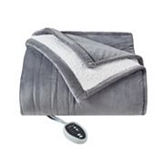  Cuddl Duds® Heated Plush Sherpa Blanket  - ColorSlate Gray  - SizeTWIN | 81867679 | 1 | $89.99 | $89.99
Estimated Arrival Fri, Nov 25 2022 to Tue, Nov 29 2022
Tracking#: 1Z596A4W0319338950 Packing Slip/Receipt
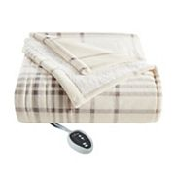  Cuddl Duds® Heated Plush Sherpa Blanket  - ColorIvory Plaid  - SizeTWIN | 34171200 | 1 | $89.99 | $89.99
Estimated Arrival Fri, Nov 25 2022 to Tue, Nov 29 2022
Tracking#: 1Z596A4W0319338950 Packing Slip/Receipt

  - BILLED TO
Ellen Wolatz
319 Cimarron Rd.,
Lombard, IL 60148
630-620-7198

  - PAYMENT METHOD
Kohl's Charge x9913
Total: -$133.85

- Subtotal:$179.98
Kohl's Cash & Promos:$54.00
SAVE30-$54.00
Shipping:FREE
Standard To 60148FREE
Fees & Tax$7.87
Sales Tax$7.87
Total$133.85
YOUR EARNINGS
Kohl's Rewards: $9.45

added to balance

