PO# | TRACKING NO
28806339 | 1Z449FE50390583368
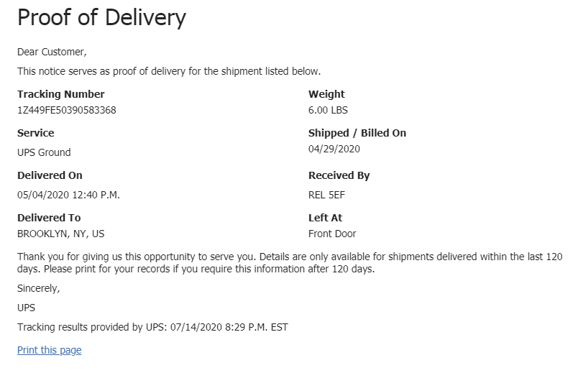
PO# | TRACKING NO
45118360 | 1Z449FE50339306861

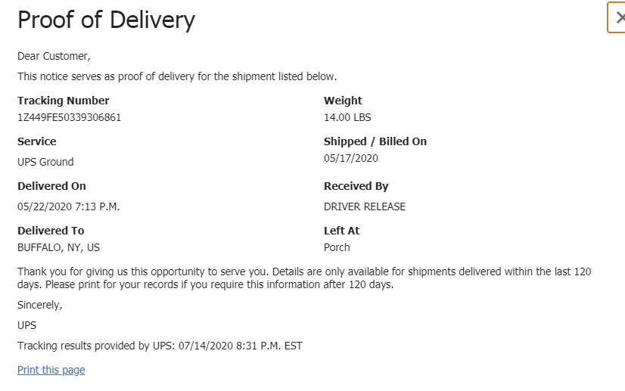

PO# | TRACKING NO
50367890 | 1Z449FE50334320247
