1Z449FE50334718970
PO# 3551384
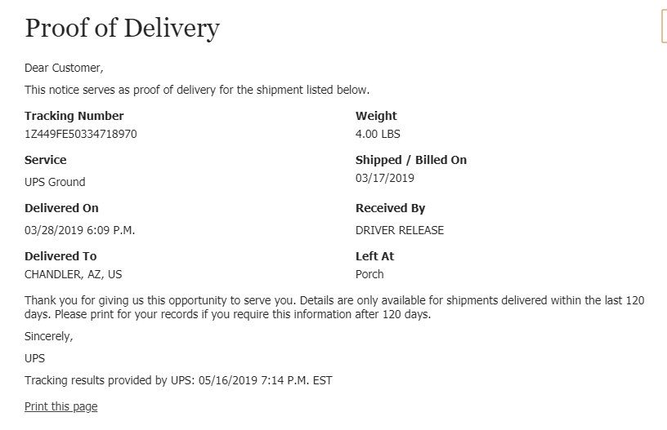
1Z449FE50322059124
Po# 5629668
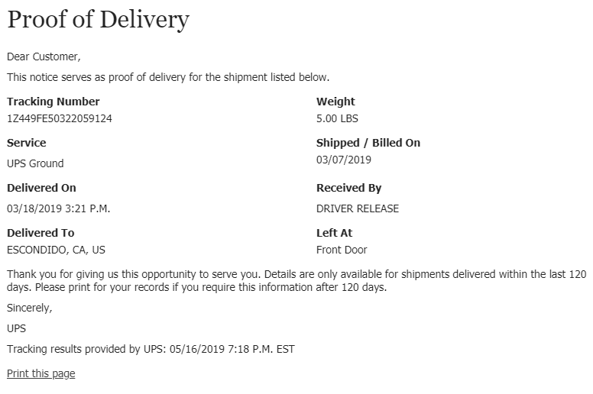
1Z449FE50333977362
Po# 5840671
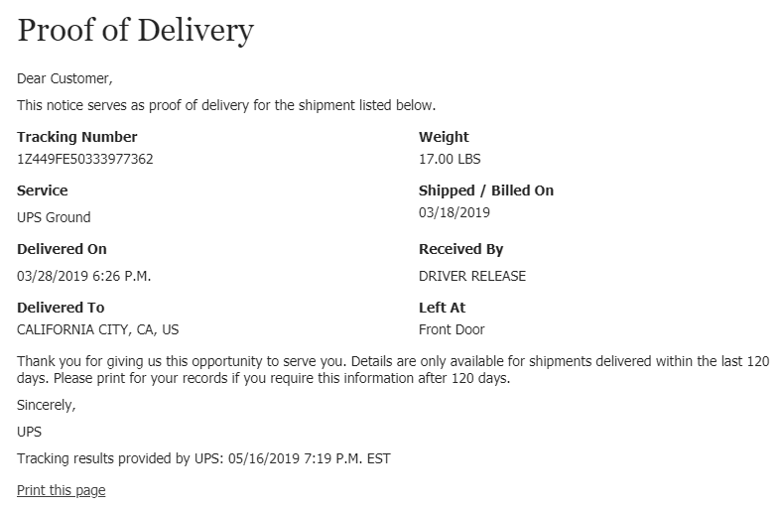
1Z449FE50335692317
Po# 6624169
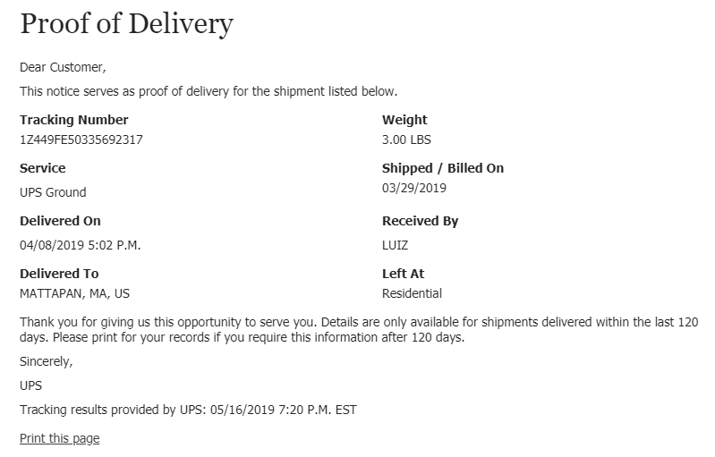
1Z449FE50334812288
Po# 8373741
