PO# | TRACKING NO.
CS153936925 | 538326913126858
CS154665320 | 538326913173999,  538326913174019
CS155629393 | 538326913242268
CS156075084 | 538326913280963
CS156432444 | 538326913303631
CS156793654 | 538326913321451
CS157113808 | 538326913341152
CS156825174 | 538326913339449
CS156957142 | 538326913339968
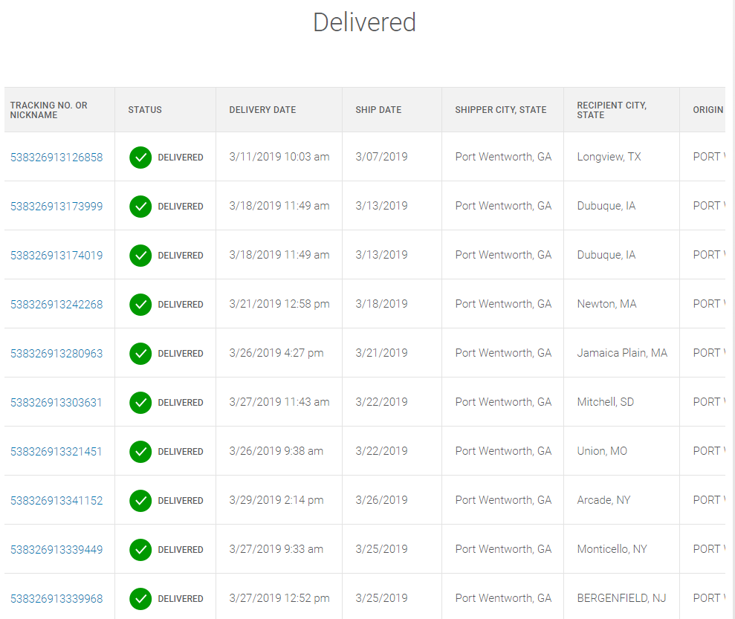
PO# | TRACKING NO.
CS157180561 | 538326913349028
CS157558302 | 538326913384555
CS158076237 | 538326913402921
CS158211824 | 538326913424596
CS158657387 | 538326913466596
CS158790093 | 538326913469818
CS158790093 | 538326913469818
CS158790093 | 538326913469818
CS158787355 | 538326913465469
CS158900514 | 538326913482213
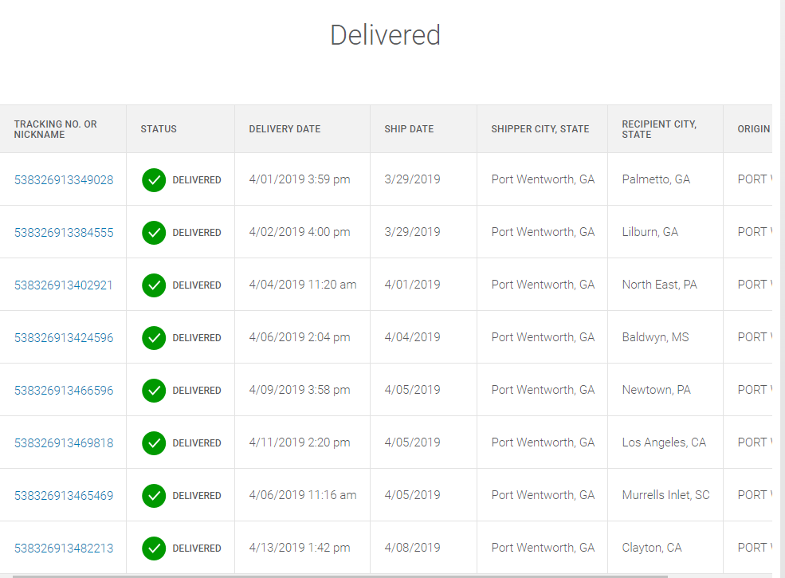
PO# | TRACKING NO.
CS158979665 | 538326913487027
CS159240695 | 538326913513559
CS159632101 | 538326913527778
CS160085496 | 538326913546656
CS159999713 | 538326913548544
CS159731672 | 538326913533670
CS160239816 | 538326913557584
CS159975251 | 538326913540005
CS160007192 | 538326913553678
CS160064978 | 538326913549824
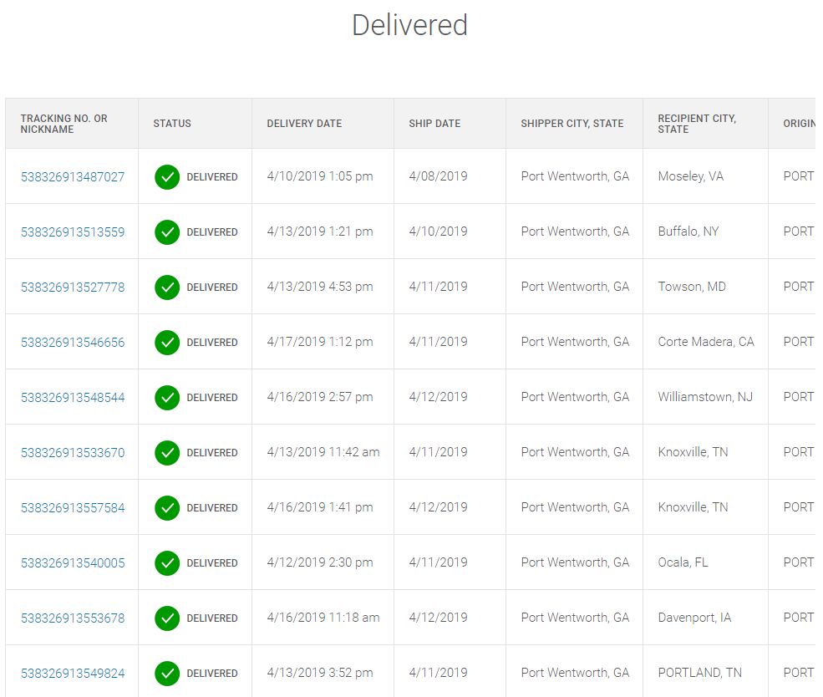
PO# | TRACKING NO.
CS160010304 | 538326913547684
CS160358756 | 538326913555160
CS160790477 | 538326913576035
CS160415294 | 538326913563189
CS160811031 | 538326913588038
CS160627458 | 538326913575328
CS160802846 | 538326913588281
CS160357556 | 538326913576646
CS160680842 | 538326913585990
CS161051051 | 538326913606961
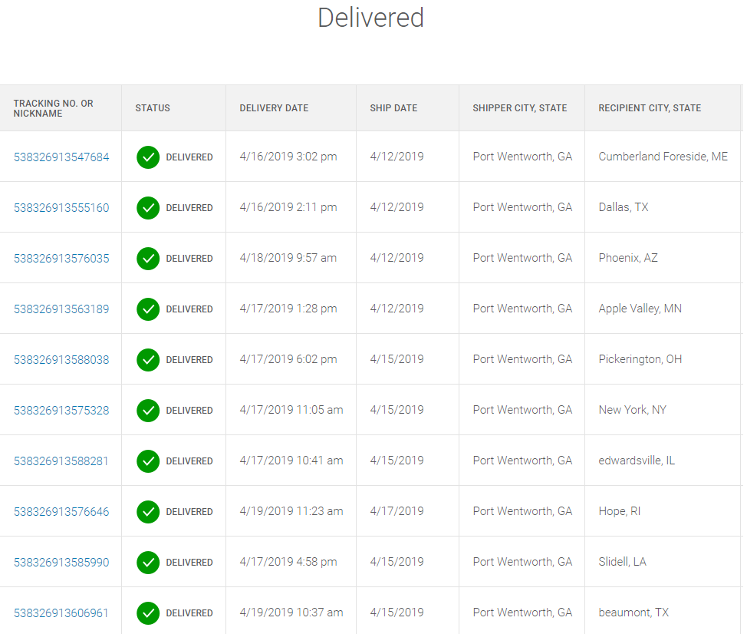
PO# | TRACKING NO.
CS160888318 | 538326913624408
CS161213459 | 538326913614607
CS160921232 | 538326913610661
CS160511794 | 538326913609207
CS160887972 | 538326913603120
CS160887972 | 538326913602840
CS161192300 | 538326913615291
CS161049974 | 538326913628536
CS161045053 | 538326913598969
CS160058626 | 538326913592028
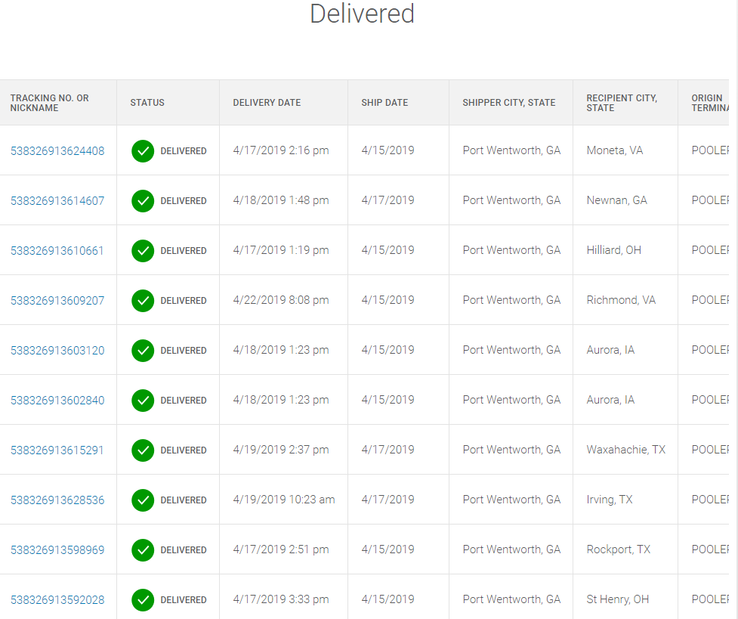
PO# | TRACKING NO.
CS161208186 | 538326913627898
CS161211216 | 538326913619022
CS161196897 | 538326913653941
CS161342521 | 538326913643249
CS161386307 | 538326913638863
CS161273591 | 538326913629656
CS161327562 | 538326913642426
CS161511642 | 538326913658229
CS161739750 | 538326913686055
CS161527494 | 538326913657932
CS161818542 | 538326913697051
