1Z449FE50393973593
PO# 1045865
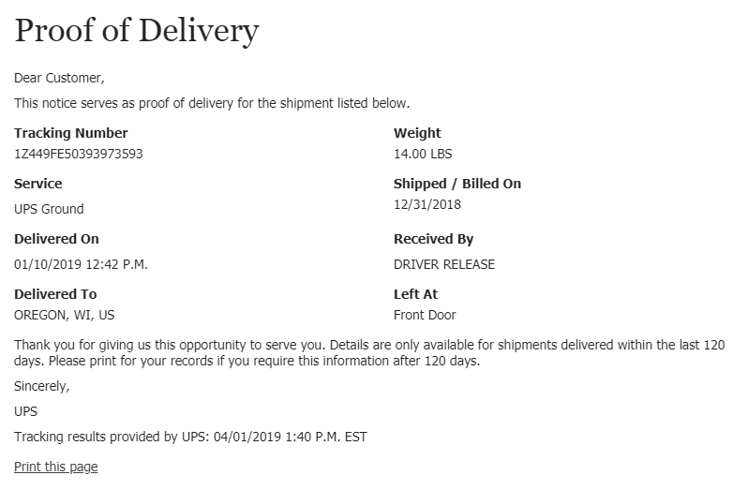
1Z449FE50331986427,
1Z449FE50336075447
PO# 3795415
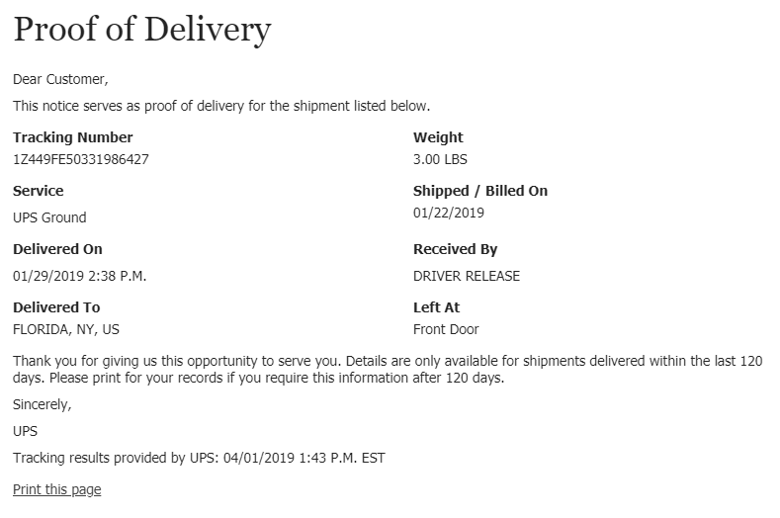
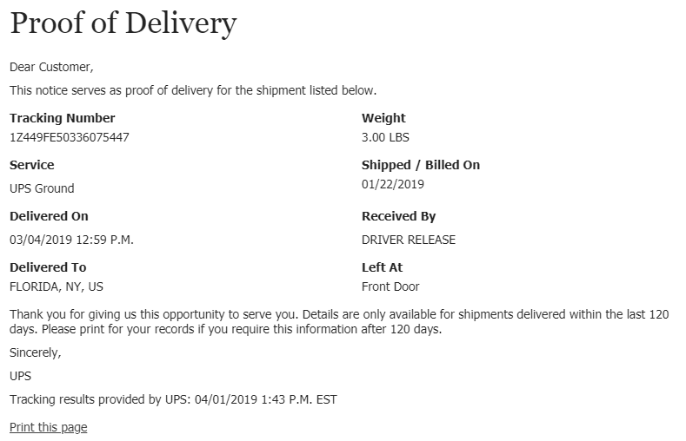
1Z449FE50390411945
PO# 7601280
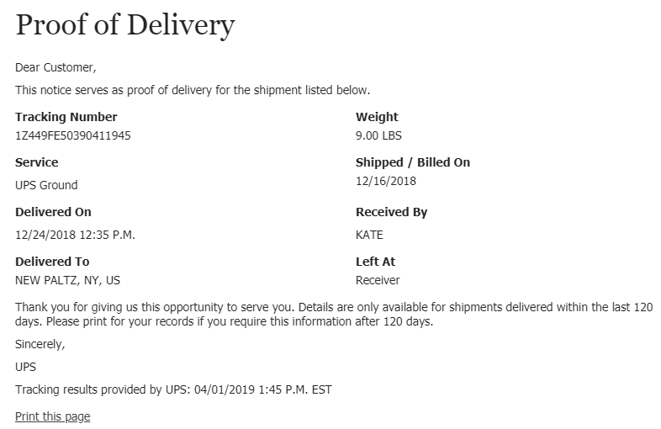

1Z449FE50327480230
PO# 8008976
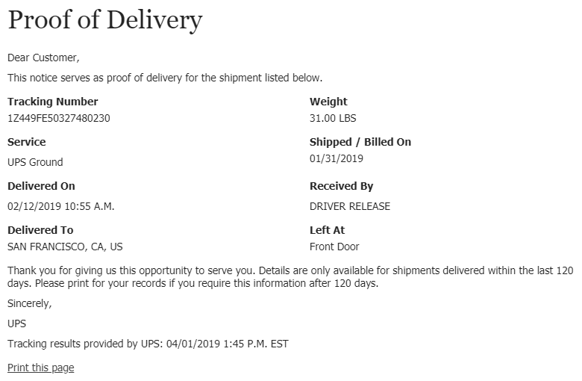
1Z449FE50339722358
PO# 8246532
