1Z449FE50390170858

PO# 8180923
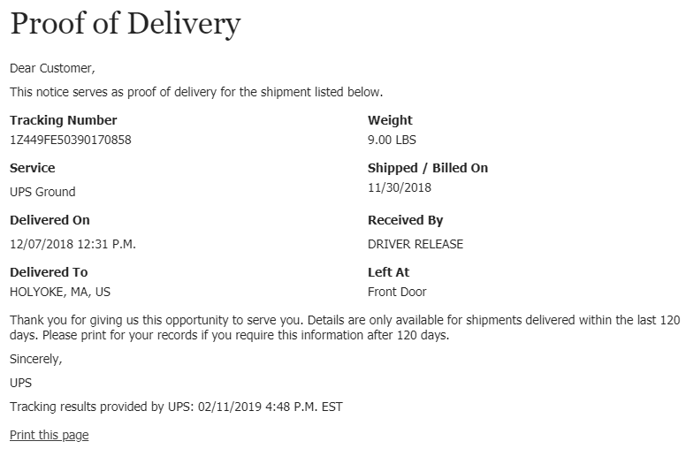

1Z449FE50327728688
PO# 4326779
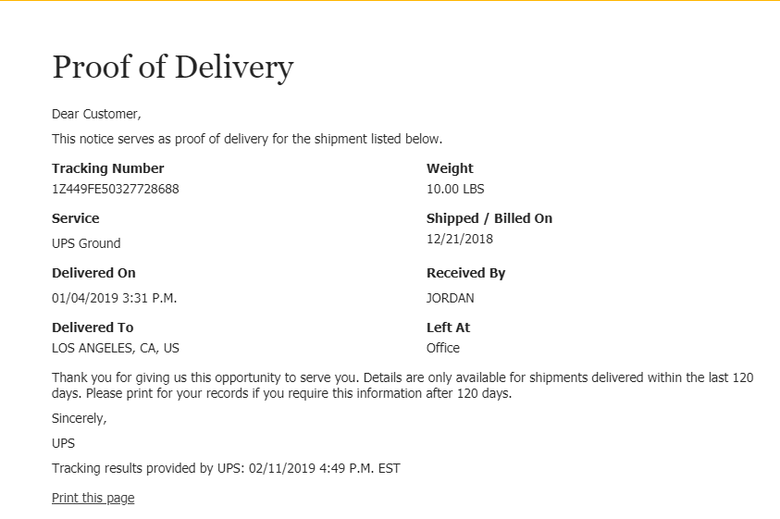
1Z449FE50393138478
PO# 2904149
