1Z8R7F310391899122
PO#455781983
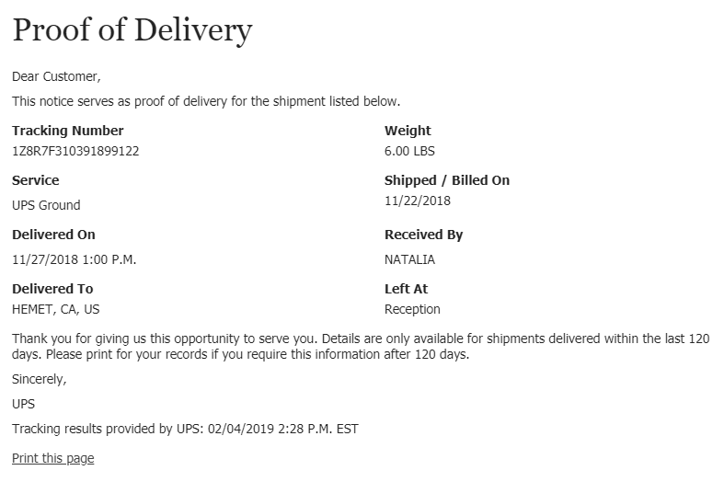

1Z8R7F310392819386
PO# 456093531
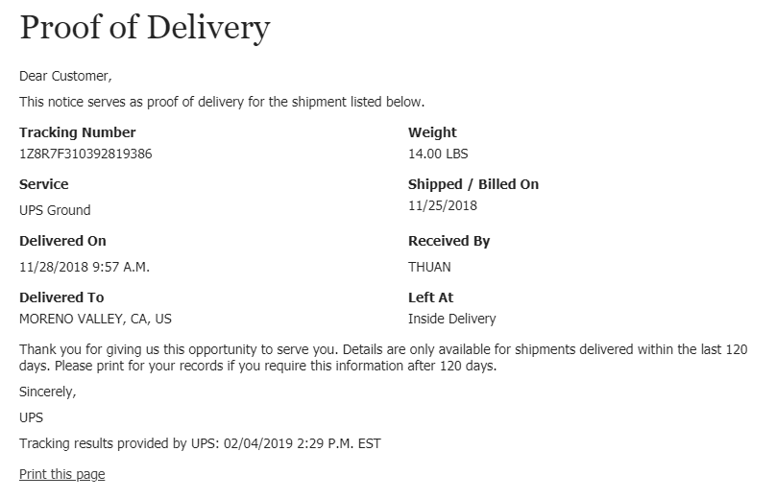
1Z8R7F310392442112
PO# 456303652
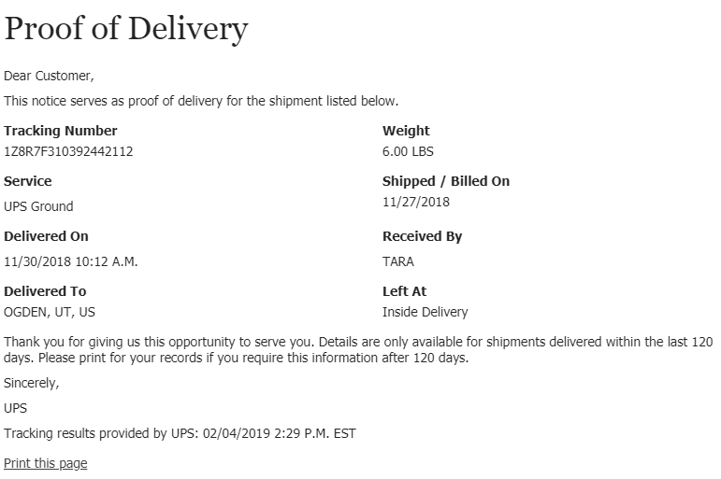
1Z8R7F310396034172
PO# 456307643
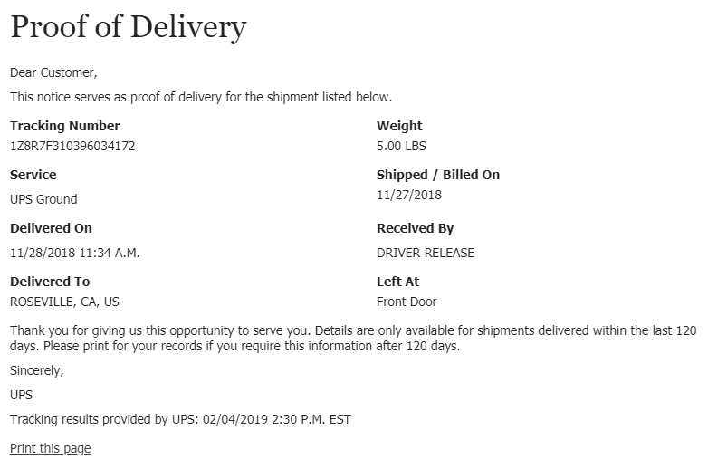
1Z3026EY0342794986,
1Z3026EY0343064530,
1Z8R7F310395940757
PO# 456320473
