1Z449FE50339354569
PO# 1549037
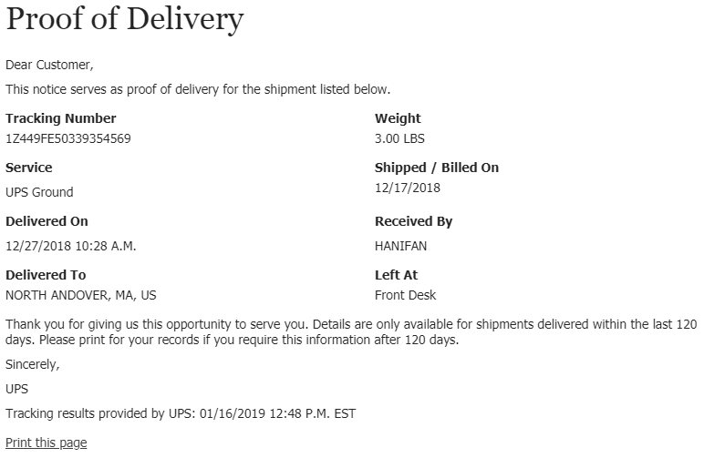
1Z449FE50391820742
PO# 3724507
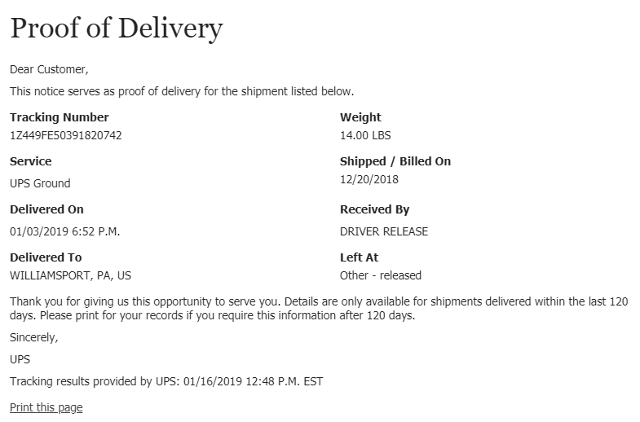
1Z449FE50391543640
PO# 4384254
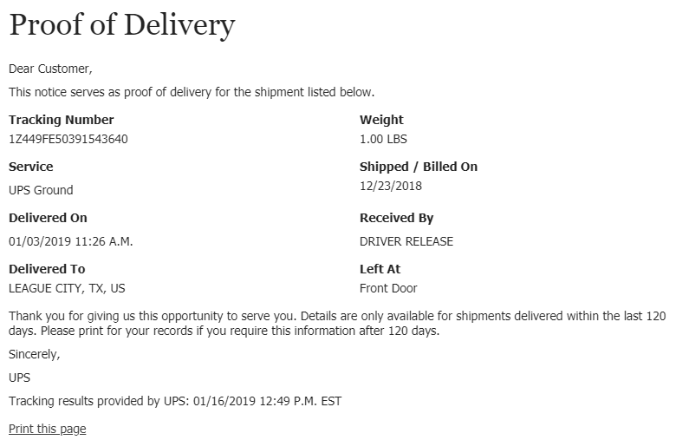
1Z449FA70318880637
PO# 5611698
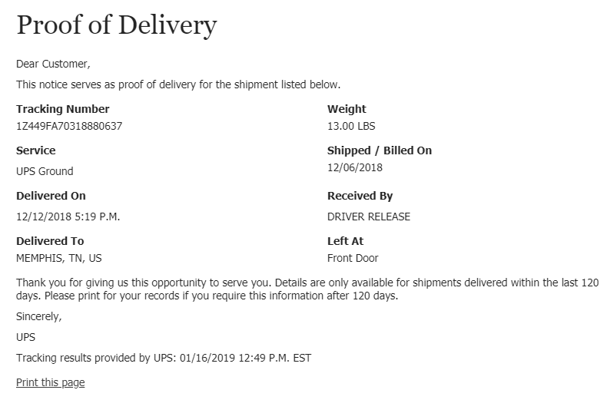
1Z449FE50394126890
PO# 6003143
