538326910934616
Po# CS136204365
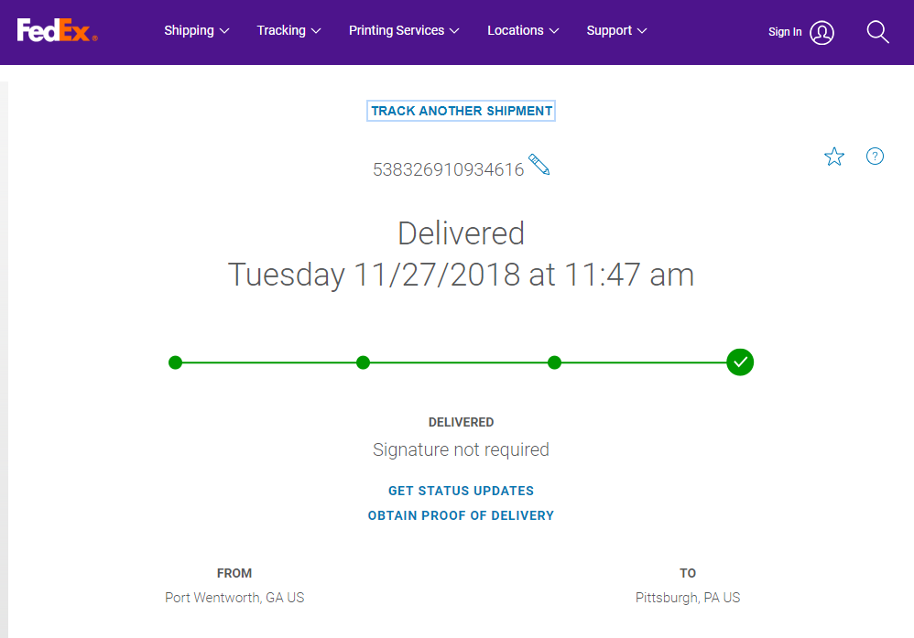
538326911103370
Po#CS137186902
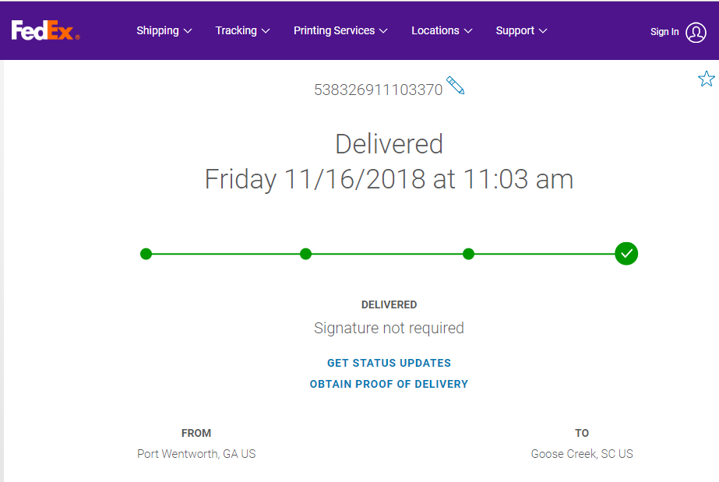
538326911713326,
538326911713340
PO# CS140005834
