1Z3026EY0334132590
PO# 28747038-1
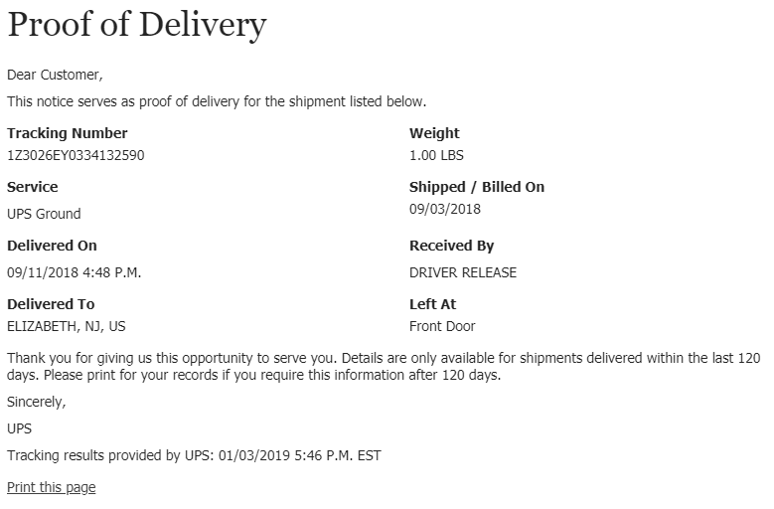
1Z1X780R0396383330
28763895-1
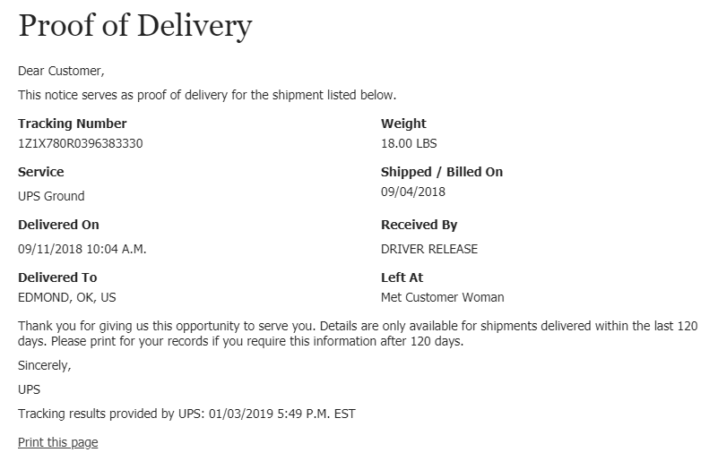
1Z1X780R0393243399
PO# 29418182-1
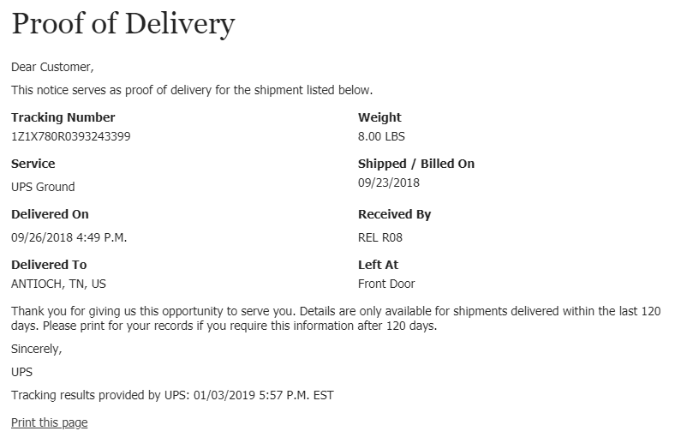

1Z1X780R0396014890
PO# 29710293-1
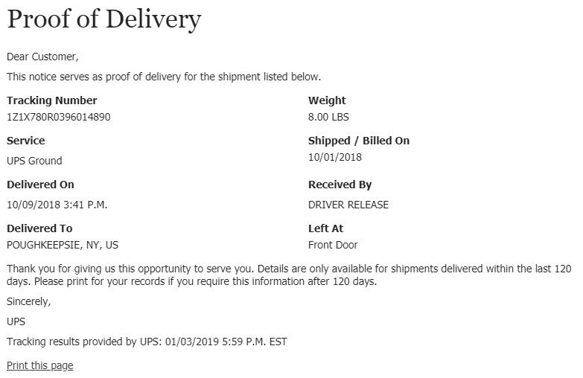
1Z1X780R0395999598
PO#29715644-1
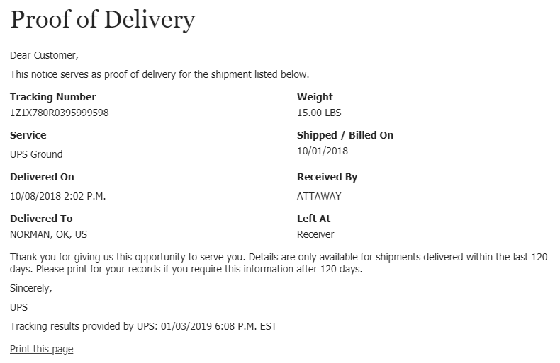
1Z1X780R0398706844
PO# 30011685-1
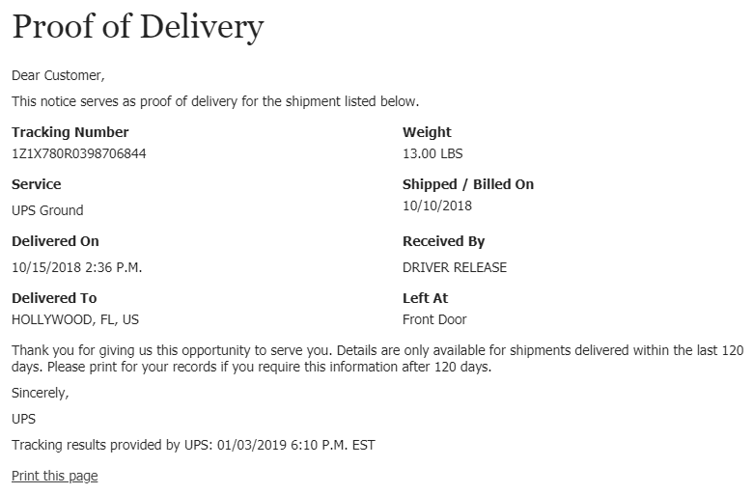
1Z1X780R0395833202,
1Z1X780R0399864109
PO# 30204280-1
