
SCM Home (Zhejiang) Co., Ltd. Dongguan Branch Company
Address: 23rd Floor, Building 5, Honghe Office Building, No.1 Jiulong Road, Dongcheng District, Dongguan City, Guangdong Province, China 523125
Tel#: +86 - 769-22660390

Open Carton Audit Report

Initial Audit Re-Audit
Pass 通过
Fail 不通过
Re-audit Required |  |  |  |  | Re-audit Waived
Customer: | HGF | Vendor: |  | HJ |  | Auditor: | Simon | Date: |  | 2023-06-14

AUDIT DETAILED FINDINGS

M: Minor Defect小缺陷 MJ: Major Defect主要缺陷 C: Critical Defect大缺陷
PO# | Customer Item No.  客人产品编号 | DESC  描述 | QTY  订单数量 | Sample Size  抽样数量 | M (1pt)  小  缺陷 | MJ  (2 pt)  主要缺陷 | C (3 pt)  大  缺陷 | @MC  (%) | Req. Sheen  (%) | Actual Sheen  (%) | Defect and Comment  缺陷和评论
HGF-230414 | HG134-0060R | 3 –Door Driscoll | 220  piece | 12 |  |  |  | 7---12 | 20 | OK | Normal

Note: A casegood item is considered “failed” when the combined values of defects exceed 2 points total.

注意：当一个产品所有缺陷超过2点时，产品被定义为“不通过”

Customer Item No.  客人产品编号 |  | Carton Size  外箱尺寸 | N.W.  净重 | G.W.  毛重 | Product Appearance Size  产品外观尺寸
HG134-0060R | Printing  纸箱印刷 | 158.8 X 43.2 X 84.5CM | 46 | 52
HG134-0060R | PDS |  |  |  | 60” X 14” X 34”H
HG134-0060R | Actuality  实际测量 | 159 X 43.2 X 85CM | 47.3 | 53 | 60 ” X 14” X 34”H

Customer Item No.: HG134-0060R
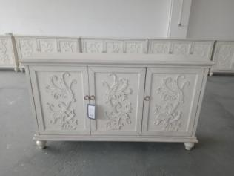 | 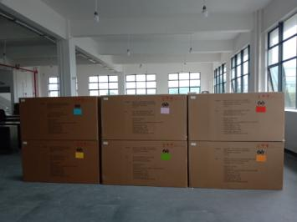
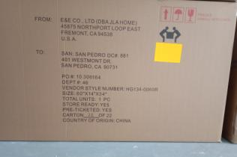 | 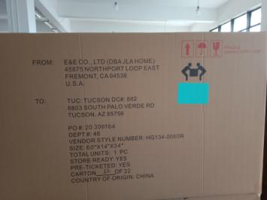
PO # 10 306164 (22pcs) Ship Merchandise to:  SAN: SAN PEDRO  DC #: 881  401 WESTMONT DR.  SAN PEDRO, CA 90731 | PO # 20 306164 (22pcs)  Ship Merchandise to:  TUC: TUCSON  DC #: 882  6803 SOUTH PALO VERDE RD  TUCSON, AZ  85756
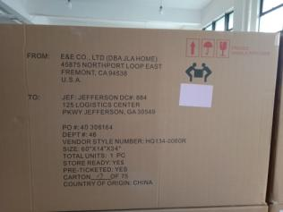 | 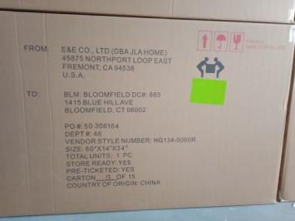
PO # 40 306164 (75pcs)  Ship Merchandise to:  JEF: JEFFERSON  DC #: 884  125 LOGISTICS CENTER  PKWY  JEFFERSON, GA  30549 | PO # 50 306164 (15pcs)  Ship Merchandise to:  BLM: BLOOMFIELD  DC #: 885  1415 BLUE HILL AVE  BLOOMFIELD, CT  06002
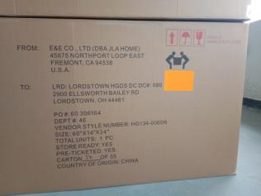 | 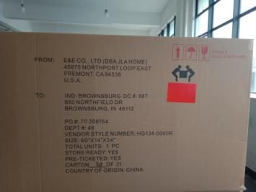
PO # 60 306164 (55pcs) Ship Merchandise to:  LRD: LORDSTOWN HGDS DC  DC #: 886  2900 ELLSWORTH BAILEY RD LORDSTOWN, OH 44481 | PO # 70 306164 (31pcs)  Ship Merchandise to:  IND: BROWNSBURG  DC #: 887  850 NORTHFIELD DR  BROWNSBURG, IN  46112
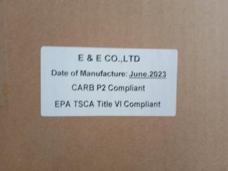 | 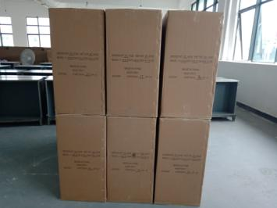
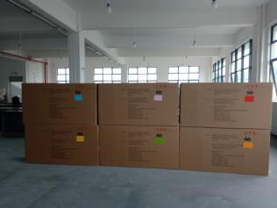 | 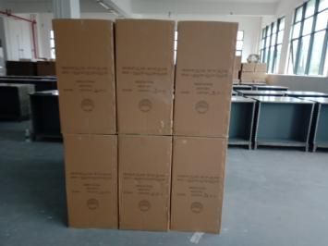
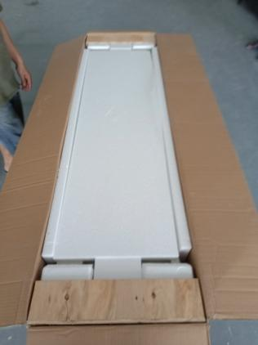 | 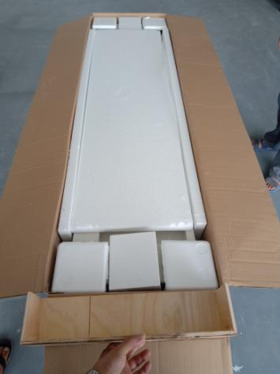
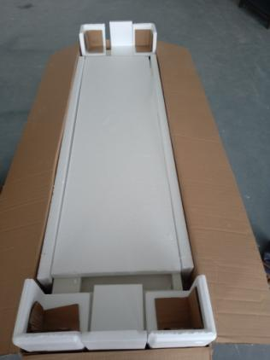 | 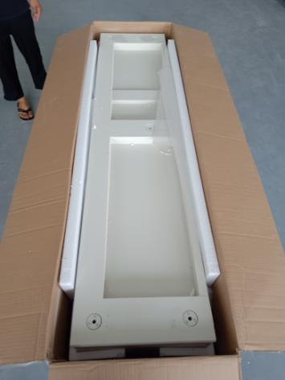
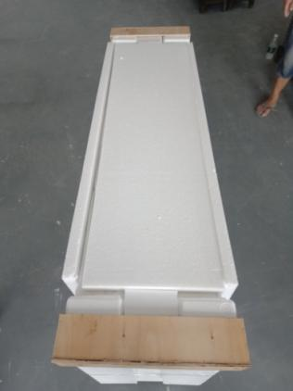 | 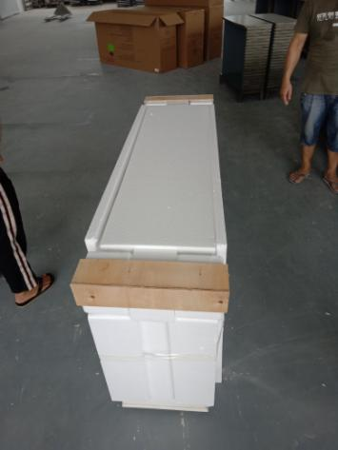
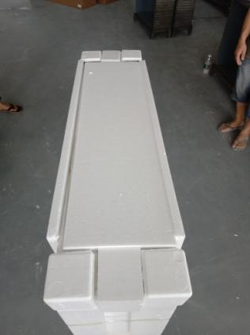 | 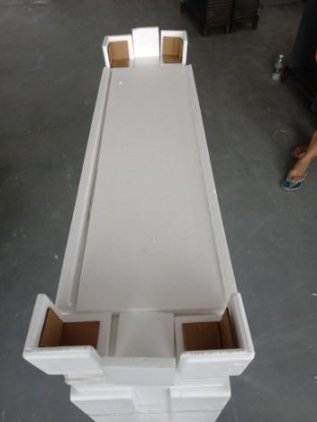
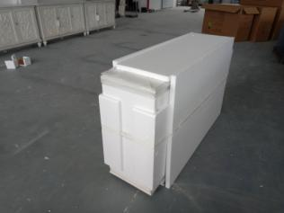 | 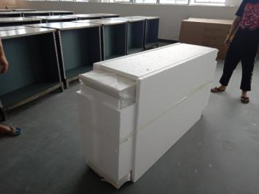
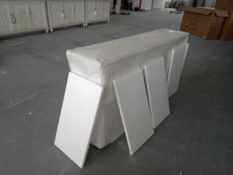 | 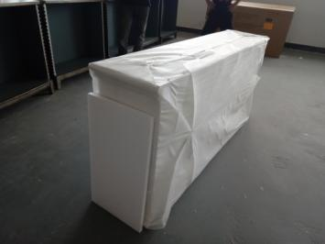
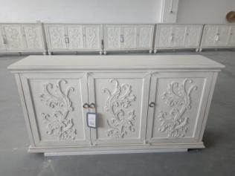 | 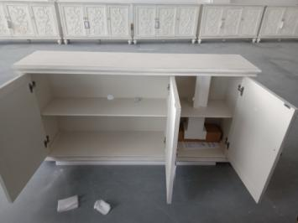
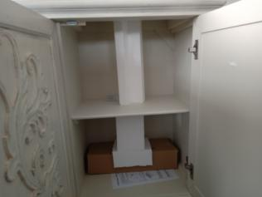 | 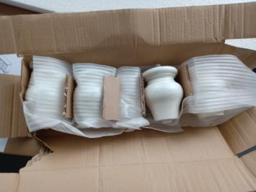
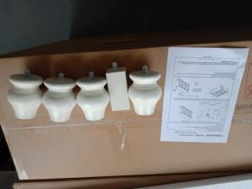 | 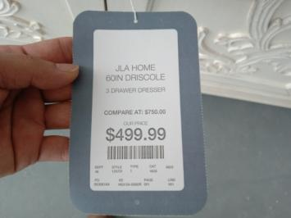
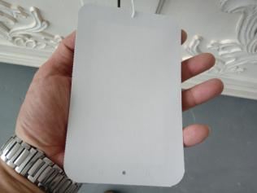 | 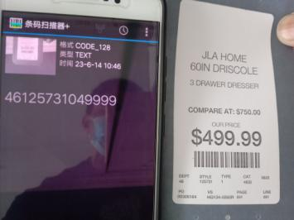
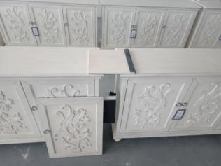 | 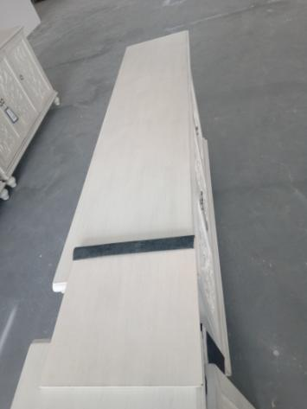
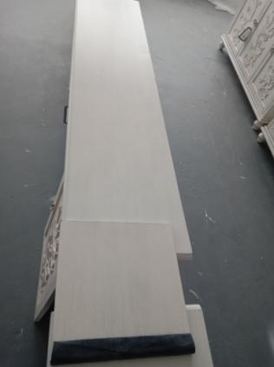 | 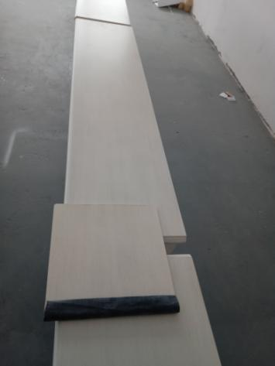
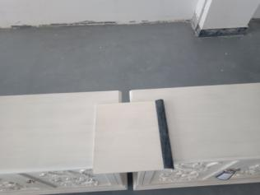 | 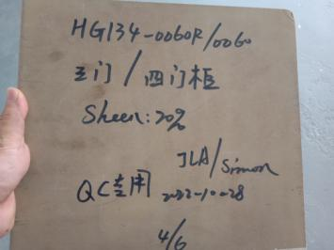
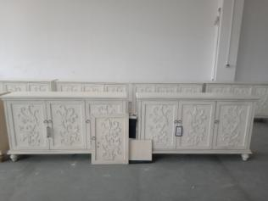 | 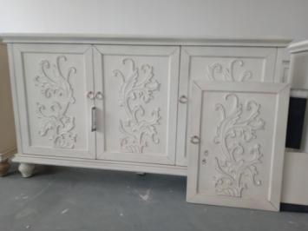
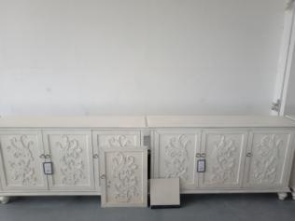 | 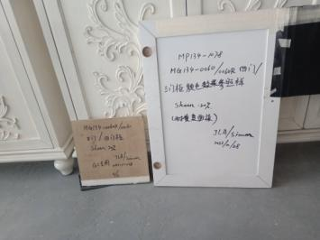
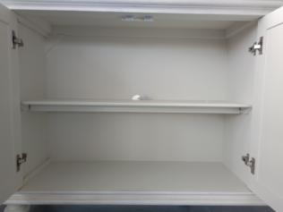 | 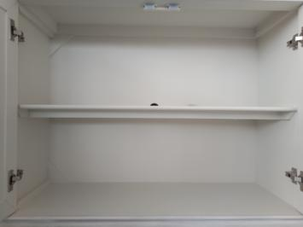
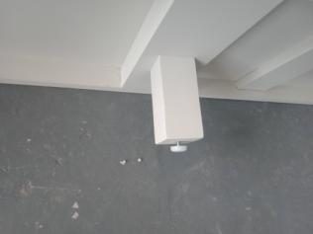 | 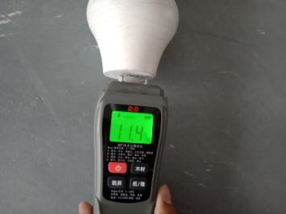
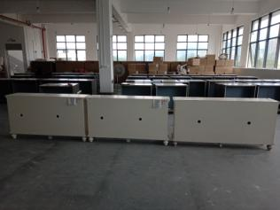 | 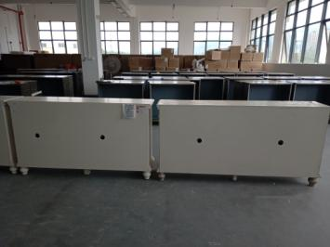
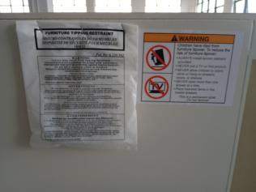 | 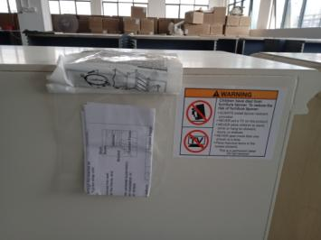
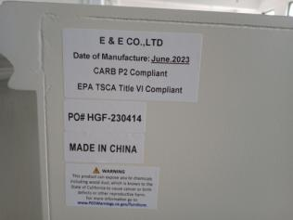

√ | All Packaging follows Specifications  所有包装符合规格 | √ | Product Data Sheets are correct and up to date.  产品数据正确且最新
√ | The carton printing follows closely the customers’ approved carton markings.  外箱印刷和客人同意的纸箱唛头相符合 | √ | These items have been compared under customer’s approved master color under the hot Light  在光线充足环境下，产品已经与客人认可的对应色板进行颜色对比
√ | All barcodes  所有条形码 | √ | Law labels  法律标
 | Hang Tags  吊牌 | √ | Confirm CARB Certification labeled on the carton and product  确认外箱和产品上有贴CARB认证标签
MCS Condition: New Like 新的 A Little Dirty but can be used 有一点脏污但仍可以使用
Dirty and Needs Replacing脏污而需要替换
Minor Defect (+1 PT): A defect that is noticeable to the customer as being a “defect”; but this defect is not likely to cause the customer to “return” the item to the seller.客人会注意到这种缺陷，但不太可能因这种缺陷造成退货。
Major Defect (+2 PT): A defect that is noticeable to the customer as being a “defect” and the customer “may or may not return” the item to the seller and or register a formal complaint.客人会注意到这种缺陷，这种缺陷可能造成退货或收到投诉。
Critical Defect (+3 PT): An “obvious defect” that “will” cause the item to be returned to the seller and register a formal complaint.客人会因为这个明显的缺陷而退货和投诉。

