We have received some SIOC chargebacks from Amazon for items listed below, we need to provide the images as proof to dispute these charges.

Please name the image files by item#
(1) Image from the product (item from the chargeback) with the product’s packaging being measured on each side. A tape measure or ruler must be clearly visible in each photo.
(2) Image from the product (item from the chargeback) being weighed, with the weight clearly visible
(3) Packaging with its labeling to ensure it is related to the item from the chargeback. The labeling of item # must be clearly visible.

Need 2 sets of photos, product’s size and weight without box & size and weight with box

Image for reference:
size being measured on each side and weight with box
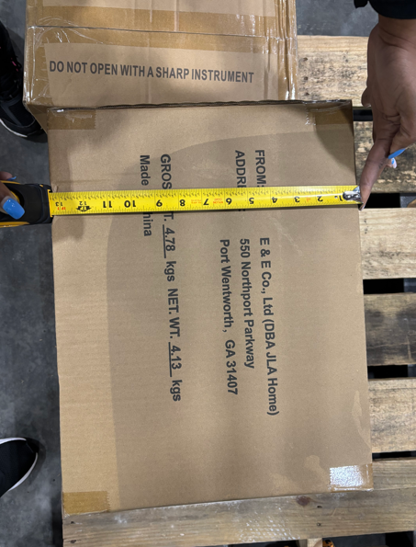
product’s size being measured on each side and weight without box
