The following workflow explains the operational and system process required to ensure inventory traceability and FEFO (First Expired, First Out) compliance for Pusen inventory.
Receiving:
When a container is received, the cartons must be offloaded and sorted by Item Number (Part Number) AND Expiration Date. To receive the inventory in the WMS, each Carton Label ID must be scanned. This barcode contains the expiration date, a unique carton ID, and the item number, all within a single barcode.
Each Pallet ID will contain cartons with only one expiration date, and the same rule applies to the bin location. In other words, a pallet and a bin location should only contain one expiration date (1:1 relationship).
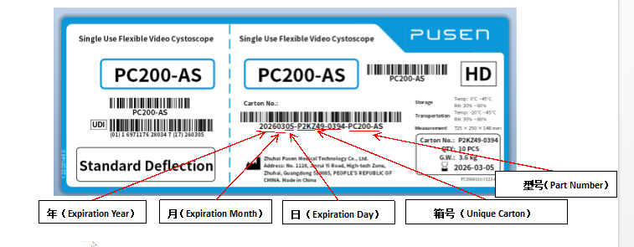
Inventory Control:
For bin transfers, if the entire pallet is being moved, the user only needs to scan the Pallet ID. If units are being moved individually, or if a Pallet ID is not available, each carton ID must be scanned so the system can track which cartons are moved to the new bin location.
The system will not allow movement of a Carton ID that does not belong to the source bin location, as every carton must be tracked from receiving to shipment (cradle to grave).
For cycle counts, the user will enter the bin location and scan one Carton ID for verification and enter the QTY. It will not be required to scan every carton ID during the cycle count.
There will also be legacy inventory that does not contain Carton Label IDs. For those bin locations, no lot number entry will be required, and this inventory will continue to follow the current process.
Outbound:
Inventory will be picked based on FEFO. The system will first prioritize legacy inventory that does not have an expiration date, and once that inventory is depleted, it will start picking cartons based on the earliest expiration date.
During picking, the picker will scan the Carton Label ID, which will appear as a new field in the Wholesale and DS picking interface. The Carton ID will also be sent to Pusen through the Shipping API.
For inventory that does not have Carton Label IDs (legacy inventory), the picker will continue scanning the UDI, following the current process. It is important to note that both processes will run in parallel until the legacy inventory is fully depleted.

