There are 3 pcs of cartons with item# MP103-1283 in shipping marks but used MP103-1271 UPC label from container#CAIU4424354/Shipment ID EE25091359.They are scanned and received in warehouse as MP103-1271. Please help to check all the cartons of the MP103-1271 from this shipment and find these 3 cartons.
Please help to open one of 3 cartons to see if the product inside is MP103-1283 in fact. Please help to take same photos. If yes, please update these cartons with MP103-1283 UPC label. Please see the picture of two items below, they are the same pattern with different fabric color.
MP103-1271 picture:
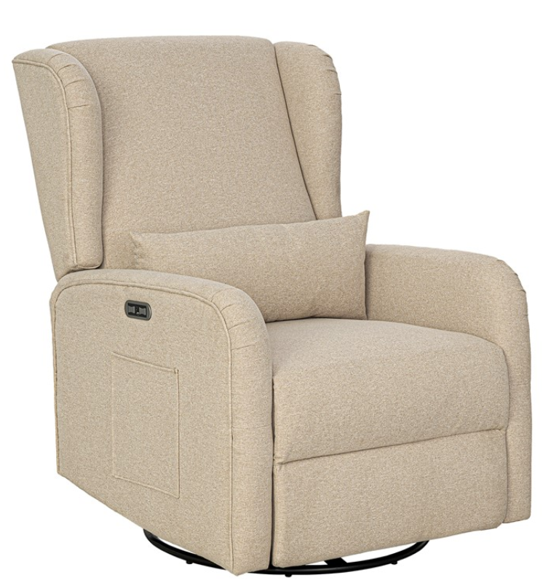
MP103-1283 Picture:
