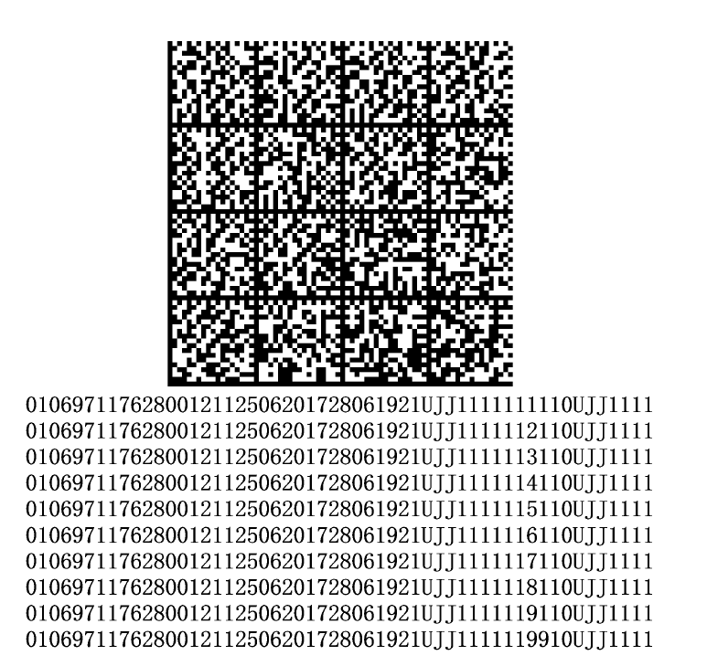

Pusen is planning to implement Data Matrix codes that contain multiple UDIs in a single, concatenated string. These UDIs are scanned as one block and need to be parsed and validated individually.
Each UDI begins with a Device Identifier, marked by (01) followed by 14 digits. This is the only consistent and reliable split point in the string, and it will be used to separate each UDI during parsing.
Each UDI contains:
- (01) Device Identifier – this is always the same across all UDIs in the same scan
- Other fields like expiration date (17) or lot number (10) or serial number(21),these may differ between UDIs
Because the number of UDIs and their field structure can vary (especially with products like those from Pusen), we can’t rely on fixed formats or lengths. Instead, we’ll:
- Parse the string using (01) + 14 digits as the delimiter
- Extract each UDI
- Check that each UDI has the same Device Identifier
- Validate the fields individually
Although the fields (like lot number or expiration) may be different across UDIs, the (01) Device Identifier will always be the same, since all the UDIs come from the same item. The first UDI in the string will be used as the reference. The system will verify that all subsequent UDIs share the same (01) and this will be the split point.
This is aligned with the current process, where the system shows the UDI screen after an item is picked. The first UDI will be used to match the picked item, and all other UDIs must have the same Device Identifier (01) to ensure they belong to the same product.
We also need to continue supporting one-by-one scanning for older products that don’t have a Data Matrix code.

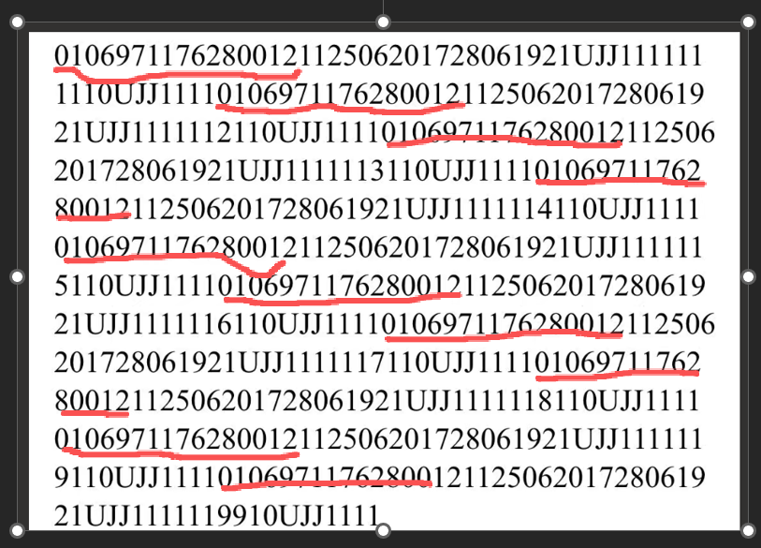

Example:
Scanned Data Matrix string:
(01)12345678901234(17)250101(10)LOT123(01)12345678901234(17)260201(10)LOT456
Two UDIs are extracted:
- UDI 1: (01)12345678901234(17)250101(10)LOT123
- UDI 2: (01)12345678901234(17)260201(10)LOT456
In this example:
- The Device Identifier (01)12345678901234 is the same in both UDIs
- The expiration date and lot number differ, which is expected
The system will use the first UDI to verify the item and will check that all UDIs share the same (01) Device Identifier to confirm they belong to the same product and as split point.

