There are 9 pcs of cartons with item# MP103-1271 in shipping marks but used II103-0600 UPC label from container#EMCU8454590/Shipment ID EE25040636.They are scanned and received in warehouse as II103-0600.
Please help to find these 9 pcs, open one of 9 cartons to see if the product inside is MP103-1271 in fact. If yes, please update these cartons with MP103-1271 UPC label. Please see the picture of two items below, the back of MP103-1271 is with two wings but II103-0600 don’t have.
MP103-1271 picture:
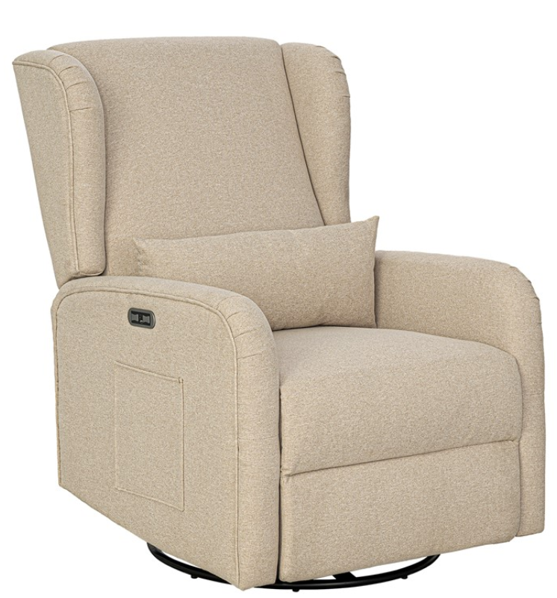
II103-0600 Picture:
