Check-In Process

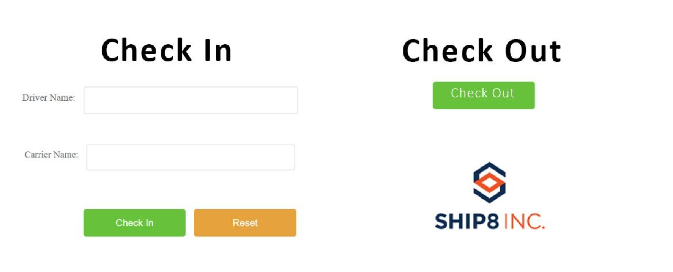
Home Screen:
- Fields:
  - Warehouse Street Address (Dropdown):
    - Functionality: Will be a blank dropdown field on window open (required field).
    - Query: Can EEC recognize different reporting IP addresses for each warehouse? Would like to look into possibilities of automating this drop down without different IP URLs, so the user doesn't need to manually input.
  - Driver Name (Text Field):
    - Functionality: Driver types in their name (required field).
- Buttons:
  - Check In (Primary action)
  - Check Out
  - Reset (Already exists in the frontend)
Check-In Workflow:
- After Input:

  - When the driver enters the above information and clicks Confirm.
    - Display all shipments for the selected warehouse location with shipment statuses:
      - Routed
      - Loading
      - Loaded
- 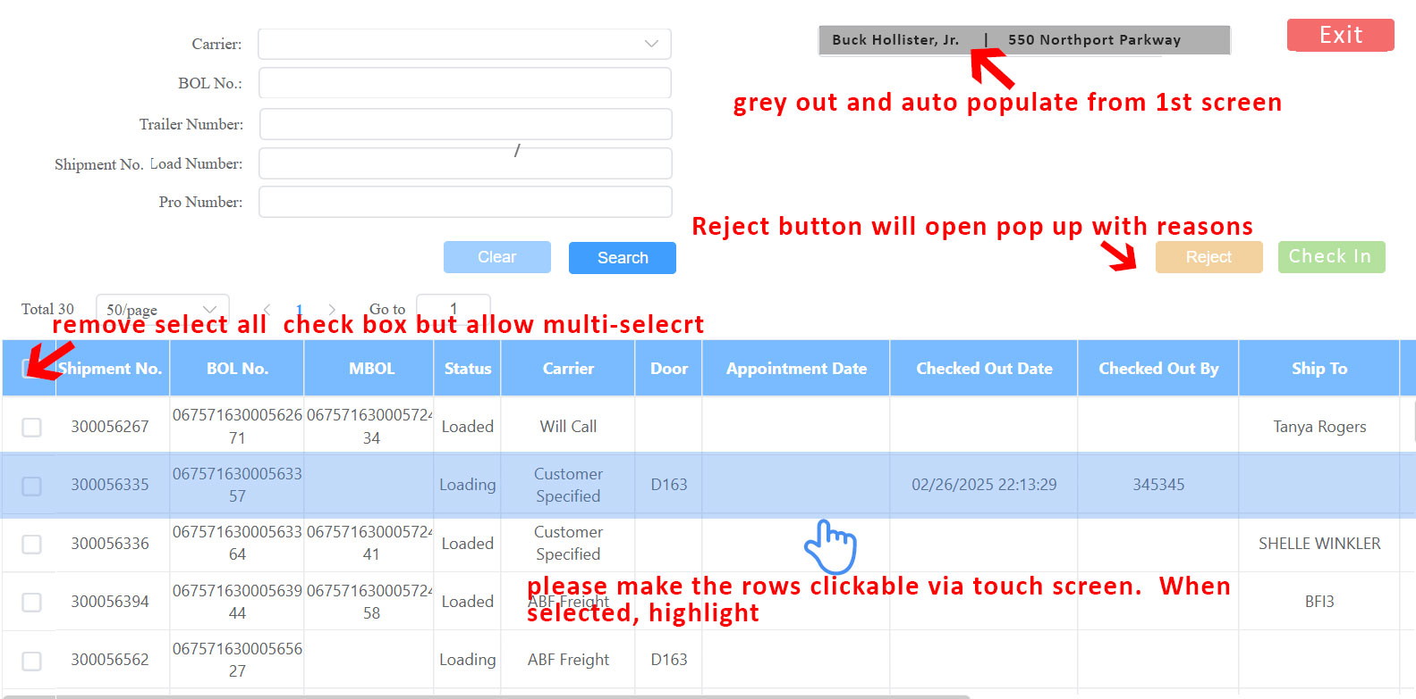

- Shipment Display:
  - Top portion columns:
    - Shipment No
    - BOL (Bill of Lading)
    - PRO Number
    - Carrier
    - (Note: These fields are optional; remove “Select All” functionality)
- Row Selection:
  - The user can click on any column in the row to select it.
  - Once selected, the row will be highlighted to indicate selection.
  - User can select more than row.
- Confirmation:
  - The user must click Confirm after selecting a row.
  - Pop-Up Window:
    - Display: All information for the selected row and the driver's name.
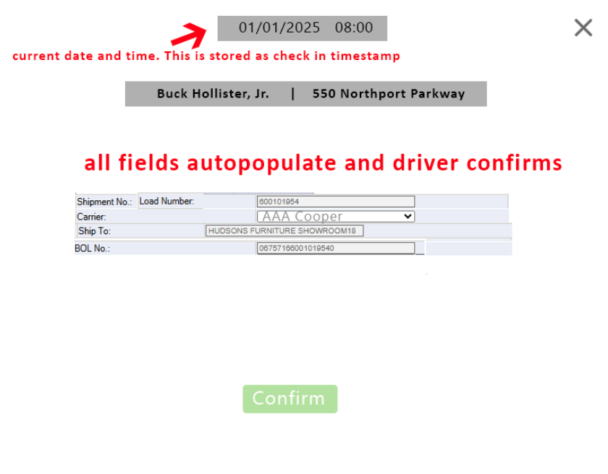
    - Buttons in Pop-Up:
      - Confirm: If confirmed, it brings the user back to the main screen (Check-In/Check-Out screen).
      - X: If user click on X , it returns the user to the previous window (shipment selection).

Check-Out Process
Check-Out Screen:
- Driver Name Dropdown:
  - After user hit Check Out.
  - The dropdown will display all driver names who have checked in but not yet checked out for the current day.
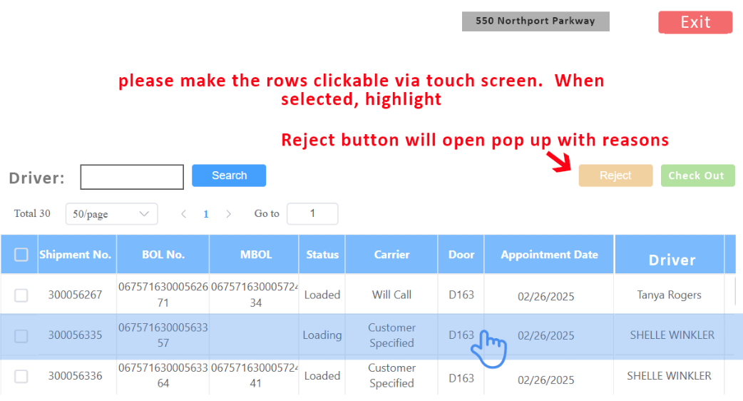

Reject Reason Dropdown:
- Update the Reject Reasons:
  - Change "Freight is not ready" to "Past Detention."
  - Add "Carrier Cancel" as a new option.
  - Ensure the reject reasons are organized for clarity.

