UDI Integration and Inventory Tracking Process
UDI Overview
UDI will be incorporated into all of the products, with each UDI associated with an item number. The barcode provided by the customer will include the following identifiers: 01, 11, 17, and 21. Add additional data delimiter, identifier if needed it. Add client column 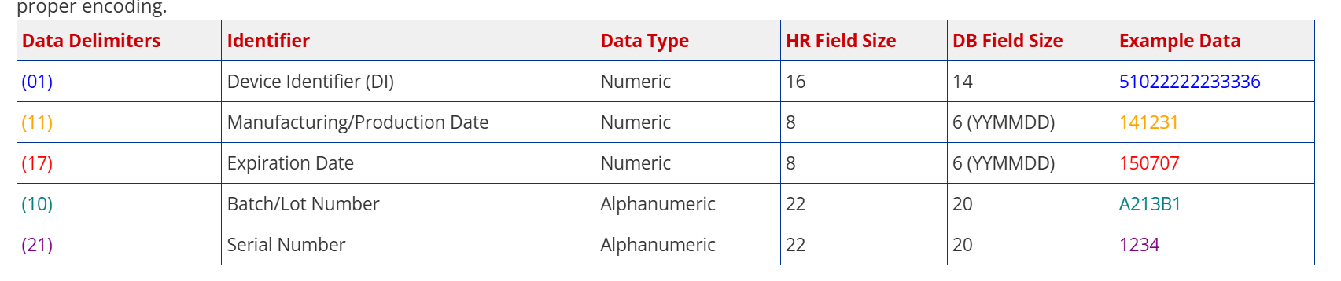
UDI as the Trackpoint
The UDI will serve as the trackpoint for all processes.
Receiving Process
- Scan Item Number and UDI
  - Pallets will be created by item number.
  - It is necessary to track where the pallet is located, as well as any bin transfers associated with it.
ONLY APPLICABLE TO SPECIFIC SKUS if the UDI attribute is flagged in the Item master. Add bullet for UDI Flag in Item Master and Item Master in Portal
Reporting on OSD (Over, Short, or Damaged Goods):
- Any discrepancies such as OSD must be reported by UDI.

Inventory Functions:
- Bin Transfers and Replenishment:
  - Any bin transfers and replenishments need to be tracked.
  - Transfers can be performed by carton (scanning the UDI) or by full pallet (scanning the pallet label applied to the bottom).
- Cycle Count:
  - The process involves scanning the location, item number, and quantity.
  - If the count matches the current system Quantity on Hand (QOH), the cycle count is considered complete.
  - If there is a mismatch, each individual UDI in that location must be verified.
- Picking:
  - The user will go to the bin location, scan the location, scan the UDI, and then scan the shipping label.
  - Once the UDI is scanned, it will be attached to the order number and tracking, enabling us to trace where each carton was loaded.

Inventory Tracking Report:
- We need a report that allows us to input a UDI and track its location, including full historical data on that specific UDI.

