EH25010022
Ecom Return application – add “Print UPC” tab
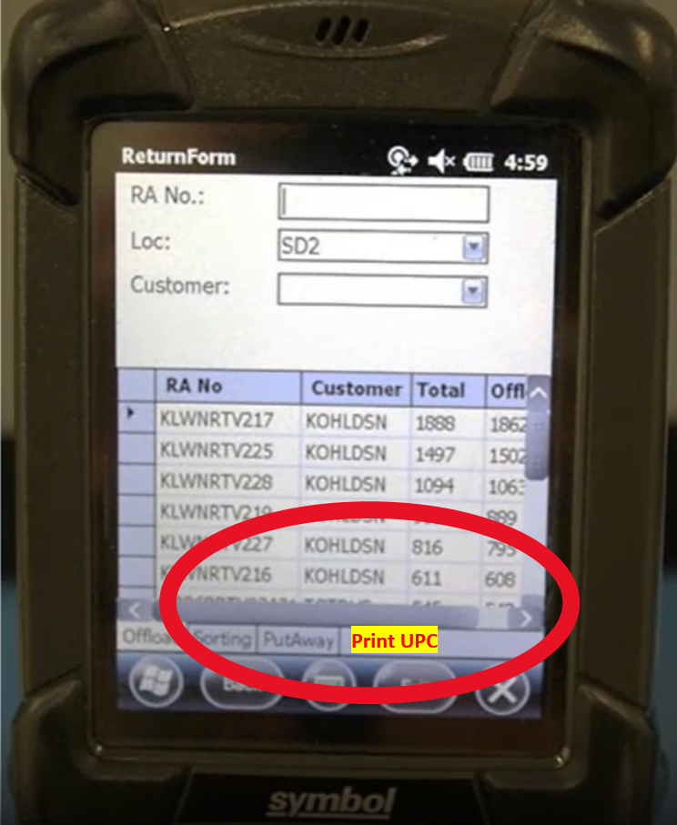
Two fields on the “Print UPC” tab page – to include “UPC” & “Qty”
Allow user to scan or enter items UPC # and enter quantity of labels to print

