From: Richard Ye <yexiaomiao@syncsoftinc.cn>
Sent: Monday, January 6, 2025 4:01 AM
To: Sebastian Ramirez <sebastian.ramirez@ship8.com>
Cc: fangfang@syncsoftinc.cn <fangfang@syncsoftinc.cn>
Subject: EH24080003

Hi Sebastian,

Please see below for EH24080003, please help to confirm my below questions.

1. This just like a login page, does this page required? Can driver directly go to the shipment list page, and search the shipment?
2. If this page is required, does system need to validate the Carrier Name and Door Number that driver entered? Does not allow to check in if not valid?
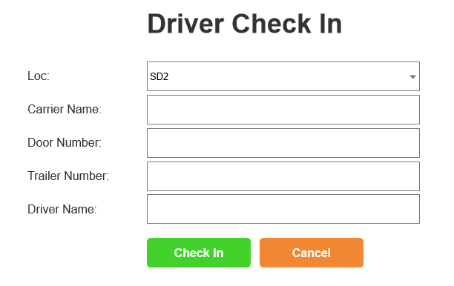

3. This is shipment list page, filter by driver entered Carrier and Door.
4. Can Driver check out multiple shipments with one check in?
5. What should we do if driver reject the shipment? Only record the reason?
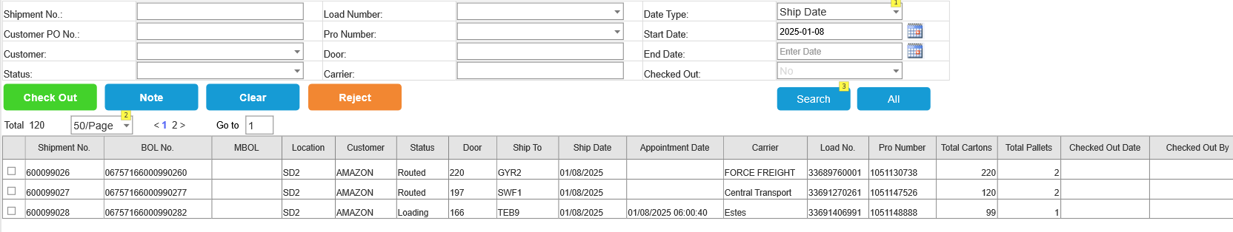

6. Select one shipment, and Click Check Out button will open below page to sign and Print out the BOL.
7. System will auto complete the shipment and send ASN, there is no chance for ship8 admin to correct the information that driver entered. So still auto complete the shipment?
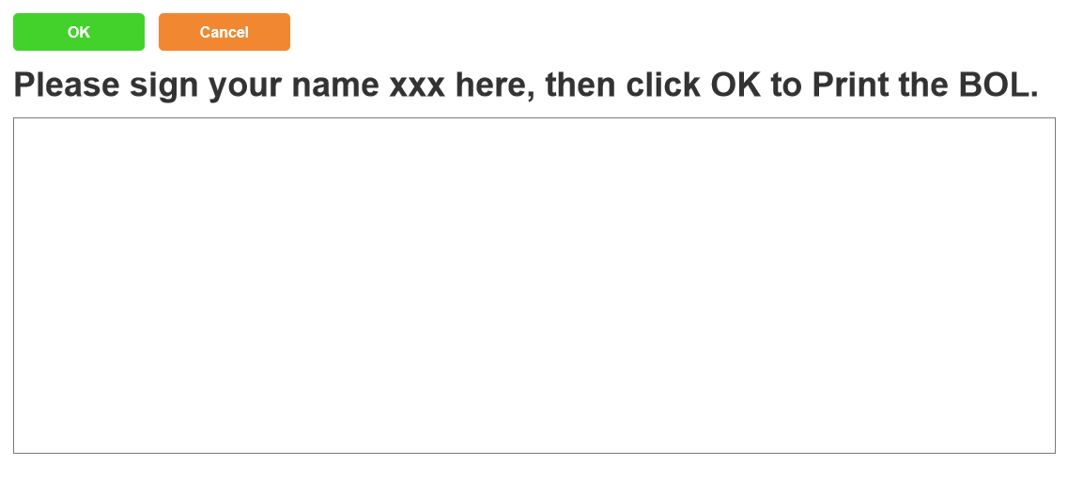

Best Regards,
Richard Ye-叶小苗

From: Sebastian Ramirez <sebastian.ramirez@ship8.com>
Sent: Tuesday, January 7, 2025 1:17 AM
To: Richard Ye <yexiaomiao@syncsoftinc.cn>
Cc: fangfang@syncsoftinc.cn; Continuous Improvement <ci@ship8.com>
Subject: Re: EH24080003

Good Morning Richard,

1. This is just like a login page, does this page required? Can driver directly go to the shipment list page, and search the shipment?
CI TEAM: Yes. This is required after the user input their info then then they will allow to select the shipment.
2. If this page is required, does system need to validate the Carrier Name and Door Number that driver entered? Does not allow to check in if not valid?
CI TEAM : For phase 1 , it is not required to validate driver information . After deployment and testing, we will how phase 1 did and what enhancement needs to be done before fully integrating and this could be part of a phase 2 enhancement for the Electronic BOL.
3. This is shipment list page, filter by driver entered Carrier and Door.
CI TEAM : Good idea
4. Can Driver check out multiple shipments with one check in?
CI TEAM: Yes
5. What should we do if driver reject the shipment? Only record the reason?
CI Team: Popup message : " Are you sure you want to reject this shipment ?" and then the reason code to be entered. We will record the reason code.
6. Select one shipment, and Click Check Out button will open below page to sign and Print out the BOL.
CI Team: Okay.
7. System will auto complete the shipment and send ASN, there is no chance for ship8 admin to correct the information that driver entered. So still auto complete the shipment?
CI Team : We can do this in two phases as mentioned above. The first phase will be to print the BOL . The user admin will need to complete the shipment and therefore it will allow to make modifications if necessary . After deploying this functionality, we shall see other insights after the utilization of this and later to publish to auto complete the shipment if there is a high success rate in the accuracy of the information provided by the driver then we can move towards autocompleting the shipment. We just do not want to put ourselves to the wall by not allowing modifications.



Sebastian Ramirez
Business Systems Analyst
550 Northport Pkwy
Port Wentworth, GA 31407
C:912.507.8964

