EH24110020
1 - add French as a Language option to the Warehouse User Maintenance page
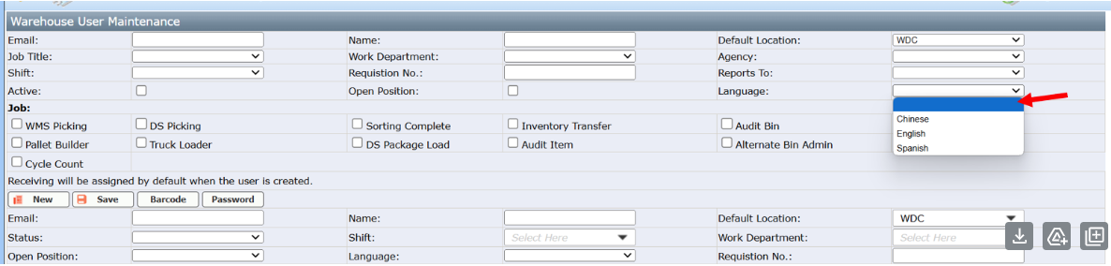
2 - add Check Point (French) to the Equipment Check Point Maintenance page. I can then utilize ChatGPT to translate and create these check point conditions in French:
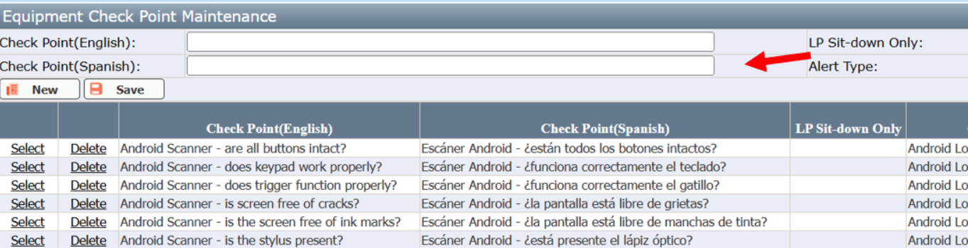

3 - update the Start Up app to display the check points in the user's French default language
