EH24070031
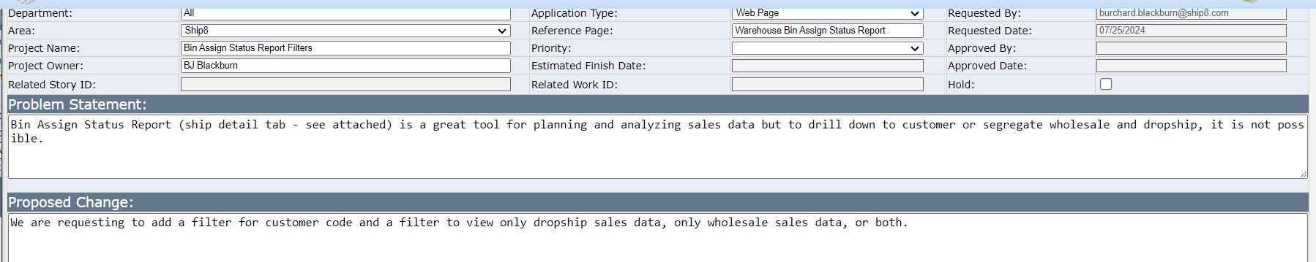
Current options – WH Bin Assign Status Report – you can filter Order Type & Division but no option for Customer
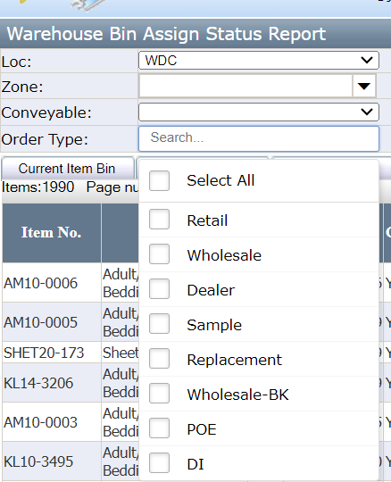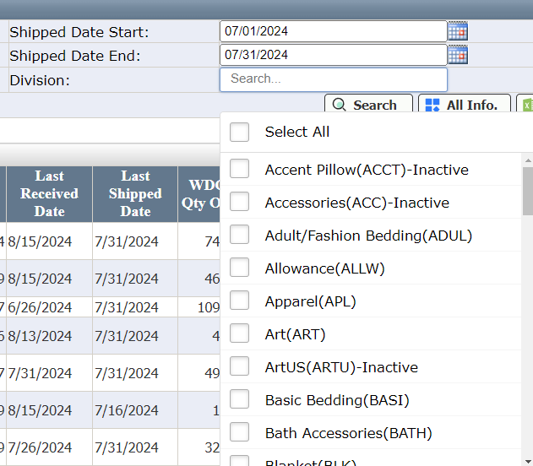

What about – WH Division Shipping Report/Item tab – options include Customer and Business Type
