- Yard Check Storage Management page -> Status = "Checked In"
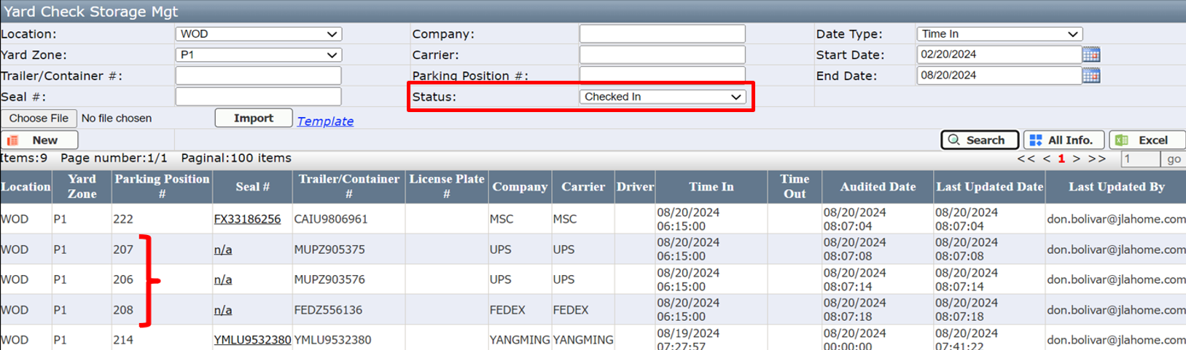
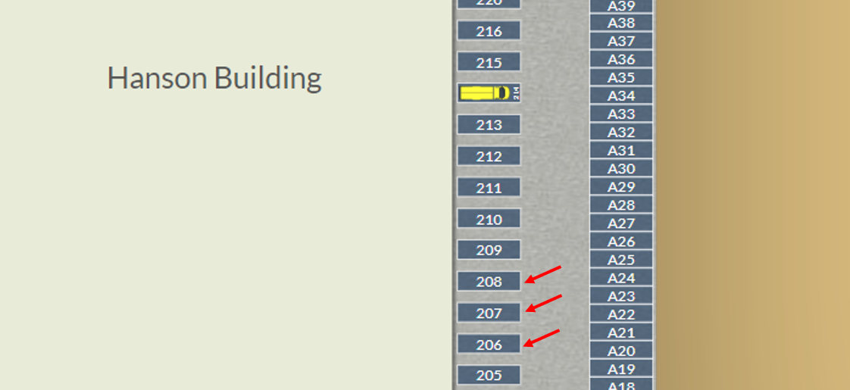
- Trailer List page -> Completed = "No"
  - Will need capability to update Door Number if/when full trailer is moved to a "Ready Line" awaiting Small Package carrier pickup
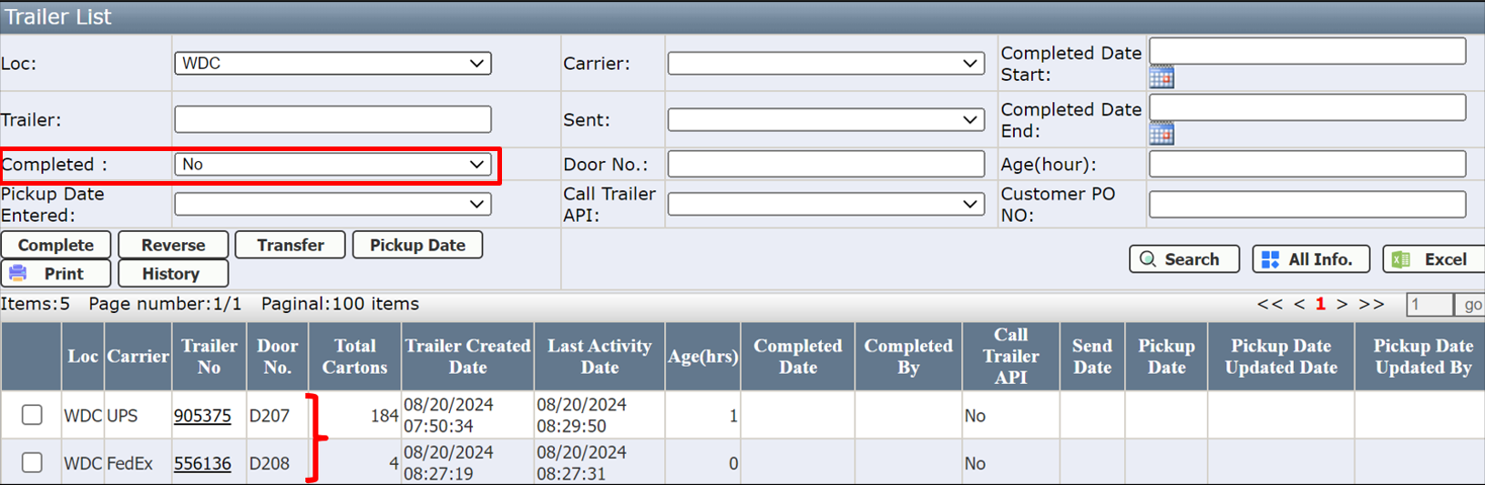


- Wholesale Shipment Management page -> Assigned = “Yes”
  - Will need capability to assign Loading Door to user and display Door Number on this webpage
