Rework details

- To Take off the Kirkland woven label

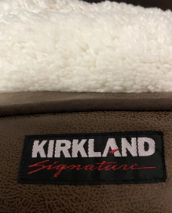 >>>>>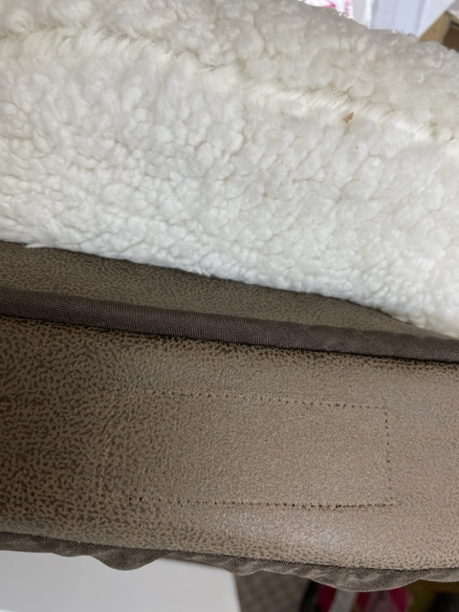
BEFORE AFTER
- To cut off top Kirkland sewn lable
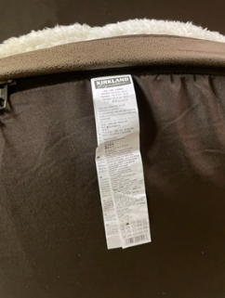 >>>>> 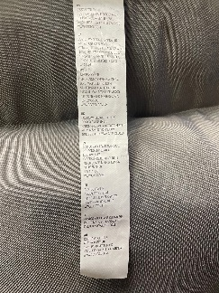
BEFORE AFTER
- To apply a new label sticker to the top part of the sewn label
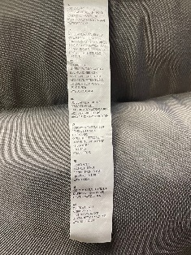>>>>>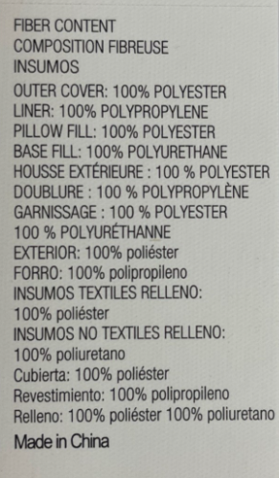>>>>>>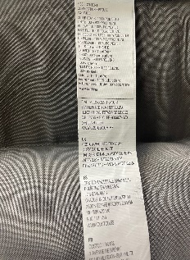
Before Label Sticker After
- To cut off the rest of the label
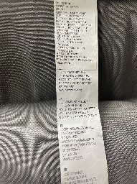>>>>> 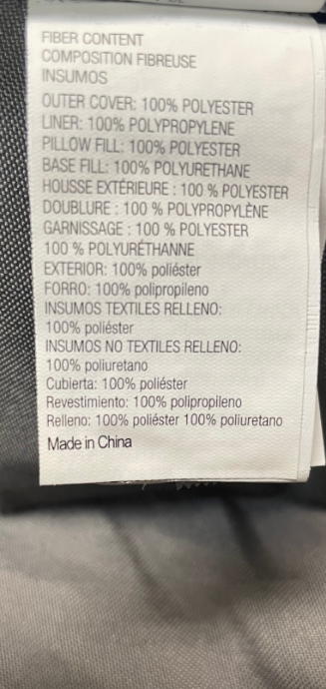
Before After

