Yard Check Manual

Select loc and scan user ID to login in Yard Link.
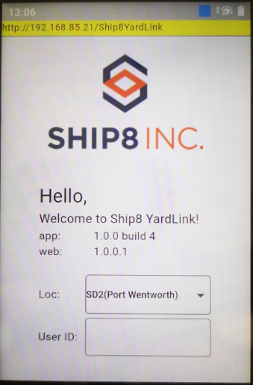

Click Yard Check.
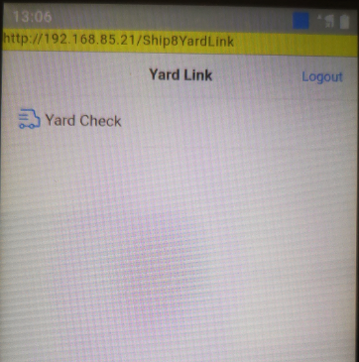

Click Yard Status and select loc, list all positions for each zone.
Total Positions: All receiving doors maintained under the zone.
Occupied Positions: All containers have checked in under the zone.
Audited Positions: All containers have been audited on current day.
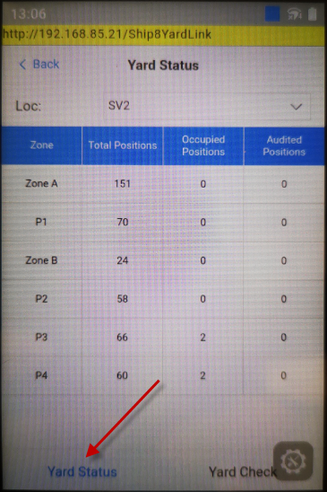

Yard Check Tab, allow user to check in, audit and check out container.
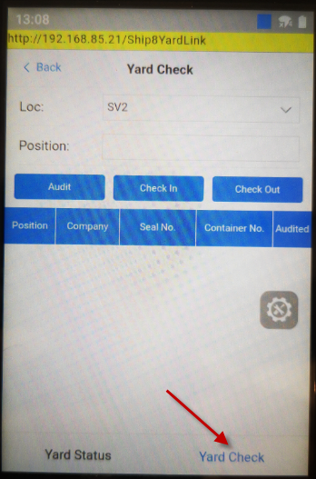
- Check In: Click check in to open detail tab.
- Loc, Position, Seal No., Trailer/Container and Company are required
- Check In Time: default as current time, allow user to edit.
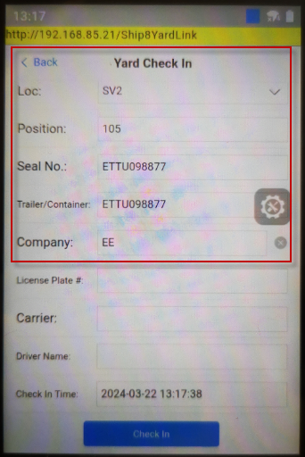
- Audit: Select container in grid and click audit button.
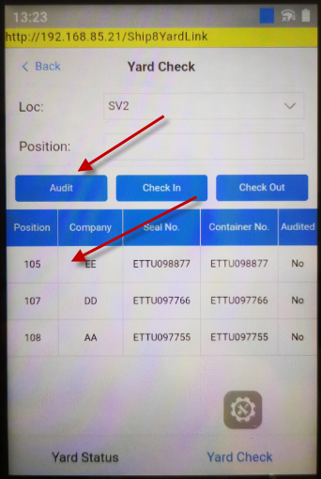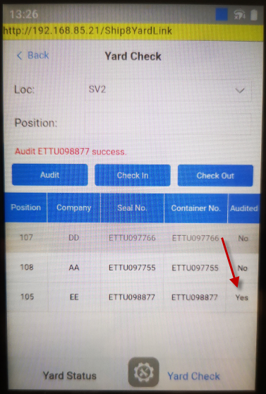
- Check Out: Select container in grid and click Check out button, the contain will disappear in grid.
