One of Ron’s top priorities this year is to focus on anything that can help reduce labor in the warehouse. An ongoing challenge for operations has been to accurately evaluate employee contribution/productivity because using just cartons or units per hour has limitations.

One solution we looked at previously was using engineered standards including measuring travel time and other factors to determine an employee’s productivity. This had some big obstacles in creating and is more detailed than needed. I did some research on what benchmark companies use for measuring performance and have created a multifactor measure that we would like to develop starting with the picking functions in our buildings.

The concept for this new measure is based on “earned minutes.” An employee earns minutes/time as they complete an event in the warehouse such as picking a carton, visiting a location, going to an aisle, or starting a picklist. Each event is assigned a standard time that it takes on average for an employee to do. For example:

Pick a carton: 6 seconds
Visit bin location: 45 seconds
Start new aisle: 1.15 minutes
Start a picklist: 2 mins

Here, each time they go to a new location, new aisle, start another picklist, or pull a carton, they get credit for that. The sum of bin locs, trips to aisles, picklists worked, and cartons pulled is multiplied by each corresponding standard time to calculate a total earned minutes. This total time is then divided by how many minutes they worked to get their productivity. This helps give fair credit to the employee. For example, if one employee pick list was to pick 20 cartons from one location and another employee pick list was to pick 20 cartons but from 20 different locations, the first employee would get finished much quicker. Using the multifactor measure helps give them fair credit.

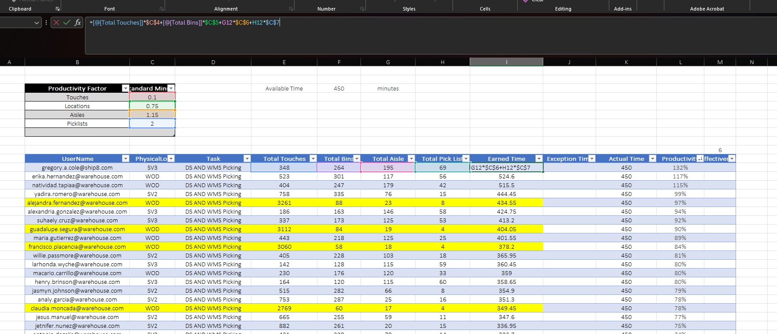

What the directors and executives would like to see is the employees performance calculated using this method. I believe we started some of this previously when the additional columns were added to the DC Performance report Working time tab for utilization, effectiveness and performance percentages. We would need to take the time recorded by the attendance app, the total minutes earned like above example, and complete the calculations for utilization, effectiveness, and performance.

This is going to be the first phase of the project and we are only doing picking functions. Similar to how performance goal is now, we would need to do something similar so we can adjust the standard minutes for each event for when conditions change in the warehouses. Also, we would make measures based on zone so we can have the correct times for if people are picking in the mods, racks, bulk, etc.

Again, I am going to start on the EEC requirement for this but wanted to give an overview here as well. Ron has asked for a timeframe for this so please let me know of any questions you have and I will get them answered ASAP.

Thanks and looking forward to your feedback.

