EH24010017
- Reduce the size of the directional arrow on this page 
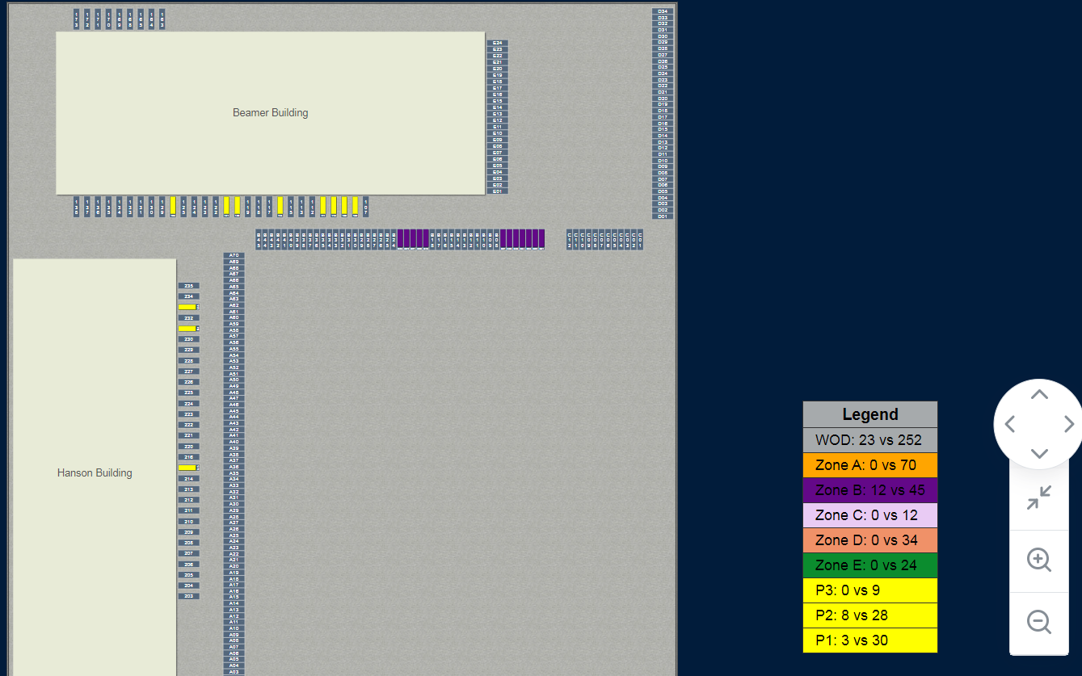
- User needs the option to be able to move this webpage screen with the “hand” , or with the navigational arrows

- Add function to select Zone from grid and the selected Zone will highlight on this webpage
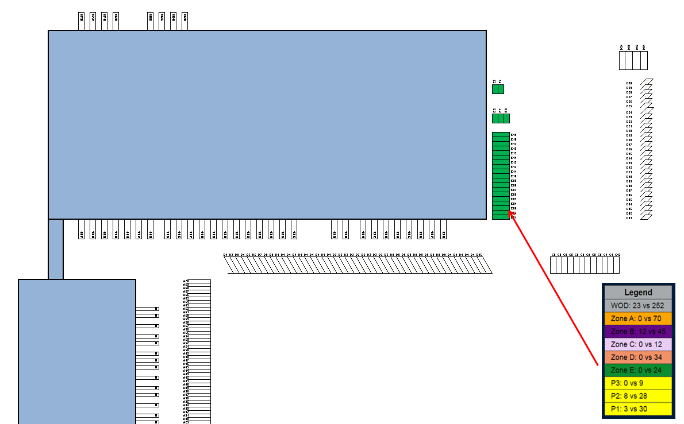

- Add Search function to include:
  - Container status = Scheduled In, Arrived, Received, Completed, Detention. Once option is selected the containers on the grid will highlight
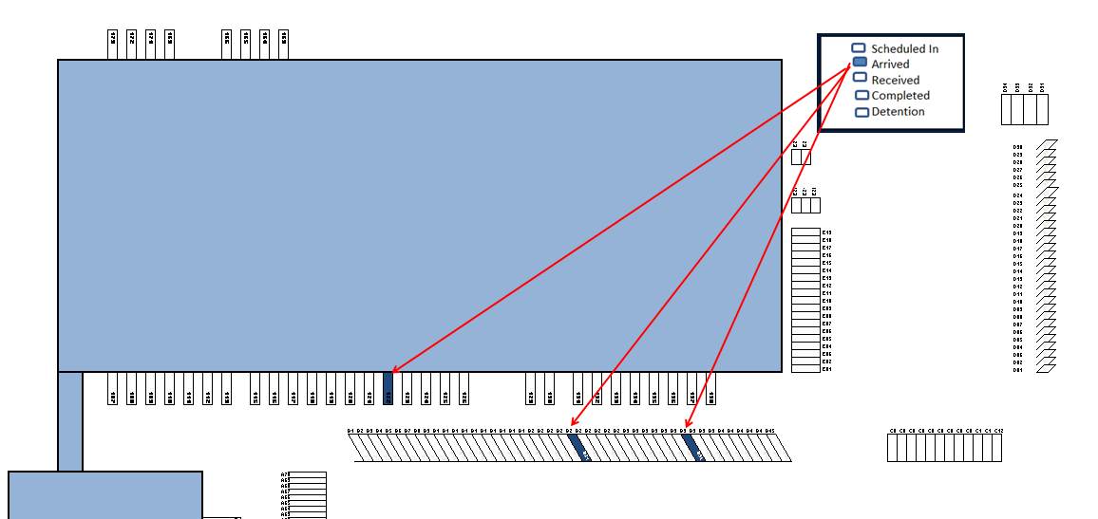

- Add Search function to include:
  - “Detention containers” based on the “container status” tab on the “container status report” webpage. When user selects the “detention” filter, the containers will highlight on the grid.
Example – the “container status report” shows 1 container in “detention containers” column for WOD as shown below. On the WOD Yard view webpage, user selects “detention containers” and the container is highlighted as shown in the screen shot below.
