EH24010016
Insert column for deactivation reason code as shown below
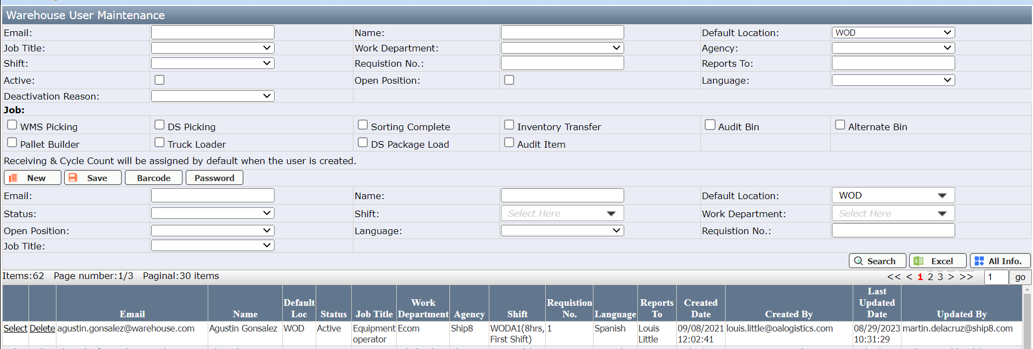
Deactivation Reason Code

