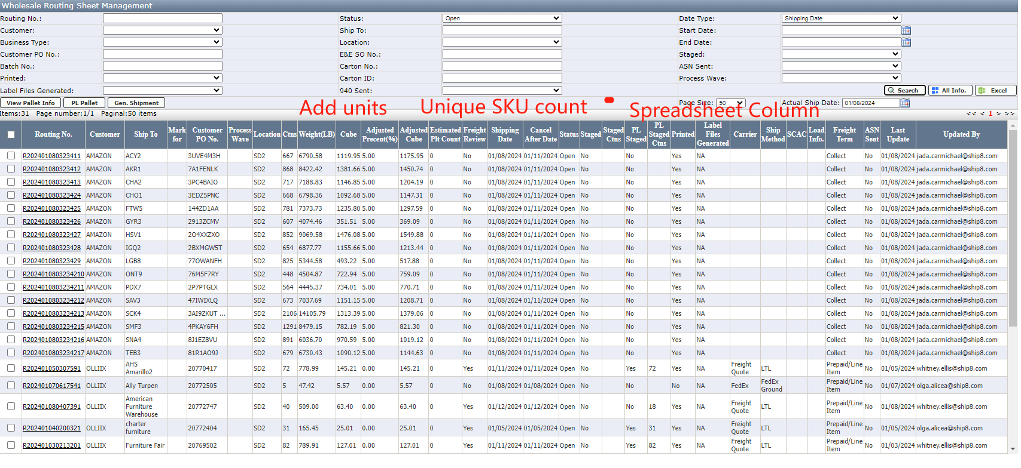

Add Units to this table after the cartons column
Add Item Count column to this table: To display Count(Distinct item_number)
Add spreadsheet column to this table: Display whether the user needs to utilize the spreadsheet on the amazon portal. Boolean answer yes or no. The rule for this column will be that if the sku count for the routing is greater than 100 skus then user needs to use the spreadsheet in the portal website.

