ASSEMBLY INSTRUCTIONS
Aelorian Table Lamp (Item# MT153-0078)
Important Safety Instructions:
- For safety purpose, this lamp is equipped with a polarized plug (one blade is wider than the other). If the plug does not fit securely into your outlet, do not force it, contact a professional electrician. Never alter the plug in any way.
- These instructions are provided for your safety. It is very important that they are read carefully and completely before assembling fixture.
- This fixture has been rated for up to (1) 60-watt maximum TYPE A bulbs or (1) 9W LED light bulbs (Included). To avoid the risk of fire, do not exceed the recommended wattage.
- This lighting fixture is intended for indoor, residential use.

Warning:
- Wires and cables are all attached (further wiring is not needed from consumer). When unpacking product, be careful to not pull wires as it may result in a bad connection. Do not plug into electrical outlet until lamp is fully assembled.
- To reduce the risk of fire, electrical shock or personal injury, do not turn on lighting fixture until light bulb is installed and assembly is complete.
- Always turn off the light fixture and allow it to cool before replacing the light bulb.

- Care instructions:
- Wipe with soft dry cloth only.
- Always avoid the use of harsh chemicals or abrasives as they may damage.

Page 1 of 3

Pre-assembly:
- Remove all parts and hardware from box along with any plastic protective packaging.
- Check that all parts listed are included.
- Do not discard any contents until after assembly is complete to avoid accidentally discarding small parts or hardware.

Component List
Part Code | Components | Description | Qty
A | 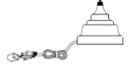 | Base with the clear cord | 1
B | 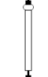 | Rod | 1
C | 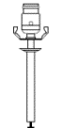 | Rod with socket | 1
D | 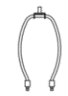 | Harp | 1
E | 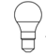 | 9W LED bulb included | 1
F | 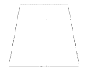 | Shade | 1
G |  | Finial | 1

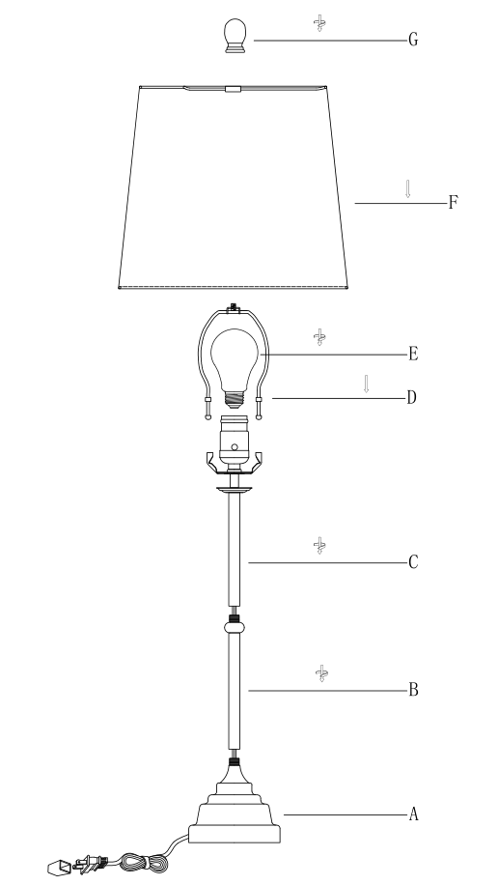

Assembly Instruction:

Step 1. Unpack and place all parts on flat surface or floor.

Step 2. Gently screw the rod (B) into the base (A).
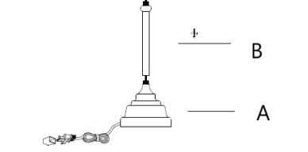
Step 3. Gently screw the rod with socket (C) into the rod (B).
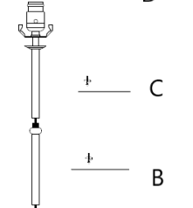
Step 4. Insert bulb (E) into the socket (C).
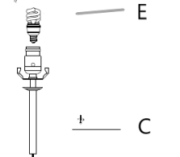
Step 5. Insert harp ends (D) into the socket (C).
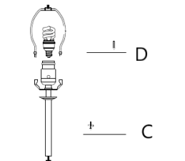
Step 6. Place the shade (F) over the harp (D). Secure the shade (F) by turning the finial (G) onto the harp top clockwise until tight.
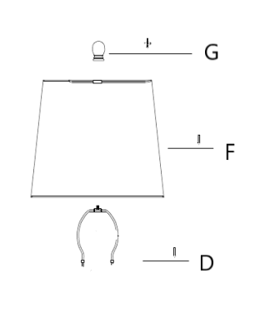
Step 6. Assembly is complete.

