
ASSEMBLY INSTRUCTIONS
Maelle Blue Reflective Table Lamp (Item# FB153-1181)
Important Safety Instructions:
- For safety purpose, this lamp is equipped with a polarized plug (one blade is wider than the other). If the plug does not fit securely into your outlet, do not force it, contact a professional electrician. Never alter the plug in any way.
- These instructions are provided for your safety. It is very important that they are read carefully and completely before assembling fixture.
- This fixture has been rated for up to (1) 60-watt maximum TYPE A bulb or (1) 9W LED light bulb (Included). To avoid the risk of fire, do not exceed the recommended wattage.
- This lighting fixture is intended for indoor, residential use.

Warning:
- Wires and cables are all attached (further wiring is not needed from consumer). When unpacking product, be careful to not pull wires as it may result in a bad connection. Do not plug into electrical outlet until lamp is fully assembled.
- To reduce the risk of fire, electrical shock or personal injury, do not turn on lighting fixture until light bulb is installed and assembly is complete.
- Always turn off the light fixture and allow it to cool before replacing the light bulb.

- Care instructions:
- Wipe with soft dry cloth only.
- Always avoid the use of harsh chemicals or abrasives as they may damage.

Page 1 of 3

Pre-assembly:
- Remove all parts and hardware from box along with any plastic protective packaging.
- Check that all parts listed are included.
- Do not discard any contents until after assembly is complete to avoid accidentally discarding small parts or hardware.

Component List
Part Code | Component | Description | Qty
A | 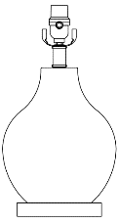 | Lamp Body with Clear Cord | 1
B | 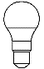 | 9W LED bulb included | 1
C | 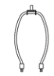 | Harp | 1
D | 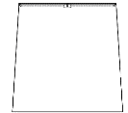 | Shade | 1
E | 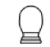 | Finial | 1

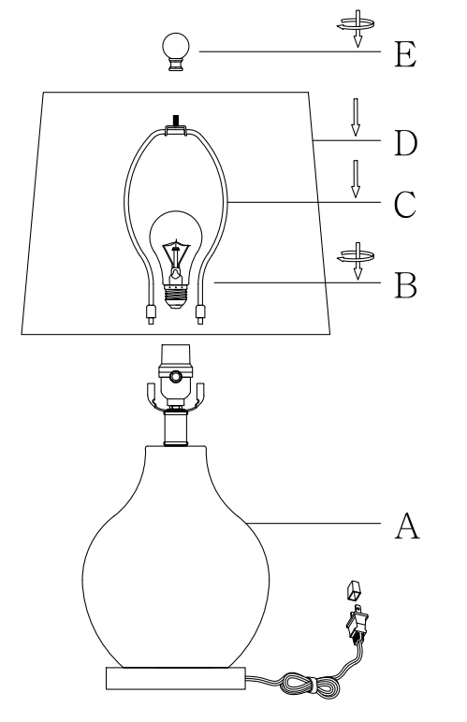

Assembly Instruction:

Step 1. Unpack and place all parts on a surface or floor.
Step 2. Safely fasten the light bulb (B) into the socket neck of the lamp body (A), and subsequently, insert the harp ends (C) into the same socket neck of the lamp body (A).
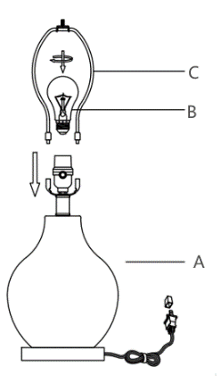
Step 3. Position the shade (D) onto the harp (C).
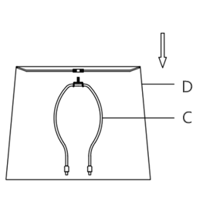

Step 4. Fasten the shade (D) by rotating the finial (E) clockwise onto the harp top until securely tightened. 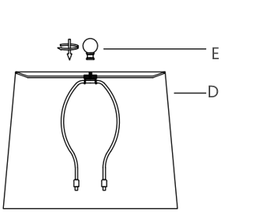

Step 5. Assembly is completed.

