

ASSEMBLY INSTRUCTIONS
Charlton Floor Lamp (Item:MT154-0065)

Important Safety Instructions:
- For safety purpose, this lamp is equipped with a polarized plug (one blade is wider than the other). If the plug does not fit securely into your outlet, do not force it, contact a professional electrician. Never alter the plug in any way.
- These instructions are provided for your safety. It is very important that they are read carefully and completely before assembling fixture.
- This fixture has been rated for up to (1) 60-watt maximum TYPE A bulb or (1) 13-watt compact fluorescent light bulb. To avoid the risk of fire, do not exceed the recommended wattage.
- This lighting fixture is intended for indoor, residential use.

Warning:
- Wires and cables are all attached (further wiring is not needed from consumer). When unpacking product, be careful to not pull wires as it may result as a bad connection. Do not plug into electrical outlet until lamp is fully assembled.
- To reduce the risk of fire, electrical shock or personal injury, do not turn on lighting fixture until light bulb is installed and assembly is complete.
- Always turn off the lighting fixture and allow it to cool before replacing the light bulb.

- Care instructions:
- Wipe with soft dry cloth only
- Always avoid the use of harsh chemicals or abrasive as they may damage

Page 1 of 4

Pre-assembly:
- Remove all parts and hardware from box along with any plastic protective packaging.
- Check that all parts listed are included.
- Do not discard any contents until after assembly is complete to avoid accidentally discarding small parts or hardware.

Component List
Part Code | Component | Description | Qty
A | 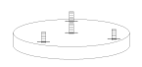 | Base with marked 1 ,2 ,3 | 1
B | 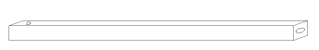 | Tube 1 | 3
C | 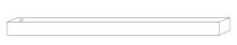 | Tube 2 (with a hole) | 3
D | 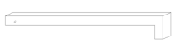 | L tube | 3
E | 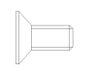 | Mounting screw G5/32-L10 | 6
F | 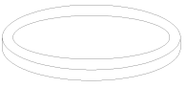 | Round ring | 1
G | 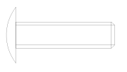 | Mounting screw G5/25-L20 | 3
H | Socket tube | Factory pre-assembled | 3
I | 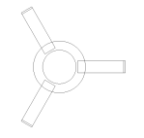 | Tri-fork holder | 1
J | 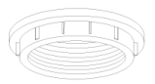 | Socket lock ring | 1
K | 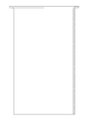 | Glass shade | 1
L | 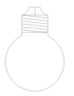 | Bulb | Not include

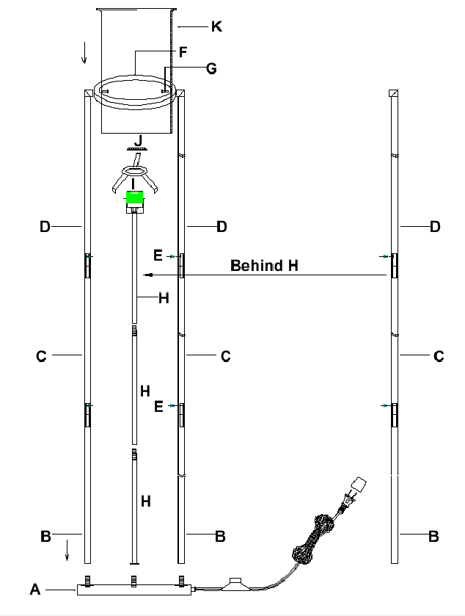

Assembly Instruction:
Step1: Pick out straight tube (B x3pcs & C x3pcs & D x3pcs).
Connect and tighten straight tubes (B) to the base (A).
Tighten 3pcs straight tube (B) with 3pcs straight tube (C).
Tighten L tube (D) with straight tube(C). Use mounting screws (E x6) to lock in place.
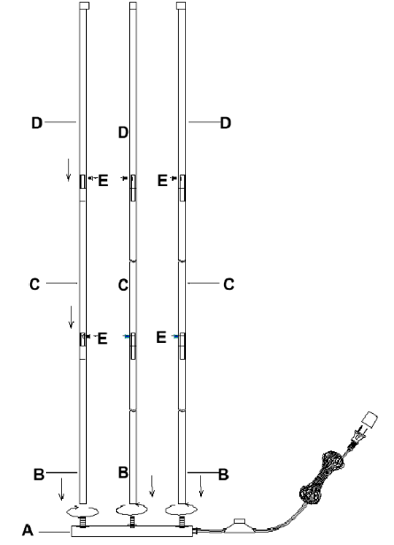

Step 2: Use mounting screw(G) to lock the round ring (F) with the L-shaped tube (D) together.
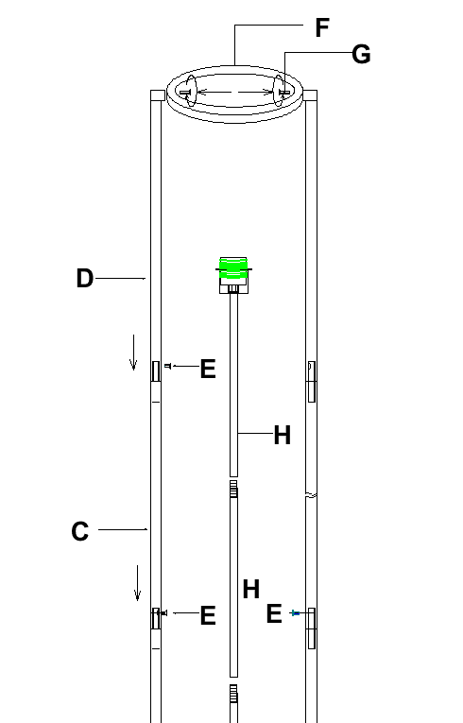

Step 3: Lock socket tube (H) to the base (A), and then tighten the wire.
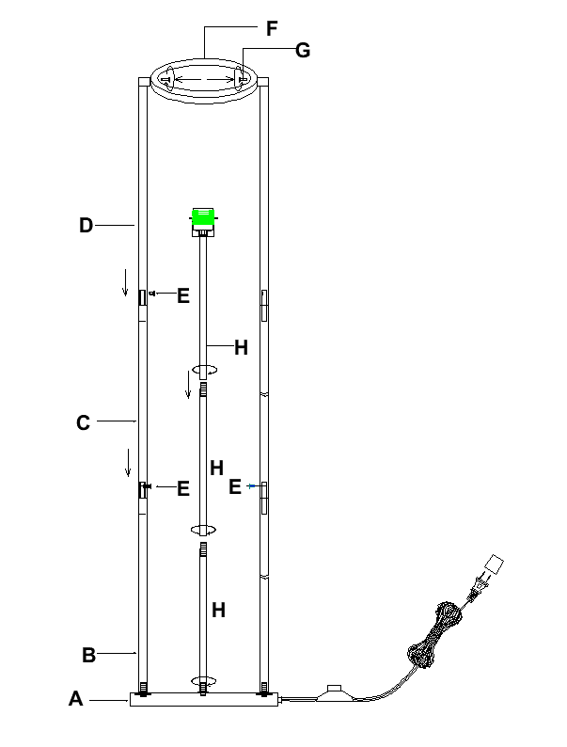

Step 4: Use the socket lock ring (J) and screw the tri-fork holder (I) into the socket. Install the bulb (L) not included.
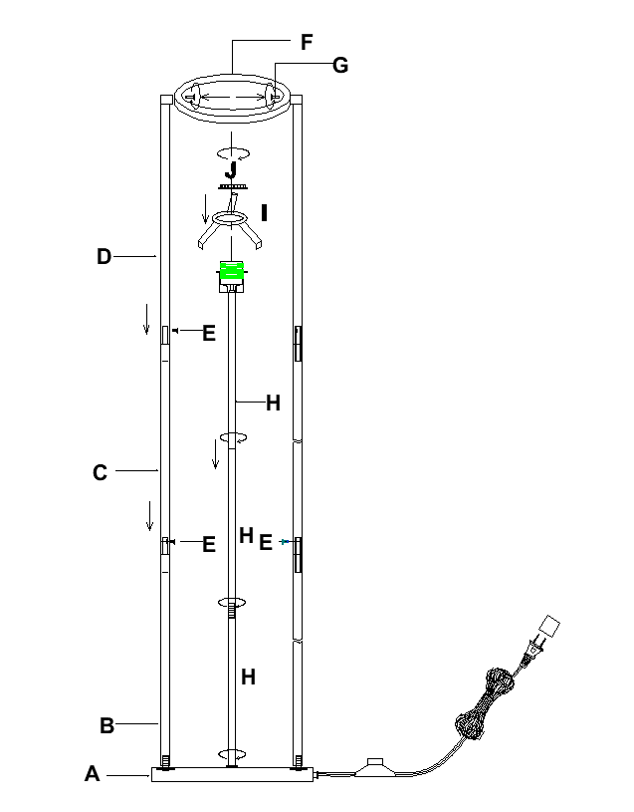

Step 5: Place the glass shade (K) on the round ring (F).
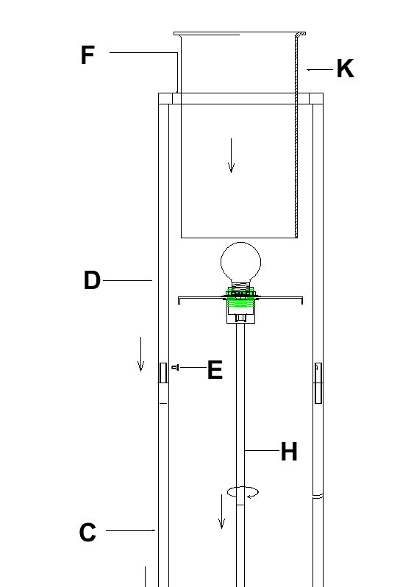

Thank you for your purchase

