

ASSEMBLY INSTRUCTIONS
Aurelia Chandelier (Item#II151-0133)
Caution:
- FOR YOUR SAFETY: Turn off the power to main electric circuit/ fuse box before beginning work.

Important Safety Instructions:
- Professional installation is recommended for hardwired lighting. Incorrect installation can lead to fires.
- These instructions are provided for your safety. It is very important that they are read carefully and completely before assembling fixture.
- We strongly recommend that two people install the lighting fixture.
- This fixture has been rated for up to (5) 40-watt maximum TYPE B bulbs (not included) or (5) 9-watt compact fluorescent light bulbs (not included). To avoid the risk of fire, do not exceed the recommended wattage.
- This lighting fixture is intended for indoor, residential use.

Warning:
- To reduce the risk of fire, electrical shock or personal injury, do not turn on lighting fixture until light bulb is installed and assembly is complete.
- Always turn off the lighting fixture and allow it to cool before replacing the light bulb.

Care instructions:
- Do not polish or use harsh cleaners as they may damage the finish.
- Wipe clean with a non-colored, lint-free soft, dry cloth.

Page 1 of 4

Pre-assembly:
- Remove all parts and hardware from box along with any plastic protective packaging.
- Check that all parts listed are included.
- Do not discard any contents until after assembly is complete to avoid accidentally discarding small parts or hardware.

Component List
Part code | Component | Description | Qty
A | 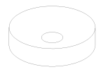 | Ceiling cap | 1
B | 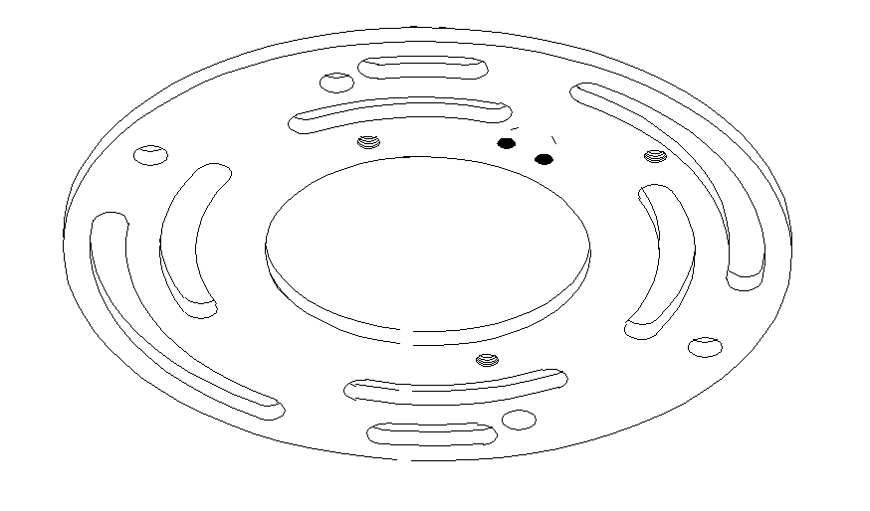 | Crossbar | 1
C | 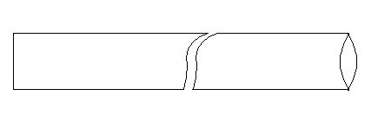 | Inner tube L152 | 1
D | 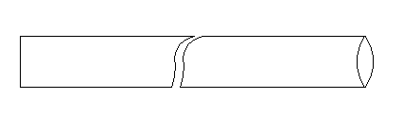 | Inner tube L305 | 3
E | 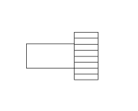 | Mounting screw for glass shade | 15
F | 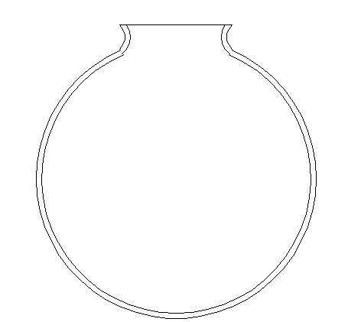 | Glass shade | 5
G | 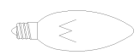 | Bulb | Not included

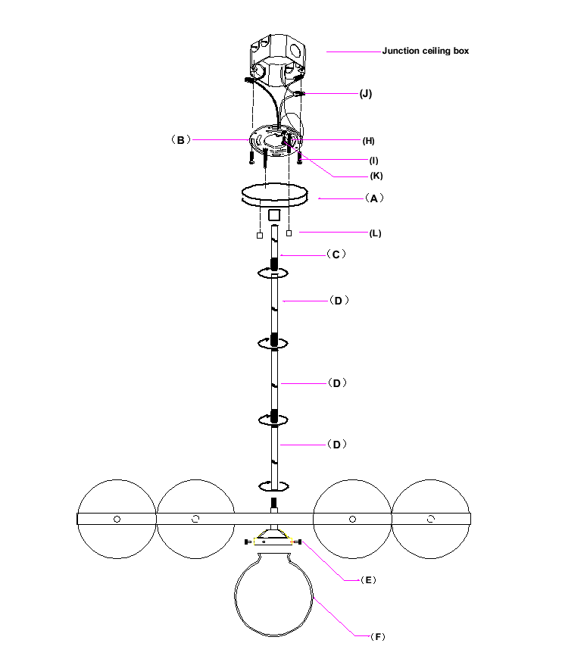

Hardware List
Part code | Component | Description | Qty
H | 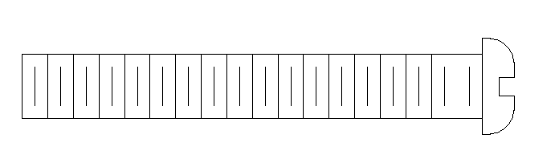 | Mounting screw G5/32-T32 L30 | 2
I |  | Mounting screw  G8/32-T32L32 | 2
J | 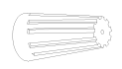 | Plastic wire nut connector | 3
K | 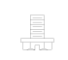 | Ground screw | 1
L |  | Nut cover | 2

Page 2 of 4

To Adjust the Suspension Length of the Fixture:
- The adjustment or shortening of the lighting fixture’s suspension length is only needed if the factory set length is not appropriate for your installation. We recommend that you adjust the lighting fixture to the proper desired length before cutting the electrical cord.
- Determine the lighting fixture suspension length from the ceiling for the product installation, allowing the extra cord length for the outlet junction box wire connections. If needed, cut off the extra power cord length on the 3 wire cords so that they are all at least 6 inches (152.4mm) long within the outlet junction box.

Assembly Instructions:
- Step1：With the help of another person to hold the weight of lighting fixture, attach the crossbar (B) onto the junction box by using 2 mounting screws(I).
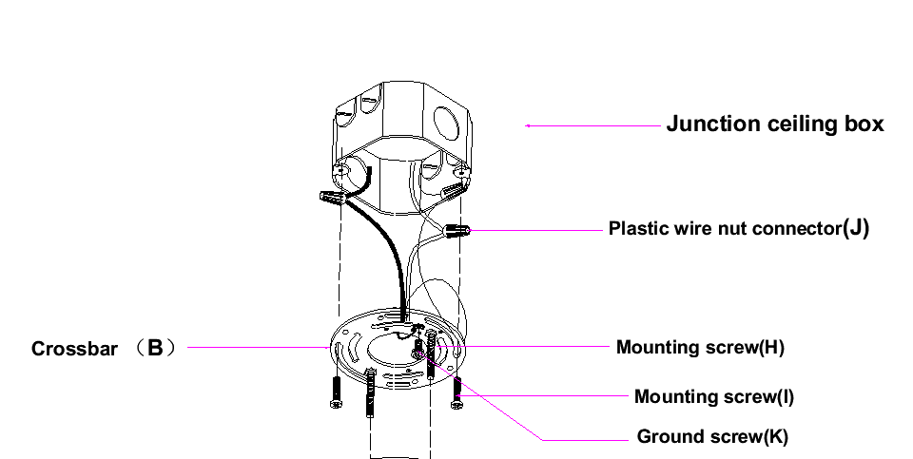
- Step 2: Tightly connect the inner tube (C and D) with light fixture and ceiling cap (A).
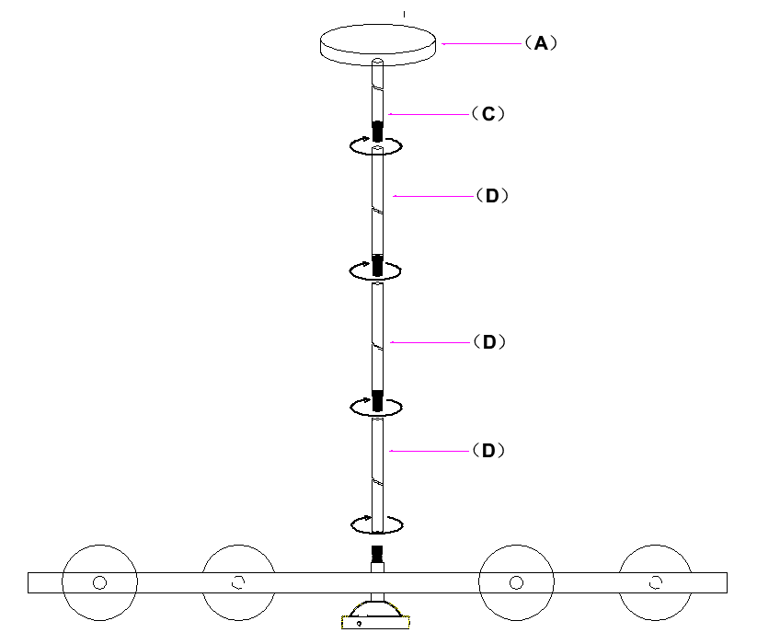

Page 3 of 4
Step 3: Connect the ceiling cap (A) with crossbar (B), tighten by using the nut cover (L) and 2 mounting screws (I).
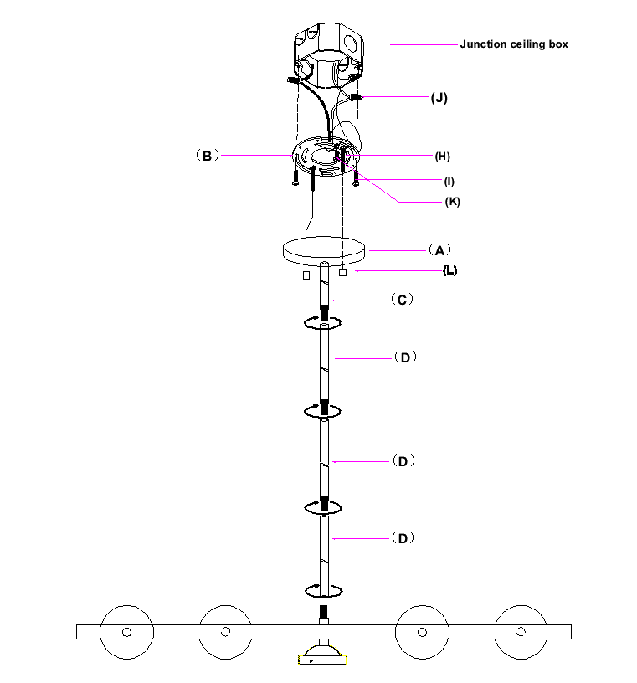

- Step 4: UDPATE: After installing the bulb, securely connect the glass shade (F) with the glass shade mounting screw (E).

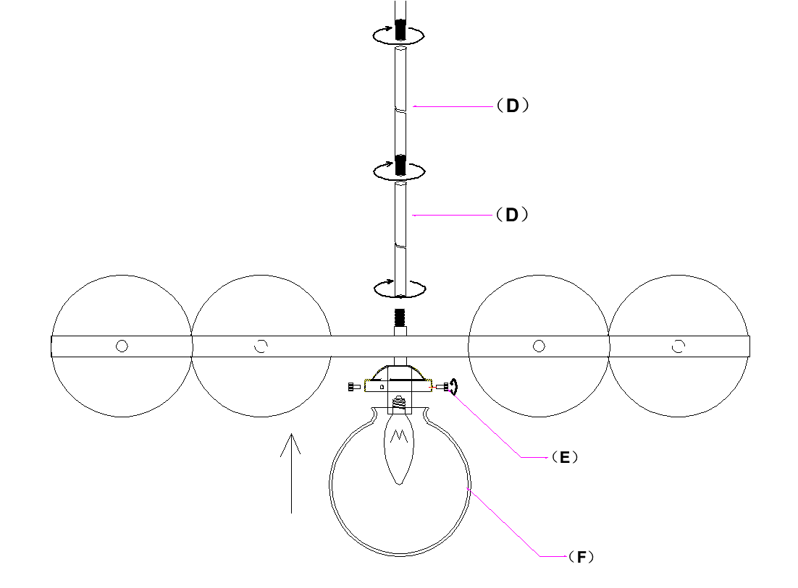
Thank you for your purchase

Page 4 of 4

