
ASSEMBLY INSTRUCTIONS
Conway Set of 2 Wall Sconces (Item#FB155-1173)
Caution:
- FOR YOUR SAFETY: Turn off the power to main electric circuit/ fuse box before beginning work.

Important Safety Instructions:
- Professional installation is recommended for hardwired lighting. Incorrect installation can lead to fires.
- These instructions are provided for your safety. It is very important that they are read carefully and completely before assembling fixture.
- We strongly recommend that two people install the lighting fixture.
- This fixture has been rated for up to (1) 40-watt maximum TYPE B bulbs (not included) or (1) 9-watt compact fluorescent light bulbs (not included). To avoid the risk of fire, do not exceed the recommended wattage.
- This lighting fixture is intended for indoor, residential use.

Warning:
- To reduce the risk of fire, electrical shock or personal injury, do not turn on lighting fixture until light bulb is installed and assembly is complete.
- Always turn off the lighting fixture and allow it to cool before replacing the light bulb.

Care instructions:
- Do not polish or use harsh cleaners as they may damage the finish.
- Wipe clean with a non-colored, lint-free soft, dry cloth.

Page 1 of 3

Pre-assembly:
- Remove all parts and hardware from box along with any plastic protective packaging.
- Check that all parts listed are included.
- Do not discard any contents until after assembly is complete to avoid accidentally discarding small parts or hardware.

Component List
Part code | Component | Description | Qty
A | 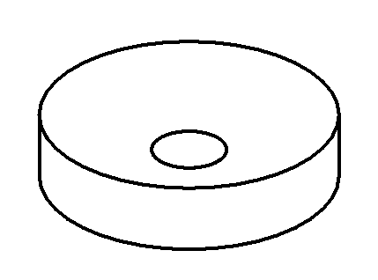 | Ceiling cap | 1
B | 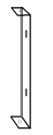 | Crossbar | 1
C | 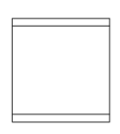 | Shade | 1
D | 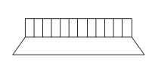 | Socket lock ring | 1
E | 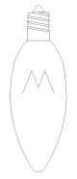 | Bulb | Not included

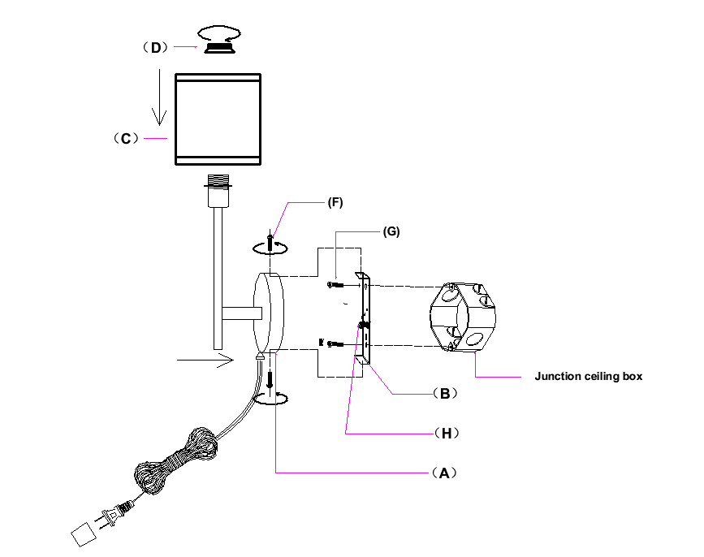

Hardware List
Part code | Component | Description | Qty
F | 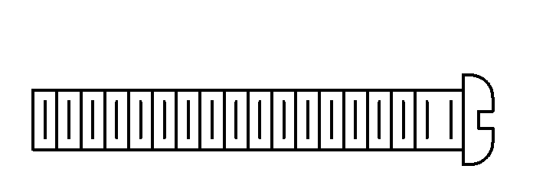 | Mounting screw G5/32-T32 L15 | 2
G |  | Mounting screw  G8/32-T32L32 | 2
H | 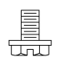 | Ground screw | 1

Page 2 of 3

Assembly Instructions:
Step1：Attach the crossbar (B) onto the electrical junction box by using 2 mounting screws(G).

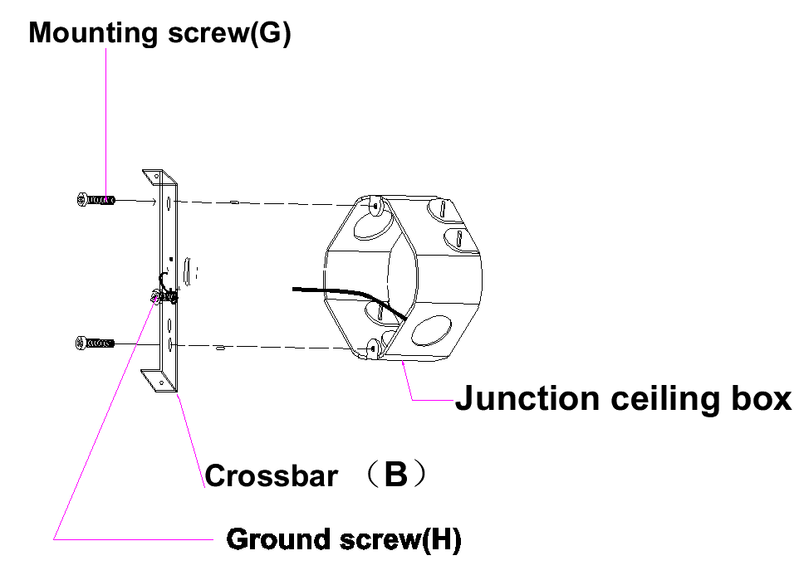
Step 2: Connect the ceiling cap (A) with crossbar (B), tightly lock by mounting screw (F).
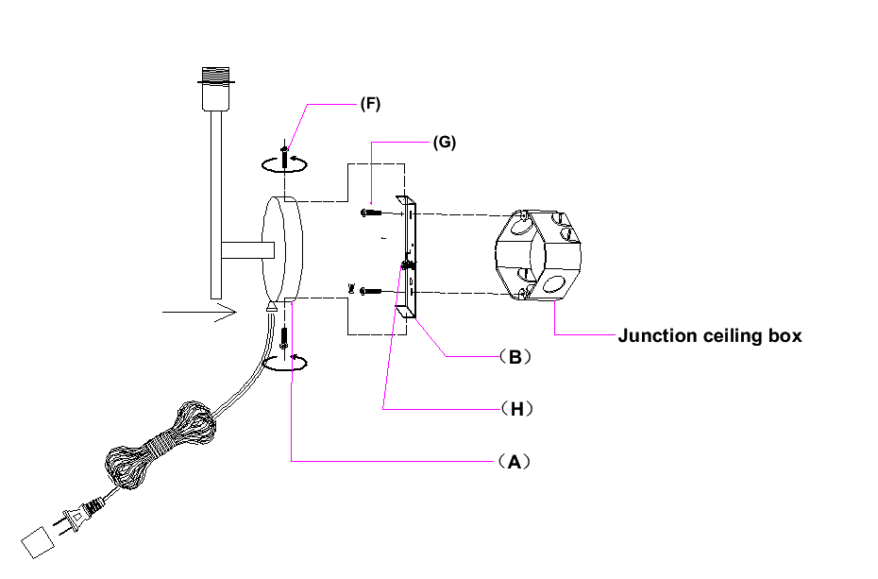
Step 3: Position the lamp shade (C) downwards and tighten with the socket lock ring (D), lastly install the bulb (E not included).

Thank you for your purchase

Page 3 of 3

