
ASSEMBLY INSTRUCTIONS
Camden Pendant (Item#MT151-0067)

Caution:
- FOR YOUR SAFETY: Turn off the power to main electric circuit/ fuse box before beginning work.

Important Safety Instructions:
- Professional installation is recommended for hardwired lighting. Incorrect installation can lead to fires.
- These instructions are provided for your safety. It is very important that they are read carefully and completely before assembling fixture.
- We strongly recommend that two people install the lighting fixture.
- This fixture has been rated for up to (4) 40-watt maximum TYPE B bulbs (not included) or (4) 9-watt compact fluorescent light bulbs (not included). To avoid the risk of fire, do not exceed the recommended wattage.
- This lighting fixture is intended for indoor, residential use.

Warning:
- To reduce the risk of fire, electrical shock or personal injury, do not turn on lighting fixture until light bulb is installed and assembly is complete.
- Always turn off the lighting fixture and allow it to cool before replacing the light bulb.

Care instructions:
- Do not polish or use harsh cleaners as they may damage the finish.
- Wipe clean with a non-colored, lint-free soft, dry cloth.

Page 1 of 5

Pre-assembly:
- Remove all parts and hardware from box along with any plastic protective packaging.
- Check that all parts listed are included.
- Do not discard any contents until after assembly is complete to avoid accidentally discarding small parts or hardware.

Component List
Part code | Component | Description | Qty
A | 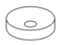 | Ceiling cap | 1
B |  | Crossbar | 1
C | 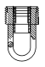 | Hang ring | 1
D | 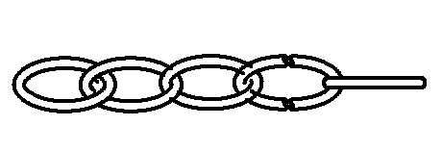 | Hang chain | 1
E | 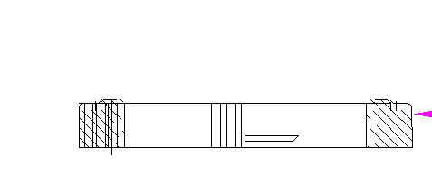 | Canopy nut | 1
F | 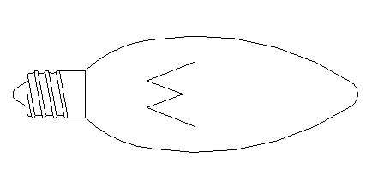 | Bulb | Not included
G | 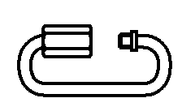 | Quick link chain connector | 2
H |  | Decorative cap | 4
I | 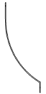 | bent metal part | 4
J | 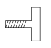 | Mounting screw | 4
K | 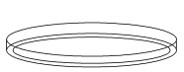 | Round ring | 1
L | 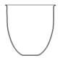 | Glass shade | 1

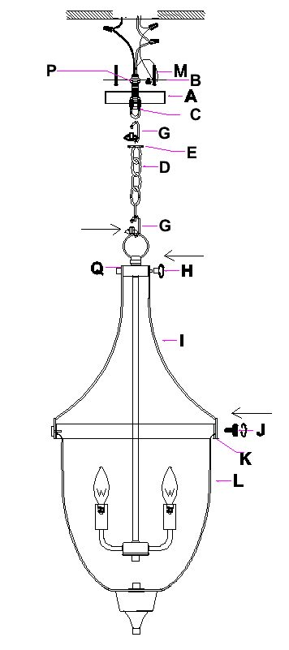

Hardware List
Part code | Component | Description | Qty
M | 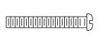 | Mounting screw | 2
N | 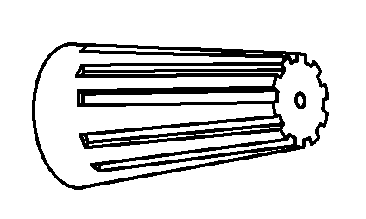 | Plastic wire nut connector | 3
O | 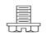 | Ground screw | 1
P | 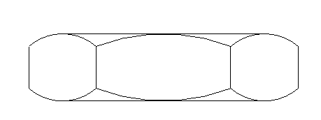 | Hex nut | 2

Page 2 of 5

To Adjust the Suspension Length of the Fixture:
- The adjustment or shortening of the lighting fixture’s suspension length is only needed if the factory set length is not appropriate for your installation. We recommend that you adjust the lighting fixture to the proper desired length before cutting the electrical cord.
- Determine the lighting fixture suspension length from the ceiling for the product installation, allowing the extra cord length for the outlet junction box wire connections. If needed, cut off the extra power cord length on the 3 wire cords so that they are all at least 6 inches (152.4mm) long within the outlet junction box.

Assembly Instructions:
Step 1: Position the canopy (A) and canopy nut (E) onto the ceiling, secure onto the hang chain (D).
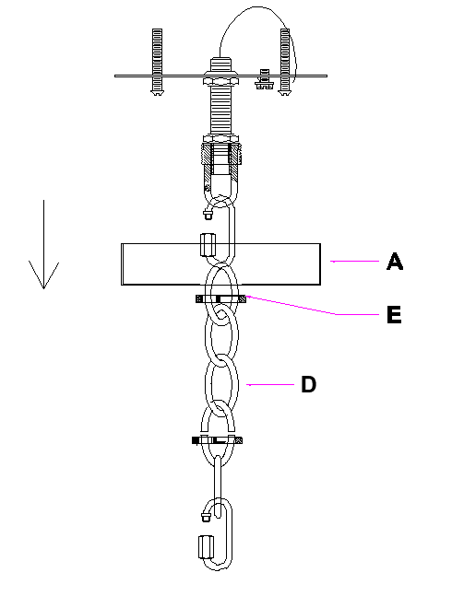
Step 2: With the help of another person to hold the weight of lighting fixture, attach the crossbar (B) onto the electrical junction box by using 2 mounting screws (M) with a screwdriver, work with a professional electrician to make the wire connection.

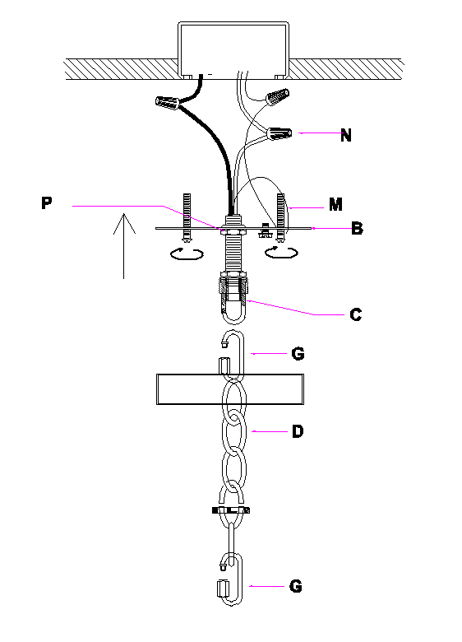

Page 3 of 5

Step 3: Position the canopy (A) and canopy nut (E) onto the ceiling. Be sure to hold the canopy(A) sturdy and in place with the canopy nut (E), then install the bulb (F not included).
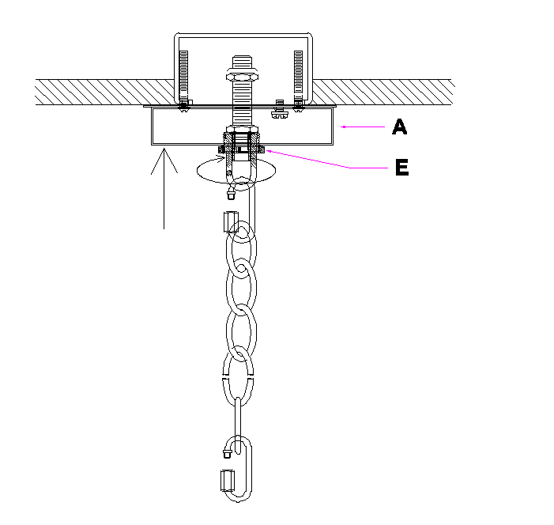
Step 4: Position the glass shade (L) downwards through the round ring (K) and carefully hold the glass shade up.

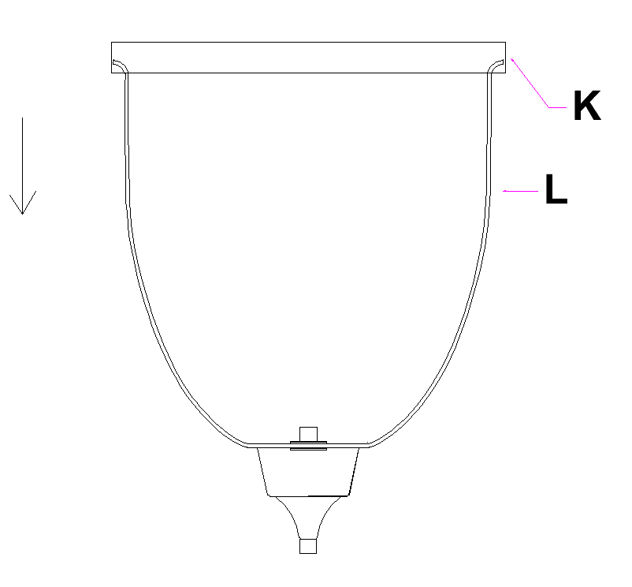
.

Step 5: Carefully tighten the round ring (K), bent metal part (I), and light body (Q) by using the decorative cap (H) and mounting screw (J).

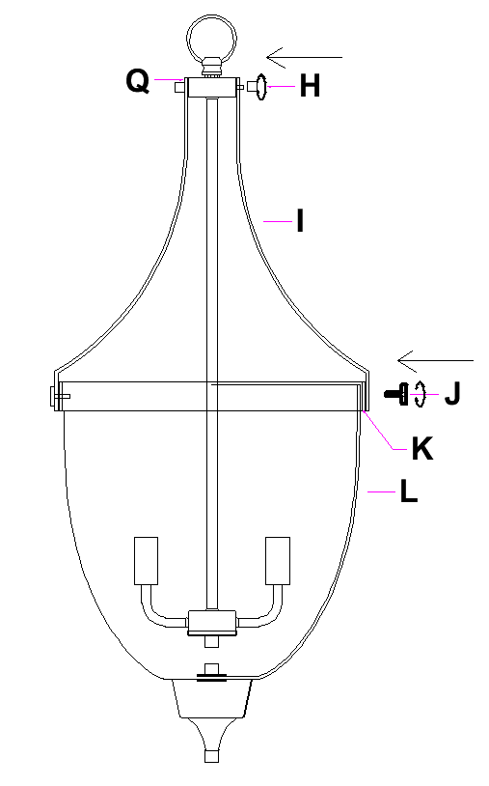

Page 4 of 5

Step 6: Connect the finished light fixture body(Q), with the quick link chain connector(G).

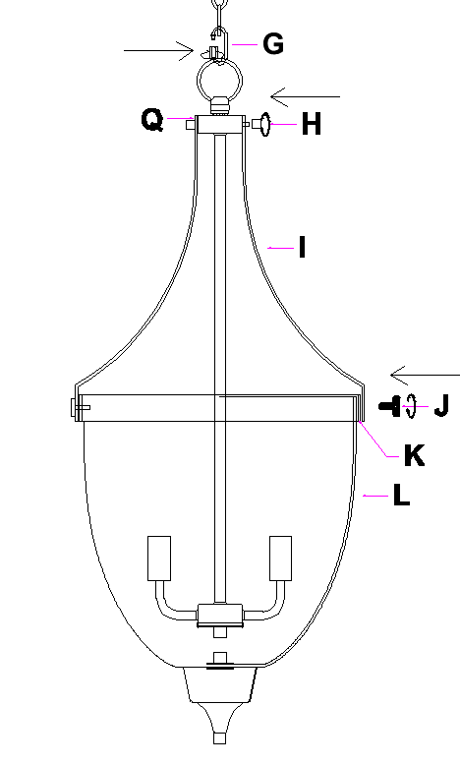

Thank you for your purchase

Page 5 of 5

